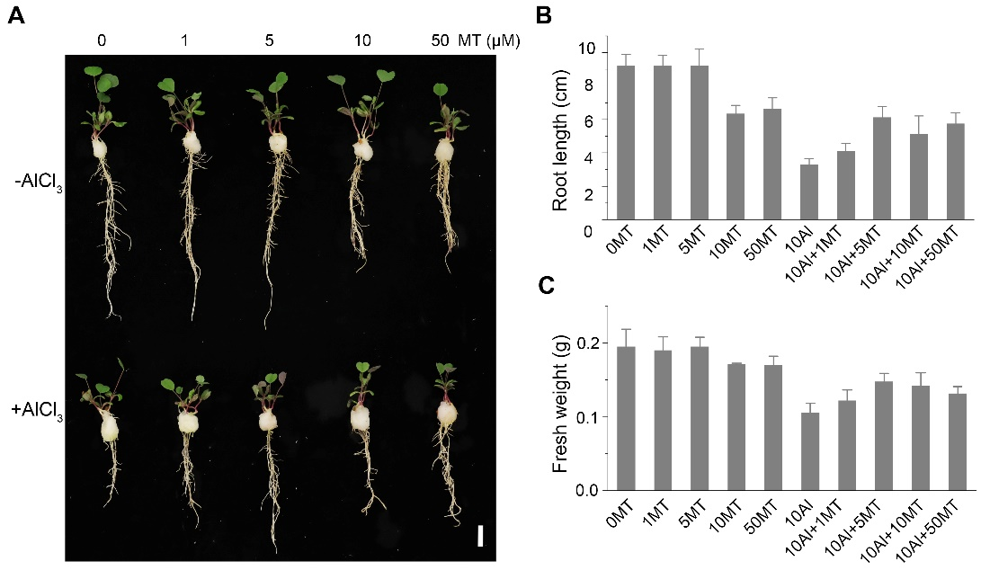
Supplementary Figure S1: Effects of different concentrations of melatonin on the phenotype of alfalfa. (A) Phenotypes after 5d of AlCl₃ and melatonin treatment. Scale bar, 1cm. (B) Root length, data were means ± SE n=16. (C) Fresh weight of 4 alfalfa seedlings on a cotton ball, data were mean ± SE n=4.

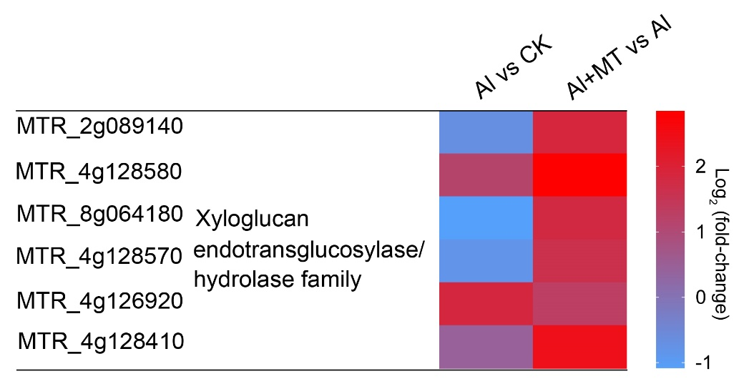
Supplementary Figure S2: Transcript changes in cell wall-related genes induced by Al and melatonin.

