Supplementary Information.

Synthesis of Calamitic Fluorinated Mesogens with Complex Crystallization Behaviour
Anokhin D.V.*^{1,2}, Maryasevskaya A.V.¹, Abukaev A.F.¹, Ozkose, U.U. ^{3,4}, Buglakov A.I. ¹, Ivanov D.A.^{1,2,5}, Ameduri B. M.*^{1,3}
Citation: To be added by editorial staff during production.
Academic Editor: Firstname Lastname
Received: date
Revised: date
Accepted: date
Published: date
Copyright: © 2023 by the authors. Submitted for possible open access publication under the terms and conditions of the Creative Commons Attribution (CC BY) license (https://creativecommons.org/licenses/by/4.0/).
- Lomonosov Moscow State University, Faculty of Chemistry, Russia,119991, Moscow 1, GSP-1, 1-3 Leninskiye Gory, Russian Federation
- Scientific Center for Genetics and Life Sciences, Sirius University of Science and Technology, 1 Olympic Ave., 354340 Sochi, Russian Federation
- Institut Charles Gerhardt, CNRS, University of Montpellier, Ecole Nationale Supérieure de Chimie de Montpellier, ENSCM, 34000 Montpellier, France
- Department of Chemistry, Faculty of Science and Letters, Piri Reis University, Tuzla, 34940 Istanbul, Turkey
⁵ Institut de Sciences des Matériaux de Mulhouse-IS2M, CNRS UMR 7361, Jean Starcky 15, F-68057 Mulhouse, France

* Correspondence: Tel.: +33(0)4-48-79-2020
Bruno.ameduri@enscm.fr; deniano@yahoo.com

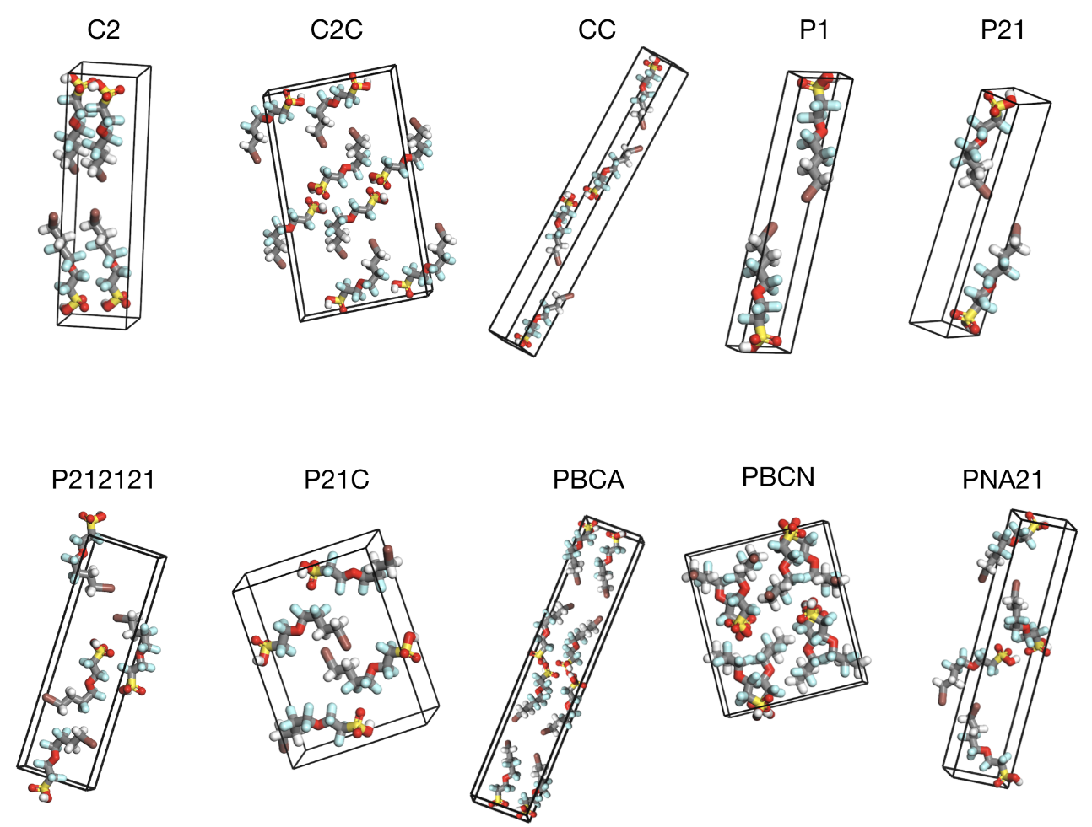
Figure S1. Possible symmetries of unit cell of ICH₂CH₂CF₂CF₂OCF₂CF₂SO₃H used in simulation.

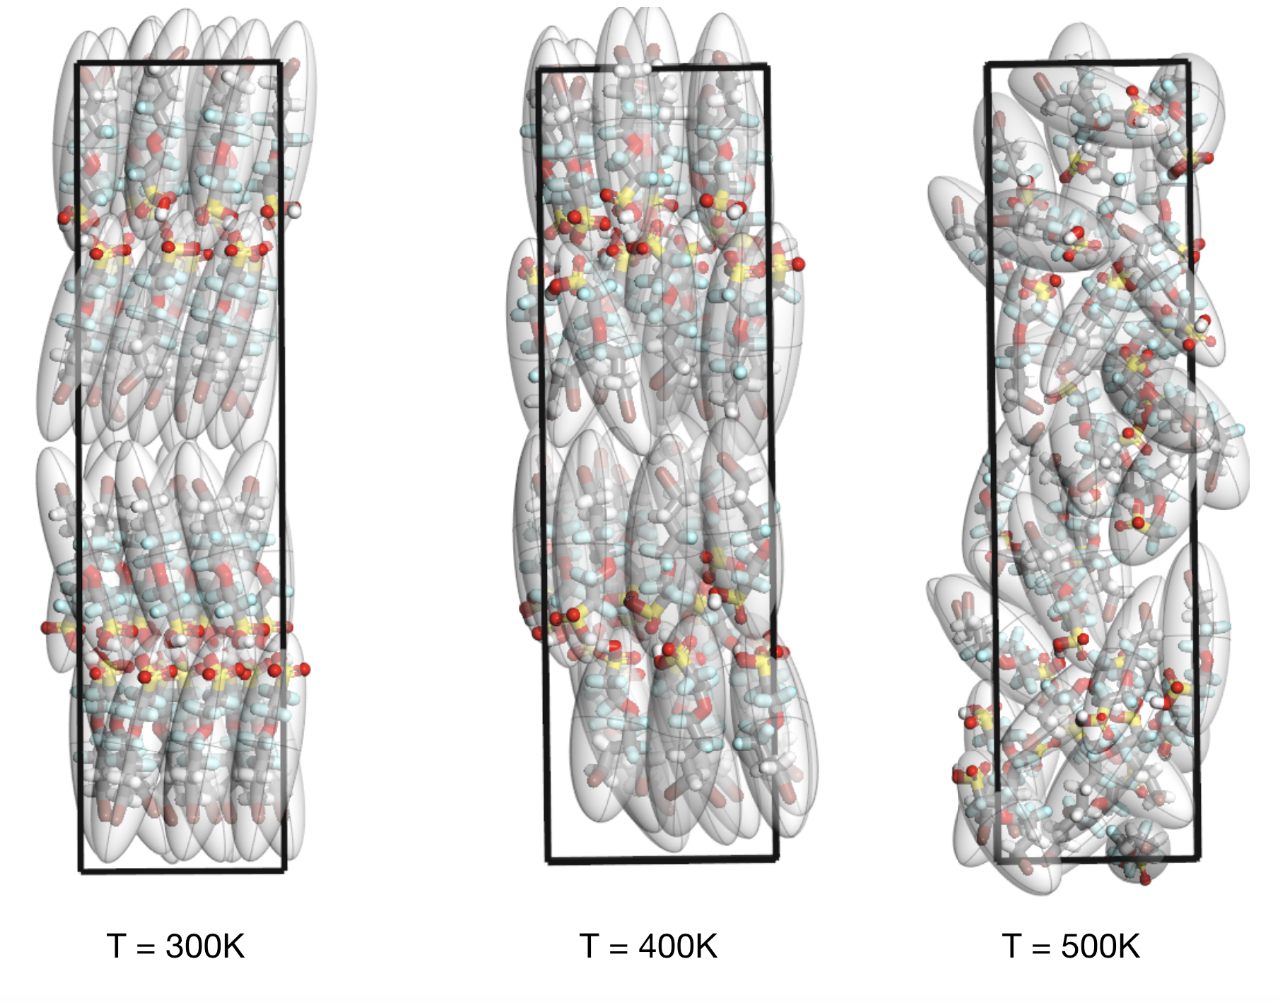
Figure S2. Model of P1 unit cell of ICH₂CH₂CF₂CF₂OCF₂CF₂SO₃H at different temperatures.

Table S1. Experimental and theoretical peak positions for ICH₂CH₂CF₂CF₂OCF₂CF₂SO₃H at room temperature.
h | k | l | d_{exp} | d_{calc}
1 | 0 | 0 | 27.54 | 27.50
2 | 0 | 0 | 13.78 | 13.80
3 | 0 | 0 | 9.17 | 9.18
0 | 1 | 0 | 5.21 | 5.16
1 | 1 | 0 | 5.04 | 5.08
0 | 0 | 1 | 4.96 | 4.97
1 | 0 | 1 | 4.87 | 4.89
2 | 0 | -1 | 4.75 | 4.67
6 | 0 | 0 | 4.57 | 4.59
3 | 0 | 1 | 4.39 | 4.37
4 | -1 | 0 | 4.14 | 4.13
4 | 0 | 1 | 3.99 | 4.03
2 | 1 | 1 | 3.72 | 3.74
5 | 0 | 1 | 3.65 | 3.69
8 | 0 | 0 | 3.47 | 3.44
2 | 1 | -1 | 3.21 | 3.24
4 | 1 | 1 | 3.39 | 3.38
1 | -1 | 1 | 3.31 | 3.34
2 | -1 | 1 | 3.21 | 3.24
3 | -1 | 1 | 3.12 | 3.14
7 | 0 | 1 | 3.05 | 3.08
6 | 1 | 1 | 2.93 | 2.97
6 | 1 | -1 | 2.67 | 2.70
1 | 2 | 0 | 2.56 | 2.57
2 | 2 | 0 | 2.51 | 2.54
1 | 1 | 2 | 2.36 | 2.38
4 | 0 | 2 | 2.32 | 2.34
5 | 0 | 2 | 2.27 | 2.26
6 | 0 | 2 | 2.18 | 2.18
8 | 2 | 0 | 2.06 | 2.07
8 | 0 | 2 | 2.02 | 2.01
3 | 2 | 2 | 1.90 | 1.90
4 | 2 | 2 | 1.86 | 1.86
5 | 2 | 2 | 1.82 | 1.83
6 | 2 | 2 | 1.78 | 1.79
0 | 3 | 0 | 1.72 | 1.72
0 | 2 | -2 | 1.68 | 1.67
3 | 2 | -2 | 1.64 | 1.64

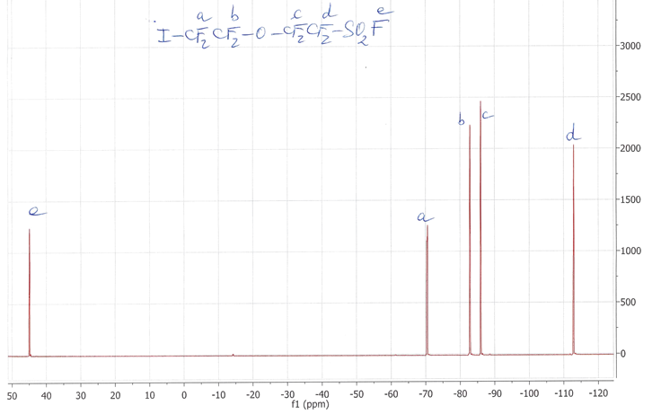

Figure S3. ¹⁹F-NMR spectrum of ICF₂CF₂OCF₂CF₂SO₂F recorded in d₆-acetone.

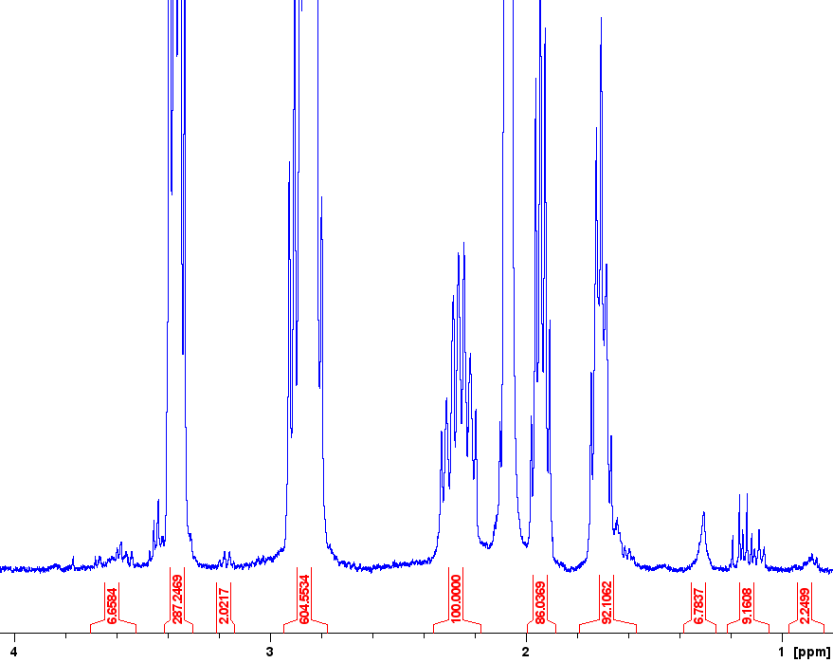

Figure S4. ¹H-NMR spectrum of ICH₂CH₂CF₂CF₂OCF₂CF₂SO₃H recorded in d₆-acetone.

Figure S5. ¹⁹F-NMR spectrum of ICH₂CH₂CF₂CF₂OCF₂CF₂SO₃H recorded in d₆-acetone.
Figure S6. FT-IR spectrum of ICH₂CH₂CF₂CF₂OCF₂CF₂SO₃H.

