Supplementary materials
Isoprenylated flavonoids and 2-arylbenzofurans from the root bark of Morus alba. L. and their cytotoxic activity of against HGC27 cancer cells

Hang-Yi Pu ^{a,b}, Dong-Yi Cao ^{c}, Xue Zhou ^{a,b}, Fu Li ^{a,b}, Lun Wang ^{a,b}, Ming-Kui Wang^{a,b,*}

ª Natural Products Research Center, Chengdu Institute of Biology, Chinese Academy of Sciences, Chengdu 610041, China
^{b} University of Chinese Academy of Sciences, Beijing 100049, China
^{c} The Third Affiliated Hospital of Yunnan University of Chinese Medicine, Kunming 650500, Yunnan, China.
* Corresponding Author at: Key Laboratory of Mountain Ecological Restoration and Bioresource Utilization and Ecological Restoration Biodiversity Conservation Key Laboratory of Sichuan Province, Chengdu Institute of Biology, Chinese Academy of Sciences, Chengdu 610041, People’s Republic of China, Tel/Fax: +86-28-82890821. E-mail address: wangmk@cib.ac.cn (Ming-Kui Wang).

Supporting Information Available
Figure S1. HR-ESI-MS spectrum of compound 1.
Figure S2. ¹H-NMR spectrum (400 MHz, CD₃OD) of compound 1.
Figure S3. ¹³C-NMR (100 MHz, CD₃OD) spectrum of compound 1.
Figure S4. DEPT 135 spectrum (100 MHz, CD₃OD) of compound 1.
Figure S5. HSQC spectrum of compound 1 in CD₃OD.
Figure S6. HMBC spectrum of compound 1 in CD₃OD.
Figure S7. ¹H-¹H COSY spectrum of compound 1 in CD₃OD.
Figure S8. NOSEY spectrum of compound 1 in CD₃OD.
Figure S9. HR-ESI-MS spectrum of compound 11.
Figure S10. ¹H-NMR spectrum (600 MHz, DMSO) of compound 11.
Figure S11. ¹³C-NMR (150 MHz, DMSO) spectrum of compound 11.
Figure S12. DEPT 135 spectrum (150 MHz, DMSO) of compound 11.
Figure S13. HSQC spectrum of compound 11 in DMSO.
Figure S14. HMBC spectrum of compound 11 in DMSO.
Figure S15. ¹H-¹H COSY spectrum of compound 11 in DMSO.
Figure S16. HR-ESI-MS spectrum of compound 12.
Figure S17. ¹H-NMR spectrum (600 MHz, CD₃OD) of compound 12.
Figure S18. ¹³C-NMR spectrum (150 MHz, CD₃OD) of compound 12.
Figure S19. DEPT 135 spectrum (150 MHz, CD₃OD) of compound 12.
Figure S20. HSQC spectrum of compound 12 in CD₃OD.
Figure S21. HMBC spectrum of compound 12 in CD₃OD.
Figure S22. ¹H-¹H COSY spectrum of compound 12 in CD₃OD.
Figure S23. ¹H-NMR spectrum (600 MHz, DMSO) of compound 12.
Figure S24. ¹³C-NMR (150 MHz, DMSO) spectrum of compound 12.
Figure S25. DEPT 135 spectrum (150 MHz, DMSO) of compound 12.

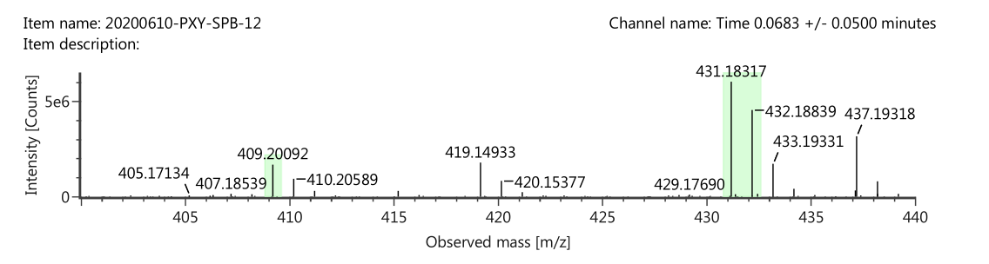Figure S1. HR-ESI-MS spectrum of compound 1.

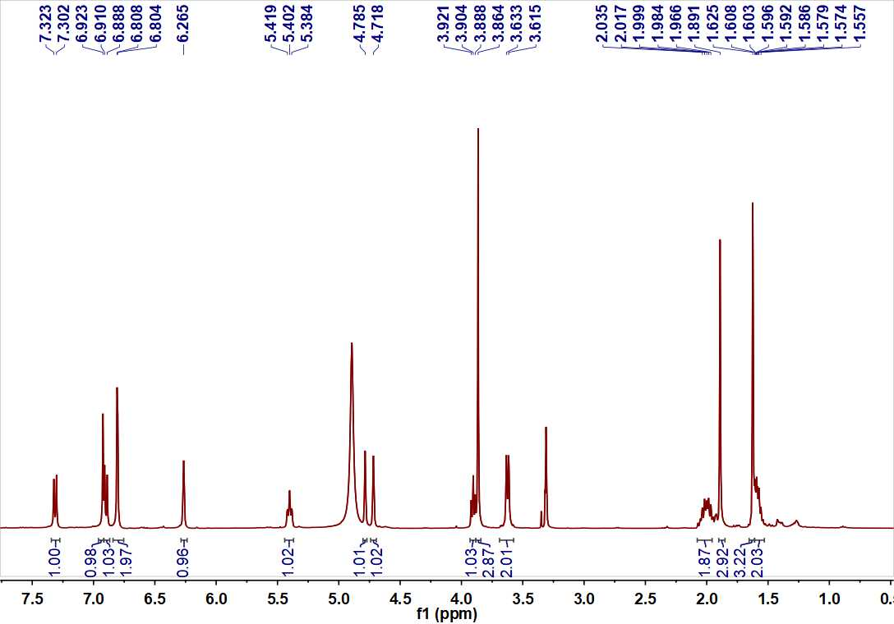
Figure S2. ¹H-NMR spectrum (400 MHz, CD₃OD) of compound 1.

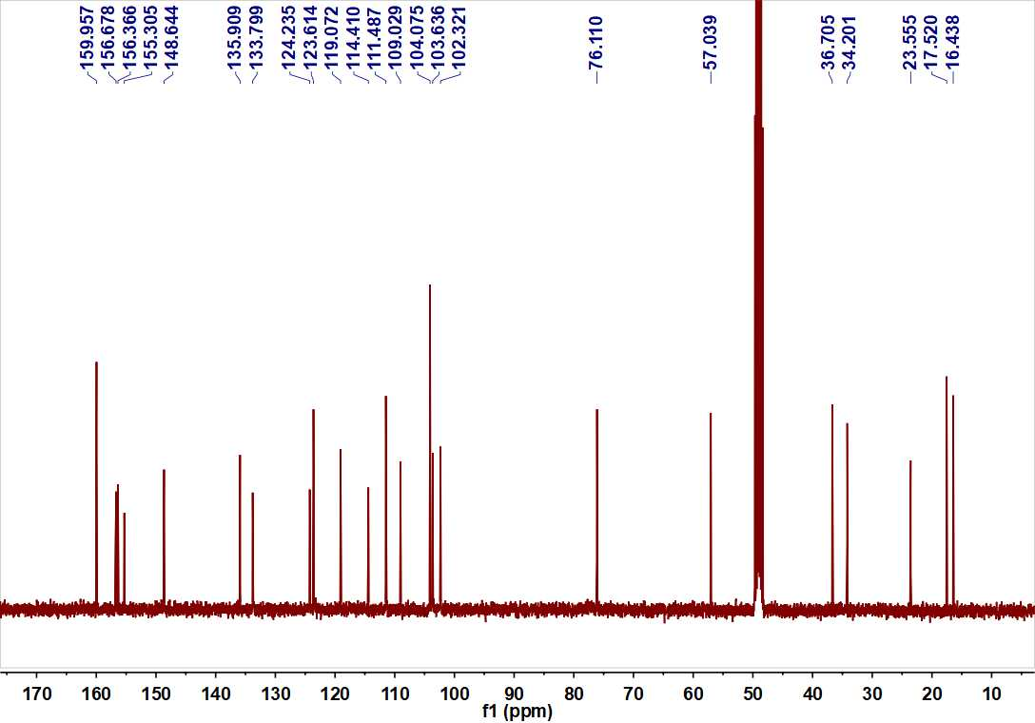
Figure S3. ¹³C-NMR (100 MHz, CD₃OD) spectrum of compound 1.

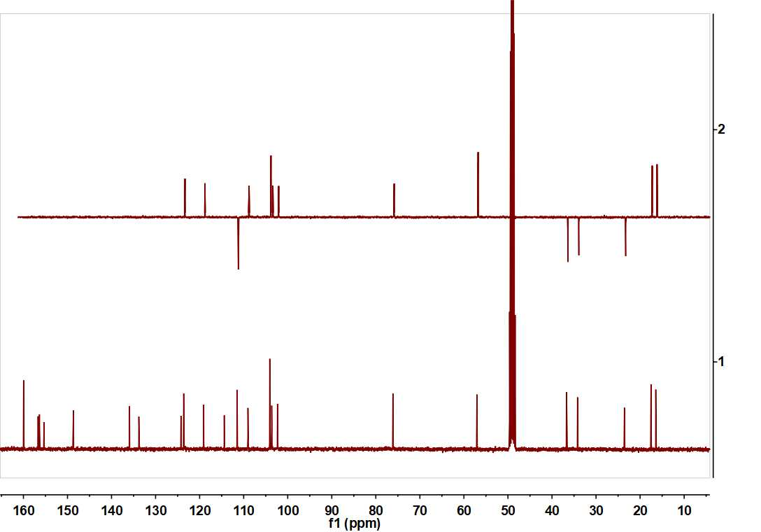
Figure S4. DEPT 135 spectrum (100 MHz, CD₃OD) of compound 1.
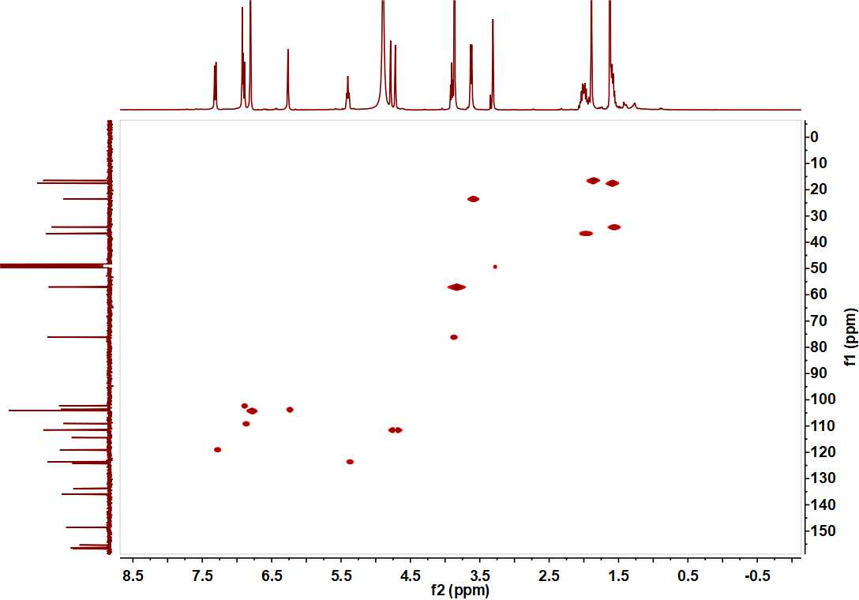
Figure S5. HSQC spectrum of compound 1 in CD₃OD.

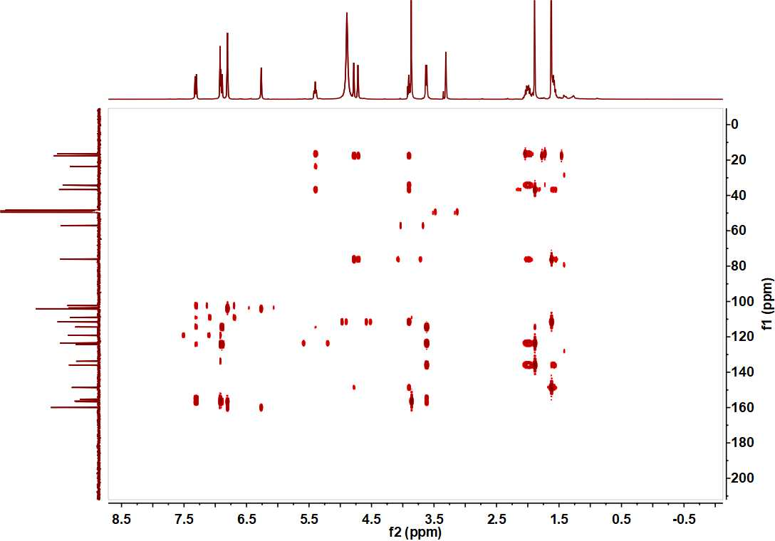
Figure S6. HMBC spectrum of compound 1 in CD₃OD

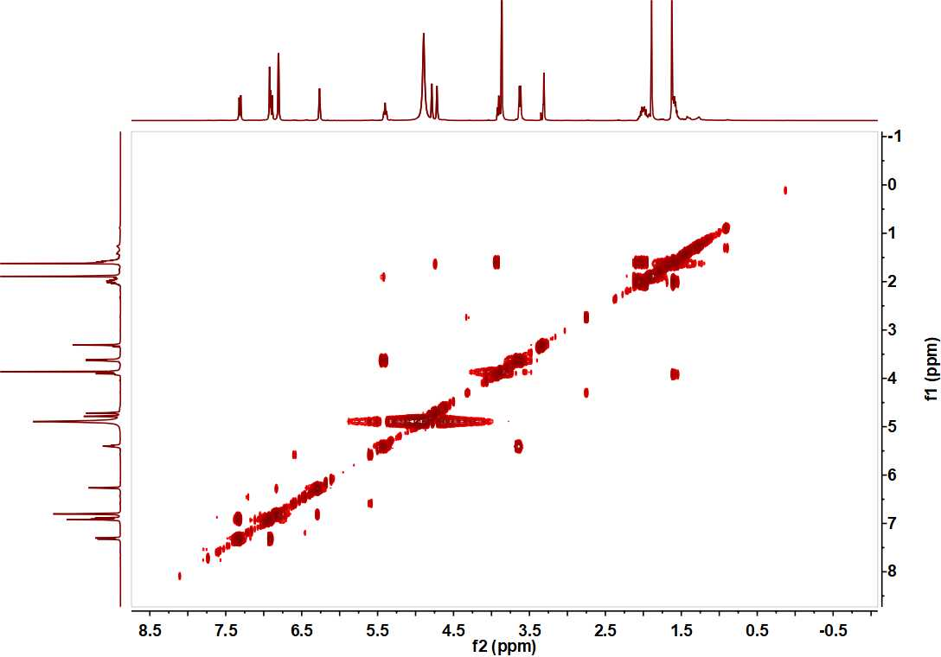
Figure S7. ¹H-¹H COSY spectrum of compound 1 in CD₃OD.

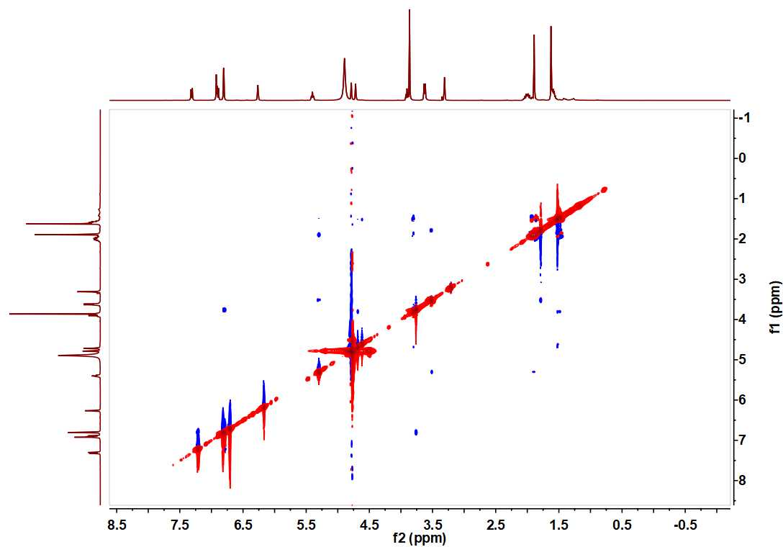
Figure S8. NOSEY spectrum of compound 1 in CD₃OD.
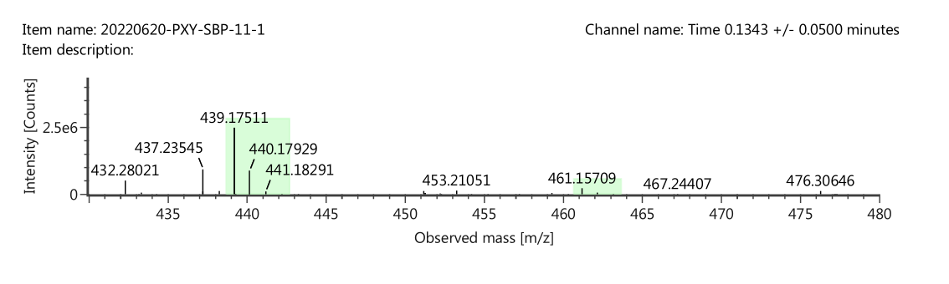
Figure S9. HR-ESI-MS spectrum of compound 11.

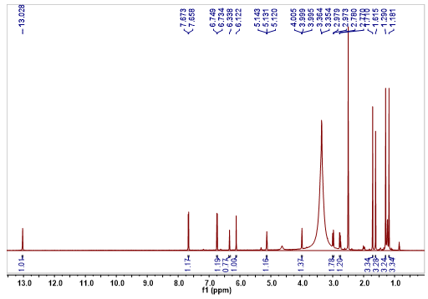
Figure S10. ¹H-NMR spectrum (600 MHz, DMSO) of compound 11.
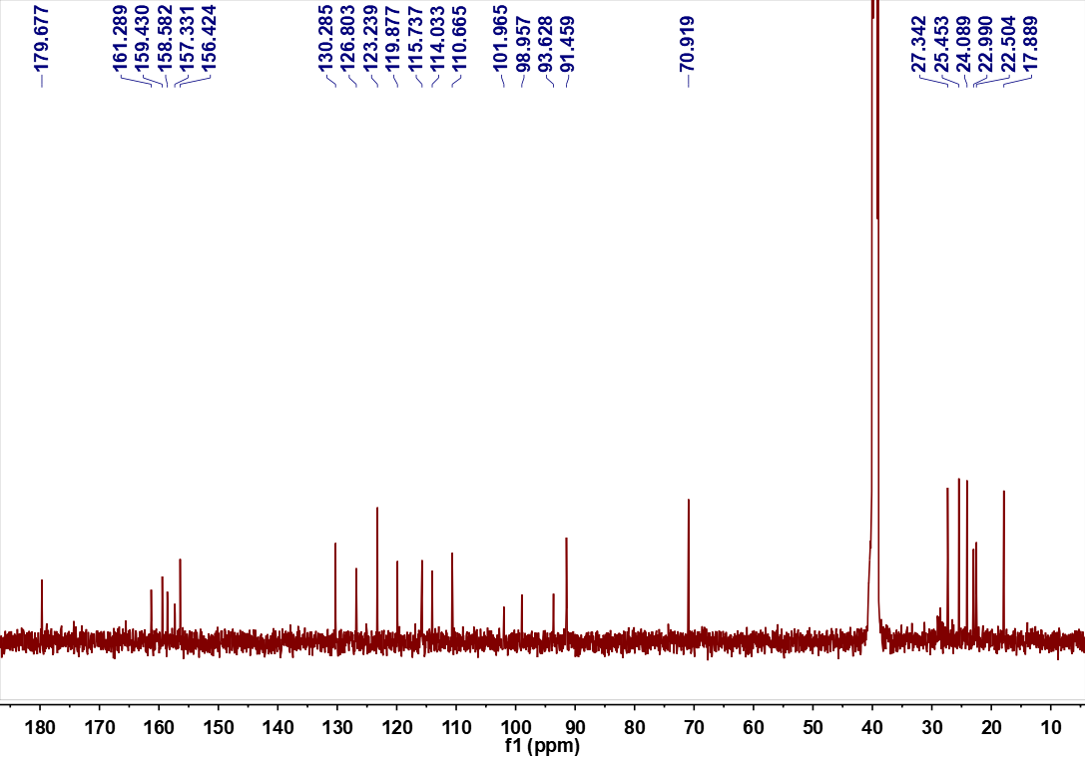
Figure S11. ¹³C-NMR (150 MHz, DMSO) spectrum of compound 11.

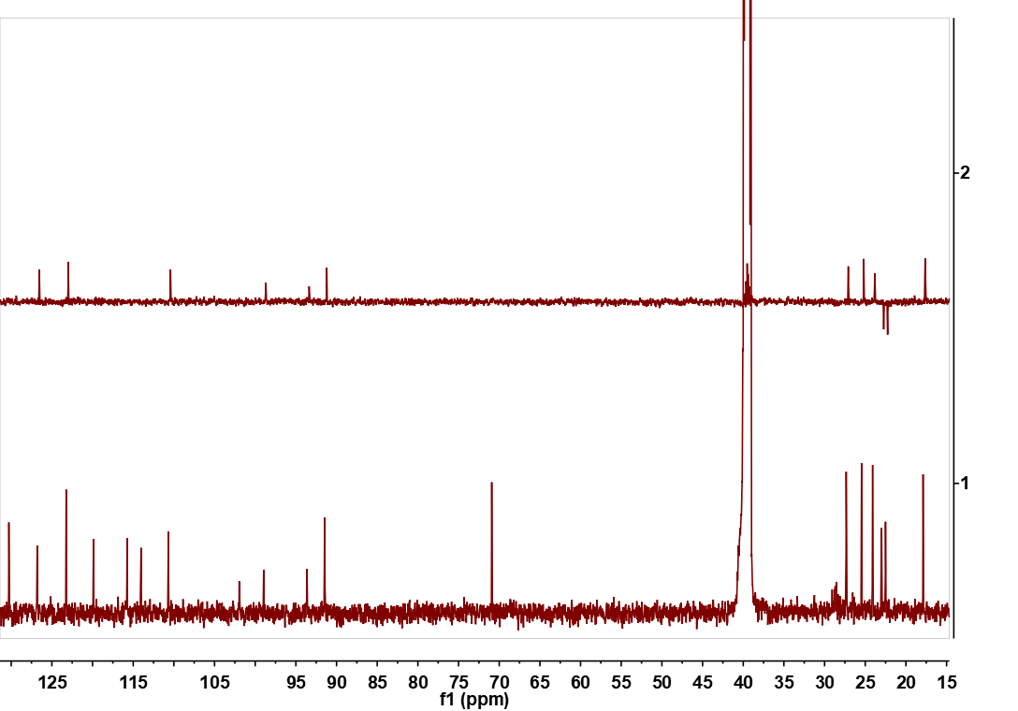
Figure S12. DEPT 135 spectrum (150 MHz, DMSO) of compound 11.
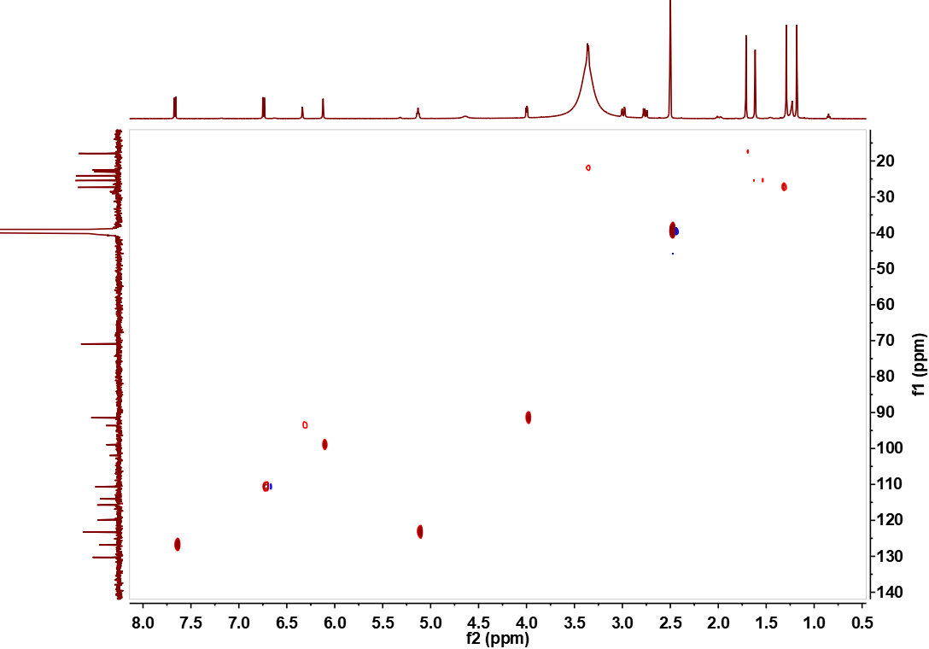
Figure S13. HSQC spectrum of compound 11 in DMSO.

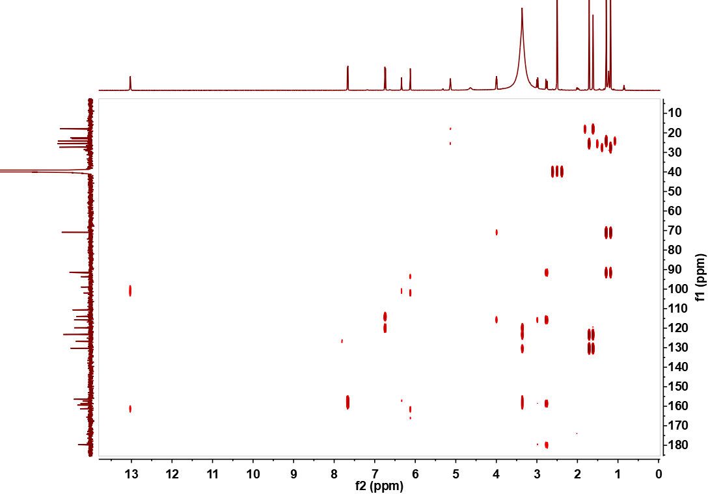
Figure S14. HMBC spectrum of compound 11 in DMSO.
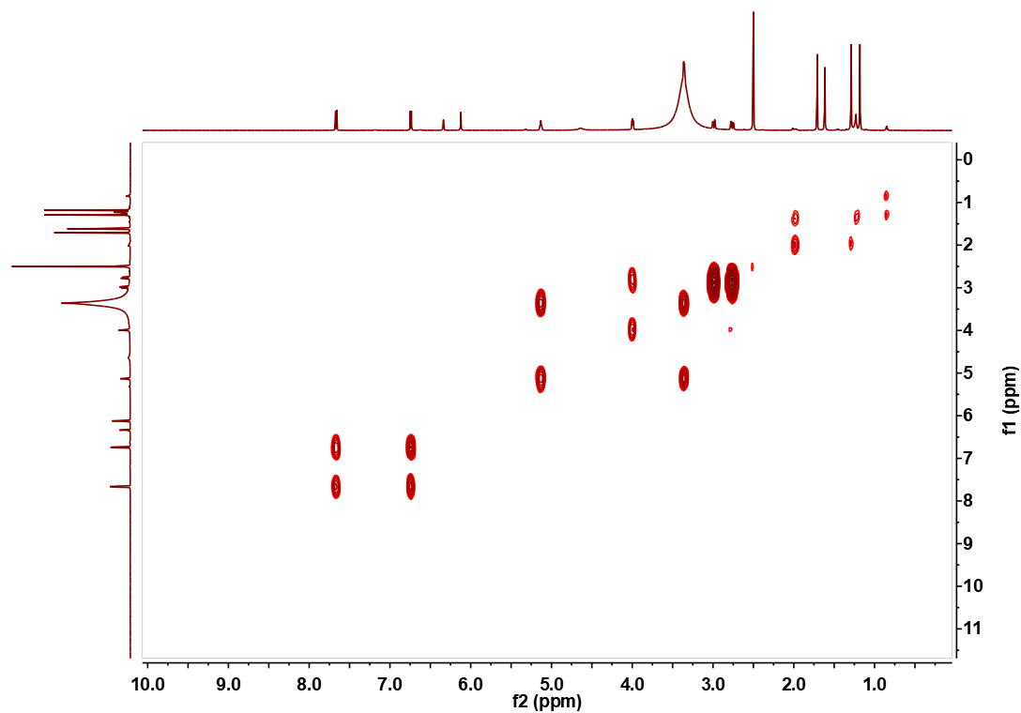
Figure S15. ¹H-¹H COSY spectrum of compound 11 in DMSO.

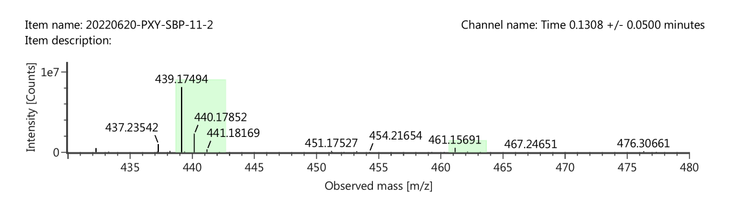
Figure S16. HR-ESI-MS spectrum of compound 12.
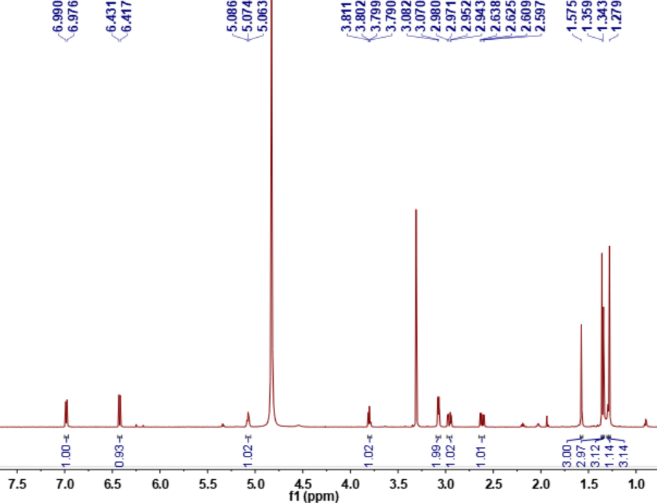
Figure S17. ¹H-NMR spectrum (600 MHz, CD₃OD) of compound 12.

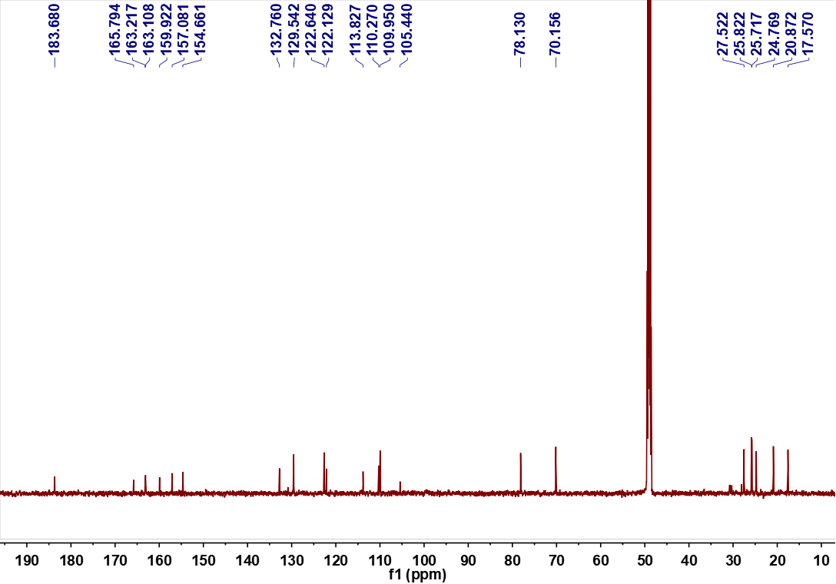
Figure S18. ¹³C-NMR spectrum (150 MHz, CD₃OD) of compound 12.

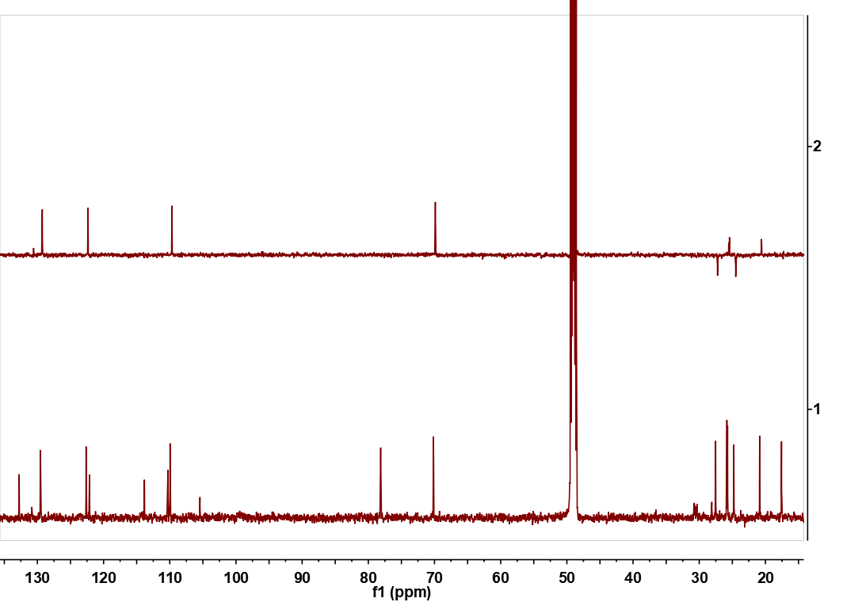
Figure S19. DEPT 135 spectrum (150 MHz, CD₃OD) of compound 12.

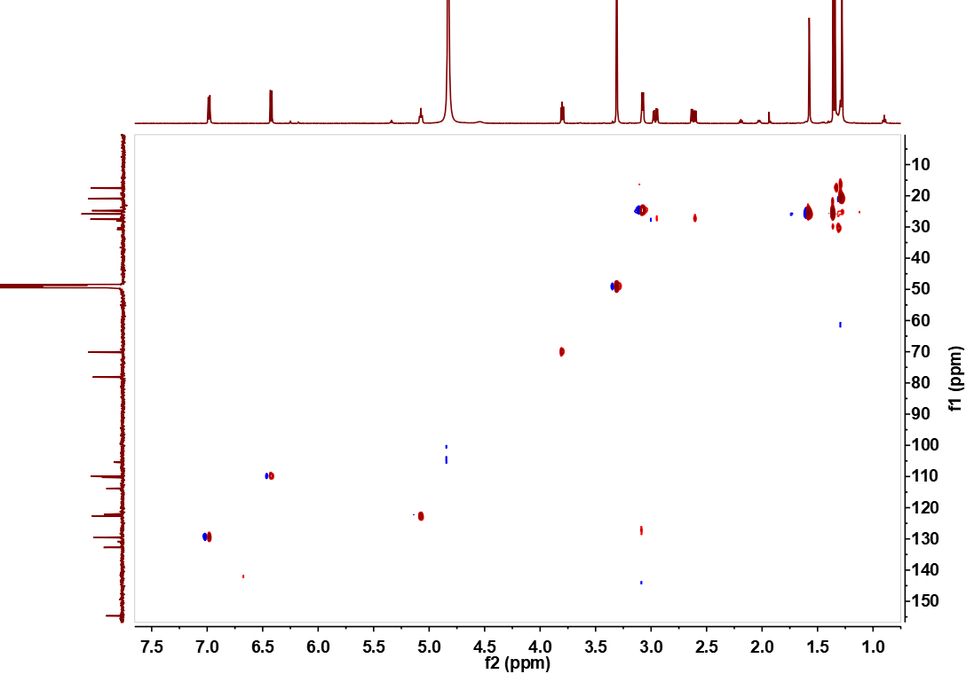
Figure S20. HSQC spectrum of compound 12 in CD₃OD.

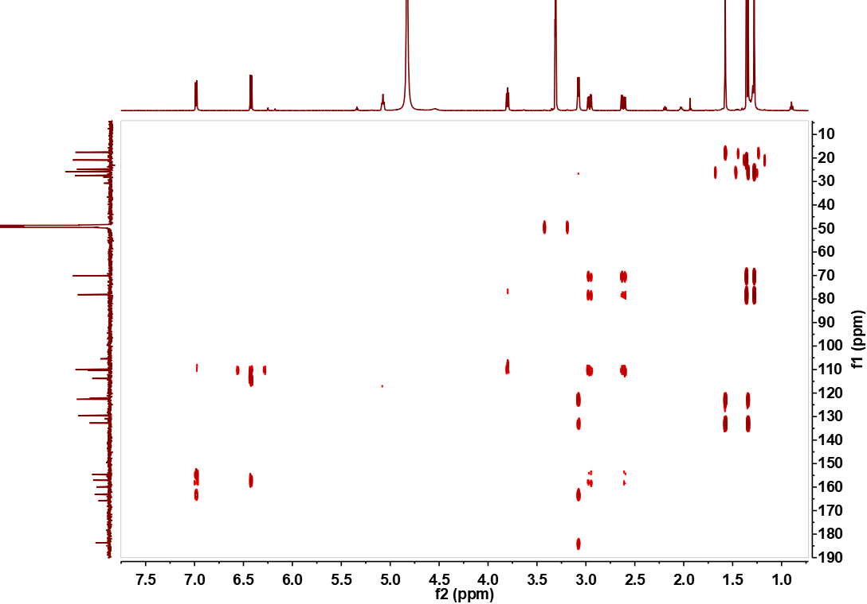
Figure S21. HMBC spectrum of compound 12 in CD₃OD.

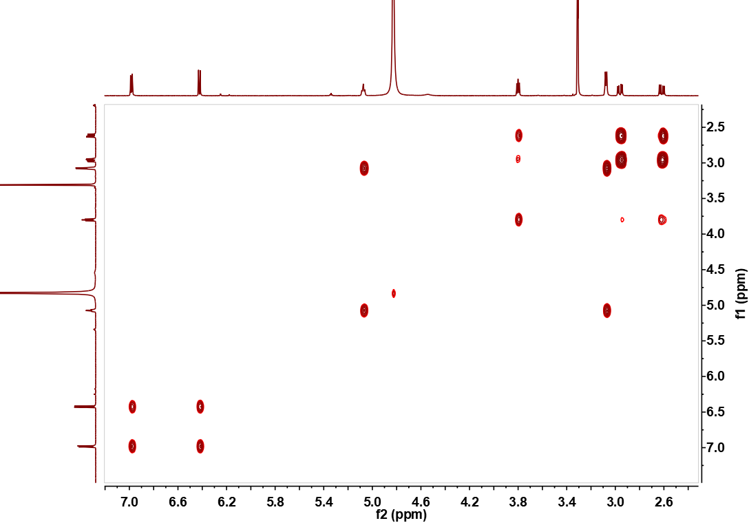
Figure S22. ¹H-¹H COSY spectrum of compound 12 in CD₃OD.
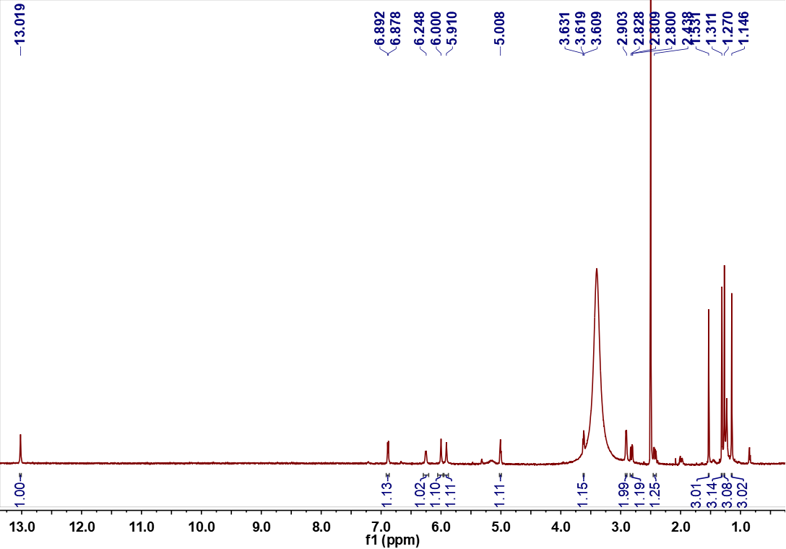
Figure S23. ¹H-NMR spectrum (600 MHz, DMSO) of compound 12.
.

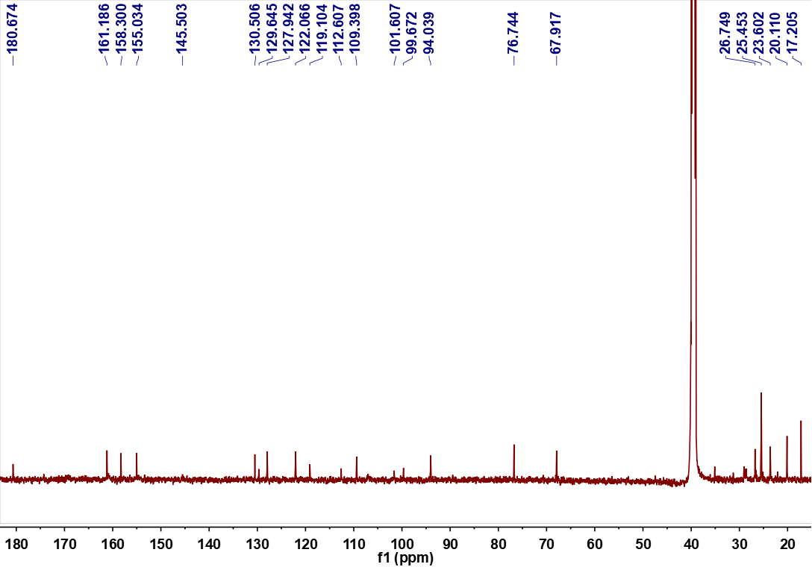
Figure S24. ¹³C-NMR (150 MHz, DMSO) spectrum of compound 12.
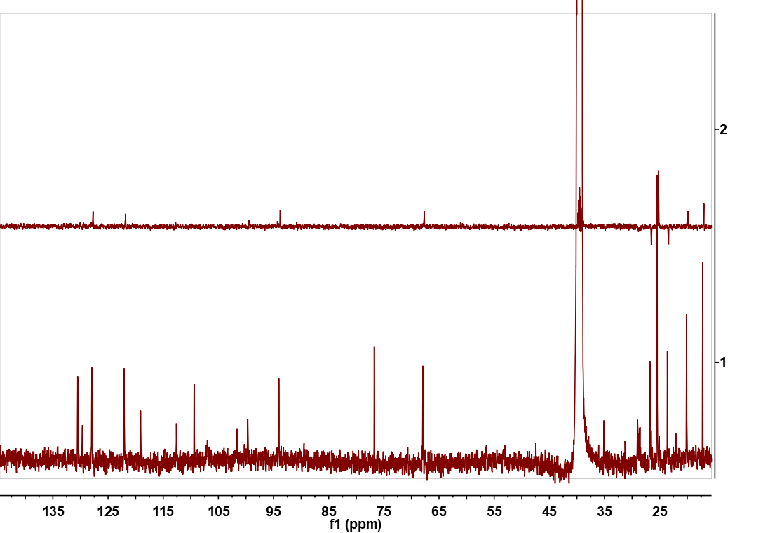
Figure S25. DEPT 135 spectrum (150 MHz, DMSO) of compound 12.

