Supplementary tables

Table 1. PCR master mix per tube and conditions for CTX-M, SHV and OXA
Reagent | Volume (µL)
10X ExTaq buffer | 5
dNTP mixture | 4
Template | 2
Forward primer (10 μM) | 5
Reverse primer (10 μM) | 5
Nuclease-free water | 28.75
TaKaRa ExTaq HS | 0.25
Total | 50 µL

98 °C | 2 min
98 °C | 10 sec
60.5 °C | 5 sec | x 25 cycles
72 °C | 1 sec
72 °C | 8 min
4 °C | ∞

Table 2. PCR master mix per tube and conditions for TEM
Reagent | Volume (µL)
10X ExTaq buffer | 5
dNTP mixture | 4
Template | 2
Forward primer (10 μM) | 5
Reverse primer (10 μM) | 5
Nuclease-free water | 28.75
TaKaRa ExTaq HS | 0.25
Total | 50 µL

94 °C | 7 min
94 °C | 30 sec
57 °C | 30 sec | x 30 cycles
72-°C | 30 sec
72 °C | 5 min
4 °C | ∞

Table 3: Primers used in this study
NAME OF PRIMERS | TARGET GENE | SEQUENCE 5’-3’
TEM1F  TEM1R | bla_{TEM} | ATGAGTATTCAACATTTCCG  CTGACAGTTACCAATGCTTA
SHVF  SHVR | bla_{SHV} | GGTTATGCGTTATATTCGCC  TTAGCGTTGCCAGTGCTC
CTX-MA1  CTX-MA2 | bla_{CTX-M} | *SCSATGTGCAG≠YACCAGTAA  CCGC¥RATATGRTTGGTGGTG
Note: *S = G or C, ≠Y = C or T, ¥R = A or T.

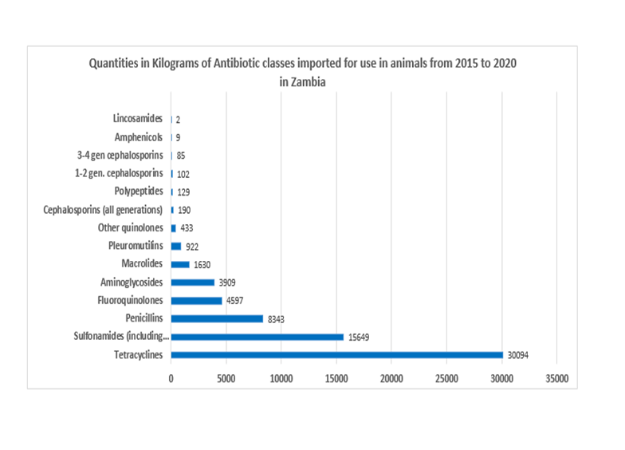
Figure 1 Importation of antibiotics from 2015 to 2020
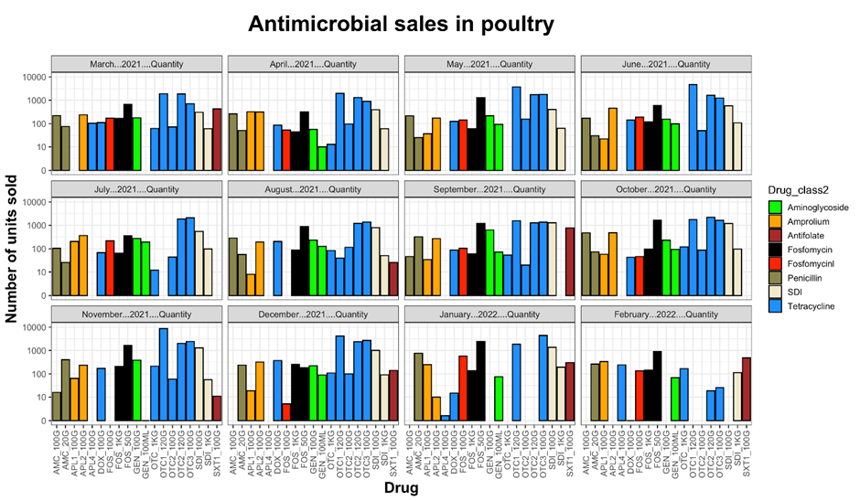
Figure 2 Antibiotic sales from March 2021 to February 2022

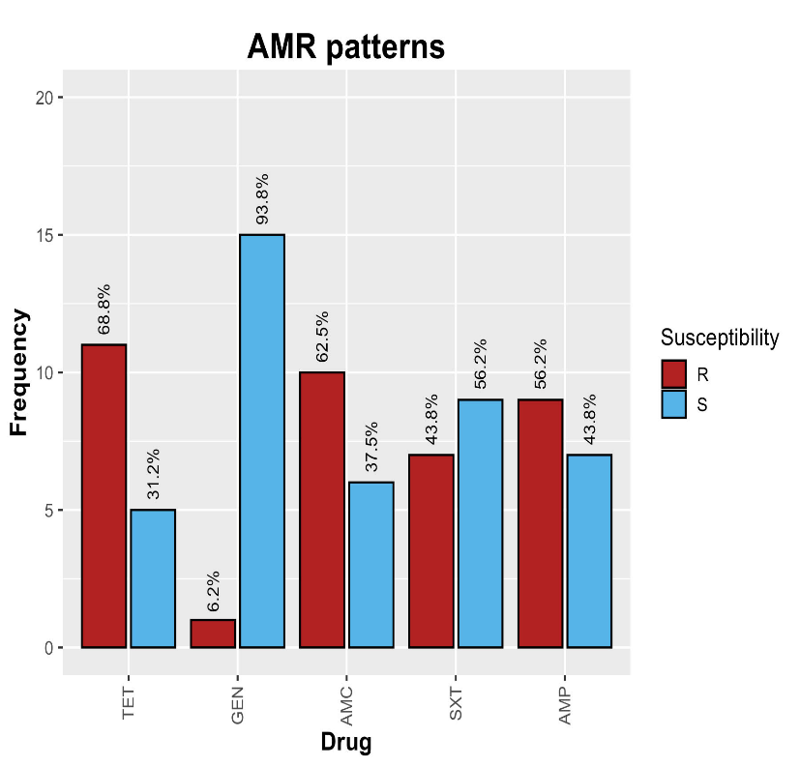
Figure 3: Overall AST for 16 Enterobacteriaceae strains

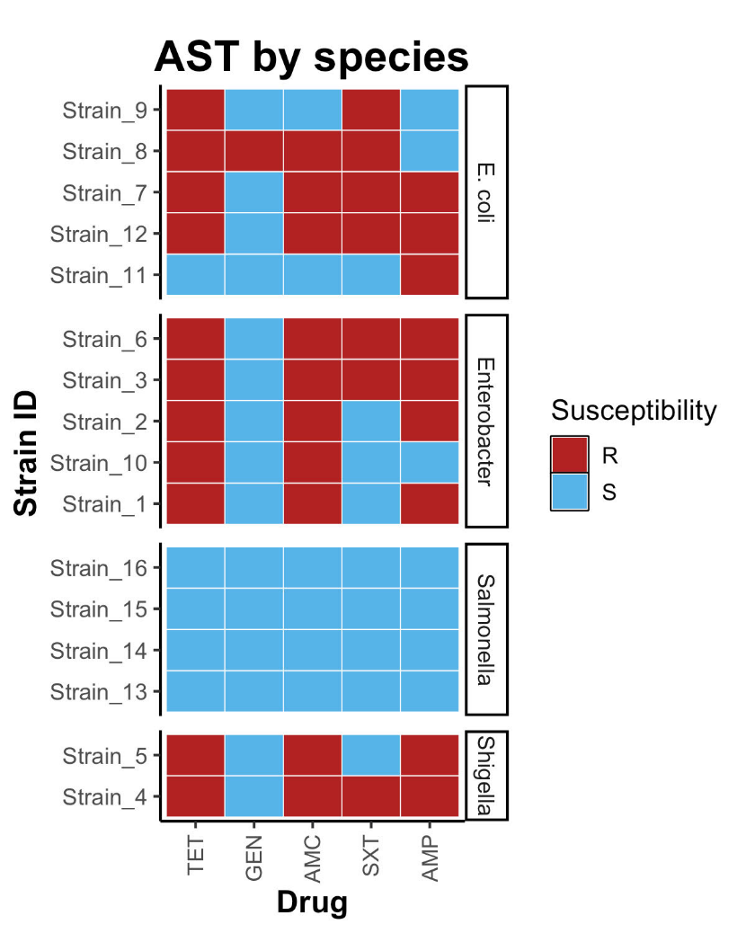
Figure 3 AST by Species

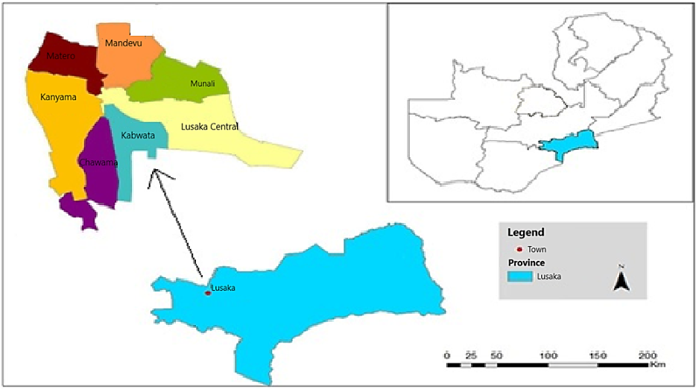
Figure 5: Map of Zambia showing the study areas

