Annex 1
Patient |  |  | Sex |  | Height, cm |  |  |  |  | Weight, kg |  |  | Age, y | BMI | AHI (initial) |  |  | AHI  (after) | SpO2 (initial) | SpO2 (after) | Diagnosis
1 |  |  | M |  | 175 |  |  |  |  | 130 |  |  | 65 | 42 | 88 |  |  | 31 | 80 | 86,4 | Severe OSA, Type 2 Respiratory Failure, Grade 3 Obesity.
2 |  |  | M |  | 148 |  |  |  |  | 51 |  |  | 75 | 23 | 21,4 |  |  | 40 | 88 | 91,7 | Kyphoscoliosis, Moderate OSA.
3 |  |  | M |  | 170 |  |  |  |  | 145 |  |  | 50 | 50 | 53,5 |  |  | 2 | 75,5 | 80,2 | Severe OSA, Grade 3 Obesity, Hypoxemia, Hypercapnia, Obesity Hypoventilation Syndrome
4 |  |  | F |  | 164 |  |  |  |  | 119 |  |  | 59 | 44 | 75 |  |  | 22,1 | 87 | 92,1 | Severe OSA, Chronic Type 1 Respiratory Failure, Grade 3 Obesity
5 |  |  | F |  | 164 |  |  |  |  | 93 |  |  | 60 | 34,6 | 42,9 |  |  | 1,3 | 83,8 | 90,7 | Severe OSA, High-Output Cardiac Failure (B), Bilateral Positive Airway Pressure (BiPAP), Type 1 Respiratory Failure
6 |  |  | M |  | 176 |  |  |  |  | 130 |  |  | 67 | 42 | 83,4 |  |  | 6,6 | 68,8 | 90,7 | Severe OSA, Grade 1 Obesity, Type 2 Respiratory Failure.
7 |  |  | M |  | 178 |  |  |  |  | 106 |  |  | 65 | 33 | 109,2 |  |  | 25,7 | 67,1 | 79,2 | Severe OSA, Grade 1 Obesity, Nocturnal Hypoxemia, High-Output Positive Airway Pressure (BiPAP).
8 |  |  | M |  | 170 |  |  |  |  | 93 |  |  | 79 | 32 | 65,1 |  |  | 11,1 | 81,2 | 91,1 | Severe OSA, Grade 3 Obesity, Night Hopyxemia, COPD (B)
9 |  |  | M |  | 177 |  |  |  |  | 135 |  |  | 71 | 44 | 29 |  |  | 14 | 90 | 94 | Moderate OSA.
10 |  |  | F |  | 169 |  |  |  |  | 150 |  |  | 59 | 52,5 | 84,7 |  |  | 18 | 78 | 87,3 | Severe OSA, Grade 3 Obesity, Hypoxemia, Obesity-Related Hypoventilation during Sleep.
11 |  |  | F |  | 165 |  |  |  |  | 150 |  |  | 69 | 55 | 87,2 |  |  | 7,3 | 74,9 | 88,2 | Severe OSA, Grade 3 Obesity, Type 2 Respiratory Failure, Obesity Hypoventilation Syndrome.
12 |  |  | M |  | 177 |  |  |  |  | 135 |  |  | 62 |  | 41,6 |  |  | 46,8 | 87,4 | 87,8 | Severe OSA, Grade 3 Obesity, Nicotine Dependence, Type 1 Respiratory Failure.
13 |  |  | M |  | 186 |  |  |  |  | 129 |  |  | 56 | 37 | 34 |  |  | 7,4 | 84,8 | 98,6 | Severe OSA, Hypoxemia, Type 1 Respiratory Failure, Grade 2 Obesity, High-Output Positive Airway Pressure (BiPAP), Type 2 Diabetes.
14 |  |  | V |  | 184 |  |  |  |  | 160 |  |  | 51 | 47 | 108,3 |  |  | 18,4 | 68,7 | 88,7 | Severe OSA, Grade 3 Obesity, Chronic Type 2 Respiratory Failure, Uncontrolled Persistent Bronchial Asthma, Arterial Hypertension, Chronic Heart Failure III F.C. (NYHA).
Annex 2
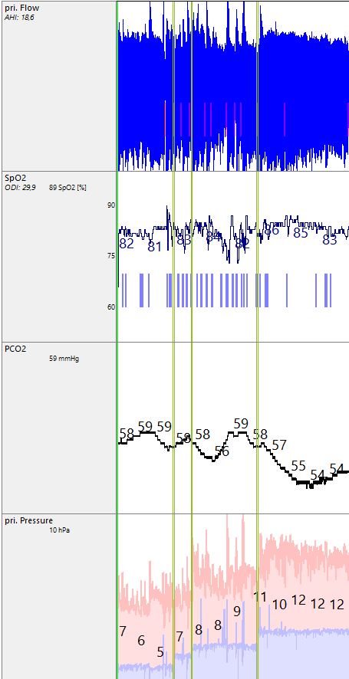 | 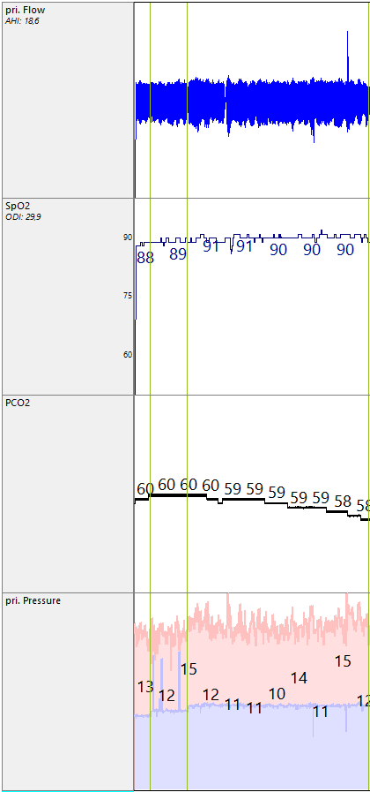 | 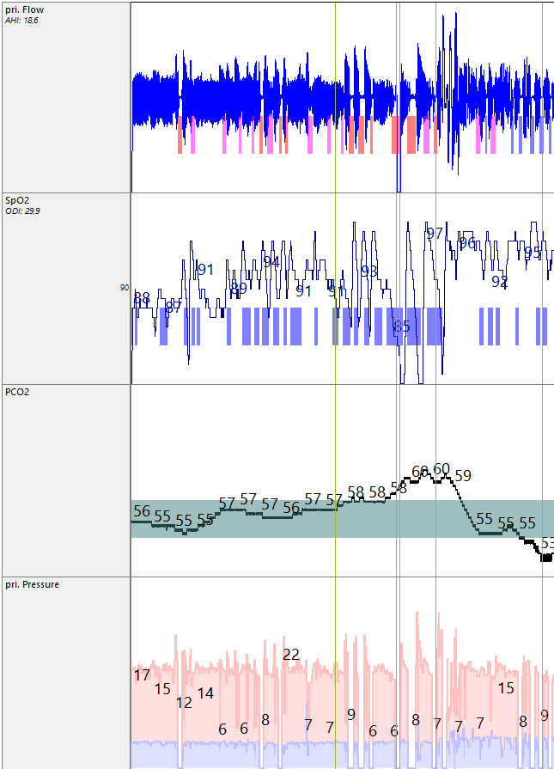
a) | b) | c)
Apnea vs CPAP pressure | pCO2 stabilized with later downtrend and additional oxygen is added | pCO2 rises with additional oxygen and then decreases when oxygen is decreases

