Gene name | Forward primer (5′→3′) | Reverse primer (5′→3′)
PyDET2e | TACAAGGTTCCCAAGGGTGG | AACTCCTCCCCGTCAGGTAA
HIS | TTTAAGACTGATCTGCGTTTCC | GAACAGCCCAACAAGGTATG
Table S1 Primer sequence of RT-qPCR

Table S2. Identification of DET2 family genes in P. yunnanensis.
Gene name | Gene ID | Amino  Acid(aa) |  | Molecular  Weight (kDa) | Isoelectric  Point (pI) |  |  |  | Instability  Index | GRAVY | Secondary structure/% |  |  |  |  | Subcellular  Localization
 |  |  |  |  |  |  |  |  |  |  | Alpha helix |  | Extended strand | Beta turn | Random coil
PyDET2a | Pyun04G015560.1 | 339 |  | 38.94 |  | 8.79 |  |  | 46.84 | 102.36 |  | 53.98 | 16.22 | 3.83 | 25.96 | Chloroplast
PyDET2b | Pyun05G003670.1 | 253 |  | 29.71 |  | 9.17 |  |  | 38.71 | 86.68 |  | 29.25 | 28.46 | 4.74 | 37.55 | Golgi apparatus
PyDET2c | Pyun08G000950.1 | 267 |  | 30.10 |  | 9.65 |  |  | 42.71 | 110.90 |  | 51.69 | 17.23 | 2.62 | 28.46 | Chloroplast.
PyDET2d | Pyun08G000960.1 | 263 |  | 29.62 |  | 9.53 |  |  | 31.45 | 102.59 |  | 49.43 | 17.11 | 5.32 | 28.14 | Cell membrane  Chloroplast  Golgi apparatus
PyDET2e | Pyun08G000970.1 | 264 |  | 30.02 |  | 9.66 |  |  | 43.18 | 108.11 |  | 47.35 | 21.97 | 3.79 | 26.89 | Chloroplast
PyDET2f | Pyun09G012590.1 | 351 |  | 40.35 |  | 8.99 |  |  | 44.34 | 101.11 |  | 47.29 | 19.66 | 4.84 | 28.21 | Cell membrane
PyDET2g | Pyun10G023000.1 | 268 |  | 30.26 |  | 9.40 |  |  | 45.98 | 109.78 |  | 48.51 | 17.91 | 4.85 | 28.73 | Cell membrane  Chloroplast  Peroxisome
PyDET2h | Pyun10G023010.1 | 253 |  | 28.74 |  | 9.58 |  |  | 40.06 | 106.32 |  | 48.22 | 18.58 | 4.74 | 28.46 | Cell membrane
PyDET2i | Pyun10G023020.1 | 264 |  | 29.76 |  | 9.34 |  |  | 43.02 | 107.08 |  | 54.20 | 13.74 | 4.2 | 27.86 | Cell membrane  Golgi apparatus  Peroxisome
PyDET2j | Pyun13G013760.1 | 264 |  | 30.90 |  | 9.35 |  |  | 43.38 | 89.02 |  | 34.09 | 25.38 | 3.41 | 37.12 | Cell membrane  Golgi apparatus  Mitochondrion
PyDET2k | Pyun13G013800.1 | 264 |  | 20.71 |  | 9.35 |  |  | 45.08 | 89.39 |  | 36.74 | 24.24 | 2.65 | 36.36 | Cell membrane  Golgi apparatus  Mitochondrion
PyDET2l | Pyun14G008550.1 | 320 |  | 38.25 |  | 9.25 |  |  | 22.63 | 94.69 |  | 43.12 | 20.62 | 3.12 | 33.12 | Chloroplast
PyDET2m | Pyun15G004230.1 | 292 |  | 33.11 |  | 8.99 |  |  | 28.32 | 114.79 |  | 46.58 | 17.47 | 4.45 | 31.51 | Cell membrane
PyDET2n | Pyun16G010440.1 | 267 | 29.68 |  |  |  | 9.48 | 46.55 |  | 91.44 |  | 38.52 | 24.51 | 3.50 | 33.46 | Cell membrane
Note: Information provided includes gene names, gene ids, amino acid, molecular weight (kDa), isoelectric points(PI), instability index, GRAVY, Secondary structure and subcellular localization.

Table S3. Base composition of codons in the DET2 gene family of P. yunnanensis.
Gene Name | T3s/% | C3s/% | A3s/% | G3s/% | CAI/% | CBI/% | Fop/% | ENc/% | GC1/% | GC2/% | GC3/% | GC/%
PyDET2a | 0.4514 | 0.1701 | 0.3529 | 0.2617 | 0.193 | -0.120 | 0.335 | 51.96 | 0.482 | 0.410 | 0.368 | 0.419
PyDET2b | 0.4135 | 0.2933 | 0.2485 | 0.2785 | 0.172 | -0.142 | 0.323 | 53.86 | 0.450 | 0.394 | 0.496 | 0.448
PyDET2c | 0.3930 | 0.2620 | 0.2900 | 0.2707 | 0.191 | -0.002 | 0.397 | 50.99 | 0.429 | 0.366 | 0.444 | 0.413
PyDET2d | 0.3991 | 0.2790 | 0.2698 | 0.2798 | 0.189 | -0.011 | 0.402 | 46.88 | 0.383 | 0.375 | 0.451 | 0.403
PyDET2e | 0.3689 | 0.2800 | 0.2814 | 0.3149 | 0.184 | -0.055 | 0.367 | 52.85 | 0.460 | 0.351 | 0.472 | 0.429
PyDET2f | 0.4184 | 0.1973 | 0.3574 | 0.2622 | 0.184 | -0.078 | 0.362 | 53.27 | 0.463 | 0.415 | 0.395 | 0.425
PyDET2g | 0.4353 | 0.2328 | 0.2965 | 0.2584 | 0.199 | -0.023 | 0.388 | 52.03 | 0.424 | 0.368 | 0.402 | 0.398
PyDET2h | 0.3641 | 0.2903 | 0.3118 | 0.2695 | 0.168 | -0.096 | 0.343 | 52.62 | 0.449 | 0.358 | 0.457 | 0.423
PyDET2i | 0.3722 | 0.2870 | 0.2915 | 0.2787 | 0.176 | -0.063 | 0.363 | 49.75 | 0.453 | 0.366 | 0.462 | 0.428
PyDET2j | 0.4045 | 0.3091 | 0.2443 | 0.2761 | 0.181 | -0.058 | 0.371 | 48.22 | 0.430 | 0.404 | 0.498 | 0.446
PyDET2k | 0.4045 | 0.3091 | 0.2472 | 0.2635 | 0.188 | -0.032 | 0.388 | 49.71 | 0.438 | 0.411 | 0.494 | 0.449
PyDET2l | 0.3900 | 0.2741 | 0.3029 | 0.2880 | 0.191 | -0.063 | 0.369 | 53.41 | 0.433 | 0.393 | 0.486 | 0.438
PyDET2m | 0.4033 | 0.2140 | 0.3213 | 0.2598 | 0.211 | 0.045 | 0.420 | 54.85 | 0.515 | 0.406 | 0.420 | 0.447
PyDET2n | 0.3364 | 0.3458 | 0.1761 | 0.3636 | 0.180 | -0.043 | 0.376 | 48.81 | 0.481 | 0.438 | 0.600 | 0.506

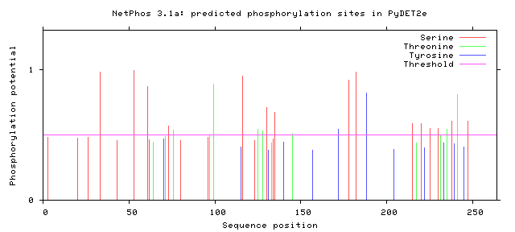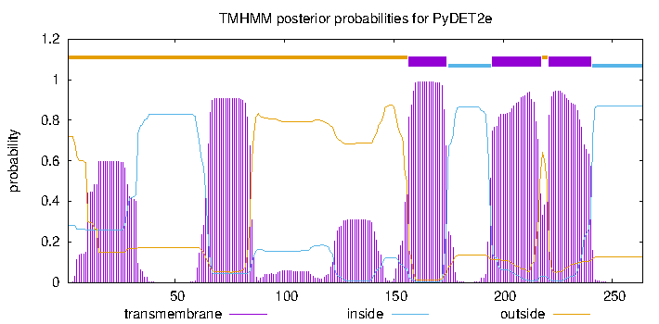
Figure S1. Prediction of phosphorylation sites and transmembrane regions of PyDET2e protein

