Supplementary Material 1
Rego et al. Transcutaneous posterior tibial nerve stimulation: an adjuvant treatment for intractable constipation in children

PROTOCOL NUMBER: ______

CURRENT CLINICAL STATUS

1. How many times do you defecate per day?_____ How many times per week? _____
2. Do you lose stool in underwear without realizing it? ○ Yes ○ No
If yes, how many times a day? ____________ How many times per week?________
3. Is this disrupting your quality of life? ○ Yes ○ No
4. Do you need to wear diapers or underwear protection? ○ Yes ○ No
5. Do you take any medication for bowel habits? ○ Yes ○ No
If yes, what? ____________________________________
6. Do you make use of any kind of special diet? ○ Yes ○ No
If yes, what? ______________
7. Have you had abdominal pain? ○ Yes ○ No
If yes, how many times per week? ____ What is the intensity of the pain (0 to 5)______
8. Have you had straining and pain to pass stool? ○ Yes ○ No
If yes, how many times per week? ____
9. Have you had bleeding during bowel movements? ○ Yes ○ No
If yes, how many times per week? ____
10. Have you had bowel movements of large fecal masses that clog the toilet?
○ Yes ○No If yes, how often? _________
11. Have you had rashes or dermatitis in the perianal region? ○ Yes ○ No
12. Have you had episodes of fecal retention requiring enemas? ○ Yes ○ No
If yes, how often? _________
13. Do you take any medication regularly? ○ Yes ○ No
If yes, what? (which are?)_________________
14. Do you have any other health problems that have required medical attention? ○ Yes ○ No If yes, what?_________________________________________

Supplementary Material 2
Rego et al. Transcutaneous posterior tibial nerve stimulation: an adjuvant treatment for intractable constipation in children

modified Bristol Stool Form Scale for Children – m-BSFS-C

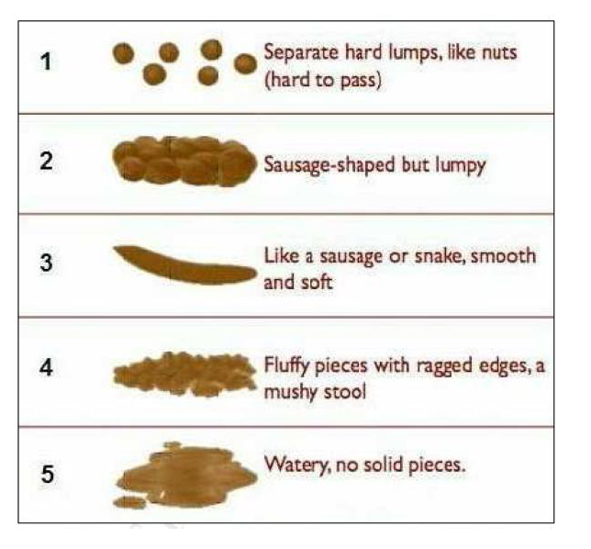
- Chumpitazi BP, Lane MM, Czyzewski DI, Weidler EM, Swank PR, Shulman RJ. Creation and initial evaluation of a stool form scale for children. J Pediatr. 2010;157: 594-597.
- Lane MM, Czyzewski DI, Chumpitazi BP, Shulman RJ. Reliability and validity of a modified Bristol Stool Form Scale for children. J Pediatr. 2011;159:437-441.
- Jozala DR, Oliveira ISF, Ortolan EVP, et al. Brazilian Portuguese translation, cross-cultural adaptation and reproducibility assessment of the modified Bristol Stool Form Scale for children. J Pediatr (Rio J). 2018 Mar 15. pii: S0021-7557(17)31151-8.

Supplementary Material 3
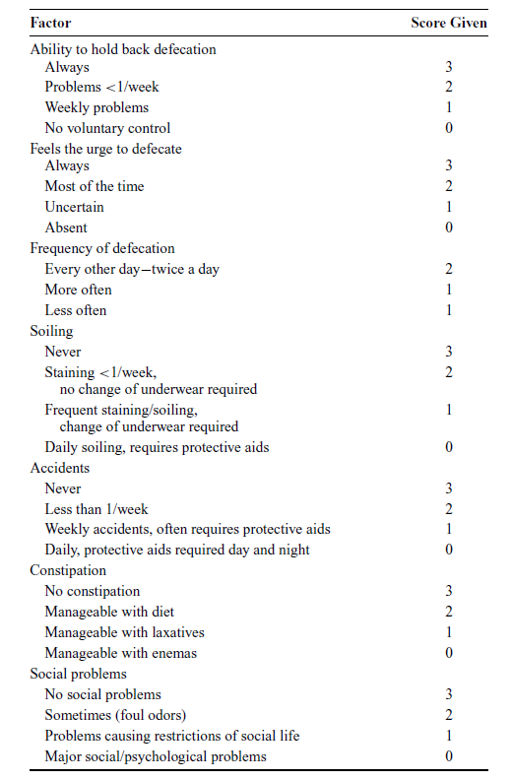
Bowel Function Score
Rego et al. Transcutaneous posterior tibial nerve stimulation: an adjuvant treatment for intractable constipation in children

Adapted from
Jarvi K, Laitakari EM, Koivusalo A, Rintala RJ, Pakarinen MP. Bowel function and gastrointestinal quality of life among adults operated for Hirschsprung disease during childhood: a population-based study. Ann Surg. 2010; 252(6):977-981.

Supplementary Material 4
Rego et al. Transcutaneous posterior tibial nerve stimulation: an adjuvant treatment for intractable constipation in children

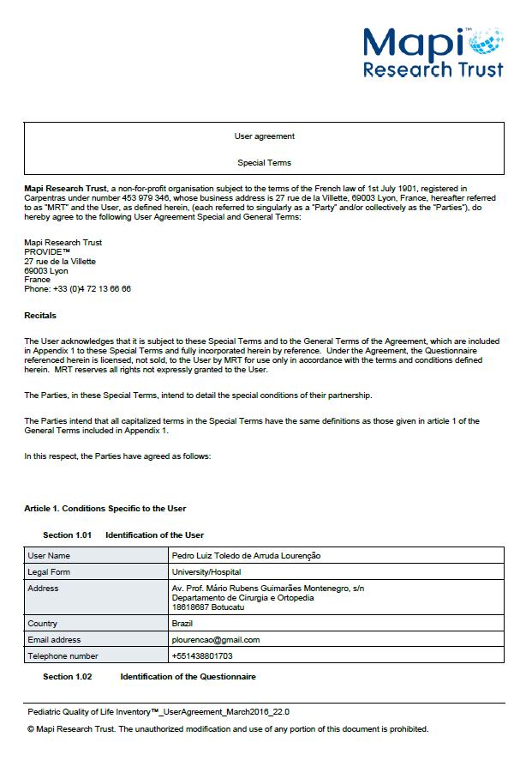

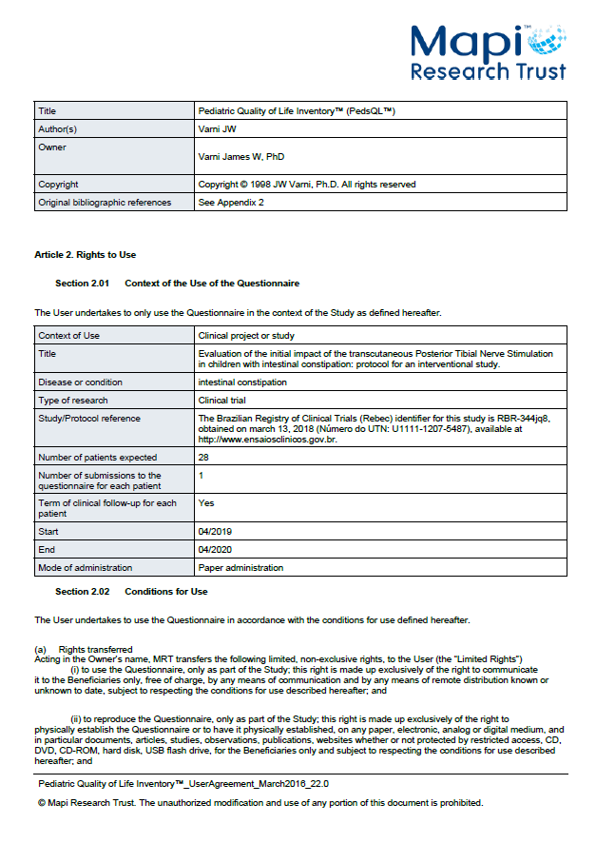

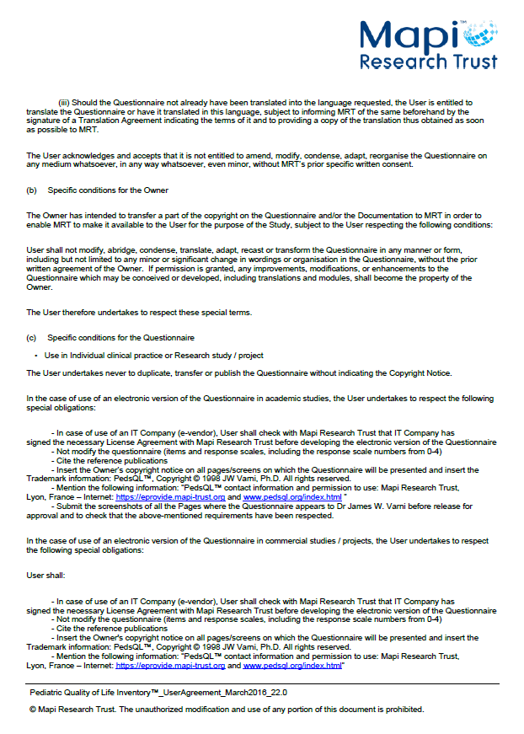

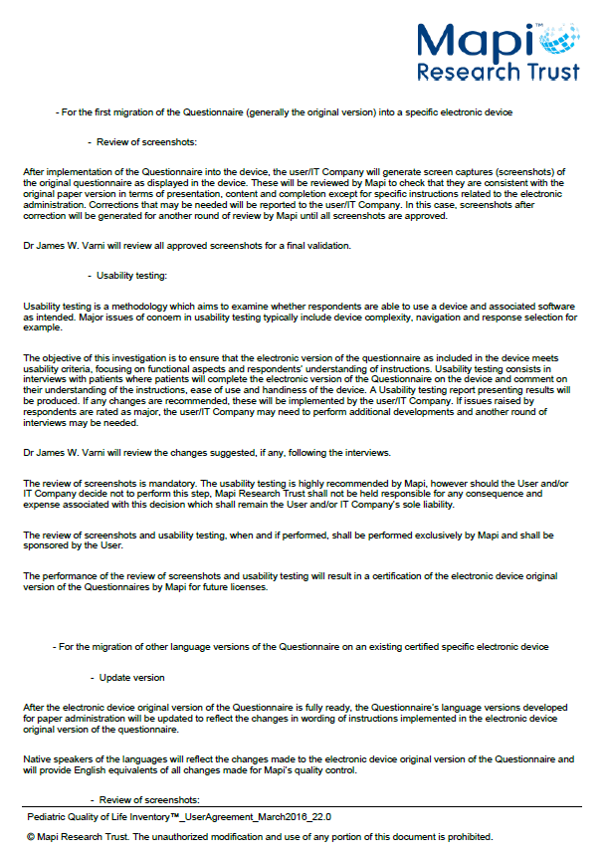

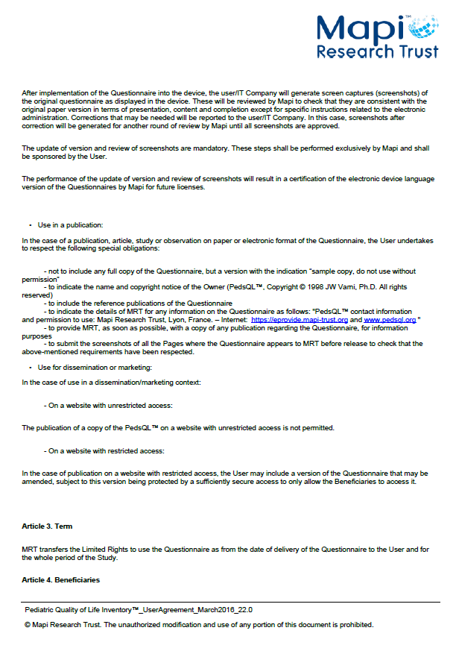

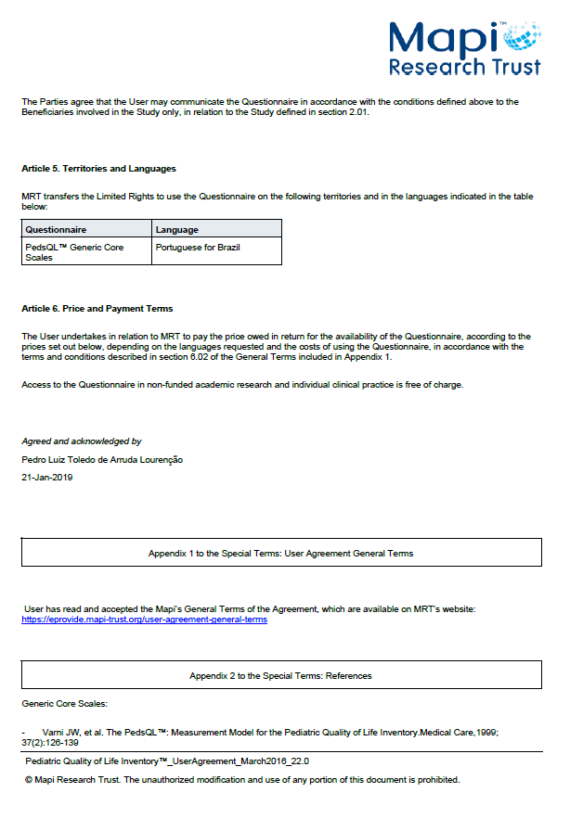

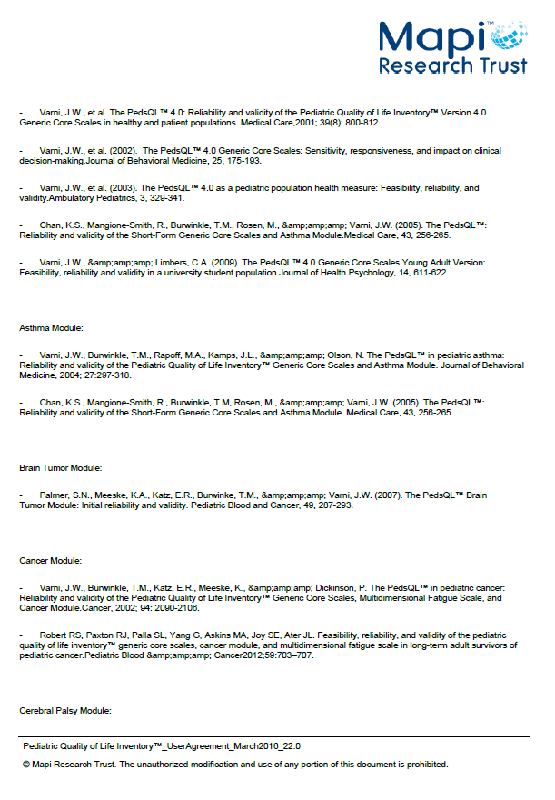

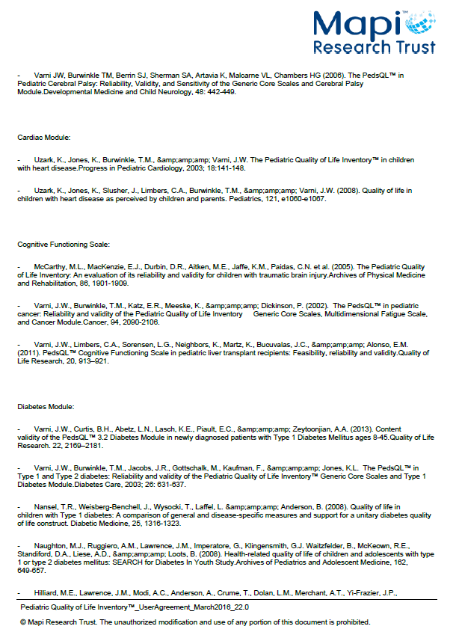

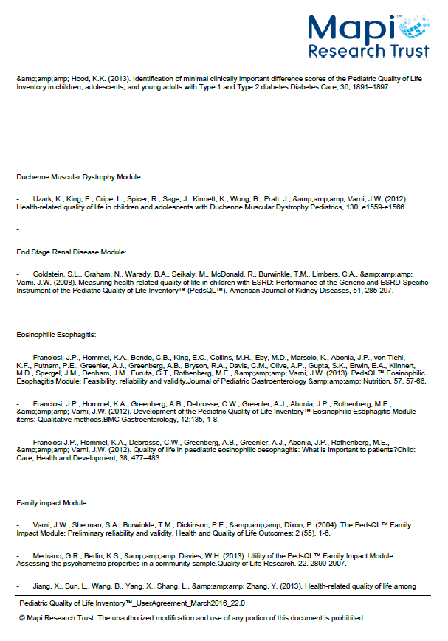

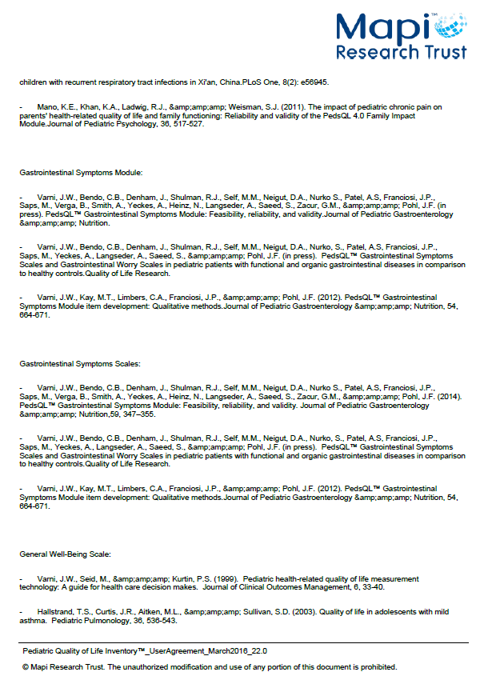

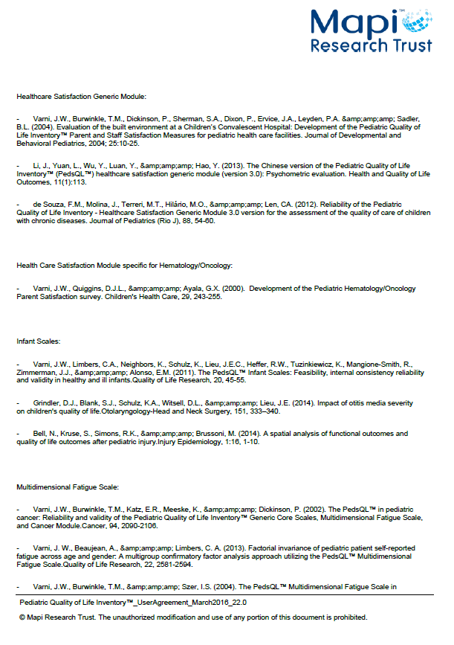

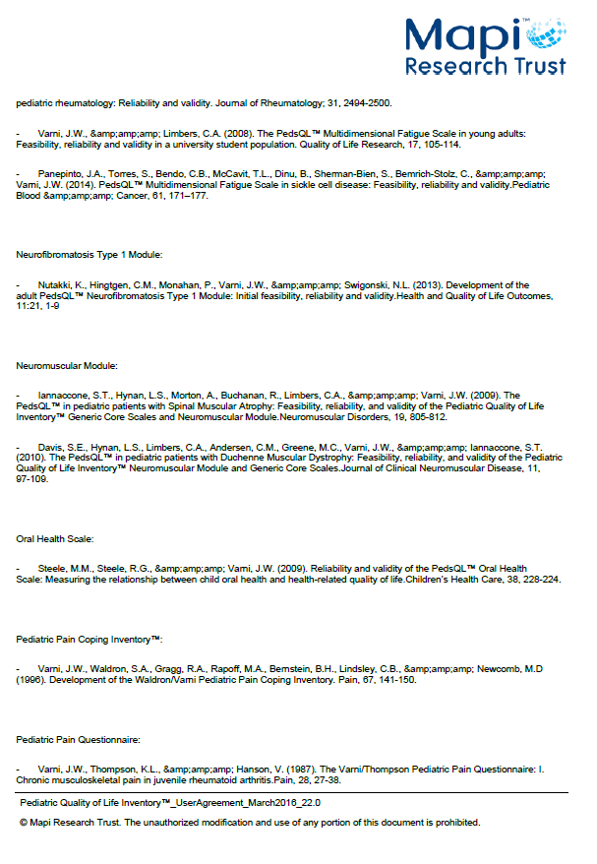

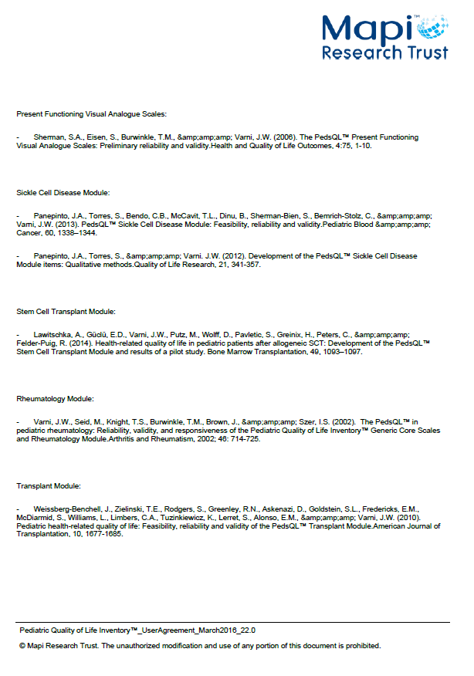

Supplementary Material 5
Assessment of Quality of Life in Children and Adolescents with Fecal Incontinence (AQLCAFI).
Rego et al. Transcutaneous posterior tibial nerve stimulation: an adjuvant treatment for intractable constipation in children

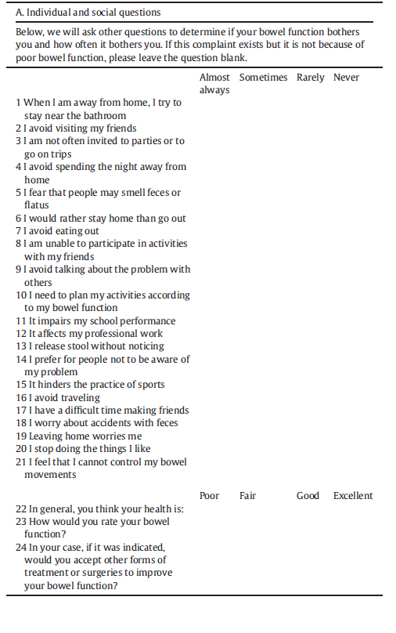

- Tannuri AC, Ferreira MA, Mathias AL, Tannuri U. Long-term results of the Duhamel technique are superior to those of the transanal pullthrough: A study of fecal continence and quality of life. J Pediatr Surg. 2017 Mar;52(3):449-453.
- Mathias AL, Tannuri AC, Ferreira MA, Santos MM, Tannuri U. Validation of questionnaires to assess quality of life related to fecal incontinence in children with anorectal malformations and Hirschsprung's disease. Rev Paul Pediatr. 2016 Jan-Mar;34(1):99-105.

Supplementary Material 6
Rego et al. Transcutaneous posterior tibial nerve stimulation: an adjuvant treatment for intractable constipation in children

QUESTIONNAIRE FOR THE EVALUATION OF THE APPLICABILITY OF PTNS DAILY HOME SESSIONS

1. How would you rate your experience with electrical stimulation?
○ Poor ○ Bad ○ Fair ○ Great

2. Do you think it is very difficult to do therapy at home? ○ Yes ○ No

3. What has been the greatest difficulty? ○ electrodes ○ regulation of the device ○ ability to connect ○ Acceptance of child
○ Other, Explain this difficulty in more detail ________________________________________

4. Does your child have any pain during the application? ○ Yes ○ No
Explain this pain in greater detail__________________________________________________

5. Local physical examination

Surface Sensitivity: ○ Hypoesthesia ○ Normoesthesia ○ Hyperesthesia
Deep sensitivity: ○ Hypoesthesia ○ Normoesthesia ○ Hyperesthesia
Skin integrity: ○ Normal ○ Altered
Inflammatory signs: ○ Present ○ Absent

