Supplementary Figure 1. Field survey results of the study area. A circle means directly found frog individuals in the area. A speaker mark means heard croaking sound of frogs in the area. In the study area, we could not hear the croaking sound of R. huanrensis and only found an adult individual.

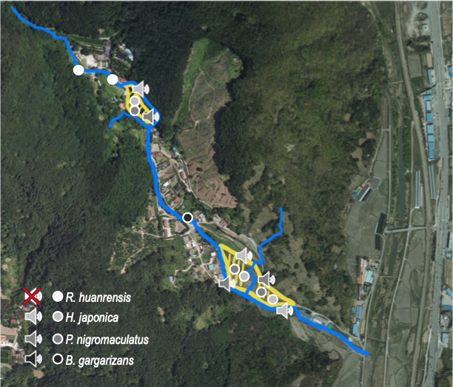

Supplementary Figure 2. The photographs of frogs that were taken in the study area. (a-c) R. huanrensis adult and tadpole were found near the pond and stream. (d-e) H. japonica adult individuals near the paddies. (f-i) P. nigromaculatus near the paddies and in the paddies. (j) B. gargarizans adult individual that was found outside the paddies.

