Type of the study: a comprehensive research study
The document titled "Research on the Construction of Digital Higher Education of China from the Perspective of Symbiotic Education" extensively explores the role of digitalization in higher education. It focuses on how digital tools can aid in achieving inclusive education goals, such as cultural diversity and sustainability, by enhancing accessibility and promoting cross-cultural understanding. The study employs a mixed-methods approach, gathering data from teachers, students, and administrative personnel through surveys, interviews, and case studies. It identifies challenges like unequal technology access and the need for culturally sensitive content, while offering strategic recommendations for creating an inclusive digital educational ecosystem. The study's findings emphasize the importance of technology in education and its potential in fostering a symbiotic, multicultural learning environment.
This research was funded by Shandong Provincial Association of Culture, Art and Science (grant number:L2022Y10170350)
The short running title：Digital Higher Education in China
First Author:
Shuguang Wu^{1 ,2}
¹School of Public Administration, China University of Geosciences, Wuhan, Hubei 430074，China.
²College of arts,Qingdao Agricultural University,Qingdao 266109, China
Email:johnsonwu12@163.com
Corresponding (Communicating) Author:
Zhenning Yuan²
²Academic Affairs Office,Qingdao Agricultural University, Qingdao 266109, China
Email: hasidagen@163.com
Additional Author:
Na Zhou³
³College of arts,Qingdao Agricultural University,Qingdao 266109, China
E-MAIL:nazhou@qau.edu.cn

AUTHOR DECLARATION TEMPLATE
We wish to draw the attention of the Editor to the following facts which maybe considered as potential conflicts of interest and to significant financial contributions to this work.
We wish to confirm that there are no known conflicts of interest associated with this publication and there has been no significant financial support for this work that could have influenced its outcome.
We confirm that the manuscript has been read and approved by all named authors and that there are no other persons who satisfied the criteria for authorship but are not listed. We further confirm that the order of authors listed in the manuscript has been approved by all of us.
We confirm that we have given due consideration to the protection of intellectual property associated with this work and that there are no impediments to publication, including the timing of publication, with respect to intellectual property. In so doing we confirm that we have followed the regulations of my institutions concerning intellectual property.
We further confirm that any aspect of the work covered in this manuscript that has involved either experimental animals or human patients has been
conducted with the ethical approval of all relevant bodies and that such approvals are acknowledged within the manuscript.
We understand that the Corresponding Author is the sole contact for the Editorial process (including Editorial Manager and direct communications with the office). He is responsible forcommunicating with the other authors about progress, submissions of revisions and final approval of proofs.
We confirm that we have provided a current, correct email address which is accessible by the Corresponding Author.

Signed by the authors :
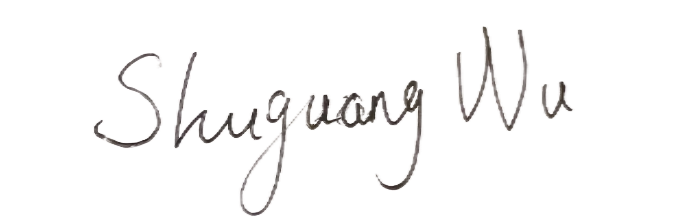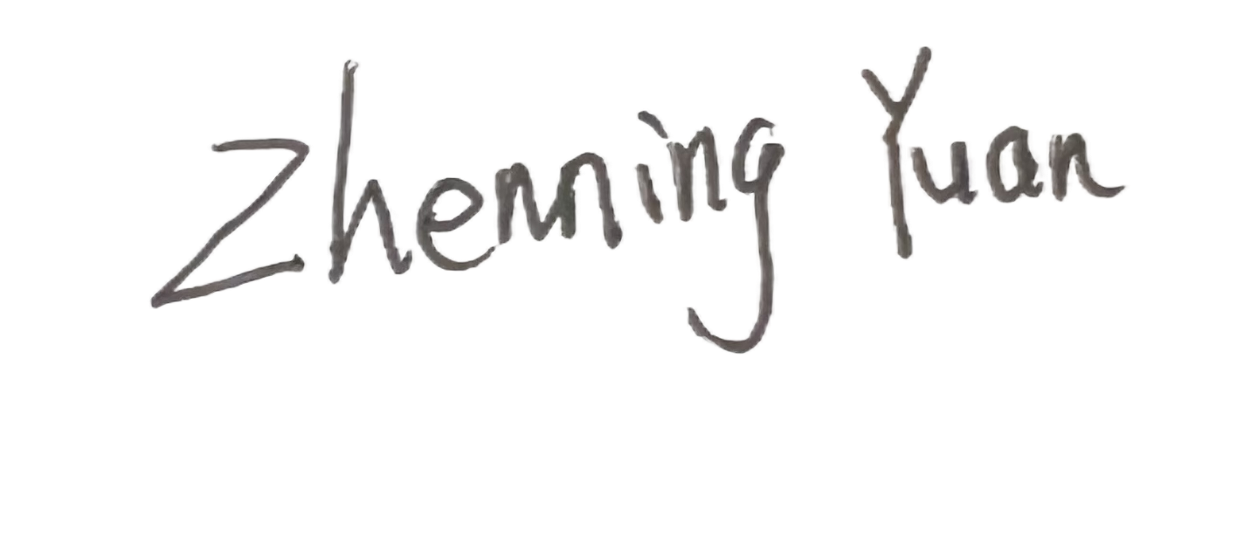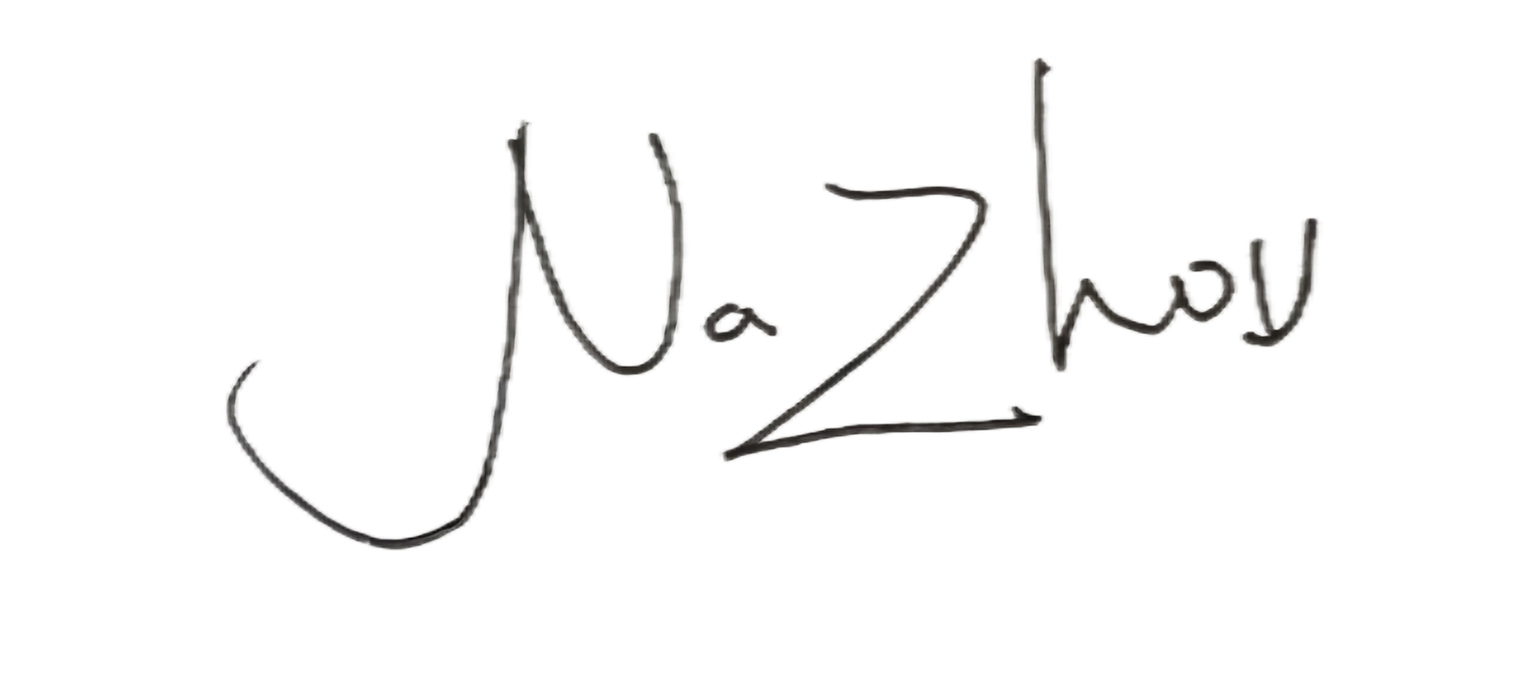

Dec 8th,2023

