Supplementary Information
- Copolymer mass fraction
Mass fraction of a species, wt%, is a common way to refer to the fraction of a mass of the species divided by the total mass of all species times 100. In our case, 1 mg of A(BC)₂ is dissolved in chloroform (CHCl₃) obtaining solution with concentration c of 1 and 4 mg·ml⁻¹. The chloroform density ρ_{CHCl3} is 1.49 g·ml⁻¹, so the total mass of a ml of solution with c = 1 mg·ml⁻¹ is m_{sol} = 1.49 + 0.001 = 1.491 g. The mass fraction of A(BC)₂ dissolved in the solution is therefore wt% = [m_{A(BC)2}·(m_{sol})⁻¹]·100 = [0.001·(1.491)⁻¹]·100 = 0.067 and, accordingly, it will be ≈ 0.268 for c = 4 mg·ml⁻¹.
- Density and viscosity of the A(BC)₂ solution
The density ρ and the viscosity η₀ of the A(BC)₂ solution are unknown, so they are assumed comparable to the ones obtained for MEH-PV [1], a polymer with similar mass M_{n}, 86 kDa, and polydispersity index PDI, 1.52. The plot η₀ (in cP) vs. wt% is obtained on the basis of data reported in Ref. [1] (see Figure S1).
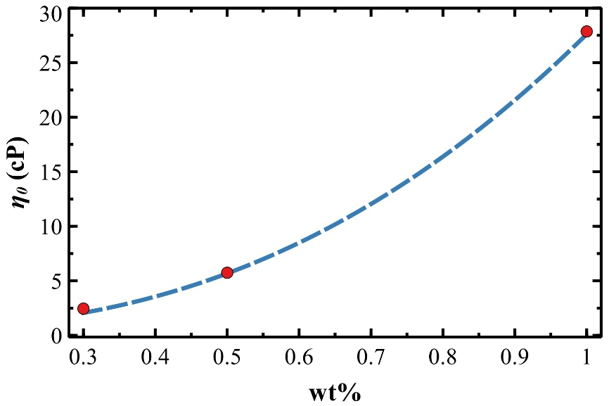
Figure S1. Viscosity η₀ of the A(BC)₂ solution vs. the mass fraction x of A(BC)₂ dissolved in the solution. The fitting curves following the equation reported in the text (dashed line).
The plot η₀ vs. wt% follows the power law η₀ = A + B·(wt%)^{C} reported in the literature [1] where the exponent C is ≈ 2.4, a value around 2.5 that is typical for photoresist solutions [2], A is the solvent viscosity fixed to 0.57 cP (i.e. pure CHCl₃ at 298 K and wt% = 0) and B ≈ 27 is a proportional constant. The power law well represents experimental data (fitting dashed curve in Figure S1) and η₀ of the A(BC)₂ solution is ≈ 0.61 cP for wt% = 0.067, reasonable close to η₀ of pure CHCl₃.
- Waviness and roughness of MP and CMP topographic profiles
One dimensional roughness parameters are obtained by splitting a topographic profile into waviness (the low-frequency components) and roughness (the high-frequency components). This procedure depends critically on the cut-off C that is determined by [3]:
$$C=\frac{2∆}{λ_{c}}$$ | (Eq. E1)
where Δ is the lateral distance between neighbour points in the topographic profile, i.e. the pixel size, and λ_{c} is the sampling length. There are a number of guidelines available for evaluating λ_{c} however, as a rule of thumb, it is commonly sets five times the (average) spacing between adjacent peaks and valleys produced by the machining process [4]. AFM images are 10 µm wide with 512 pixels, so Δ = 19.5 nm.
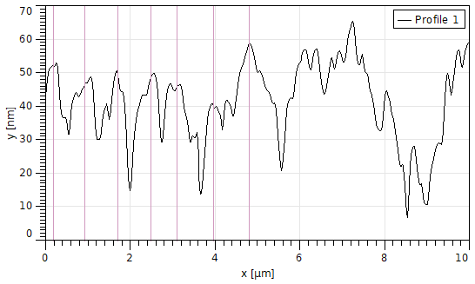
Figure S2. Intersections of adjacent peaks and valleys (purple horizontal lines) for a typical MP topographic profile. To be representative of the entire AFM image, the topographic profile is obtained by averaging 90 adjacent profiles.
As shown in Figure S2, peaks and valleys are present in the topographic profile of the MP surface although it is not periodically spaced. The average distance between two adjacent peaks, also defined as “sample length” [4], is (800 ± 100) nm (see profile intersections in Figure S2) for the MP surface. By following the rule of thumb described above, λ_{c} is 4000 and C calculated as 0.0098 by using Equation E1.
References
1. Chang, C.-C.; Pai, C.-L.; Chen, W.-C.; Jenekhe, S.A. Spin Coating of Conjugated Polymers for Electronic and Optoelectronic Applications. Thin Solid Films 2005, 479, 254–260, doi:https://doi.org/10.1016/j.tsf.2004.12.013.
2. Meyerhofer, D. Characteristics of Resist Films Produced by Spinning. J. Appl. Phys. 1978, 49, 3993–3997, doi:10.1063/1.325357.
3. Palma, D. Re: [Gwyddion-Users] Roughness Parameters Available online: https://sourceforge.net/p/gwyddion/mailman/message/29363255/.
4. Metrology, S. An Introduction to Surface Roughness Measurement Available online: https://www.spectrum-metrology.co.uk/surface-roughness/theory.php.

