Supplementary Materials for

Porous SHS material based on TiNi with a microporous surface structure of its pore walls for creating an ophthalmic orbital implants

Sergey G. Anikeev^{1,2,}*, Valentina N. Hodorenko¹, Maria I. Kaftaranova¹, Anastasiia V. Shabalina¹, Nadezhda V. Artyukhova¹, Elena N. Terletskaya³, Sergei A. Kulinich^{4,}*, Sofiya Pakholkina ¹, Elena A. Bolshevich ¹, Vladimir Promakhov ⁵, Yuri A. Medvedev ⁶, and Victor E. Gunther ¹
¹ Laboratory of Medical Materials Science, Tomsk State University, 634050 Tomsk, Russia
² Institute of Physics, Kazan Federal University, 420008 Kazan, Russia
³ Kuzbass Regional Clinical Hospital, 650000 Kemerovo, Russia
⁴ Research Institute of Science and Technology, Tokai University, Hiratsuka, Kanagawa 259-1292, Japan
⁵ Scientific and Educational Center “Additive Technologies“, Tomsk State University, 634050 Tomsk, Russia
⁶ Department of Oral and Maxillofacial Surgery, Moscow State Medical and Dental University, 127006 Moscow, Russia
* Correspondence: anikeev_sergey@mail.ru (S.G.A.); skulinich@tokai-u.jp (S.A.K.)

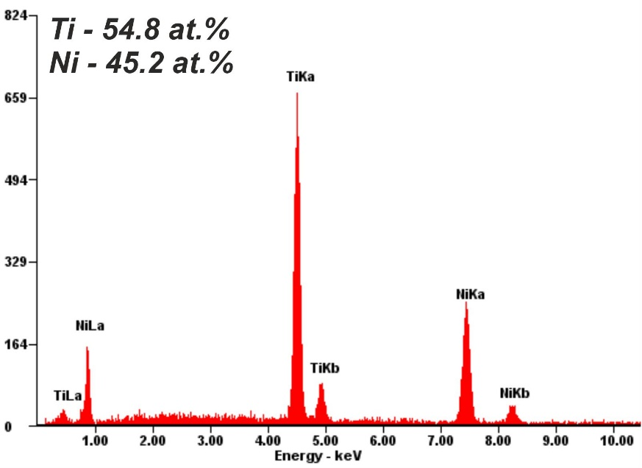

Figure S1. EDX spectrum taken on the surface of TiNi after first stage of etching (1-3 s) showing its enrichment in Ti.

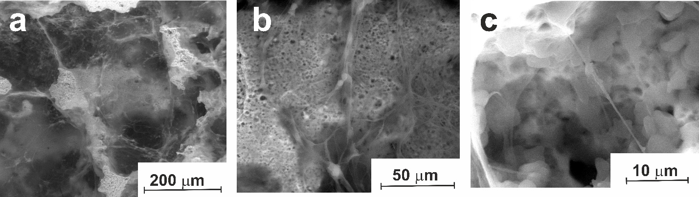

Figure S2. SEM images (low vacuum SE mode) of the pore space of modified TiNi on day 7 of cell cultivation. Many cells are seen to be connected to each other by pseudopodia spreading over the surface at different magnifications: (a) 500x; (b) 2000x; (c) 8000x.

