Appendix A
Table A1. Spectral bands of the Micasense Altum multispectral camera from Blackswift E2 UAS.
Name | Center Wavelength (nm) | Bandwidth (nm)
Blue | 475 | 32
Green | 560 | 27
Red | 668 | 14
Near-infrared | 840 | 57
RedEdge | 717 | 12

Table A2. Regression relationships between Satellite Indices and GSM data before diagnostic test across time points and depths. Asterisks refer to the level of significance for the coefficient (* p < 0.05, **, p < 0.01, *** p < 0.001).
Month | Depth (cm) | Variables | R² | SE | Pearson Correlation
August | 0 – 20 | NSDSI2 | 0.70 | 4.46 | 0.83***
 |  | NDVI | 0.73 | 4.20 | 0.86***
 |  | dB | 0.26 | 6.94 | -0.52***
 | 0 – 10 | NSDSI2 | 0.27 | 17.71 | 0.52***
 |  | NDVI | 0.24 | 17.99 | 0.49***
 |  | dB | 0.12 | 19.44 | -0.34*
September | 0 – 10 | NSDSI2 | 0.67 | 7.99 | 0.82***
 |  | NDVI | 0.60 | 8.78 | 0.77***
 |  | dB | 0.32 | 11.44 | -0.57**
 | 0 – 5 | NSDSI2 | 0.77 | 10.08 | 0.88***
 |  | NDVI | 0.73 | 10.84 | 0.85***
 |  | dB | 0.39 | 16.35 | -0.62***

Table A3. Regression relationships between UAS and GSM data before diagnostic test across all depths. Asterisks refer to the level of significance for the coefficient (* p < 0.05, **, p < 0.01, *** p < 0.001).
Month | Depth (cm) | Variables | R² | Std error | Pearson Correlation
September | 0 – 10 | NDVI | 0.71 | 7.53 | 0.84***
 |  | ENDVI | 0.59 | 8.86 | 0.77***
 |  | NDRE | 0.70 | 7.57 | 0.84***
 |  | GRVI | 0.68 | 7.88 | 0.82***
 |  | GLI | 0.69 | 7.73 | 0.83***
 | 0 – 5 | NDVI | 0.85 | 8.13 | 0.92***
 |  | ENDVI | 0.73 | 10.88 | 0.85***
 |  | NDRE | 0.86 | 7.67 | 0.93***
 |  | GRVI | 0.77 | 10.07 | 0.88***
 |  | GLI | 0.81 | 9.02 | 0.90***

Table A4. Regression relationships between satellite indices and VSM data across time points and depths. Asterisks refer to the level of significance for the coefficient (* p < 0.05, **, p < 0.01, *** p < 0.001).

Month | Depth (cm) | Variables | R² | Standard Error | Pearson Correlation
August | 0 – 20 | NSDSI2 | 0.22 | 7.29 | 0.47***
 |  | NDVI | 0.21 | 7.35 | 0.46**
 |  | dB | 0.03 | 8.12 | -0.18
 | 0 – 7.6 | NSDSI2 | 0.21 | 8.03 | 0.46***
 |  | NDVI | 0.18 | 8.19 | 0.42**
 |  | dB | 0.06 | 8.73 | -0.25
September | 0 – 7.6 | NSDSI2 | 0.22 | 3.47 | 0.47**
 |  | NDVI | 0.19 | 3.52 | 0.44*
 |  | dB | 0.18 | 3.56 | -0.42*

Table A5. Regression relationships between UAS indices and VSM data. Asterisks refer to the level of significance for the coefficient (* p < 0.05, **, p < 0.01, *** p < 0.001).
Month | Depth (cm) | Variables | R² | Std error | Pearson Correlation
September | 0 – 7.6 | NDVI | 0.24 | 3.41 | 0.492**
 |  | ENDVI | 0.19 | 3.52 | 0.439*
 |  | NDRE | 0.24 | 3.41 | 0.492**
 |  | GRVI | 0.31 | 3.26 | 0.554**
 |  | GLI | 0.28 | 3.33 | 0.529**

(a)
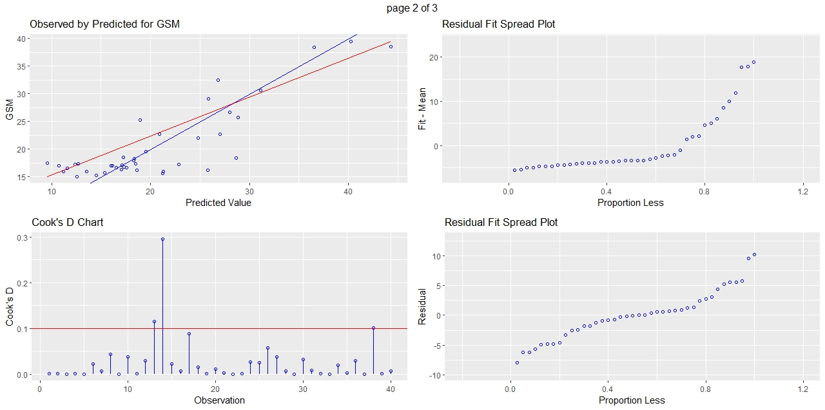

(b)
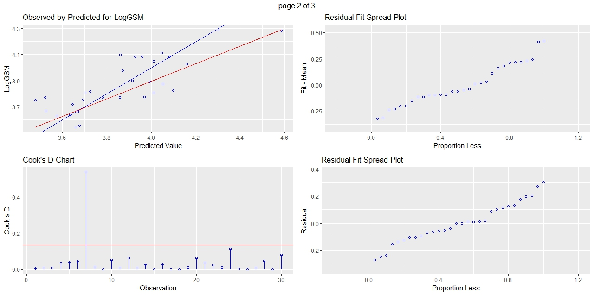

(c)
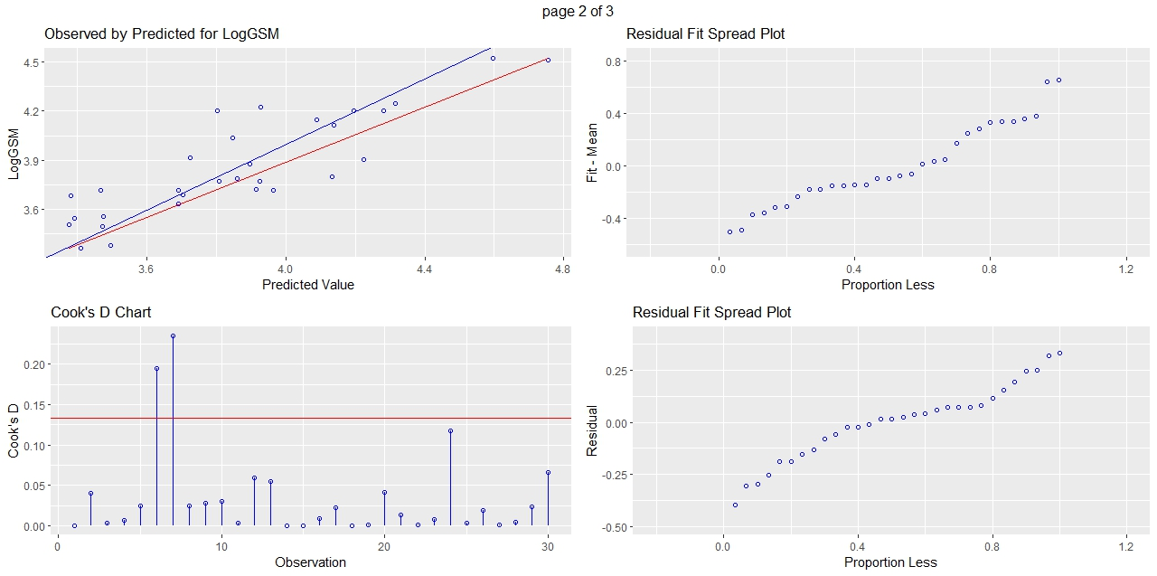
Figure A1. Satellite/GSM models diagnostic plots. A: NDVI at the depth of 0 – 20 cm; B: NSDSI2 at the depth of 0 – 10 cm; C: NSDSI2 at the depth of 0 – 5 cm

(a)
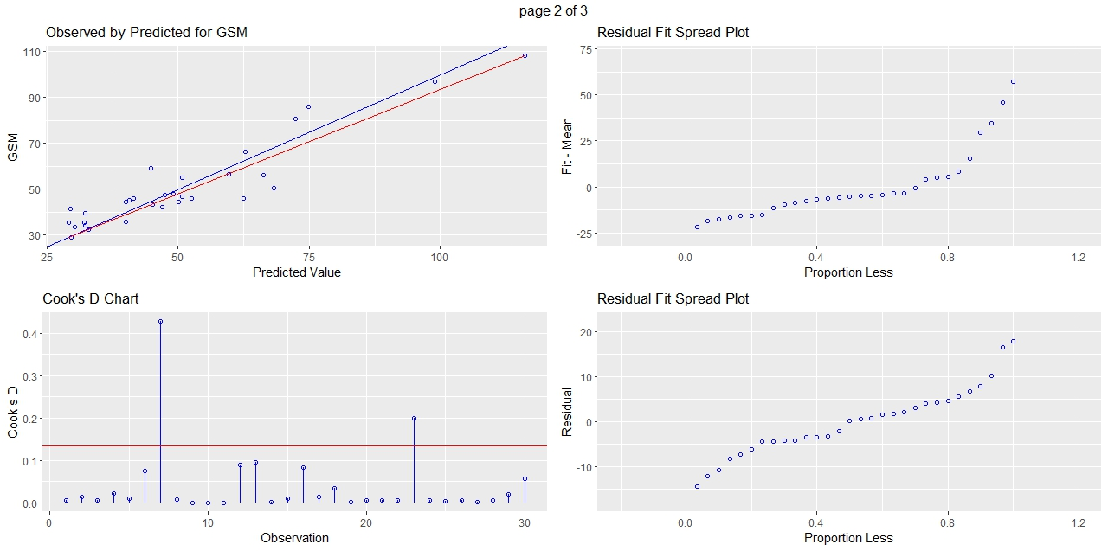
(b)
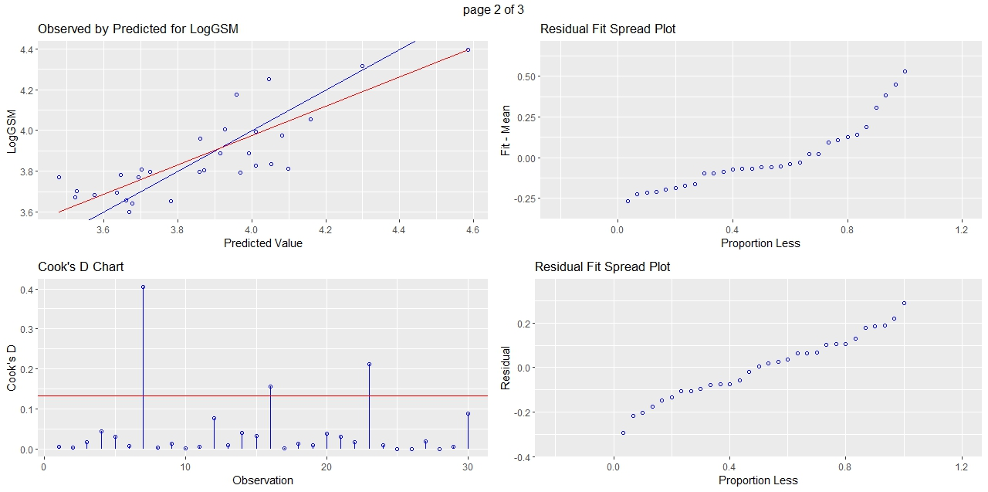
Figure A2. UAS/GSM models Diagnostic plots. A: NDRE at the depth of 0 – 5 cm; B: NDVI at the depth of 0 – 10 cm

