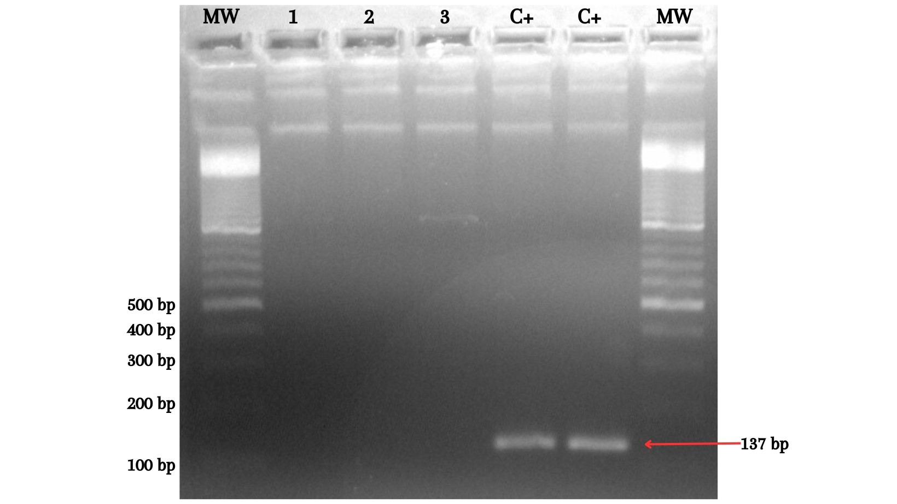
Figure S1. Agarose gel electrophoresis. Lanes 5 to 6 show a 137 bp band as a result of amplification of the GPI gene from the C. auris reference strain. Lanes 1, 2 and 3 isolates of K. ohmeri, no amplification products are observed. Molecular weight marker from lanes 1 and 7 (size 100 bp).

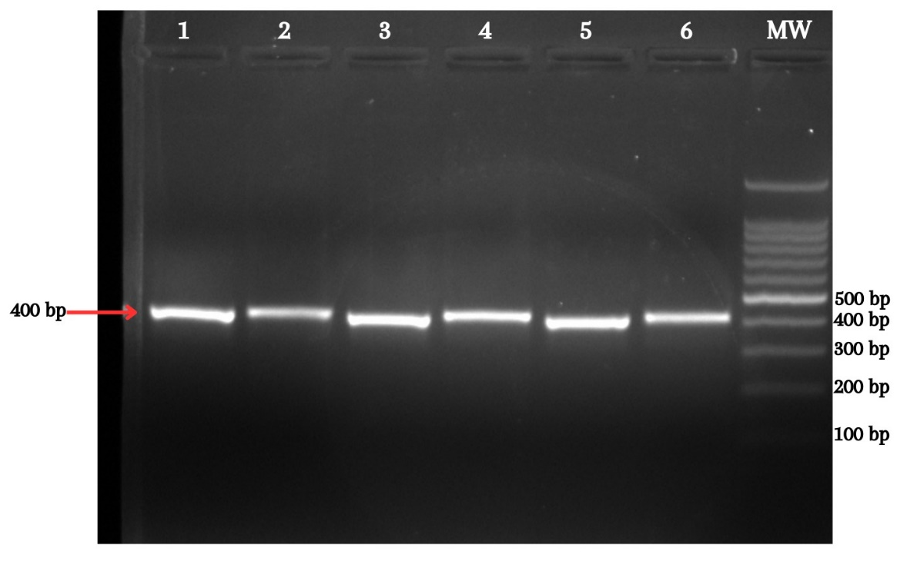

Figure S2. Agarose gel electrophoresis. Lanes 1, 3, and 5 show the amplification products of the internal transcribed spacer (ITS) of the ribosomal region of K. ohmeri. Lanes 2, 4, and 6 show the PCR products after being subjected to the MspI enzyme. Molecular weight marker lane 7 (size 100 bp).

Figure S3. Determination of phospholipase activity of Kodamaea ohmeri isolates on Sabouraud agar supplemented with egg yolk.

Figure S4. Determination of the protease activity of Kodamaea ohmeri isolates, gelatinase test.

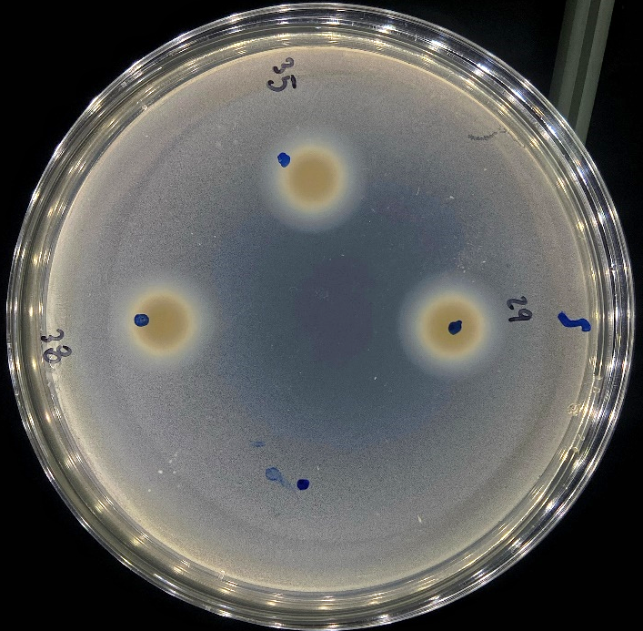
Figure S5. Determination of the protease activity of Kodamaea ohmeri isolates, Bovine serum albumin agar (BSA).

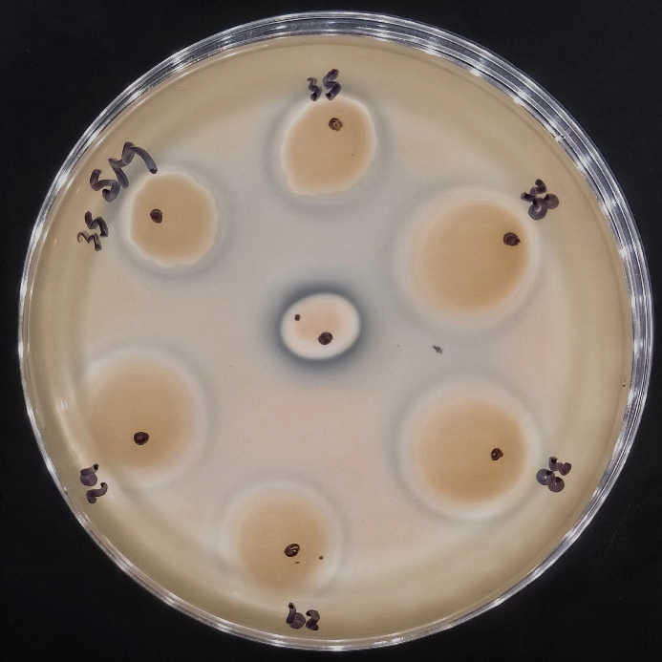
Figure S6. Determination of the protease activity of Kodamaea ohmeri isolates. Caseinase activity.

Figure S7. Determination of the hemolytic activity of Kodamaea ohmeri isolates. Test on Sabouraud agar supplemented with 6% human blood and 3% glucose (pH = 5.6).

