Disulfide cross-linked polymeric redox-responsive nanocarrier based on heparin, chitosan and lipoic acid improved drug accumulation, increased cytotoxicity and selectivity against leukemia cells by tumor targeting via “Aikido” principle
Igor D. Zlotnikov ¹, Alexander A. Ezhov ², Natalia V. Dobryakova ¹ and Elena V. Kudryashova ^{1,}*

¹ Faculty of Chemistry, Lomonosov Moscow State University, Leninskie Gory, 1/3,
119991 Moscow, Russia; zlotnikovid@my.msu.ru (I.D.Z.);
² Faculty of Physics, Lomonosov Moscow State University, Leninskie Gory, 1/2, 119991 Moscow, Russia; alexander-ezhov@yandex.ru
* Correspondence: helenakoudriachova@yandex.ru (E.V.K.)

Figure S1. FTIR spectra of Chit5, LA, its conjugate Chit5-LA. PBS (0.01 M, pH 7.4). T = 22 °C.

Figure S2. Zoomed FTIR spectra of Chit5-LA and DoxMC2 (Dox-SS-LA-Chit5) in the wavenumber region 2650-2450 cm^{–1}. PBS (0.01 M, pH 7.4). T = 22 °C.

Figure S3. FTIR spectra of normal HEK293T cells during incubation for 30 min with free Dox (0.1 mg/mL) and micellar Dox formulation (DoxM1). PBS (0.01 M, pH = 7.4). T = 22 or 37 °C.

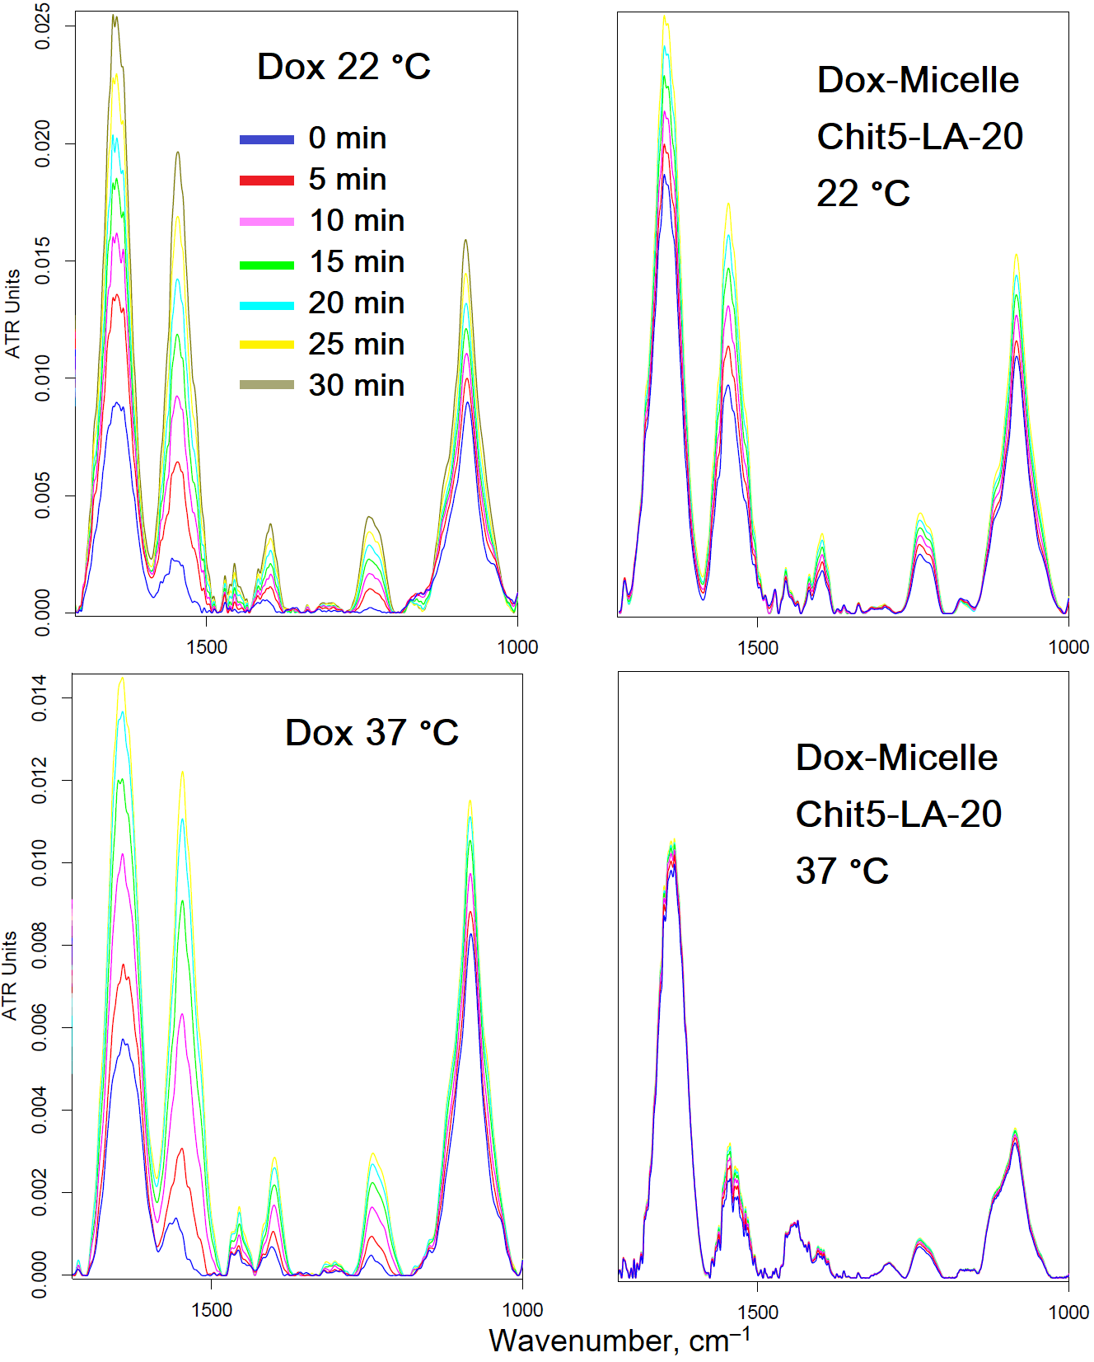
Figure S4. ¹H NMR of Chit5 grafted with (a) lipoic acid and (b) oleic acid. PBS (0.01M, pH = 7.4). T = 22 °C.
(a)
(b)

