Bioaccumulation and trophic transfer in mussels after short term exposure to DCOIT and SiNC-DCOIT

Bruno G. Campos, Olga Kaczerewska, Frederico Maia, Denis M. S. Abessa, Susana Loureiro, Roberto Martins

Supplementary Material

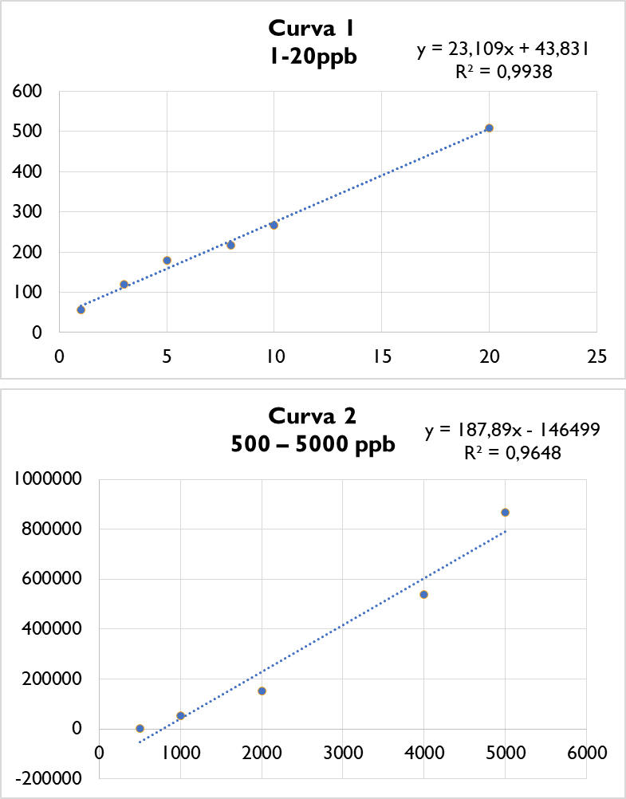
Figure S1. Standard curves prepared with DCOIT during the calibration of the equipment.

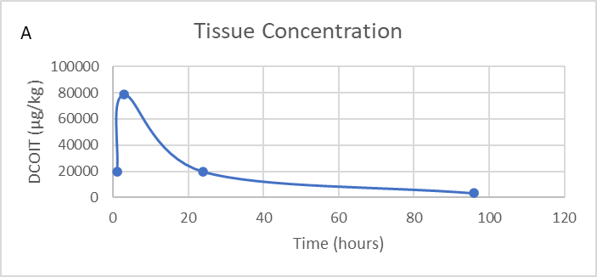
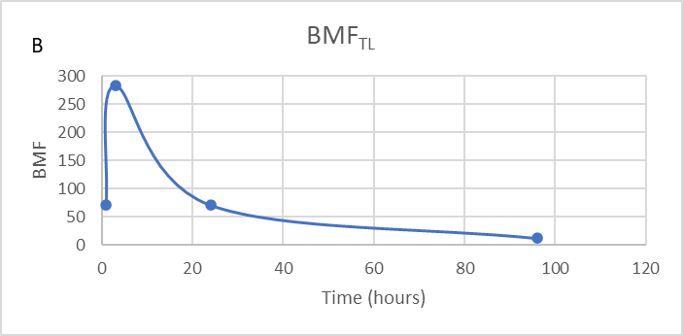
Figure S2: Mytilus galloprovincialis tissue concentration (µg/Kg) (A) and predatory biomagnification factor (BMF_{TL}) (B) for the replicate 2 organism at the food exposure treatment.

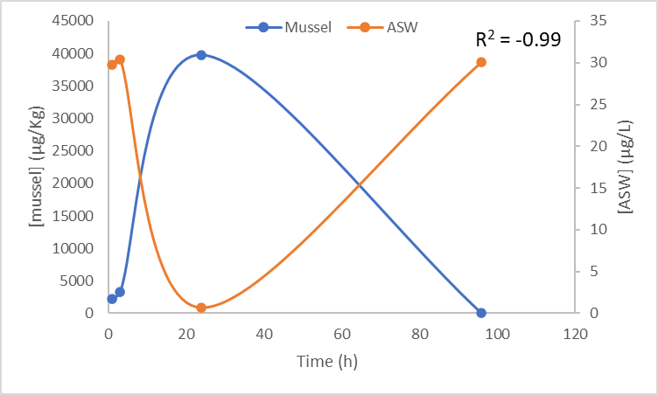
Figure S3: Replicate 2, Mytilus galloprovincialis tissue concentration (µg/Kg) and ASW concentration (µg/Kg) of DCOIT, during the water + food exposure treatment. R² indicates the correlation between DCOIT in the media (ASW) and M. galloprovincialis tissue.

