Article
Consumption of Limosilactobacillus fermentum inhibits corneal damage and inflammation in dry eye disease mice model through regulating the gut microbiome
Kippeum Lee †, Hyeonjun Gwon, Jae Jung Shim, Joo Yun Kim *, and Jae Hwan Lee
Citation: To be added by editorial staff during production.
Academic Editor: Firstname Lastname
Received: date
Revised: date
Accepted: date
Published: date
Copyright: © 2023 by the authors. Submitted for possible open access publication under the terms and conditions of the Creative Commons Attribution (CC BY) license (https://creativecommons.org/licenses/by/4.0/).
¹ R&BD Center, hy Co Ltd., 22, Giheungdanji-ro 24 beon-gil, Giheung-gu, Gyeonggi-do 17086, Korea; joy4917@hanmail.net (K.L.); hjgwon@hy.co.kr (H. K.); jjshim@hy.co.kr (J.J.S.); monera@hy.co.kr (J.Y.K); jaehwan@hy.co.kr (J.W.L)
* Correspondence: monera@hy.co.kr (J.Y.K)
† First author

Figure S1. Effect of HY7302 on the taxonomy difference genus profile in BAC-induced cornea damag mice. Taxonomic abundance comparisonat genus level from 16S rDNA sequencing. CON (Control group); DE (0.1% BAC treated group); DE + Ω-3 (0.1% BAC with 200mg/mL omega-3 treated mice); DE + HY7302L (0.1% BAC with 10⁸ CFU/mL HY7302 treated mice); DE + HY7302H (0.1% BAC with 10⁹ CFU/mL HY7302 treated mice).
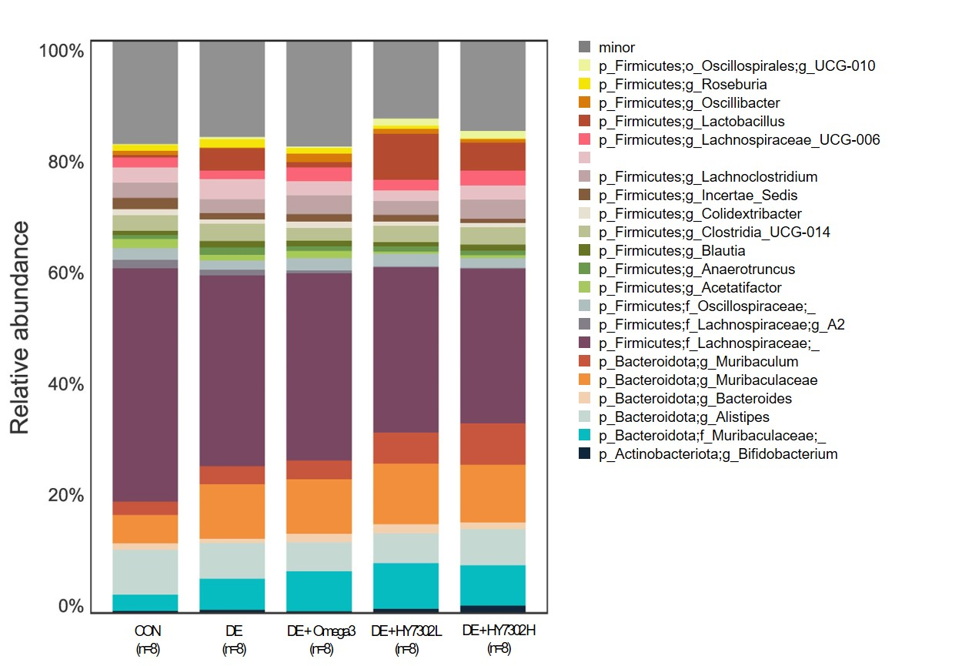

Figure S2. Effect of HY7302 on microbial taxa differing in BAC-induced cornea damag. Linear discriminant analysis effect size (LEfSe) results (A) a bar plot between DE (Dry Eye) and Control group. (B) Omega 3, (C) HY7302 L (Low concentration), and (D) HY7302 H (High concentration) compared to the DE group (LDA > 2.0)
