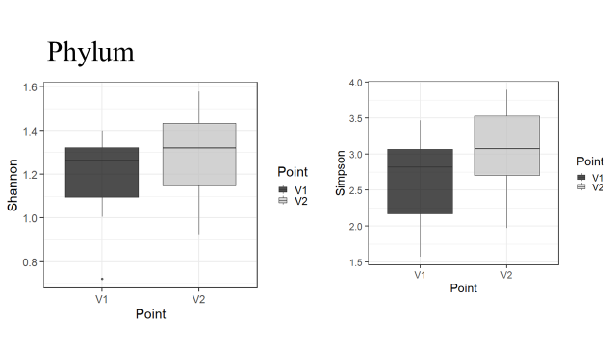
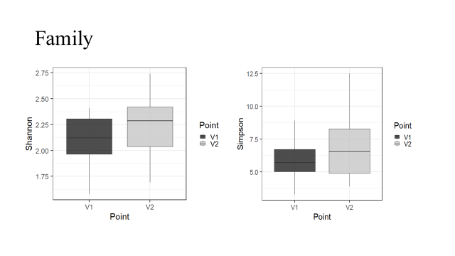
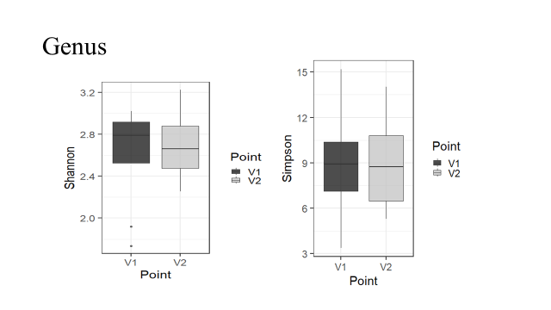
Figure S1. Alpha-biodiversity before and after therapy in the levels of phylum (A), family (B) and genus (C).

