TLC-Densitometric Method for Determination of Metronidazole and Tinidazole in Pharmaceutical Preparations

Alina Pyka-Pająk
Department of Analytical Chemistry, Faculty of Pharmaceutical Sciences in Sosnowiec, Medical University of Silesia in Katowice, Jagiellońska 4, 41-200 Sosnowiec, Poland
Correspondence: apyka@sum.edu.pl; Tel.: +48-32-364-15-30

Table S1. Mobile phases tested
No | Mobile phase | Volume composition of mobile phase | Ref
1 | benzene + ethyl acetate + toluene + methanol + glacial acetic acid | 9.5:2:5:1.5:0.5 | [21]
2 | acetone + chloroform + ethyl acetate | 4:4:1 | [37]
3 | toluene + ethyl acetate + chloroform + methanol | 1:2:3:2:0.8 | [3]
4 | toluene + ethyl acetate + methanol + triethylamina | 5.5:1:1:0.1 | [3]
5 | toluene + ethyl acetate + methanol + triethylamina | 5:1:1:0.1 | [3]
6 | Methanol + diethyl ether + chloroform | 1:9:3 | [3]
7 | methylene chloride + isopropyl alcohol + acetonitrile + ammonia | 11:1.2:5:0.2 | [3]
8 | chloroform + methanol + ammonia | 9:1:0.1 | [20]
9 | chloroform + methanol + ammonia | 9:1:0.06
10 | chloroform + acetone + glacial acetic acid | 7.5:2.5:0.1 | [16]
11 | chloroform + methanol | 9:1 | [36,38]
12 | chloroform + methanol + glacial acetic acid | 9:1:0.1
13 | chloroform + methanol + glacial acetic acid | 9:1:0.05
14 | acetone + chloroform + ethyl acetate ₊ glacial acetic acid | 4:4:1:0.05
15 | acetone + chloroform + ethyl acetate ₊ ammonia | 4:4:1:0.05
16 | acetone + chloroform + ethyl acetate ₊ acetonitrile | 3:4:1:1
17 | chloroform + acetonitrile | 9:1
18 | chloroform + acetonitrile + glacial acetic acid | 9:1:0.05
19 | chloroform + methanol + diethylamine | 9:1:1

Table S2. Details of the validation of the proposed TLC-densitometric method.

Range and linearity of the method used
The linearity and range of the TLC method was evaluated by analyzing 16 standard solutions of metronidazole and tinidazole applied to chromatographic plates in a volume of 5 µL. The plates were developed using a mobile phase: chloroform + methanol + diethylamine in a volume composition of 9: 1: 1. The analysis was repeated three times.

Determination of the precision of the method used
The inta-day and inter-day precisions of the method were determined based on the analysis of the surface area of the chromatographic bands of the tested samples. Test solutions (5 µL) of metronidazole and tinidazole (0.06 mg/mL, 0.20 mg/mL, 0.35 mg/mL) were applied to the chromatographic plates. Densitometric measurement of the resulting spots was performed and the relative standard deviation CV [%] was calculated.

The accuracy of the method used
Determination of the accuracy of the proposed method by a recovery test of metronidazole and tinidazole
The accuracy of the TLC method combined with the densitometric analysis was determined based on the recovery measurements. For this purpose, three drug samples containing 100 mg of metronidazole and 100 mg of tinidazole were prepared, and then internal standards were added to them in the amount of 50, 100, and 150% metronidazole and tinidazole. Samples were extracted and solutions were prepared about concentrations 0.30 mg/mL, 0.25 mg/mL, and 0.20 mg/mL. 5 µL of the solutions prepared in this way were taken and applied to the chromatographic plates. The chromatographic and densitometric analyzes were repeated six times.

Determination of the accuracy of the proposed method by comparing the results obtained with pharmakopeia method B considered to be accurate
The accuracy of the method was also assessed by comparing the results with the pharmakopeia method [1].
Specificity of the method used
The specificity of the normal phase thin-layer chromatography (NP-TLC) method was determined by selecting the appropriate chromatographic sorbent and mobile phase, with the use of which it is possible to separate metronidazole, secnidazole, ornidazole and tinidazole as well as 2-methyl-5-nitroimidazole.
By analyzing the obtained densitogram and using the following equation (1), the resolution factors (Rs) were determined:
$R_{S}=\frac{2d}{w_{b1}+w_{b2}}$ (1)
where: d- distance between the centers of two adjacent densitometric bands; w_{b1}, w_{b2}- width of densitometric bands at the base.
Limit of detection and quantification of the method used
Three standard solutions containing metronidazole and tinidazole were prepared: 0.06, 0.04, 0.02, mg⋅mL⁻¹. 5 µL of each solution was taken and applied to chromatography plates. The process was repeated three times. The limit of detection (LOD) was determined using the calibration curve. The limit of detection (LOD) was calculated from formula (2):
$LOD=\frac{3.3}{s}$$LOD=\frac{3,3σ}{s}$ (2)

The limit of quantification (LOQ) was calculated from formula (3):

$LOQ=\frac{10}{s}$ $LOD=\frac{3,3σ}{s}$$LOQ=\frac{10σ}{s}$ $LOQ=\frac{10σ}{S}$ (3)
where: s - slope of the calibration curve; σ- standard deviation.
Robustness
The rules for testing robustness were described in detail in reference publications [30,34,35].
The robustness of the method was checked by spotting sample solutions on the plate and developing the plate after altering the conditions (Table S3). The conditions changed were the sorbent type, development distance, the temperature of plate activation, extraction time, saturation time of the chamber, wavelength in densitometric analysis at λ, and the volume of chloroform in mobile phase. The method conditions and the selected factors which the values of their (+) and (-) levels are summarized in Table 4. A high level is represented by “+” and a low level by “-“.

Table S3: The factors and their levels investigated in robustness test.
Symbol | Factors | Method  Condition | Levels
 |  |  | + | -
X₁ | Sorbent type | Al sheet  (1.05554) | Al sheet  (1.05554) | Al sheet  (1.05570)
X₂ | Development distance [cm] | 7.5 | 7.4 | 7.6
X₃ | Temperature of plate activation [ºC] | 120 | 130 | 110
X₄ | Extraction time [min] | 20 | 22 | 18
X₅ | Saturation time of the chamber [min] | 30 | 32 | 28
X₆ | Wavelength in densitometric analysis at λ [nm] | 313 | 316 | 310
X₇ | Volume of chloroform [mL] | 9.0 | 9.1 | 8.9

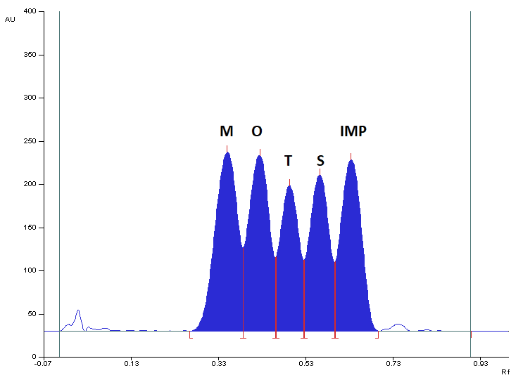
Figure S1. Densitogram of a mixture of standard substances: metronidazole (M), secnidazole (S), ornidazole (O), tinidazole (T), and 2-methyl-5-nitroimidazole (IMP) made at 313 nm, using silica gel 60F₂₅₄ plate and mobile phase: acetone + chloroform + ethyl acetate (4:4:1, v/v).

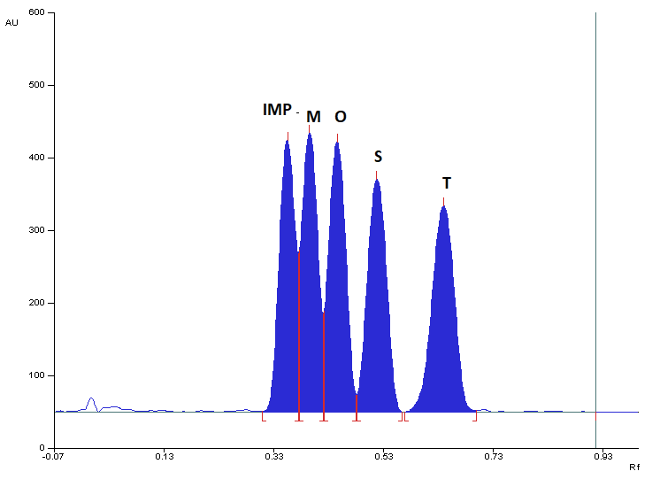
Figure S2. Densitogram of a mixture of standard substances: metronidazole (M), secnidazole (S), ornidazole (O), tinidazole (T), and 2-methyl-5-nitroimidazole (IMP) made at 313 nm, using silica gel 60F₂₅₄ plate and mobile phase: chloroform + methanol + ammonia (9:1:0.06, v/v).

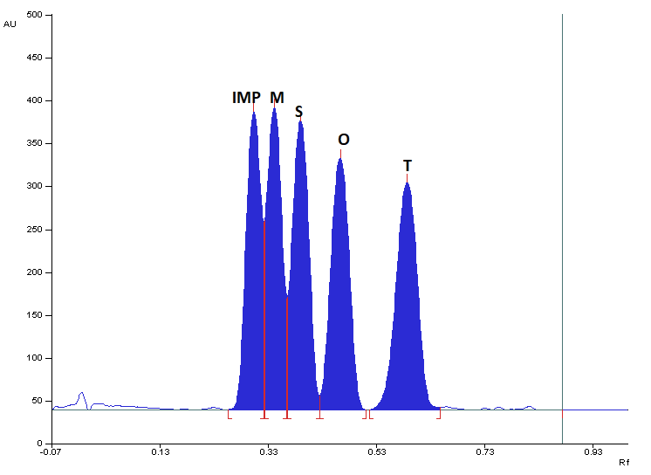
Figure S3. Densitogram of a mixture of standard substances: metronidazole (M), secnidazole (S), ornidazole (O), tinidazole (T), and 2-methyl-5-nitroimidazole (IMP) made at 313 nm, using silica gel 60F₂₅₄ plate and mobile phase: chloroform + methanol + ammonia (9:1:0.1, v/v).
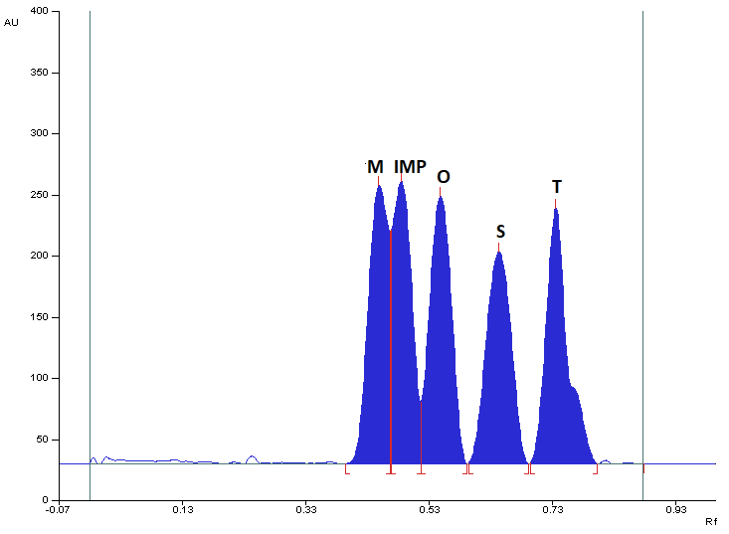

Figure S4. Densitogram of a mixture of standard substances: metronidazole (M), secnidazole (S), ornidazole (O), tinidazole (T), and 2-methyl-5-nitroimidazole (IMP) made at 313 nm, using silica gel 60F₂₅₄ plate and mobile phase: chloroform + methanol + glacial acetic acid (9:1:0.1, v/v).

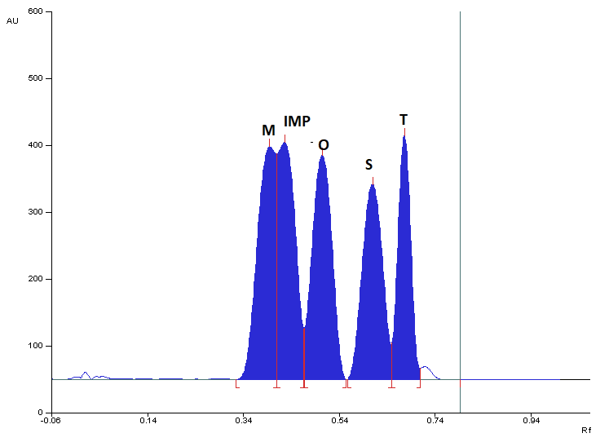
Figure S5. Densitogram of a mixture of standard substances: metronidazole (M), secnidazole (S), ornidazole (O), tinidazole (T), and 2-methyl-5-nitroimidazole (IMP) made at 313 nm, using silica gel 60F₂₅₄ plate and mobile phase: chloroform + methanol + glacial acetic acid (9:1:0.05, v/v).
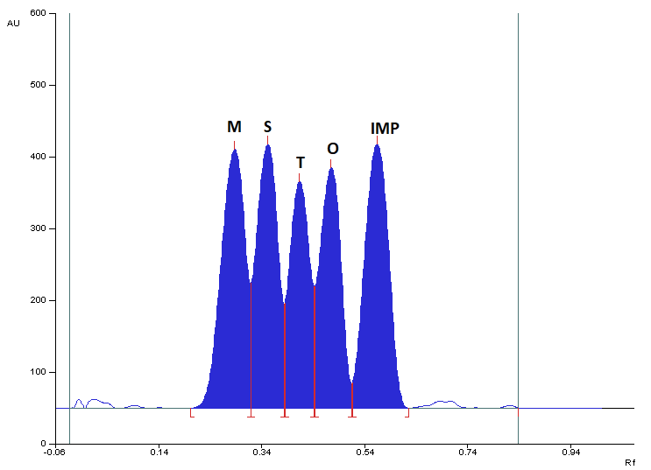
Figure S6. Densitogram of a mixture of standard substances: metronidazole (M), secnidazole (S), ornidazole (O), tinidazole (T), and 2-methyl-5-nitroimidazole (IMP) made at 313 nm, using silica gel 60F₂₅₄ plate and mobile phase: acetone + chloroform + ethyl acetate ₊ glacial acetic acid (4:4:1:0.05, v/v).

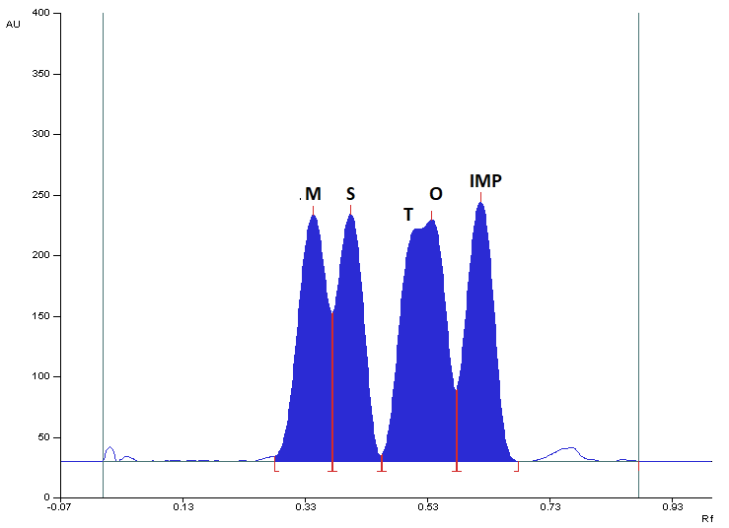
Figure S7. Densitogram of a mixture of standard substances: metronidazole (M), secnidazole (S), ornidazole (O), tinidazole (T), and 2-methyl-5-nitroimidazole (IMP) made at 313 nm, using silica gel 60F₂₅₄ plate and mobile phase: acetone + chloroform + ethyl acetate ₊ acetonitrile (3:4:1:1, v/v).

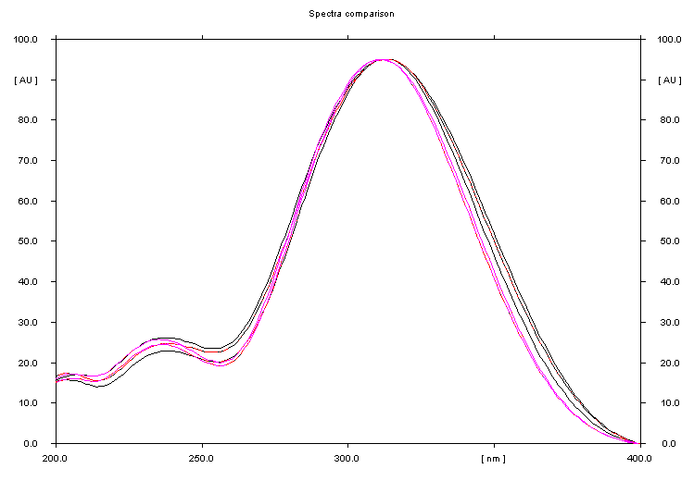
Figure S8. Comparison of spectrodensitograms of M, S, O, T, and IMP.

Figure S9. Calibration plot (A) and plot of residuals (B) for metronidazole (M) in the linear working range mobile phase: chloroform + methanol + diethylamine in a volume ratio of 9:1:1.

Figure S10. Calibration plot (A) and plot of residuals (B) for tinidazole (T) in the linear working range mobile phase: chloroform + methanol + diethylamine in a volume ratio of 9:1:1.

