Supplemental File
Fluorescently tagged Verticillium dahliae to understand the infection process on cotton (Gossypium hirsutum) and its survival on other plants including weed species
Andrew Chen ^{1, †,} *, Sabrina Morrison ^{1, 2, †}, Aphrika Gregson ^{1, 3, †}, Duy P. Le ⁴, Andrew S. Urquhart ⁵, Linda J. Smith ⁶, Elizabeth A. B. Aitken ^{1,} * and Donald M. Gardiner ^{2,} *

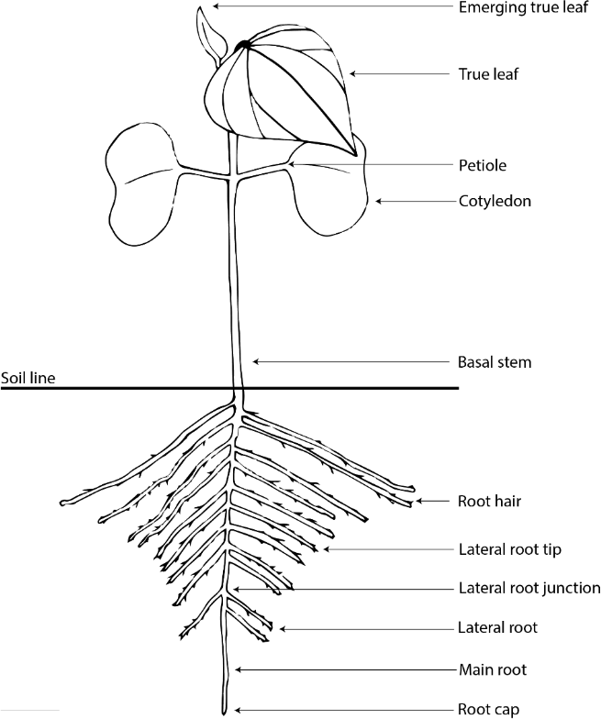
Figure S1. Anatomy of a cotton seedling approximately 10 -14 days after sowing. Plant sections excised by hand for confocal microscopy include root cap, main root, lateral root, lateral root junction and tip, basal stem, and petiole of true leaves.

Table S1. Primers for yeast recombinantion-based cloning of to generate a plasmid for expression of mCherry in Verticillium dahliae.
Primer name | Sequence² | Target notes
DG1346¹ | cctcaccgcggcccatggtctagaactagtggatccAACGGGC | Forward primer for TEF promoter
DG1347¹ | gcccttggagaccatGGTGAAGGTTGTGTTATGTTTTGTGGA | Reverse primer for TEF promoter
DG1348¹ | aacacaaccttcaccATGGTCTCCAAGGGCGAGGAGGA | Forward primer for mCherry
DG1349¹ | aaatcgaatgtccgcTCATTTGTACAGCTCGTCCATACCG | Reverse primer for mCherry
DG1350¹ | gagctgtacaaatgaGCGGACATTCGATTTATGCCG | Forward primer for TEF terminator
DG1351¹ | CTCGAGGTCGACAAGCTTGT | Reverse primer for TEF terminator
¹ Primers used in the cloning of TEF promoter/terminator and mCherry fragments into pPZPnat1. ² lowercase = homology arms of primer, uppercase = sequence with homology to PCR template, bold = BamHI restriction site.

Table S2. Verticillium dahliae-specific primers [1] amplifying a 200 bp ITS product were used to confirm its identity.
Name | Primer type | Organism | Sequence (5’-3’) | Target
ITS1-F | Forward | Fungi | CTTGGTCATTTAGAGGAAGTAA | 18S rDNA
ST-VE1 | Reverse | Verticillium spp. | AAAGTTTTAATGGTTCGCTAAGA | ITS 1

Table S3. Summary of rate of colonisation based on timing of initial observation at each infection stage throughout the confocal microscopy experiment (At each observation, n = 3 samples of plant tissue section examined).
Infection stage | First observed¹ time |  | Fungal structures² | Number of  observations³
 | Sicot | Siokra 1-4
Germination | 24 hpi | 24 hpi | Conidia, germ tubes,  infection peg (Siokra) | 1 observation
Hyphal elongation | 5 dpi | 24 hpi | Conidia, hyphae | 2 observations
Penetration | 5 dpi | 24 hpi | Conidia, hyphae | 2 observations
Colonisation of the root  epidermis | 5 dpi | 5 dpi | Mycelia | 1 observation
Colonisation of the root vasculature | 7 dpi | 7 dpi | Mycelia, occlusion with conidia (Sicot) | 2 observations
Colonisation of the above  ground vasculature | - | 7 dpi | Conidia, germ tube,  hyphae | 1 observation
Colonisation of the petiole | - | 7 dpi | Conidia, hyphae | 1 observation
¹ Time point at which infection stage was first observed.
² Fungal structures listed were observed on both varieties unless indicated otherwise.
³ Independent observations.

Table S4. mCherry transformant isolates selected for comparison against Verticillium dahliae VCG-1A parent, 'Vd71181', that originated from Gwydir Valley, NSW. Isolates were selected for brightness and uniformity of fluorescence. Table includes corresponding Agrobacterium strain used for transformation of mCherry protein into V. dahliae.

Isolate¹ | Origin strain | VCG | Agrobacterium strain
81T0028 | Vd71181 | 1A | AGL1
81T0029 | Vd71181 | 1A | AGL1
81T0030 | Vd71181 | 1A | AGL1
81T0069 | Vd71181 | 1A | EHA105
81T0073 | Vd71181 | 1A | EHA105
¹ Isolate names are abbreviated to indicate Gw = Gwydir Valley and T = mCherry Transformant.

1. Lievens, B.; Brouwer, M.; Vanachter, A.C.R.C.; Cammue, B.P.A.; Thomma, B.P.H.J. Real-time PCR for detection and quantification of fungal and oomycete tomato pathogens in plant and soil samples. Plant Science 2006, 171, 155-165, doi:https://doi.org/10.1016/j.plantsci.2006.03.009.

