**Supporting Information**

**A Remarkable Impact of pH to the Thermoresponsive Properties of Alginate-Based Composite Hydrogels Incorporating P2VP-PEO Micellar Nanoparticles**

Amalia Iliopoulou1, [Zacharoula Iatridi](https://sciprofiles.com/profile/270454)1, [Constantinos Tsitsilianis](https://sciprofiles.com/profile/15095)1,*

1Department of Chemical Engineering, University of Patras, 26500 Patras

**Table S1.**Molecular characteristics of the ALG-g-HG heterograft copolymer.

|  |  |
| --- | --- |
| **ALG-g-HG heterograft copolymer** | |
| **Molecular weight, Mw (g/mol)** | 262,000 |
| **Average number of**  **P(NIPAM86-co-NtBAM14) chains per Alginate backbone** | 3.5 |
| **Average number of PNIPAM chains per Alginate backbone** | 1.8 |

**Table S2.** Molecular characteristics of the P2VP-*b*-PEO copolymer.

|  |  |  |  |
| --- | --- | --- | --- |
| **Composition\*** | | **Molecular weight\*\*** | |
|  | **(P2VP %moles)** | **Mn (g/mol)** | **Mw (g/mol)** |
| **P2VP block** | - | 2583 | 2678 |
| **P2VP-*b*-PEO** | 9 | 13144 | 14384 |

*by 1H-NMR; ** by Size Exclusion Chromatography

**Table S3.** Characteristic factors of thermoresponsiveness at various pH for the pure ALG-g-HG copolymer.



**Table S4.** The hydrodynamic diameters of P2VP-*b*-PEO polymeric micelles obtained from the number- and volume- weighted distributions of the DLS analyses. Values are reported as the mean value of the peak size.

|  |  |  |
| --- | --- | --- |
| **Particle Size Distributions** | | |
| **Diameter, nm** | | |
| **pH** | **Number-weighted** | **Volume-weighted** |
| **7.4** | 20.03 | 22.38 |
| **5.4** | 28.92 | 33.73 |
| **3.5** | 3.21 | 3.50 |



**Figure S1.** Storage (G’) and loss (G”) modulus as a function of temperature of ALG-g-HG solutions (a) 5 wt% and (b) 4 wt%.



**Figure S2.** Zeta potential of aqueous P2VP‐*b*‐PEO (■) and ALG-g-HG (▲) solutions at different pH.

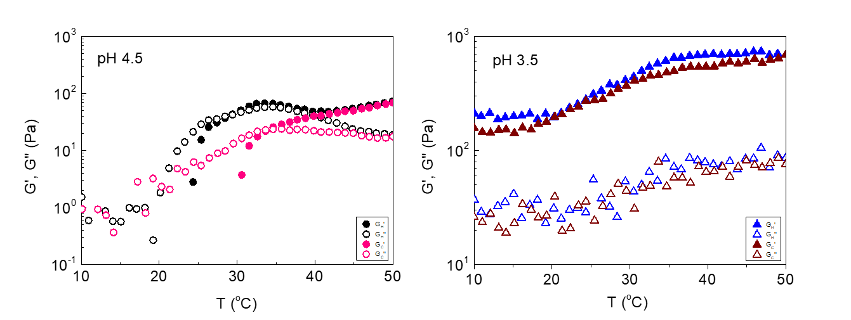

**Figure S3.** Storage (G’) and loss (G”) modulus as a function of temperature of 4 wt% ALG-g-HG hydrogels at (**a**) pH 4.5 and (**b**) pH 3.5.

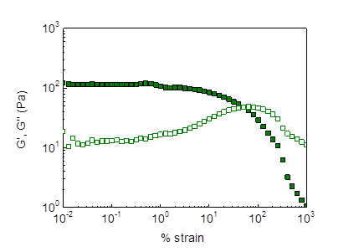

**Figure S4.** Oscillatory strain sweepdata at 1 Hz of the 4 wt% ALG-g-HG hydrogel at pH 4 and 37 oC.



**Figure S5.** pH dependence of complex viscosity (1Hz) at 37 oC. The data were extracted from the experiments of Figure 2 (heating ramp).