Type of the Pape: Supplementary materials
A secondary retrospective analysis of the predictive value of Neutrophil-Reactive Intensity (NEUT-RI) in Septic and Non-septic Patients in Intensive Care
Paolo Formenti^{1°}, Letizia Isidori¹, Stefano Pastori², Vincenzo Roccaforte², Elena Maria Alessandra Mantovani¹ , Massimiliano Iezzi³, Alessandro Menozzi³, Rossella Panella², Andrea Galimberti¹, Giovanni Brenna¹, Michele Umbrello⁴, Angelo Pezzi¹, Francesco Vetrone¹, Giovanni Sabbatini¹, Miriam Gotti¹
Citation: To be added by editorial staff during production.
Academic Editor: Firstname Lastname
Received: date
Revised: date
Accepted: date
Published: date
Copyright: © 2024 by the authors. Submitted for possible open access publication under the terms and conditions of the Creative Commons Attribution (CC BY) license (https://creativecommons.org/licenses/by/4.0/).
1 SC Anestesia, Rianimazione e Terapia Intensiva, ASST Nord Milano, Ospedale Bassini, Cinisello Balsamo, 20097, Italy.
2 S.C. Analisi Chimico Cliniche e Microbiologiche, ASST Nord Milano, Ospedale Bassini; Cinisello Balsamo, 20097, Italy.
3 School of Medicine and Surgery, University of Milano-Bicocca, 20126 Milano, Italy.
4. Department of Intensive Care, New Hospital of Legnano: Ospedale Nuovo di Legnano, 20025, Legnano, Milan, Italy.

° Correspondence: paolo.formenti@asst-nordmilano.it

Table S1. Comparison of inflammatory parameters between patients with "renal failure" and patients with "normal renal function."

 | Renal Failure  (n=70) | Normal renal function  (n=130) | P
Age | 75.50 [67.00 - 80.00] | 71.00 [56.00 - 77.00] | 0.006
Male% | 42.9 | 54.6 | 0.150
Creatinine | 2.12 [1.59 – 3.73] | 0.89 [0.69 – 1.25] | < 0.001
CPR | 21.20 [12.31 - 134.65] | 11.37 [2.25 - 32.53] | < 0.001
PCT | 11.91 [1.02 - 63.71] | 0.68 [0.32 - 3.24] | < 0.001
NEUT-RI | 52.15 [47.95 - 56.48] | 48.70 [46.60 - 52.58] | 0.002

Table S2: NEUT-RI, PCT and CPR values for the detection of septic and non-septic patients.

 | AUROC  (95% CI) | Cut-off | Sens  (95% CI) | Spec  (95% CI) | PPV  (95% CI) | NPV  (95% CI)
NEUT-RI | 0.79 [0.73 - 0.86] | 50.75 | 70.9  [60.4 - 79.7] | 80.7  [71.6-88.1] | 75.6  [65.1-84.2] | 77.2  [68.4-84.5]
CPR | 0.73  [0.66 - 0.80] | 7.38 | 84.6  [75.8-91.2 | 56.2  [45.5-64.0] | 65.8  [56.5-74.3] | 77.8  [65.5-87.3]
PCT | 0.76  [0.69 - 0.84] | 2.17 | 62.9  [52.8 - 74.2] | 82.9  [76.4-90] | 82.3  [71.2-90] | 63.7  [52.9-73.6]

There were not statistically significant differences between AUROC of the three parameters (NEUT-RI vs PCT p=0.83, NEUT-RI vs PCR p=0.29, DeLong’s test for two correlated ROC curves). The CPR specificity is statistically different from the NEUT.RI specificity (p=0.01, specificity test for two correlated ROC curves) and from PCT specificity (p=0.007, specificity test for two correlated ROC curves). AUROC= Area Under the ROC curve; Sens = Sensibility; Spec = Specificity; PPV= Positive Predictive Value; NPV= Negative Predictive Value; NEUT-RI= Neutrophil-Reactive Intensity; PCT= procalcitonin; CRP= C-reactive protein

Table S3. NEUT-RI and PCT values for discriminating between "survivors" and "deceased" at 28 days.

 | AUROC  (95% CI) | Cut-off | Sens  (95% CI) | Spec  (95% CI) | PPV  (95% CI) | NPV  (95% CI)
NEUT-RI | 0.70[0.56-0.83] | 53.6 | 62.5  [39.5-81.3] | 76.9  [68.7-82.3] | 28.30  [16.8-42.34] | 93.0  [87.17-96.76]
PCT | 0.76  [0.65-0.88] | 12.18 | 76.2  [54.6-90.5] | 79.9  [71.5-84.6] | 38.09  [23.6-54.3] | 95.10  [88.93-98.39]

There were not statistically significant differences between AUROC of the two parameters (p=0.57, DeLong’s test for two correlated ROC curves). AUROC= Area Under the ROC curve; Sens = Sensibility; Spec = Specificity; PPV= Positive Predictive Value; NPV= Negative Predictive Value; NEUT-RI= Neutrophil-Reactive Intensity; PCT= procalcitonin

Table S4. NEUT-RI and PCT at ICU admission time, after 48 and 96 hours in septic patients.

 | Admission time | 48 hours | 96 hours | p-value  (ANOVA) | P values pairwaise comparisons
 |  |  |  |  | 0h vs  48h | 0h vs 96h | 48h vs 96h
NEUT-RI (FI) (n=59) | 52.70  [49.65-56.80] | 53  [49.00-57.60] | 50.50  [47.60-52.90] | 0.0002 | 1 | 0.0011 | <0.0001
PCT (ng/ml) (n=63) | 6.36  [0.52-36.95] | 5.51  [0.90-34.82] | 1.65  [0.53-5.74] | <0.0001 | 0.01 | <0.0001 | <0.0001

Figure S1. NEUT-RI and CPR depending on the site of infection in “septic” group.
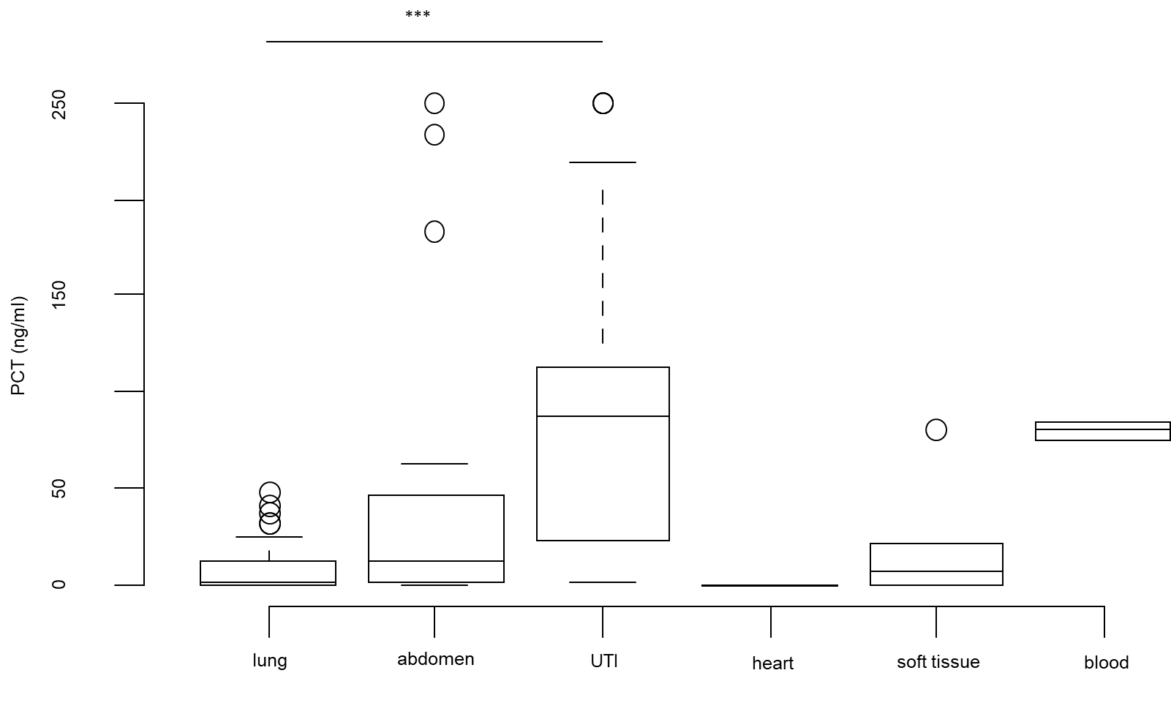
There were no differences in NEUT-RI and CPR depending on the site of infection in “septic” group. There was a statistically significant difference in PCT depending on site of infection (p<0.001, Kruskal-Wallis rank sum test), in particular PCT was higher in patients with kidney or urinary tract infection compared to lung infection (88.50 [24.20-113.00] vs 1.64[0.39-12.54], p<0.001 Pairwise comparisons using Wilcoxon rank sum test with continuity correction.

Figure S2. NEUT-RI and PCT stratified for severity classes based on SAPS II.

