Supplementary Materials
Transcriptomic analysis reveals early alterations associated with intrinsic resistance to target therapy in lung adenocarcinoma cell lines
Mario Perez-Medina^{1,2‡}, Jose S. Lopez-Gonzalez^{1‡}, Jesus J. Benito-Lopez^{1,3‡}, Santiago Avila-Rios⁴, Maribel Soto-Nava⁴, Margarita Matias-Florentino⁴, Alfonso Mendez-Tenorio⁵, Miriam Galicia-Velasco¹, Rodolfo Chavez-Dominguez¹, Sergio E. Meza-Toledo², and Dolores Aguilar-Cazares¹*

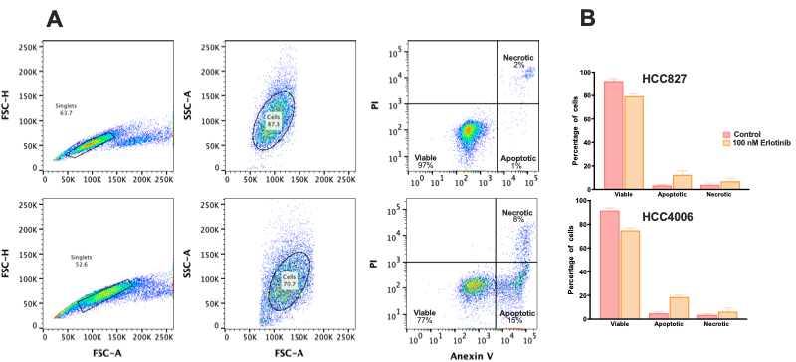
Figure S1. Representative strategy of cytometry analysis for the quantification of viable, apoptotic, and necrotic cells. Effect of erlotinib in EGFR-mutated lung adenocarcinoma cell lines. (A) Compared to control, erlotinib induces a slight cytotoxic effect in the cell line studied. (B) Percentages of viable, apoptotic and necrotic cells in the HCC827 and HCC4006 cell lines are Indica mainly a cytostatic effect, inducing damage in a low proportion of tumor cells. Percentages of viable, apoptotic, and necrotic cells in HCC827 (B) and HCC4006 (C) cell lines are indicated. Three independent experiments were done. Mean ± SD is shown. ****p < 0.0001.

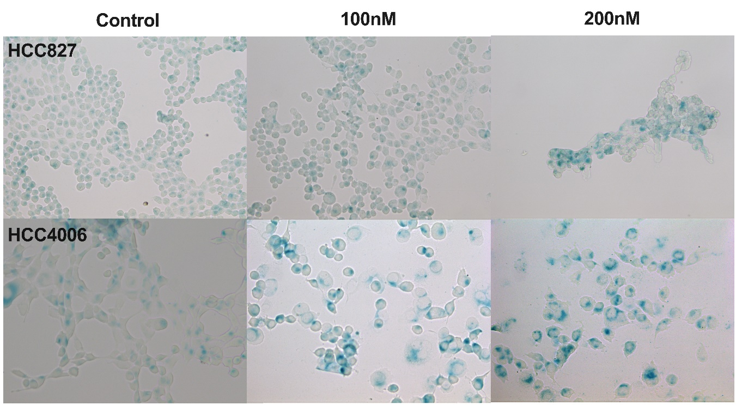
Figure S2. SA-ß-gal-positive cells evidencing DTP cells showing a senescent-like phenotype. After osimertinib exposure for 48 h, residual cells were cultured in fresh complete media for additional five days and the expression of beta-galactosidase was detected. Micrographs show SA-ß-gal-positive cells evidencing DTP cells with a senescent-like phenotype. Magnification 40x.
Table S1. TaqMan® gene expression assays.
Gene | TaqMan assay ID
AGAP2-AS1 | Hs01096080_s1
MEG3 | Hs00292028_m1
NKILA | Hs04937740_s1
CERS6-AS1 | Hs01372066_g1
LINC01133 | Hs04274447_m1
CD74 | Hs00269961_m1
NFYC-AS1 | Hs03670565_s1
FLJ31104 | Hs01377183_m1
SLC25A25-AS1 | Hs05052217_s1
ARIH2OS | Hs03644906_s1
GAPDH | Hs02786624_g1

Table S2. DsiRNA sequences employed for knockdown
Name | Sequence | Sense
hs.Ri.AGAP2-AS1.13.1 | 5’ rGrUrCrCrArCrGrCrArGrArUrUrGrArArUrUrCrCrCrCrUTG 3’ | +
 | 5’ rCrArArGrGrGrGrArArUrUrCrArArUrCrUrGrCrGrUrGrGrArCrUrG 3’ | -
hs.Ri.AGAP2-AS1.13.2 | 5’ rCrCrCrCrArCrUrUrGrUrUrArCrCrUrGrCrUrUrUrArUrAAA 3’ | +
 | 5’ rUrUrUrArUrArArArGrCrArGrGrUrArArCrArArGrUrGrGrGrGrArG 3’ | -
hs.AGAP2-AS1.13.3 | 5’ rCrCrArCrUrUrGrUrUrArCrCrUrGrCrUrUrUrArUrArArATA 3’ | +
 | 5’ rUrArUrUrUrArUrArArArGrCrArGrGrUrArArCrArArGrUrGrGrGrG 3’ | -
hs.Ri.LINC01133.13.1 | 5’ rArArArGrCrUrUrGrArCrUrGrArArGrGrUrArCrCrArArGGT 3’ | +
 | 5’ rArCrCrUrUrGrGrUrArCrCrUrUrCrArGrUrCrArArGrCrUrUrUrUrA 3’ | -
hs.Ri.LINC01133.13.2 | 5’ rCrCrArArArGrUrCrCrArGrCrArUrGrGrUrArGrArCrArUCA 3’ | +
 | 5’ rUrGrArUrGrUrCrUrArCrCrArUrGrCrUrGrGrArCrUrUrUrGrGrArG 3’ | -
hs.Ri.LINC01133.13.3 | 5’ GrCrArUrGrGrUrArGrArCrArUrCrArGrUrGrGrUrGrGrUAA 3’ | +
 | 5’ rUrUrArCrCrArCrCrArCrUrGrArUrGrUrCrUrArCrCrArUrGrCrUrG 3’ | -
hs.Ri.NFYC-AS1.13.1 | 5’ rGrArArUrArArArGrArArCrArGrUrArCrUrUrArCrCrArAGA 3’ | +
 | 5’ rUrCrUrUrGrGrUrArArGrUrArCrUrGrUrUrCrUrUrUrArUrUrCrUrA 3’ | -
hs.Ri.NFYC-AS1.13.2 | 5’ rCrArGrCrUrArUrUrUrArCrCrArGrGrUrArGrUrArCrUrAGA 3’ | +
 | 5’ rUrCrUrArGrUrArCrUrArCrCrUrGrGrUrArArArUrArGrCrUrGrCrU 3’ | -
hs.Ri.NFYC-AS1.13.3 | 5’ ArGrArArArUrUrUrArUrGrArGrCrUrArUrCrUrUrArCrAAT 3’ | +
 | 5’ rArUrUrGrUrArArGrArUrArGrCrUrCrArUrArArArUrUrUrCrUrGrC 3’ | -

Table S3. LncRNAs overexpressed in erlotinib-DTP cells.
Ensembl ID | Gene name
ENSG00000214548 | MEG3
ENSG00000231187 | SYT15-AS1
ENSG00000231638 | LUARIS
ENSG00000255737 | AGAP2-AS1
ENSG00000260604
ENSG00000265666 | RARA-AS1
ENSG00000278709 | NKILA
ENSG00000280303 | ERICD

Table S4. LncRNAs overexpressed in Osimertinib-DTP cells.
Ensembl ID | Gene name
ENSG00000224032 | EPB41L4A-AS1
ENSG00000224259 | LINC01133
ENSG00000226200 | SGMS1-AS1
ENSG00000227617 | CERS6-AS1
ENSG00000253671
ENSG00000254231 | WWP1-AS1
ENSG00000258634
ENSG00000258701 | LINC00638
ENSG00000259976
ENSG00000260604
ENSG00000261799
ENSG00000273033 | LINC02035
ENSG00000277496 | SLCO4A1-AS2

Table S5. LncRNAs overexpressed in CDDP-DTP cells.
Ensembl ID | Gene name
ENSG00000170161 | FAM88B
ENSG00000174365 | SNHG11
ENSG00000203804 | ADAMTSL4-AS1
ENSG00000204802 | FAM88C
ENSG00000215014
ENSG00000215458 | AATBC
ENSG00000221883 | ARIH2OS
ENSG00000222043
ENSG00000224046 | DMTF1-AS1
ENSG00000224281 | SLC25A5-AS1
ENSG00000224358 | TMCO1-AS1
ENSG00000224635
ENSG00000227354 | RBM26-AS1
ENSG00000227518 | MIR1302-9HG
ENSG00000227896 | WAPL-DT
ENSG00000227908 | IL6ST-DT
ENSG00000229178
ENSG00000230337 | EXOSC10-AS1
ENSG00000230736
ENSG00000231305
ENSG00000232956 | SNHG15
ENSG00000234912 | SNHG20
ENSG00000235529 | AGAP1-IT1
ENSG00000236255
ENSG00000242622 | GSK3B-DT
ENSG00000244945 | RUFY1-AS1
ENSG00000245748
ENSG00000246863 | GPR176-DT
ENSG00000246889 | CTTN-DT
ENSG00000247092 | SNHG10
ENSG00000247373 | TMED2-DT
ENSG00000252690
ENSG00000254473 | UBQLN1-AS1
ENSG00000254911 | SCARNA9
ENSG00000255198 | SNHG9
ENSG00000255224
ENSG00000255717 | SNHG1
ENSG00000258738 | BAZ1A-AS1
ENSG00000259802
ENSG00000259818 | CZIB-DT
ENSG00000260339 | HEXA-AS1
ENSG00000260367
ENSG00000260589 | STAM-DT
ENSG00000260778 | MIR3677HG
ENSG00000260806 | PAPOLA-DT
ENSG00000260942 | CAPN10-DT
ENSG00000260948
ENSG00000261087 | ZNNT1
ENSG00000261360 | OTULIN-DT
ENSG00000261758 | STAG1-DT
ENSG00000262202
ENSG00000263823
ENSG00000263990
ENSG00000267322 | SNHG22
ENSG00000267342
ENSG00000268403
ENSG00000268798
ENSG00000269846
ENSG00000270332 | SMC2-DT
ENSG00000270673 | YTHDF3-DT
ENSG00000272056
ENSG00000272103
ENSG00000272145 | NFYC-AS1
ENSG00000272631
ENSG00000272677 | HNRNPD-DT
ENSG00000272768
ENSG00000272843
ENSG00000272994 | C2orf49-DT
ENSG00000273199
ENSG00000274213
ENSG00000274270
ENSG00000274292
ENSG00000274925 | ZKSCAN2-DT
ENSG00000275198 | LINC02960
ENSG00000275401
ENSG00000275437
ENSG00000275807
ENSG00000276603
ENSG00000277182
ENSG00000277597
ENSG00000277895
ENSG00000279762
ENSG00000280213 | UCKL1-AS1
ENSG00000280614
ENSG00000280800
ENSG00000281181
ENSG00000281207 | SLFNL1-AS1
ENSG00000281383
ENSG00000282021
ENSG00000283078
ENSG00000285230 | RALY-AS1
ENSG00000285763

