Street | 550-300 | 700-300 | 550-300 | 700-350
 | 700-400 | 400-200 | 400-150 | 400-100
 | 400-150 | No thinning | 700-400 | 700-350 | 400-100
 | 550-200 | 550-200 | 400-150 | 400-200 | No thinning | 550-250
 | 550-200 | 700-300 | 400-200 | 550-250 | 700-300 | 400-100
 | 700-400 |  |  | No thinning | 550-250 | 700-350 | 550-300

Figure S1. Diagram of plots distribution and the description of the number of trees per hectare in the first and second thinning of each plot.

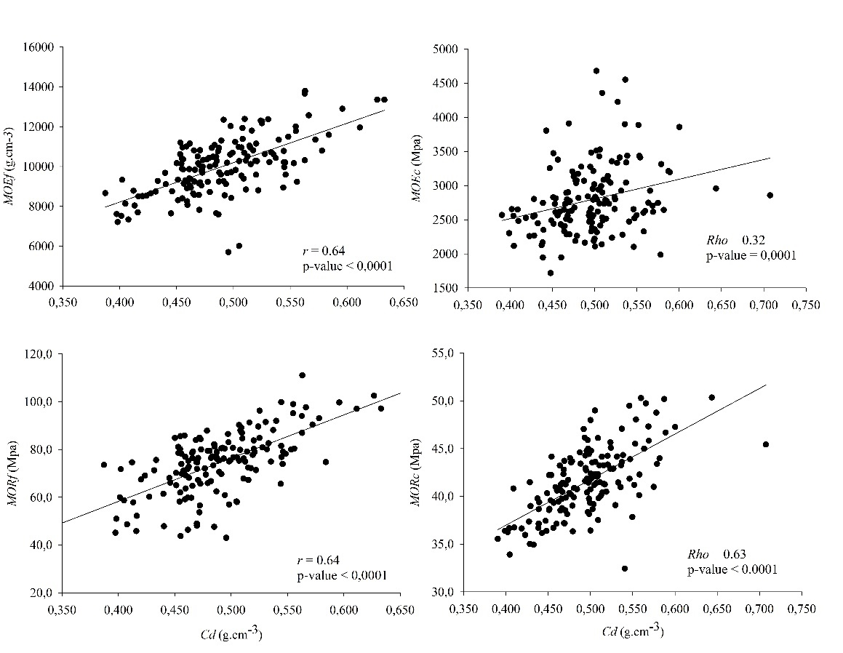
Figure S2. Scatter plots between Cd values versus mechanical parameters for all thinning schemes evaluated.

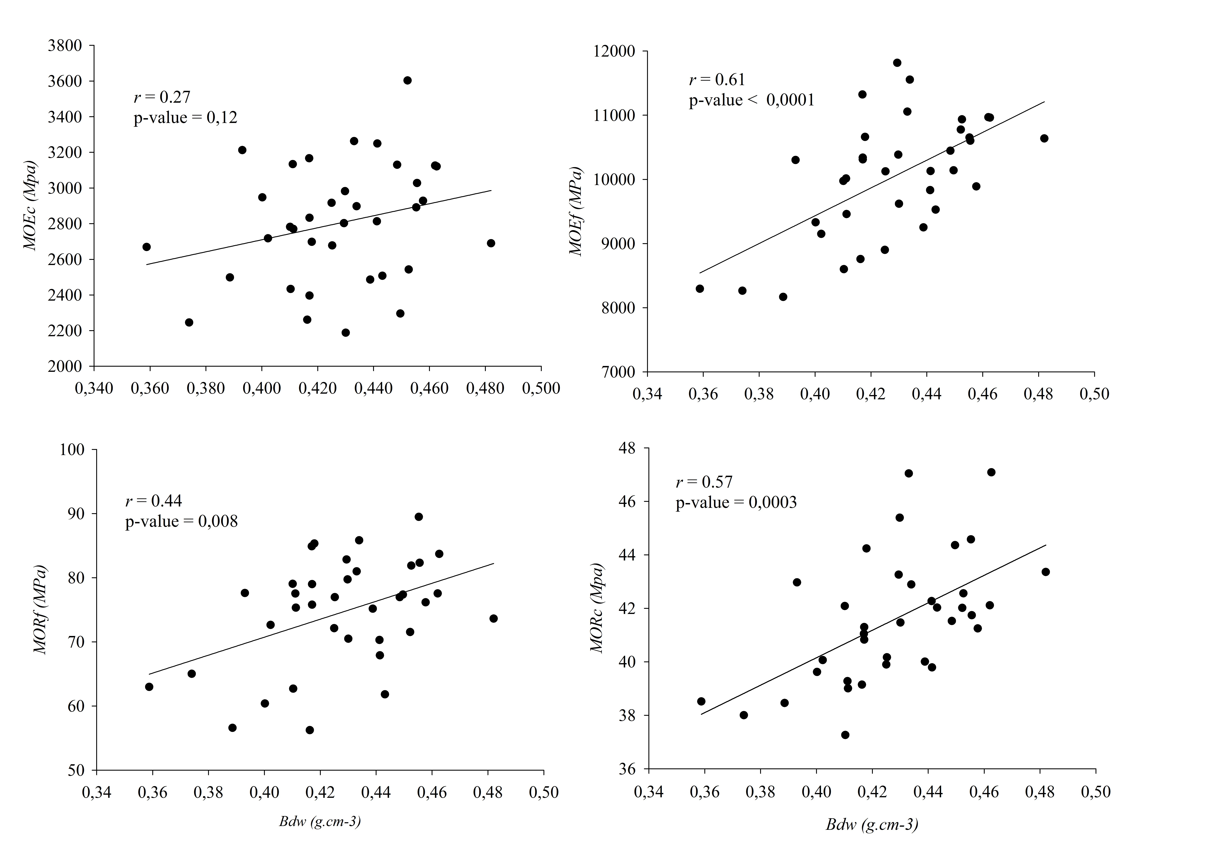
Figure S3. Scatter plots between Bdw values versus mechanical parameters for all thinning schemes evaluated.
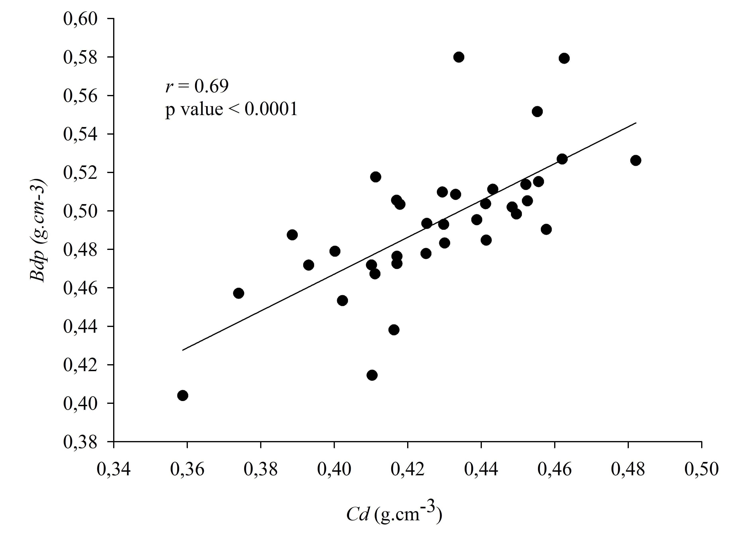
Figure S4. Scatter plot between the values of Bdw and Cd for all the thinning schemes evaluated.

