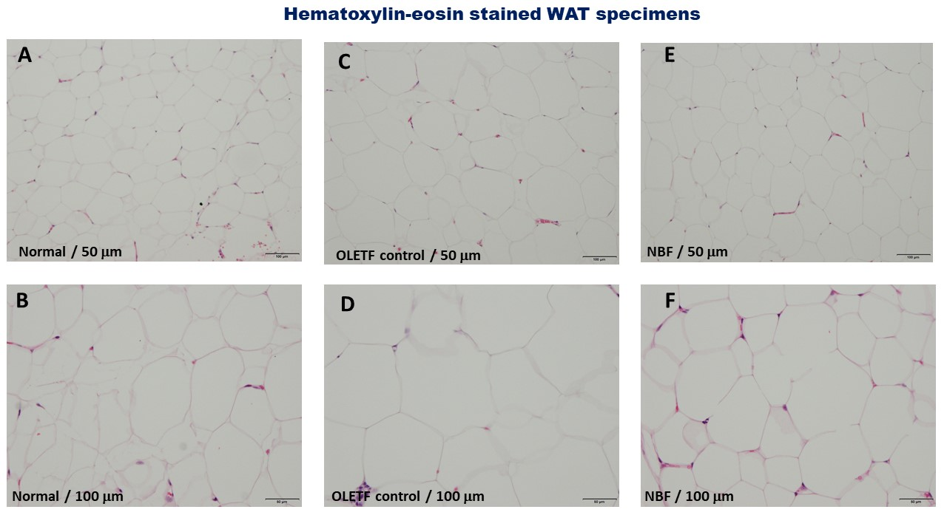
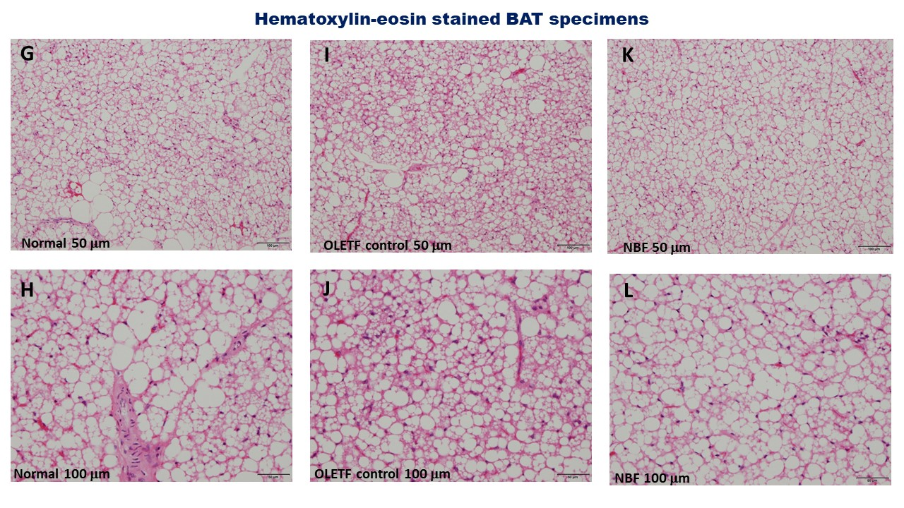
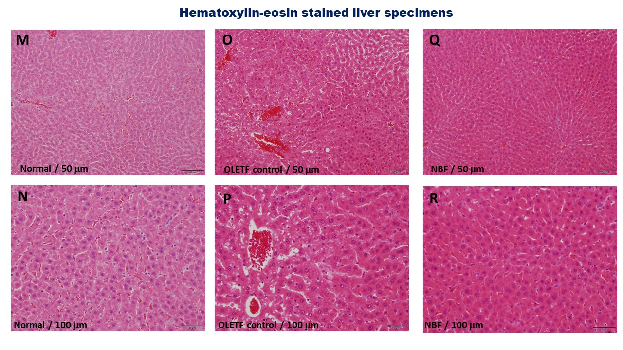
Supplementary Fig. 1: Histopathologic changes in rat white/brown adipose tissue and liver specimens following NBF2 treatment
- Legend: OLETF, Otsuka Long Evans Tokushima Fatty rats; LETO, Long Evans Tokushima Otsuka rat; BAT, brown adipose tissue; WAT, white adipose tissue; LIV, liver tissue. Figure 5 shows numerous large adipocytes observed in white adipose tissue (WAT) specimen from OLETF control rat than that of NBF2-treated rat and normal rats (5C-D), and higher number of large adipocytes observed in brown adipose tissue (BAT) specimen from normal and NBF2-treated OLETF) rats (5G-H; 5K-L). On the other hand, there is presence of images of blood sinusoids dilation, hepatic steatosis with lipid droplets in liver specimen from OLETF control rat (5O-P), reduced or absence of images of blood sinusoids dilation, hepatic steatosis in liver specimens from NBF2-treated OLETF and normal rats (5Q-R,5M-N).

