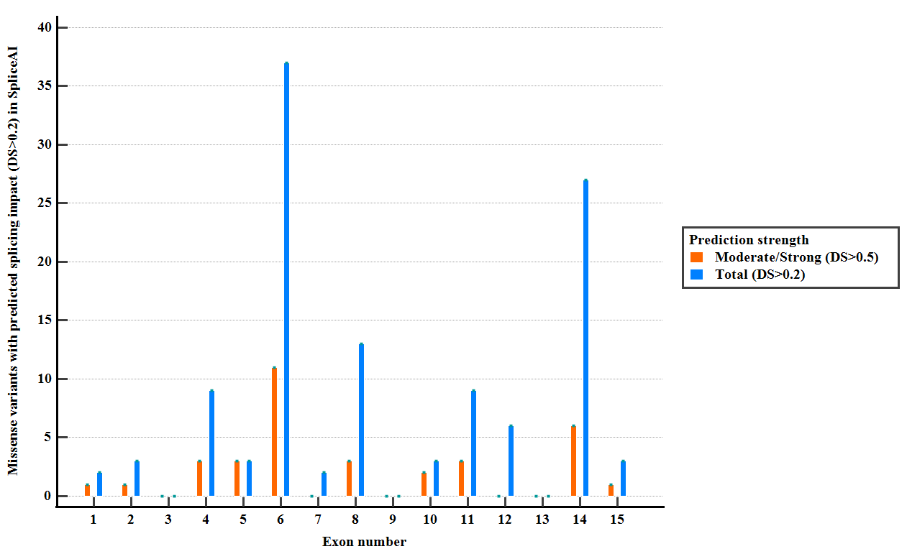

**Supp. Figure 1.** Distribution of reported *PMS2* missense variants (ClinVar, LOVD) with predicted splicing impact (DS > 0.2) in SpliceAI

**Exon 2**

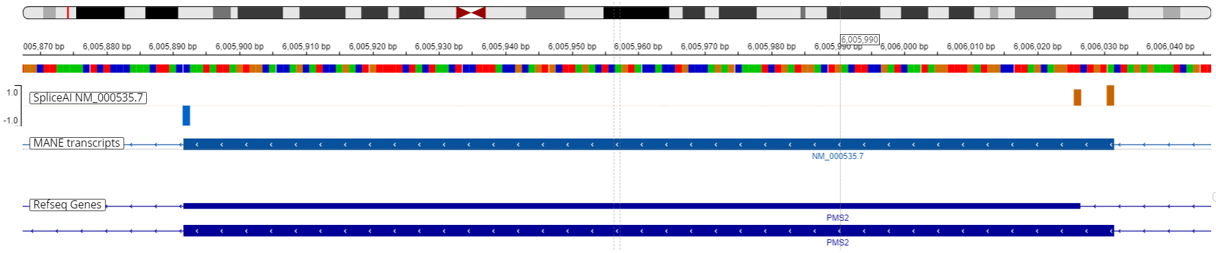

**Exon 5**

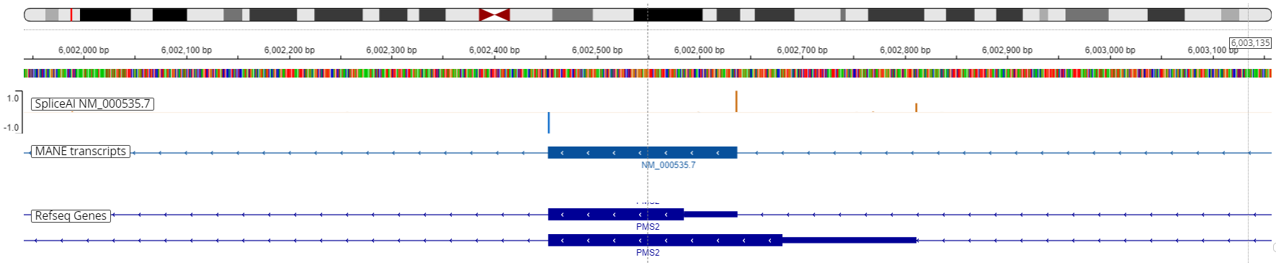

**Exon 6**

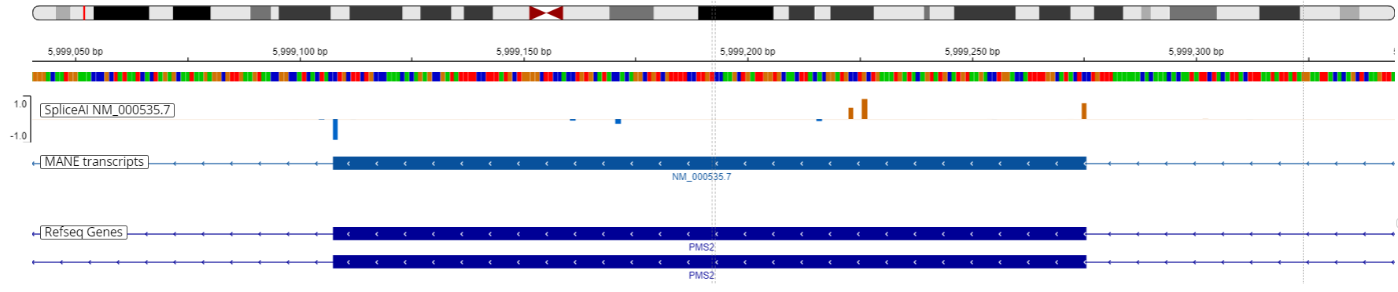

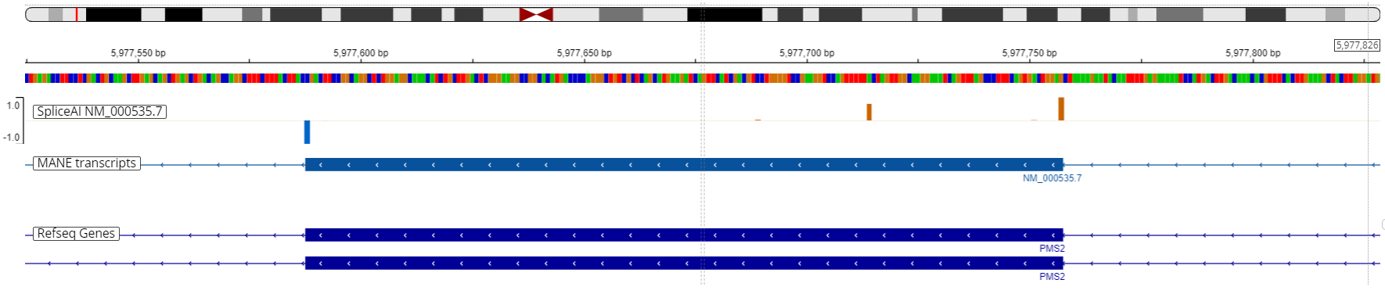**Exon 14**

**Supp. Figure 2.** SpliceAI-visual predictions (IGV interface, MobiDetails) for *PMS2* wild type sequence. Canonical and cryptic splice sites are depicted as vertical bars: blue bars denote donor splice sites, orange bars denote acceptor splice sites.

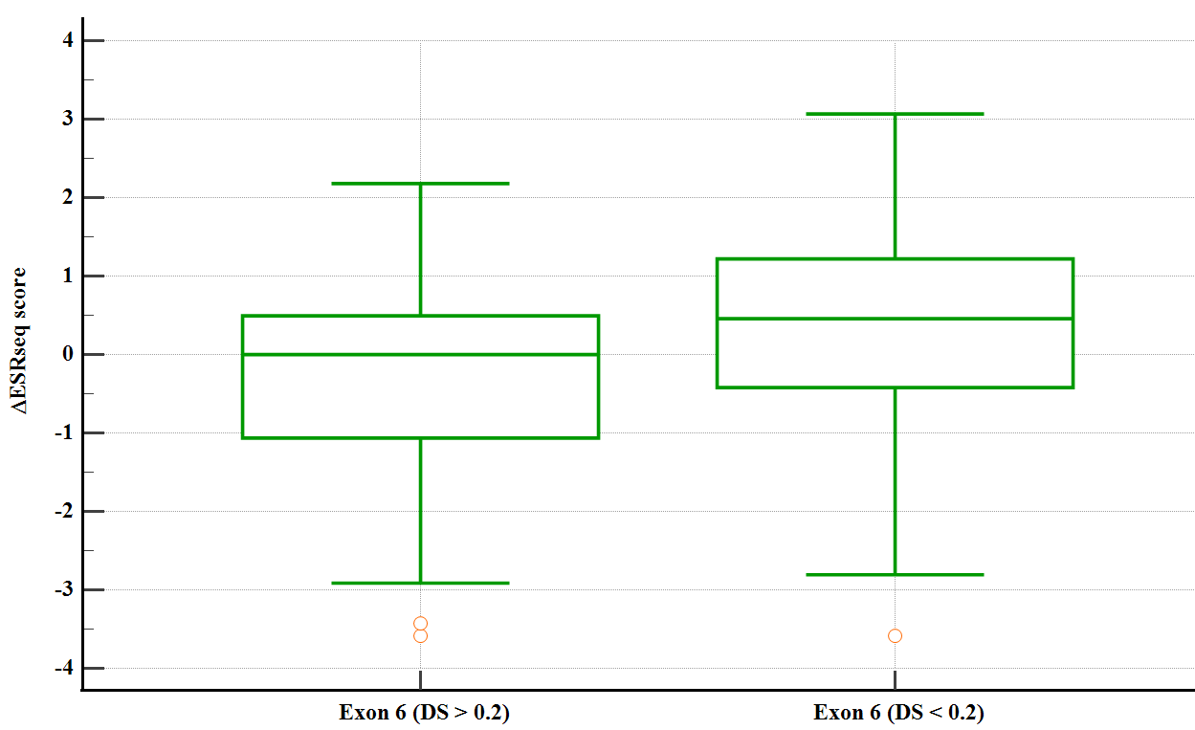

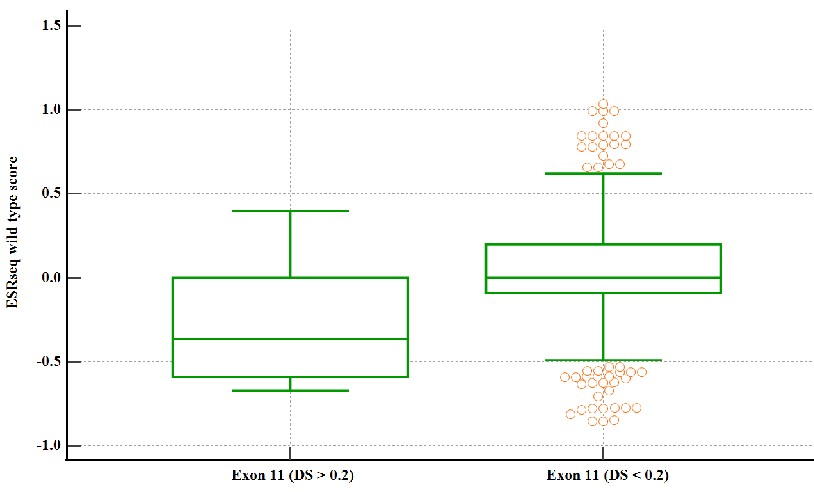

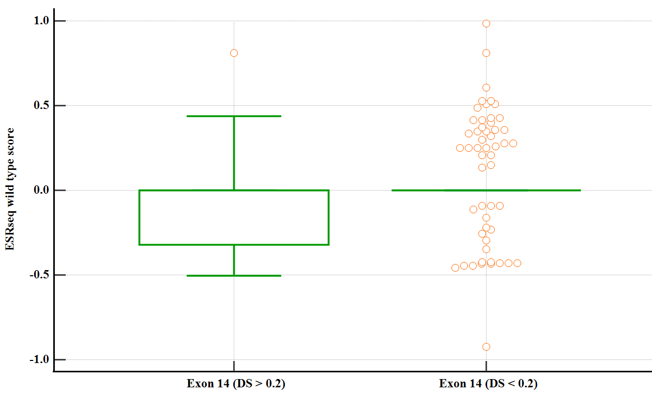

**Supp. Figure 3.** Wild-type ESRseq and ΔESRseq scores comparison between predicted splicing variants (DS > 0.2) and variants with no predicted splicing impact (DS < 0.2) in exons 6, 11 and 14 with significant difference between splicing and non-splicing variant-associated ESRseq or ΔESRseq scores

**Supp. Table 1.** *PMS2* short intronic variants (< 50 bp) with predicted splicing impact (SpliceAI and SpliceAI-visual). AG – acceptor gain, AL – acceptor loss, DG – donor gain, DL – donor loss, DS – delta score

|  |  |  |  |  |  |  |  |  |
| --- | --- | --- | --- | --- | --- | --- | --- | --- |
| Variant nomenclature | Clinical significance | SpliceAI-visual | SpliceAI-50nt (DS) | | | | Functional data | |
| **AG** | **AL** | **DG** | **DL** | |  |
| NM_000535.7:c.164-9_178delinsGATCC | Conflicting | Acceptor loss, novel acceptor site | 0.98 | 1 | 0 | 0 | | No |
| NM_000535.7:c.251-6_251-3del | VUS | Acceptor loss | 0 | 0.72 | 0 | 0 | | No |
| NM_000535.7:c.251-11CT[2] | Conflicting | Acceptor loss | 0 | 0.36 | 0 | 0 | | Yes |
| NM_000535.7:c.251-15dup | LB | Acceptor gain | 0.12 | 0.01 | 0 | 0 | | No |
| NM_000535.7:c.354-18_354-15dup | LB | Cryptic acceptor site | 0 | 0.01 | 0 | 0 | | No |
| NM_000535.7:c.538-5_538-4del | LB | Acceptor loss | 0 | 0.28 | 0.01 | 0 | | No |
| NM_000535.7:c.538-12dup | Conflicting | Acceptor gain | 0.12 | 0 | 0 | 0 | | No |
| NM_000535.7:c.706-2dup | Conflicting | Acceptor loss | 0.02 | 0.28 | 0 | 0 | | No |
| NM_000535.7:c.706-4_706-3delinsA | LB | Acceptor loss | 0.01 | 0.32 | 0 | 0 | | No |
| NM_000535.7:c.706-10_706-4del | VUS | Acceptor loss | 0.01 | 0.1 | 0 | 0 | | No |
| NM_000535.7:c.1145-31_1145-13del | VUS | Acceptor loss, novel acceptor site | 0.5 | 0.85 | 0 | 0 | | No |
| NM_000535.7:c.1145-2_1145-1del | VUS | Acceptor loss, cryptic acceptor site | 0.59 | 0.98 | 0 | 0 | | No |
| NM_000535.7:c.1970_2006+9dup | VUS | Novel donor site | 0 | 0 | 0.27 | 0.07 | | No |
| NM_000535.7:c.2007-2_2007-1delinsCA | Conflicting | Cryptic acceptor site | 0.94 | 0.99 | 0 | 0 | | No |

**Supp. Table 2.** *In silico* prediction tools (ESEfinder 3.0, FSplice, MaxEntScan, NetGene2, NNSplice) assessing canonical splice site strength of *PMS2* exons

|  |  |  |  |  |  |  |  |  |  |  |
| --- | --- | --- | --- | --- | --- | --- | --- | --- | --- | --- |
| Exon number | ESEfinder 3.0 | | FSplice | | MaxEntScan | | NetGene2 | | NNSplice | |
| *Donor* | *Acceptor* | *Donor* | *Acceptor* | *Donor* | *Acceptor* | *Donor* | *Acceptor* | *Donor* | *Acceptor* |
| 1 | 11.9703 | - | 10.72 | - | 8.70 | - | 0.81 | - | 0.99 | - |
| 2 | 8.8481 | 7.7962 | 14.92 | 4.97 | 10.47 | 4.33 | 0.83 | 0.44 | 1 | 0.45 |
| 3 | 7.2524 | 0 | 12.4 | 5.42 | 8.07 | 5.91 | 0.90 | 0.19 | 0.99 | 0.71 |
| 4 | 0 | 8.2679 | 0 | 6.80 | 3.13 | 9.15 | 0 | 0.71 | 0.48 | 0.80 |
| 5 | 0 | 0 | 10.86 | 9.25 | 8.04 | 8.59 | 0.69 | 0.20 | 0.8 | 0.68 |
| 6 | 6.7284 | 6.8515 | 8.76 | 7.62 | 6.13 | 9.96 | 0.81 | 0.71 | 0.46 | 0.66 |
| 7 | 0 | 12.5959 | 9.88 | 11.60 | 7.79 | 11.6 | 0 | 0.56 | 0.94 | 1 |
| 8 | 0 | 0 | 9.04 | 0 | 7.64 | 3.54 | 0 | 0 | 0.83 | 0 |
| 9 | 11.1192 | 9.1049 | 15.06 | 9.30 | 10.86 | 9.01 | 0.93 | 0.96 | 1 | 0.98 |
| 10 | 9.6691 | 8.7348 | 14.92 | 11.70 | 10.57 | 10 | 1 | 0.64 | 1 | 0.98 |
| 11 | 7.3820 | 0 | 13.24 | 6.47 | 9.06 | 7.77 | 0.81 | 0 | 0.94 | 0.63 |
| 12 | 0 | 7.4782 | 8.34 | 9.72 | 8.20 | 8.61 | 0.93 | 0.85 | 0.95 | 0.54 |
| 13 | 8.3829 | 10.2591 | 15.62 | 11.75 | 11.01 | 10.75 | 0.99 | 0.96 | 1 | 0.99 |
| 14 | 0 | 9.4881 | 15.62 | 4.88 | 11.78 | 6.62 | 0.94 | 0.23 | 1 | 0.90 |
| 15 | - | 6.7994 | - | 9.30 | - | 8.57 | - | 0.76 | - | 0 |

**A**

**B**

**Supp. Figure 4.** Canonical acceptor (A) and donor (B) splice sites strength determined using splicing prediction tools (ESEfinder 3.0, FSplice, MaxEntScan, NetGene2, NNSplice)

**Supp. Table 3.** Exonic density of SR proteins motifs identified using ESEfinder 3.0 software

|  |  |  |  |  |  |
| --- | --- | --- | --- | --- | --- |
| Exon | SRp55% | SRp40% | SF2/ASF% | SF2/ASF(IgM-BRCA1)% | SC35% |
| 2 | 2.857143 | 5 | 2.142857 | 2.857143 | 2.857143 |
| 3 | 1.149425 | 4.597701 | 1.149425 | 2.298851 | 2.298851 |
| 4 | 1.941748 | 3.883495 | 2.912621 | 6.796117 | 3.883495 |
| 5 | 1.630435 | 6.521739 | 3.804348 | 7.608696 | 3.26087 |
| 6 | 4.166667 | 4.166667 | 2.380952 | 3.571429 | 3.571429 |
| 7 | 2.040816 | 2.040816 | 0 | 2.040816 | 2.040816 |
| 8 | 1 | 3 | 7 | 9 | 2 |
| 9 | 3.529412 | 5.882353 | 7.058824 | 3.529412 | 4.705882 |
| 10 | 1.282051 | 5.769231 | 1.282051 | 1.282051 | 3.205128 |
| 11 | 2.784223 | 4.292343 | 4.408353 | 5.916473 | 3.596288 |
| 12 | 4.166667 | 4.166667 | 3.571429 | 3.571429 | 3.571429 |
| 13 | 0 | 1.980198 | 0.990099 | 1.980198 | 1.980198 |
| 14 | 1.764706 | 4.705882 | 4.117647 | 9.411765 | 4.705882 |

**Supp. Table 4.** Splicing Regulatory Elements (SREs) prediction for *PMS2* exons using ESEfinder 3.0, HExoSplice and HOT-SKIP

|  |  |  |  |  |  |  |  |
| --- | --- | --- | --- | --- | --- | --- | --- |
| Exon | ESEfinder 3.0 | HExoSplice | | | HOT-SKIP | | |
|  | **ESE%** | **ESS%** | **ESE%** | **ESS/ESE*100** | **ESS%** | **ESE%** | **ESS/ESE*100** |
| 2 | 15.71429 | 38.57143 | 17.14286 | 225 | 52.14286 | 81.42857 | 64.03509 |
| 3 | 11.49425 | 0 | 0 | 0 | 52.87356 | 93.10345 | 56.79012 |
| 4 | 19.41748 | 26.21359 | 20.38835 | 128.5714 | 51.45631 | 80.58252 | 63.85542 |
| 5 | 22.82609 | 27.71739 | 26.63043 | 104.0816 | 47.82609 | 93.47826 | 51.16279 |
| 6 | 17.85714 | 40.47619 | 19.64286 | 206.0606 | 67.2619 | 76.19048 | 88.28125 |
| 7 | 8.163265 | 32.65306 | 29.59184 | 110.3448 | 72.44898 | 76.53061 | 94.66667 |
| 8 | 22 | 20 | 24 | 83.33333 | 60 | 72 | 83.33333 |
| 9 | 24.70588 | 27.05882 | 17.64706 | 153.3333 | 60 | 52.94118 | 113.3333 |
| 10 | 12.82051 | 33.33333 | 17.94872 | 185.7143 | 75.64103 | 79.48718 | 95.16129 |
| 11 | 20.99768 | 25.52204 | 27.4942 | 92.827 | 46.2877 | 86.89095 | 53.27103 |
| 12 | 19.04762 | 27.38095 | 30.35714 | 90.19608 | 54.7619 | 85.71429 | 63.88889 |
| 13 | 6.930693 | 28.71287 | 24.75248 | 116 | 70.29703 | 79.20792 | 88.75 |
| 14 | 24.70588 | 18.82353 | 30 | 62.7451 | 39.41176 | 85.88235 | 45.89041 |

**Supp. Table 5.** Exonic distribution of SREs motifs in HExoSplice software in exons with concordant high density of ESEs or ESSs

|  |  |  |  |  |  |
| --- | --- | --- | --- | --- | --- |
| Exon | R2 | Intercept (CI 95%) | p | Slope (CI 95%) | p |
| Exon 5 | 0.1142 | 0.2242 (0.0881;0.3602) | **0.0015** | -0.0023 (-0.0036;-0.0010) | **0.0005** |
| Exon 6 | 0.0067 | -0.1557 (-0.3020;-0.0093) | **0.0373** | 0.0005 (-0.0008;0.0019) | 0.4135 |
| Exon 7 | 0.0244 | 0.0584 (-0.1797;0.2967) | 0.6251 | -0.0024 (-0.0064;0.0015) | 0.2288 |
| Exon 10 | 0.0007 | -0.0917 (-0.2675;0.0840) | 0.3019 | -0.0002 (-0.0020;0.0016) | 0.8135 |
| Exon 11 | 0.0046 | 0.0860 (0.0107;0.1614) | **0.0253** | -0.0001 (-0.0002;0.00004) | 0.1474 |
| Exon 14 | 0.0904 | -0.0972 (-0.2713;0.0768) | 0.2698 | 0.0025 (0.0007;0.0043) | **0.0057** |

**Supp. Table 6.** Exon expression (median read count per base) for *PMS2* gene (ENSG00000122512.14) in Lynch syndrome-related tissues. Data Source: GTEx Analysis Release V8 (dbGaP Accession phs000424.v8.p2)

|  |  |  |  |  |  |  |  |  |  |  |  |  |  |
| --- | --- | --- | --- | --- | --- | --- | --- | --- | --- | --- | --- | --- | --- |
| Exons | Whole blood | Pancreas | Stomach | Bladder | Kidney - Medulla | Prostate | Skin - Sun exposed (lower leg) | Brain - Cortex | Uterus | Colon - Transverse | Colon - Sigmoid | Ovary | Breast - Mamary tissue |
| 1 | 0.069 | 0.012 | 0.017 | 0.029 | 0.038 | 0.021 | 0.052 | 0.035 | 0.027 | 0.023 | 0.025 | 0.028 | 0.034 |
| 2 | 0.031 | 0.047 | 0.074 | 0.143 | 0.103 | 0.088 | 0.216 | 0.142 | 0.121 | 0.106 | 0.106 | 0.125 | 0.144 |
| 3 | 0.035 | 0.057 | 0.096 | 0.204 | 0.119 | 0.117 | 0.278 | 0.186 | 0.163 | 0.131 | 0.137 | 0.159 | 0.180 |
| 4 | 0.033 | 0.052 | 0.087 | 0.152 | 0.133 | 0.111 | 0.257 | 0.182 | 0.148 | 0.118 | 0.124 | 0.150 | 0.177 |
| 5 | 0.038 | 0.060 | 0.097 | 0.174 | 0.130 | 0.128 | 0.273 | 0.185 | 0.165 | 0.133 | 0.141 | 0.161 | 0.183 |
| 6 | 0.042 | 0.061 | 0.105 | 0.189 | 0.162 | 0.131 | 0.293 | 0.221 | 0.167 | 0.139 | 0.149 | 0.177 | 0.189 |
| 7 | 0.038 | 0.055 | 0.104 | 0.171 | 0.150 | 0.125 | 0.251 | 0.206 | 0.166 | 0.128 | 0.134 | 0.153 | 0.168 |
| 8 | 0.042 | 0.062 | 0.108 | 0.187 | 0.159 | 0.143 | 0.268 | 0.237 | 0.172 | 0.138 | 0.144 | 0.166 | 0.184 |
| 9 | 0.044 | 0.062 | 0.108 | 0.165 | 0.155 | 0.158 | 0.302 | 0.255 | 0.169 | 0.138 | 0.155 | 0.187 | 0.198 |
| 10 | 0.050 | 0.070 | 0.122 | 0.210 | 0.235 | 0.192 | 0.363 | 0.264 | 0.192 | 0.154 | 0.174 | 0.212 | 0.220 |
| 11 | 0.077 | 0.094 | 0.160 | 0.294 | 0.310 | 0.254 | 0.465 | 0.385 | 0.270 | 0.217 | 0.244 | 0.275 | 0.286 |
| 12 | 0.051 | 0.060 | 0.103 | 0.191 | 0.206 | 0.179 | 0.296 | 0.219 | 0.168 | 0.136 | 0.155 | 0.162 | 0.180 |
| 13 | 0.094 | 0.093 | 0.162 | 0.356 | 0.394 | 0.301 | 0.438 | 0.351 | 0.258 | 0.213 | 0.243 | 0.262 | 0.277 |
| 14 | 0.098 | 0.092 | 0.169 | 0.307 | 0.296 | 0.296 | 0.448 | 0.357 | 0.275 | 0.220 | 0.24 | 0.269 | 0.272 |
| 15 | 0.042 | 0.044 | 0.071 | 0.134 | 0.138 | 0.134 | 0.212 | 0.170 | 0.110 | 0.095 | 0.103 | 0.106 | 0.133 |

**Supp. Table 7.** *PMS2* alternative RefSeq transcripts available on UCSC genome browser (December 2023)

|  |  |  |  |  |  |  |  |  |  |  |  |  |
| --- | --- | --- | --- | --- | --- | --- | --- | --- | --- | --- | --- | --- |
|  | RefSeq transcript | Splicing | Transcript type | CDS start | Protein | Chromosome | Strand | Start (g.) | End  (g.) | Start (c.) | End (c.) | Total |
| 1 | [NM_001322003.2](https://www.ncbi.nlm.nih.gov/entrez/query.fcgi?cmd=Search&db=Nucleotide&term=NM_001322003.2&doptcmdl=GenBank&tool=genome.ucsc.edu) | Δ2p | splice acceptor shift | exon 5 | [NP_001308932.1](https://www.ncbi.nlm.nih.gov/protein/NP_001308932.1) | 7p22.1 | - | 5970925 | 6009049 | 1 | 5088 | 5088 |
| 2 | [NM_001406903.1](https://www.ncbi.nlm.nih.gov/entrez/query.fcgi?cmd=Search&db=Nucleotide&term=NM_001406903.1&doptcmdl=GenBank&tool=genome.ucsc.edu) | Δ12 | cassette | exon 1 | [NP_001393832.1](https://www.ncbi.nlm.nih.gov/protein/NP_001393832.1) | 7p22.1 | - | 5970925 | 6009049 | 1 | 4822 | 4822 |
| 3 | [NM_001322004.2](https://www.ncbi.nlm.nih.gov/entrez/query.fcgi?cmd=Search&db=Nucleotide&term=NM_001322004.2&doptcmdl=GenBank&tool=genome.ucsc.edu) | Δ2 | cassette | exon 5 | [NP_001308933.1](https://www.ncbi.nlm.nih.gov/protein/NP_001308933.1) | 7p22.1 | - | 5970925 | 6009049 | 1 | 4953 | 4953 |
| 4 | [NM_001322005.2](https://www.ncbi.nlm.nih.gov/entrez/query.fcgi?cmd=Search&db=Nucleotide&term=NM_001322005.2&doptcmdl=GenBank&tool=genome.ucsc.edu) | ▼1q | splice donor shift | exon 5 | [NP_001308934.1](https://www.ncbi.nlm.nih.gov/protein/NP_001308934.1) | 7p22.1 | - | 5970925 | 6009049 | 1 | 5283 | 5283 |
| 5 | [NM_001322006.2](https://www.ncbi.nlm.nih.gov/entrez/query.fcgi?cmd=Search&db=Nucleotide&term=NM_001322006.2&doptcmdl=GenBank&tool=genome.ucsc.edu) | Δ10 | cassette | exon 3 | [NP_001308935.1](https://www.ncbi.nlm.nih.gov/protein/NP_001308935.1) | 7p22.1 | - | 5970925 | 6009049 | 1 | 4937 | 4937 |
| 6 | [NM_001322008.2](https://www.ncbi.nlm.nih.gov/entrez/query.fcgi?cmd=Search&db=Nucleotide&term=NM_001322008.2&doptcmdl=GenBank&tool=genome.ucsc.edu) | Δ2, Δ4 | cassette | exon 3 | [NP_001308937.1](https://www.ncbi.nlm.nih.gov/protein/NP_001308937.1) | 7p22.1 | - | 5970925 | 6009049 | 1 | 4850 | 4850 |
| 7 | [NM_001322008.2](https://www.ncbi.nlm.nih.gov/entrez/query.fcgi?cmd=Search&db=Nucleotide&term=NM_001322008.2&doptcmdl=GenBank&tool=genome.ucsc.edu) | ▼1q, Δ2p, ▼14p | splice donor shift + splice acceptor shift | exon 5 | [NP_001308938.1](https://www.ncbi.nlm.nih.gov/protein/NP_001308938.1) | 7p22.1 | - | 5970925 | 6009049 | 1 | 5311 | 5311 |
| 8 | [NM_001322010.2](https://www.ncbi.nlm.nih.gov/entrez/query.fcgi?cmd=Search&db=Nucleotide&term=NM_001322010.2&doptcmdl=GenBank&tool=genome.ucsc.edu) | Δ2, Δ10 | cassette | exon 5 | [NP_001308939.1](https://www.ncbi.nlm.nih.gov/protein/NP_001308939.1) | 7p22.1 | - | 5970925 | 6009049 | 1 | 4797 | 4797 |
| 9 | [NM_001322011.2](https://www.ncbi.nlm.nih.gov/entrez/query.fcgi?cmd=Search&db=Nucleotide&term=NM_001322011.2&doptcmdl=GenBank&tool=genome.ucsc.edu) | Δ6p | splice acceptor shift | exon 1 | [NP_001308940.1](https://www.ncbi.nlm.nih.gov/protein/NP_001308940.1) | 7p22.1 | - | 5970925 | 6009049 | 1 | 5044 | 5044 |
| 10 | [NM_001322012.2](https://www.ncbi.nlm.nih.gov/entrez/query.fcgi?cmd=Search&db=Nucleotide&term=NM_001322012.2&doptcmdl=GenBank&tool=genome.ucsc.edu) | Δ2p, Δ6p | splice acceptor shift | exon 9 | [NP_001308941.1](https://www.ncbi.nlm.nih.gov/protein/NP_001308941.1) | 7p22.1 | - | 5970925 | 6009049 | 1 | 5039 | 5039 |
| 11 | [NM_001322013.2](https://www.ncbi.nlm.nih.gov/entrez/query.fcgi?cmd=Search&db=Nucleotide&term=NM_001322013.2&doptcmdl=GenBank&tool=genome.ucsc.edu) | Δ2p, Δ6 | splice acceptor shift + cassette | exon 5 | [NP_001308942.1](https://www.ncbi.nlm.nih.gov/protein/NP_001308942.1) | 7p22.1 | - | 5970925 | 6009049 | 1 | 4920 | 4920 |
| 12 | [NM_001322014.2](https://www.ncbi.nlm.nih.gov/entrez/query.fcgi?cmd=Search&db=Nucleotide&term=NM_001322014.2&doptcmdl=GenBank&tool=genome.ucsc.edu) | ▼14p | splice acceptor shift | exon 1 | [NP_001308943.1](https://www.ncbi.nlm.nih.gov/protein/NP_001308943.1) | 7p22.1 | - | 5970925 | 6009049 | 1 | 5126 | 5126 |
| 13 | [NM_001322015.2](https://www.ncbi.nlm.nih.gov/entrez/query.fcgi?cmd=Search&db=Nucleotide&term=NM_001322015.2&doptcmdl=GenBank&tool=genome.ucsc.edu) | Δ2p, ▼5p | splice acceptor shift | exon 5 | [NP_001308944.1](https://www.ncbi.nlm.nih.gov/protein/NP_001308944.1) | 7p22.1 | - | 5970925 | 6009049 | 1 | 5263 | 5263 |
| 14 | [NM_001406866.1](https://www.ncbi.nlm.nih.gov/entrez/query.fcgi?cmd=Search&db=Nucleotide&term=NM_001406866.1&doptcmdl=GenBank&tool=genome.ucsc.edu) | intron 1 inclusion | intron inclusion | exon 1 | [NP_001393795.1](https://www.ncbi.nlm.nih.gov/protein/NP_001393795.1) | 7p22.1 | - | 5970925 | 6009049 | 1 | 5279 | 5279 |
| 15 | [NM_001406868.1](https://www.ncbi.nlm.nih.gov/entrez/query.fcgi?cmd=Search&db=Nucleotide&term=NM_001406868.1&doptcmdl=GenBank&tool=genome.ucsc.edu) |  |  | exon 1 | [NP_001393797.1](https://www.ncbi.nlm.nih.gov/protein/NP_001393797.1) | 7p22.1 | - | 5970925 | 6009049 | 1 | 5117 | 5117 |
| 16 | [NM_001406869.1](https://www.ncbi.nlm.nih.gov/entrez/query.fcgi?cmd=Search&db=Nucleotide&term=NM_001406869.1&doptcmdl=GenBank&tool=genome.ucsc.edu) | Δ6q | splice acceptor shift | exon 1 | [NP_001393798.1](https://www.ncbi.nlm.nih.gov/protein/NP_001393798.1) | 7p22.1 | - | 5970925 | 6009049 | 1 | 4985 | 4985 |
| 17 | [NM_001406870.1](https://www.ncbi.nlm.nih.gov/entrez/query.fcgi?cmd=Search&db=Nucleotide&term=NM_001406870.1&doptcmdl=GenBank&tool=genome.ucsc.edu) | Δ10, ▼14p | cassette + splice acceptor shift | exon 1 | [NP_001393799.1](https://www.ncbi.nlm.nih.gov/protein/NP_001393799.1) | 7p22.1 | - | 5970925 | 6009049 | 1 | 4970 | 4970 |
| 18 | [NM_001406871.1](https://www.ncbi.nlm.nih.gov/entrez/query.fcgi?cmd=Search&db=Nucleotide&term=NM_001406871.1&doptcmdl=GenBank&tool=genome.ucsc.edu) | Δ13_14p | cassette + splice acceptor shift | exon 1 | [NP_001393800.1](https://www.ncbi.nlm.nih.gov/protein/NP_001393800.1) | 7p22.1 | - | 5970925 | 6009049 | 1 | 4949 | 4949 |
| 19 | [NM_001406871.1](https://www.ncbi.nlm.nih.gov/entrez/query.fcgi?cmd=Search&db=Nucleotide&term=NM_001406871.1&doptcmdl=GenBank&tool=genome.ucsc.edu) | Δ12 | cassette | exon 1 | [NP_001393800.1](https://www.ncbi.nlm.nih.gov/protein/NP_001393800.1) | 7p22.1 | - | 5970925 | 6009049 | 1 | 4949 | 4949 |
| 20 | [NM_001406873.1](https://www.ncbi.nlm.nih.gov/entrez/query.fcgi?cmd=Search&db=Nucleotide&term=NM_001406873.1&doptcmdl=GenBank&tool=genome.ucsc.edu) | Δ7_8 | multi-cassette | exon 1 | [NP_001393802.1](https://www.ncbi.nlm.nih.gov/protein/NP_001393802.1) | 7p22.1 | - | 5970925 | 6009049 | 1 | 4895 | 4895 |
| 21 | [NM_001406874.1](https://www.ncbi.nlm.nih.gov/entrez/query.fcgi?cmd=Search&db=Nucleotide&term=NM_001406874.1&doptcmdl=GenBank&tool=genome.ucsc.edu) | Δ6 | cassette | exon 1 | [NP_001393803.1](https://www.ncbi.nlm.nih.gov/protein/NP_001393803.1) | 7p22.1 | - | 5970925 | 6009049 | 1 | 4925 | 4925 |
| 22 | [NM_001406875.1](https://www.ncbi.nlm.nih.gov/entrez/query.fcgi?cmd=Search&db=Nucleotide&term=NM_001406875.1&doptcmdl=GenBank&tool=genome.ucsc.edu) | ▼1q, ▼5p, ▼14p | splice donor shift + splice acceptor shift | exon 5 | [NP_001393804.1](https://www.ncbi.nlm.nih.gov/protein/NP_001393804.1) | 7p22.1 | - | 5970925 | 6009049 | 1 | 5491 | 5491 |
| 23 | [NM_001406876.1](https://www.ncbi.nlm.nih.gov/entrez/query.fcgi?cmd=Search&db=Nucleotide&term=NM_001406876.1&doptcmdl=GenBank&tool=genome.ucsc.edu) | Δ4, ▼14p | cassette + splice acceptor shift | exon 3 | [NP_001393805.1](https://www.ncbi.nlm.nih.gov/protein/NP_001393805.1) | 7p22.1 | - | 5970925 | 6009049 | 1 | 5023 | 5023 |
| 24 | [NM_001406877.1](https://www.ncbi.nlm.nih.gov/entrez/query.fcgi?cmd=Search&db=Nucleotide&term=NM_001406877.1&doptcmdl=GenBank&tool=genome.ucsc.edu) | ▼1q, ▼5p, intron 1 inclusion | splice donor shift + splice acceptor shift + intron inclusion | exon 5 | [NP_001393806.1](https://www.ncbi.nlm.nih.gov/protein/NP_001393806.1) | 7p22.1 | - | 5970925 | 6009049 | 1 | 5625 | 5625 |
| 25 | [NM_001406878.1](https://www.ncbi.nlm.nih.gov/entrez/query.fcgi?cmd=Search&db=Nucleotide&term=NM_001406878.1&doptcmdl=GenBank&tool=genome.ucsc.edu) | ▼5p | splice acceptor shift | exon 5 | [NP_001393807.1](https://www.ncbi.nlm.nih.gov/protein/NP_001393807.1) | 7p22.1 | - | 5970925 | 6009049 | 1 | 5268 | 5268 |
| 26 | [NM_001406879.1](https://www.ncbi.nlm.nih.gov/entrez/query.fcgi?cmd=Search&db=Nucleotide&term=NM_001406879.1&doptcmdl=GenBank&tool=genome.ucsc.edu) | Δ2, ▼5p | cassette + splice acceptor shift | exon 5 | [NP_001393808.1](https://www.ncbi.nlm.nih.gov/protein/NP_001393808.1) | 7p22.1 | - | 5970925 | 6009049 | 1 | 5128 | 5128 |
| 27 | [NM_001406880.1](https://www.ncbi.nlm.nih.gov/entrez/query.fcgi?cmd=Search&db=Nucleotide&term=NM_001406880.1&doptcmdl=GenBank&tool=genome.ucsc.edu) | Δ4q, ▼5p | splice donor shift + splice acceptor shift | exon 5 | [NP_001393809.1](https://www.ncbi.nlm.nih.gov/protein/NP_001393809.1) | 7p22.1 | - | 5970925 | 6009049 | 1 | 5215 | 5215 |
| 28 | [NM_001406881.1](https://www.ncbi.nlm.nih.gov/entrez/query.fcgi?cmd=Search&db=Nucleotide&term=NM_001406881.1&doptcmdl=GenBank&tool=genome.ucsc.edu) | Δ2, Δ4, ▼5p | cassette + splice acceptor shift | exon 5 | [NP_001393810.1](https://www.ncbi.nlm.nih.gov/protein/NP_001393810.1) | 7p22.1 | - | 5970925 | 6009049 | 1 | 5025 | 5025 |
| 29 | [NM_001406882.1](https://www.ncbi.nlm.nih.gov/entrez/query.fcgi?cmd=Search&db=Nucleotide&term=NM_001406882.1&doptcmdl=GenBank&tool=genome.ucsc.edu) | ▼1q, ▼5p | splice donor shift + splice acceptor shift | exon 5 | [NP_001393811.1](https://www.ncbi.nlm.nih.gov/protein/NP_001393811.1) | 7p22.1 | - | 5970925 | 6009049 | 1 | 5458 | 5458 |
| 30 | [NM_001406883.1](https://www.ncbi.nlm.nih.gov/entrez/query.fcgi?cmd=Search&db=Nucleotide&term=NM_001406883.1&doptcmdl=GenBank&tool=genome.ucsc.edu) | Δ2p, Δ4 | splice acceptor shift + cassette | exon 3 | [NP_001393812.1](https://www.ncbi.nlm.nih.gov/protein/NP_001393812.1) | 7p22.1 | - | 5970925 | 6009049 | 1 | 4985 | 4985 |
| 31 | [NM_001406884.1](https://www.ncbi.nlm.nih.gov/entrez/query.fcgi?cmd=Search&db=Nucleotide&term=NM_001406884.1&doptcmdl=GenBank&tool=genome.ucsc.edu) | Δ6, Δ10 | cassette | exon 1 | [NP_001393813.1](https://www.ncbi.nlm.nih.gov/protein/NP_001393813.1) | 7p22.1 | - | 5970925 | 6009049 | 1 | 4769 | 4769 |
| 32 | [NM_001406885.1](https://www.ncbi.nlm.nih.gov/entrez/query.fcgi?cmd=Search&db=Nucleotide&term=NM_001406885.1&doptcmdl=GenBank&tool=genome.ucsc.edu) | Δ4_6p | multi-cassette + splice acceptor shift | exon 1 | [NP_001393814.1](https://www.ncbi.nlm.nih.gov/protein/NP_001393814.1) | 7p22.1 | - | 5970925 | 6009049 | 1 | 4757 | 4757 |
| 33 | [NM_001406886.1](https://www.ncbi.nlm.nih.gov/entrez/query.fcgi?cmd=Search&db=Nucleotide&term=NM_001406886.1&doptcmdl=GenBank&tool=genome.ucsc.edu) | Δ6_8 | multi-cassette | exon 1 | [NP_001393815.1](https://www.ncbi.nlm.nih.gov/protein/NP_001393815.1) | 7p22.1 | - | 5970925 | 6009049 | 1 | 4727 | 4727 |
| 34 | [NM_001406887.1](https://www.ncbi.nlm.nih.gov/entrez/query.fcgi?cmd=Search&db=Nucleotide&term=NM_001406887.1&doptcmdl=GenBank&tool=genome.ucsc.edu) | Δ2p, ▼14p | splice acceptor shift | exon 5 | [NP_001393816.1](https://www.ncbi.nlm.nih.gov/protein/NP_001393816.1) | 7p22.1 | - | 5970925 | 6009049 | 1 | 5121 | 5121 |
| 35 | [NM_001406888.1](https://www.ncbi.nlm.nih.gov/entrez/query.fcgi?cmd=Search&db=Nucleotide&term=NM_001406888.1&doptcmdl=GenBank&tool=genome.ucsc.edu) | Δ4q, ▼14p | splice donor shift + splice acceptor shift | exon 5 | [NP_001393817.1](https://www.ncbi.nlm.nih.gov/protein/NP_001393817.1) | 7p22.1 | - | 5970925 | 6009049 | 1 | 5073 | 5073 |
| 36 | [NM_001406889.1](https://www.ncbi.nlm.nih.gov/entrez/query.fcgi?cmd=Search&db=Nucleotide&term=NM_001406889.1&doptcmdl=GenBank&tool=genome.ucsc.edu) | Δ2p, Δ4q | splice donor shift + splice acceptor shift | exon 5 | [NP_001393818.1](https://www.ncbi.nlm.nih.gov/protein/NP_001393818.1) | 7p22.1 | - | 5970925 | 6009049 | 1 | 5035 | 5035 |
| 37 | [NM_001406890.1](https://www.ncbi.nlm.nih.gov/entrez/query.fcgi?cmd=Search&db=Nucleotide&term=NM_001406890.1&doptcmdl=GenBank&tool=genome.ucsc.edu) | Δ4q | splice donor shift | exon 5 | [NP_001393819.1](https://www.ncbi.nlm.nih.gov/protein/NP_001393819.1) | 7p22.1 | - | 5970925 | 6009049 | 1 | 5083 | 5083 |
| 38 | [NM_001406891.1](https://www.ncbi.nlm.nih.gov/entrez/query.fcgi?cmd=Search&db=Nucleotide&term=NM_001406891.1&doptcmdl=GenBank&tool=genome.ucsc.edu) | intron 1 inclusion | intron inclusion | exon 5 | [NP_001393820.1](https://www.ncbi.nlm.nih.gov/protein/NP_001393820.1) | 7p22.1 | - | 5970925 | 6009049 | 1 | 5260 | 5260 |
| 39 | [NM_001406892.1](https://www.ncbi.nlm.nih.gov/entrez/query.fcgi?cmd=Search&db=Nucleotide&term=NM_001406892.1&doptcmdl=GenBank&tool=genome.ucsc.edu) | Δ4q | splice donor shift | exon 5 | [NP_001393821.1](https://www.ncbi.nlm.nih.gov/protein/NP_001393821.1) | 7p22.1 | - | 5970925 | 6009049 | 1 | 5040 | 5040 |
| 40 | [NM_001406893.1](https://www.ncbi.nlm.nih.gov/entrez/query.fcgi?cmd=Search&db=Nucleotide&term=NM_001406893.1&doptcmdl=GenBank&tool=genome.ucsc.edu) | intron 1 inclusion | intron inclusion | exon 5 | [NP_001393822.1](https://www.ncbi.nlm.nih.gov/protein/NP_001393822.1) | 7p22.1 | - | 5970925 | 6009049 | 1 | 5333 | 5333 |
| 41 | [NM_001406894.1](https://www.ncbi.nlm.nih.gov/entrez/query.fcgi?cmd=Search&db=Nucleotide&term=NM_001406894.1&doptcmdl=GenBank&tool=genome.ucsc.edu) | ▼1q, Δ4q | splice donor shift | exon 5 | [NP_001393823.1](https://www.ncbi.nlm.nih.gov/protein/NP_001393823.1) | 7p22.1 | - | 5970925 | 6009049 | 1 | 5230 | 5230 |
| 42 | [NM_001406895.1](https://www.ncbi.nlm.nih.gov/entrez/query.fcgi?cmd=Search&db=Nucleotide&term=NM_001406895.1&doptcmdl=GenBank&tool=genome.ucsc.edu) | Δ2, Δ4q | cassette + splice donor shift | exon 5 | [NP_001393824.1](https://www.ncbi.nlm.nih.gov/protein/NP_001393824.1) | 7p22.1 | - | 5970925 | 6009049 | 1 | 4900 | 4900 |
| 43 | [NM_001406896.1](https://www.ncbi.nlm.nih.gov/entrez/query.fcgi?cmd=Search&db=Nucleotide&term=NM_001406896.1&doptcmdl=GenBank&tool=genome.ucsc.edu) | Δ3_4 | multi-cassette | exon 5 | [NP_001393825.1](https://www.ncbi.nlm.nih.gov/protein/NP_001393825.1) | 7p22.1 | - | 5970925 | 6009049 | 1 | 4903 | 4903 |
| 44 | [NM_001406897.1](https://www.ncbi.nlm.nih.gov/entrez/query.fcgi?cmd=Search&db=Nucleotide&term=NM_001406897.1&doptcmdl=GenBank&tool=genome.ucsc.edu) | ▼1q, Δ2p | splice donor shift + splice acceptor shift | exon 5 | [NP_001393826.1](https://www.ncbi.nlm.nih.gov/protein/NP_001393826.1) | 7p22.1 | - | 5970925 | 6009049 | 1 | 5278 | 5278 |
| 45 | [NM_001406898.1](https://www.ncbi.nlm.nih.gov/entrez/query.fcgi?cmd=Search&db=Nucleotide&term=NM_001406898.1&doptcmdl=GenBank&tool=genome.ucsc.edu) | ▼1q | splice donor shift | exon 5 | [NP_001393827.1](https://www.ncbi.nlm.nih.gov/protein/NP_001393827.1) | 7p22.1 | - | 5970925 | 6009049 | 1 | 5265 | 5265 |
| 46 | [NM_001406899.1](https://www.ncbi.nlm.nih.gov/entrez/query.fcgi?cmd=Search&db=Nucleotide&term=NM_001406899.1&doptcmdl=GenBank&tool=genome.ucsc.edu) | Δ4q, intron 1 inclusion | splice donor shift + intron inclusion | exon 5 | [NP_001393828.1](https://www.ncbi.nlm.nih.gov/protein/NP_001393828.1) | 7p22.1 | - | 5970925 | 6009049 | 1 | 5226 | 5226 |
| 47 | [NM_001406900.1](https://www.ncbi.nlm.nih.gov/entrez/query.fcgi?cmd=Search&db=Nucleotide&term=NM_001406900.1&doptcmdl=GenBank&tool=genome.ucsc.edu) | Δ4, ▼5p, Δ10 | cassette + splice acceptor shift | exon 5 | [NP_001393829.1](https://www.ncbi.nlm.nih.gov/protein/NP_001393829.1) | 7p22.1 | - | 5970925 | 6009049 | 1 | 5009 | 5009 |
| 48 | [NM_001406901.1](https://www.ncbi.nlm.nih.gov/entrez/query.fcgi?cmd=Search&db=Nucleotide&term=NM_001406901.1&doptcmdl=GenBank&tool=genome.ucsc.edu) | Δ4, Δ10 | cassette | exon 3 | [NP_001393830.1](https://www.ncbi.nlm.nih.gov/protein/NP_001393830.1) | 7p22.1 | - | 5970925 | 6009049 | 1 | 4834 | 4834 |
| 49 | [NM_001406902.1](https://www.ncbi.nlm.nih.gov/entrez/query.fcgi?cmd=Search&db=Nucleotide&term=NM_001406902.1&doptcmdl=GenBank&tool=genome.ucsc.edu) | Δ2p, Δ4, Δ10 | splice acceptor shift + cassette | exon 3 | [NP_001393831.1](https://www.ncbi.nlm.nih.gov/protein/NP_001393831.1) | 7p22.1 | - | 5970925 | 6009049 | 1 | 4829 | 4829 |
| 50 | [NM_001406903.1](https://www.ncbi.nlm.nih.gov/entrez/query.fcgi?cmd=Search&db=Nucleotide&term=NM_001406903.1&doptcmdl=GenBank&tool=genome.ucsc.edu) | Δ4 | cassette | exon 3 | [NP_001393832.1](https://www.ncbi.nlm.nih.gov/protein/NP_001393832.1) | 7p22.1 | - | 5970925 | 6009049 | 1 | 4822 | 4822 |
| 51 | [NM_001406904.1](https://www.ncbi.nlm.nih.gov/entrez/query.fcgi?cmd=Search&db=Nucleotide&term=NM_001406904.1&doptcmdl=GenBank&tool=genome.ucsc.edu) | Δ2p, Δ4q, Δ6q | splice donor shift + splice acceptor shift | exon 5 | [NP_001393833.1](https://www.ncbi.nlm.nih.gov/protein/NP_001393833.1) | 7p22.1 | - | 5970925 | 6009049 | 1 | 4927 | 4927 |
| 52 | [NM_001406905.1](https://www.ncbi.nlm.nih.gov/entrez/query.fcgi?cmd=Search&db=Nucleotide&term=NM_001406905.1&doptcmdl=GenBank&tool=genome.ucsc.edu) | Δ2p, Δ6q | splice donor shift + splice acceptor shift | exon 5 | [NP_001393834.1](https://www.ncbi.nlm.nih.gov/protein/NP_001393834.1) | 7p22.1 | - | 5970925 | 6009049 | 1 | 4980 | 4980 |
| 53 | [NM_001406906.1](https://www.ncbi.nlm.nih.gov/entrez/query.fcgi?cmd=Search&db=Nucleotide&term=NM_001406906.1&doptcmdl=GenBank&tool=genome.ucsc.edu) | Δ2p, Δ10 | splice acceptor shift + cassette | exon 5 | [NP_001393835.1](https://www.ncbi.nlm.nih.gov/protein/NP_001393835.1) | 7p22.1 | - | 5970925 | 6009049 | 1 | 4932 | 4932 |
| 54 | [NM_001406907.1](https://www.ncbi.nlm.nih.gov/entrez/query.fcgi?cmd=Search&db=Nucleotide&term=NM_001406907.1&doptcmdl=GenBank&tool=genome.ucsc.edu) | Δ4q, Δ10 | splice donor shift + cassette | exon 5 | [NP_001393836.1](https://www.ncbi.nlm.nih.gov/protein/NP_001393836.1) | 7p22.1 | - | 5970925 | 6009049 | 1 | 4884 | 4884 |
| 55 | [NM_001406908.1](https://www.ncbi.nlm.nih.gov/entrez/query.fcgi?cmd=Search&db=Nucleotide&term=NM_001406908.1&doptcmdl=GenBank&tool=genome.ucsc.edu) | Δ2p, Δ12 | splice acceptor shift + cassette | exon 5 | [NP_001393837.1](https://www.ncbi.nlm.nih.gov/protein/NP_001393837.1) | 7p22.1 | - | 5970925 | 6009049 | 1 | 4920 | 4920 |
| 56 | [NM_001406909.1](https://www.ncbi.nlm.nih.gov/entrez/query.fcgi?cmd=Search&db=Nucleotide&term=NM_001406909.1&doptcmdl=GenBank&tool=genome.ucsc.edu) | Δ4q, Δ6 | splice donor shift + cassette | exon 5 | [NP_001393838.1](https://www.ncbi.nlm.nih.gov/protein/NP_001393838.1) | 7p22.1 | - | 5970925 | 6009049 | 1 | 4872 | 4872 |
| 57 | [NM_001406910.1](https://www.ncbi.nlm.nih.gov/entrez/query.fcgi?cmd=Search&db=Nucleotide&term=NM_001406910.1&doptcmdl=GenBank&tool=genome.ucsc.edu) | Δ2p, Δ12_14p | splice acceptor shift + cassette | exon 5 | [NP_001393839.1](https://www.ncbi.nlm.nih.gov/protein/NP_001393839.1) | 7p22.1 | - | 5970925 | 6009049 | 1 | 4776 | 4776 |
| 58 | [NM_001406911.1](https://www.ncbi.nlm.nih.gov/entrez/query.fcgi?cmd=Search&db=Nucleotide&term=NM_001406911.1&doptcmdl=GenBank&tool=genome.ucsc.edu) | Δ2, Δ6_8 | multi-cassette | exon 5 | [NP_001393840.1](https://www.ncbi.nlm.nih.gov/protein/NP_001393840.1) | 7p22.1 | - | 5970925 | 6009049 | 1 | 4587 | 4587 |
| 59 | [NM_001406912.1](https://www.ncbi.nlm.nih.gov/entrez/query.fcgi?cmd=Search&db=Nucleotide&term=NM_001406912.1&doptcmdl=GenBank&tool=genome.ucsc.edu) | Δ8_11 | multi-cassette | exon 1 | [NP_001393841.1](https://www.ncbi.nlm.nih.gov/protein/NP_001393841.1) | 7p22.1 | - | 5970925 | 6009049 | 1 | 3890 | 3890 |
| 60 | [NM_000535.7](https://www.ncbi.nlm.nih.gov/entrez/query.fcgi?cmd=Search&db=Nucleotide&term=NM_000535.7&doptcmdl=GenBank&tool=genome.ucsc.edu) |  | MANE Select | exon 1 | [NP_000526.2](https://www.ncbi.nlm.nih.gov/protein/NP_000526.2) | 7p22.1 | - | 5970925 | 6009049 | 1 | 5093 | 5093 |

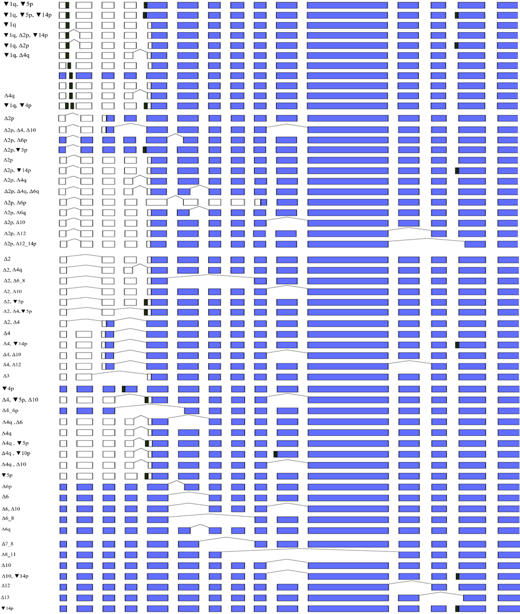

**Supp. Figure 5.** Visual representation of *PMS2* protein coding transcripts reported in RefSeq. Δ – complete or partial (adjacent to canonical splice sites) exonic deletion, ▼ – intronic sequence inclusion (adjacent to canonical splice sites), p – acceptor site shift, q – donor site shift. Black rectangles denote intronic regions included in in the final transcripts. White rectangles denote noncoding regions. Colored rectangles mark the coding regions. 5’-UTRs, 3’-UTRs and MANE Select transcript were not figured.