Supplementary materials
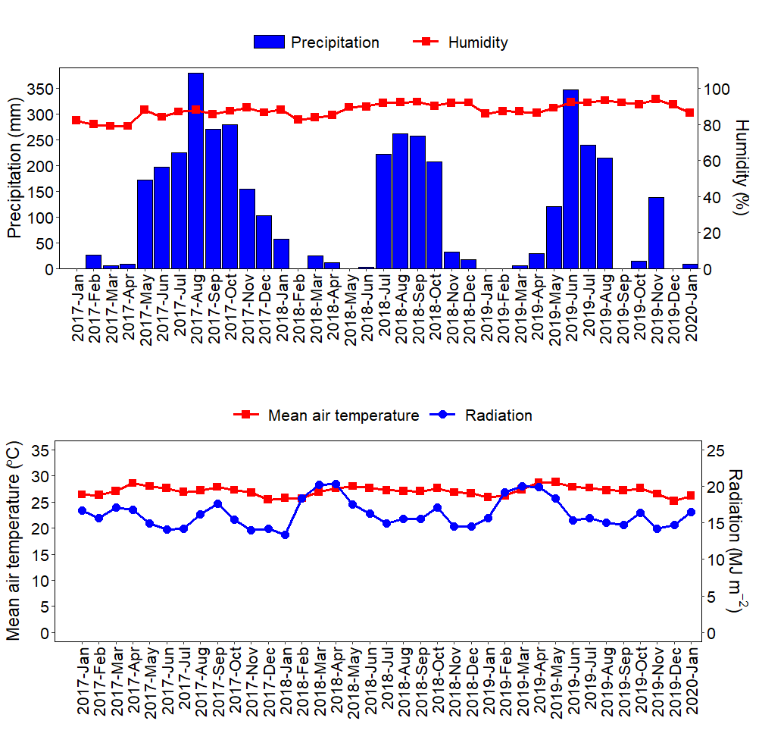
Figure S1. Monthly precipitation, and average humidity, air temperature and solar radiation from January 2017 to January 2020 (Data were recorded by a WS-GP2 automatic weather station, Delta-T Devices Ltd., installed adjacent to the field trial, except from January to August 2017 when data were obtained from the nearest meteorological station, Cang Long Meteorological Station, approximately 29.4 km from the field trial).

Table S1. Functions assigned to the soil indicators.
No. | Soil indicators | Scoring curve | References
1 | Penetration resistance (MPa) | Less is better | [86], [112]
2 | Bulk density (g cm^{–3}) | Less is better | [43], [54], [67], [70] , [105]
3 | Porosity (%) | More is better | [22], [54]
4 | Water stable aggregates (%) | More is better | [54], [70]
5 | Plant available water capacity (m³ m^{–3}) | More is better | [67], [70]
6 | Air capacity (m³ m^{–3}) | More is better | [100]
7 | Relative water capacity (-) | Optimum | [99], [100]
8 | Macropores (m³ m^{–3}) | More is better | [31], [70]
9 | Mesopores (m³ m^{–3}) | More is better | Expert knowledge
10 | Micropores (m³ m^{–3}) | More is better | [70] (40–60% clay)
11 | pH (1:2.5) | Optimum | [54], [61], [67], [70], [105]
12 | EC (1:2.5) (µS cm^{–1}) | Less is better | [32], [67], [105]
13 | Total OC (g kg^{–1}) | More is better | [54], [67], [105]
14 | Total N (g kg^{–1}) | More is better | [32], [70], [105]
15 | Exch. P (mg kg^{–1}) | More is better | [32], [67], [70]
16 | Exch. K (mg kg^{–1}) | More is better | [54], [67], [70], [105]
17 | Exch. Ca (mg kg^{–1}) | More is better | [70]
18 | Exch. Mg (mg kg^{–1}) | More is better | [39], [70]
19 | Exch. Cu (mg kg^{–1}) | More is better | [39], [105]
20 | Exch. Fe (mg kg^{–1}) | More is better | [105]
21 | Exch. Mn (mg kg^{–1}) | More is better | [105]
22 | Exch. Si (mg kg^{–1}) | More is better | [39], [87]
23 | Exch. Zn (mg kg^{–1}) | More is better | [32], [105]

