Supplementary Materials

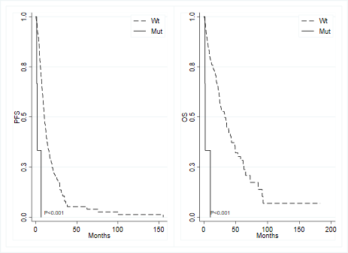
Figure S1 - Kaplan-Meier curves for progression-free survival (left) and overall survival (right) based on the mutational status of CTNBB1 gene.

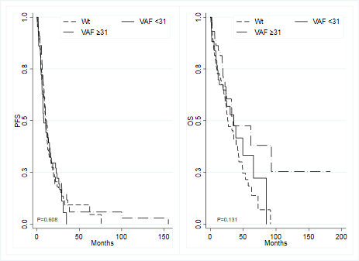
Figure S2 - Kaplan-Meier curves for progression-free survival (left) and overall survival (right) by KRAS mutational status and variant allele frequency (VAF) dichotomized on the median value.

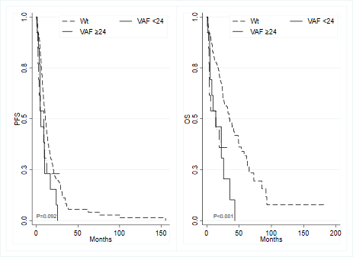
Figure S3 - Kaplan-Meier curves for progression-free survival (left) and overall survival (right) by BRAF mutational status and variant allele frequency (VAF) dichotomized on the median value.

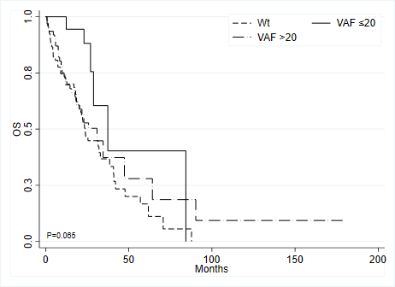
Figure S4 - Kaplan-Meier curves for overall survival (right) by RAS mutational status and variant allele frequency (VAF) >20 vs ≤20

