Dear Dr. Jean Wu,
Thanks for the effective and efficient reviewing of Symmetry. By reviewer’s precious comments, together we (three authors of this paper) revised this version.
All the changes have been colored in red so that it is easily visible to the editors and reviewers.
The following are replies to Reviewers.
Regards,
Peichang

Reply to Reviewer 1:
English language and style
( ) Extensive editing of English language and style required
( ) Moderate English changes required
(x) English language and style are fine/minor spell check required
( ) I don't feel qualified to judge about the English Language and Style
 | Yes | Can be improved | Must be improved | Not applicable
Does the introduction provide sufficient background and include all relevant references? | (x) | ( ) | ( ) | ( )
Is the research design appropriate? | (x) | ( ) | ( ) | ( )
Are the methods adequately described? | (x) | ( ) | ( ) | ( )
Are the results clearly presented? | (x) | ( ) | ( ) | ( )
Are the conclusions supported by the results? | (x) | ( ) | ( ) | ( )
Comments and Suggestions for Authors
(a) The authors succeed in creating aesthetic images with the symmetry of platonic solids. They do this by mapping points on a sphere to a fundamental region and coloring according to a color mapping. This process seems familiar, although I cannot offer a reference. Have the authors previously submitted this work elsewhere? The exposition is clear and results are interesting.
Reply to (a): Thanks for your carefully reading and precious suggestions. We have summated the manuscript to Visual Computer. Visual Computer informed us that this paper beyond the scope of the "Visual Computer” and cannot be recommended for publication in it.

(b)The authors somewhat exaggerate the advantage of their method over (1.3) in the sense that at each iteration, 3 transformations are applied so that the factors they give near 3 5 and 8 should be multiplied by 3 and compared to the group orders 24, 48, 120. But they do have an advantage.
Reply to (b): Thanks for your suggestion. You might be a very attentive person.
To know how fast that points are transformed into fundamental region, we tested the algorithm. We were a little surprised that “On average, each point of S2 will be transformed into △[3;3], △[3;4], △[3;5] within 3.16, 4.70, 7.94 times.” This is just an experimental result. They needn’t be multiplied by 3.
(c) Minor comments:
(1)In the title, symmetries needs a capital S
(2)In the third sentence of the introduction, “artwork” might be better than “arts”
(3)Throughout, the authors are inconsistent about whether references at the end of a sentence come before or after the period.
(4)First sentence of second section “are surrounded alike” is awkward. Perhaps “have similar neighborhoods” or rewrite the sentence.
(5)Last word before Figure 1. “conceptions” should be “concepts”
Reply to (c): Thanks for your tolerance and patience. By your suggestion we have revised the manuscript accordingly.
(1) In the title, “symmetries” has been revised as “Symmetries”.
(2) In the third sentence of the introduction, “arts” has been revised as “artwork”.
(3) We revised the paper so that the references are arranged in a consistent style. But we do not show those changes in red.
(4) “are surrounded alike” has been revised as “have similar neighborhoods”. Thanks for your suggestion.
(5) The last word before Figure 1. “conceptions” has been revised as “concepts”.
Except for (3), all changes have been colored in red in the paper. Thanks for your carefully reviewing.

Reply to Reviewer 2:
English language and style
( ) Extensive editing of English language and style required
( ) Moderate English changes required
(x) English language and style are fine/minor spell check required
( ) I don't feel qualified to judge about the English Language and Style
 | Yes | Can be improved | Must be improved | Not applicable
Does the introduction provide sufficient background and include all relevant references? | (x) | ( ) | ( ) | ( )
Is the research design appropriate? | (x) | ( ) | ( ) | ( )
Are the methods adequately described? | (x) | ( ) | ( ) | ( )
Are the results clearly presented? | (x) | ( ) | ( ) | ( )
Are the conclusions supported by the results? | (x) | ( ) | ( ) | ( )
Comments and Suggestions for Authors
Aesthetic Patterns with symmetries of the Regular
Polyhedron by Peichang Ouyanga, Liying Wangb∗, Tao Yua, Xuan Huanga
(d) This paper develops a method to paste multiple copies of a ‘fundamental region’ to the sphere, the copying dictated by the (tetrahedral, octahedral or icosahedral) symmetry desired of the final product. It is well-written and very clear. The authors have done an outstanding job of explaining an outstanding project.
That said, I have suggestions for minor improvements:
Title: The word “aesthetic” is not defined or indeed, not measurable. Is that word appropriate for the title or even for the text?
Reply to (d):
Thanks for your carefully reviewing. Your understanding of the paper is accurate. Thanks for your encouragement.
Thanks for your precious advices about the accuracy of some words. The authors of this paper are interested in using computer to explore geometric arts. We noticed that many paper used “aesthetic” to describe various beautiful patterns. We have considered using “colorful” or “symmetrical” to replace “aesthetic”. Since one motivation of the submitted paper is using computer to create arts, we think that “aesthetic” might be a more appropriate word, though it is not measurable.
(e) Abstract: The abstract claims that the new method “can be similarly extended to treat regular polytopes in n-dimensional space for n ≥ 4.” The only mentions of this feature in the paper are speculation that the method can be extended to polytopes in section 3 and in the very last two lines of the text in the last section (#4): “Yet (4.1) avoids such order restriction, which can be ex tended to treat regular polytopes of thousands of symmetries. This will be reported in forthcoming papers.” Perhaps this claim in true, but nothing in this paper provides any evidence. The claim should be deleted from this paper and left to the ‘forthcoming papers’.
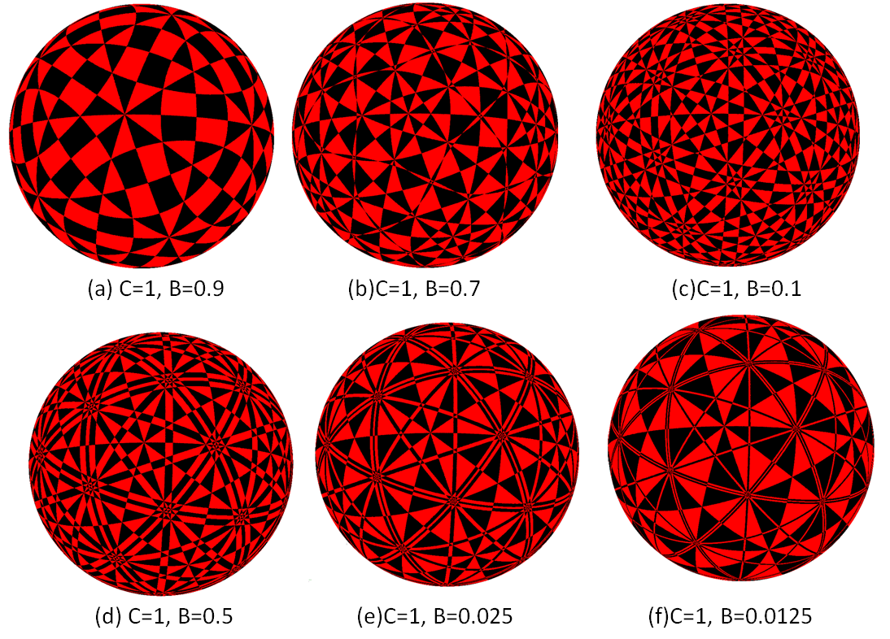
Fig 1. Cross sections of 600-cell in space: $Δ=\{(x,y,z,w)∈R^{4}|A(x^{2}+y^{2}+z^{2})+Bw^{2}=C\}$.
Reply to (e):
Thanks for your nice suggestion. You are right. We have deleted “can be similarly extended to treat regular polytopes in n-dimensional space for n ≥ 4.” in abstract part and “Second, as pointed out in Section 1, (4.1) is not appropriate for the symmetry group of large order. Yet (4.1) avoids such order restriction, which can be extended to treat regular polytopes of thousands of symmetries. This will be reported in forthcoming papers” has been revised as “Second, as pointed out in Section 1, (1.3) is not appropriate for the symmetry group of large order. By contrast, (4.1) avoids such a restriction on symmetry order, so it should be possible to extend the method to treat regular polytopes with thousands of symmetries.”
Actually, part goal of the submitted paper serves as a preparation for regular polytopes in n-dimensional space for n ≥ 4. Recently we have extended the algorithm used in this paper and obtained many interesting projected figures of regular polytopes (see part results shown in Fig 1). A search of Google (https://g.ojson.com/search?q=regular+polytopes&newwindow=1&safe=strict&biw=1920&bih=947&source=lnms&tbm=isch&sa=X&ved=0ahUKEwi0opWYu-jQAhWIqJQKHYfYCM8Q_AUIBigB) will show thousands of nice polytopes. However, there is no one similar to the results shown in Fig 1.We will discuss the detailed method in a special paper.
(f) Section 1. Introduction
Paragraph 2: “This is why nobody considers polynomials to yield regular dodecahedron patterns of great complexity.” ‘Nobody’ is not a term used in scientific papers. You might revise this sentence as follows: “This is why polynomials do not appear to yield regular dodecahedron patterns of great complexity.”
Reply to (f): Thanks for patient teaching. We have revised the sentence as” This is why polynomials do not appear to yield regular dodecahedron patterns of great complexity”.
(g) Equation (1.3): Define sigma.
Reply to (g): Sorry, can you tell us that what is the meaning of “Define sigma”? We are willing to change it.
(h) Paragraph 3: Replace “According to” with “Following”.
Reply to (h): Thanks for the suggestion. We have revised “According to” as “Following”.
(i) Paragraph 4: “Although (1.3) is easy to construct and theoretically feasible for any finite group, this strategy is not appropriate for the symmetry group of large order.” But, in the prior paragraph, “Reiter successfully realized the dodecahedron attractor that possesses complex symmetries [20].” Is there a contradiction here?
Reply to (i): Thanks for the carefully reviewing.
(1.3) is just theoretically feasible for any finite group. In practice the effect is not good for the group of large order. For example, chaotic attractors with dodecahedral symmetry (of order 120) generated by (1.3) have many bad noise (see Fig 2). You can image that it would be worse if the order is larger. For example, (1.3) is not feasible for 600-cell whose order is 14400.
So under this meaning it is not contradictory.
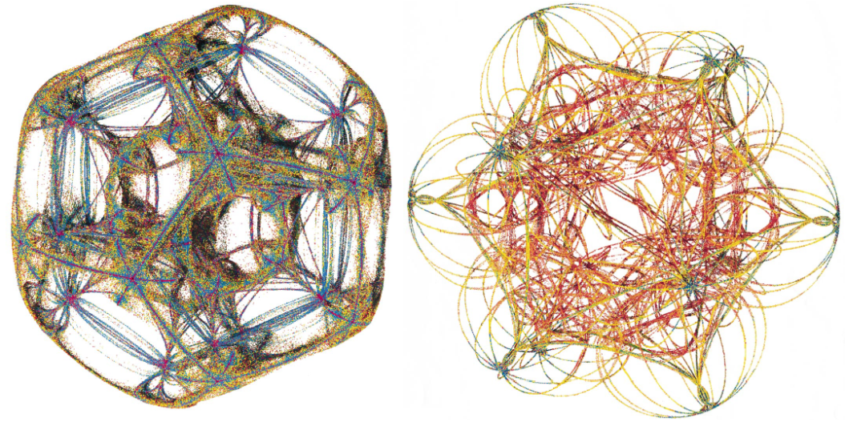
Fig 2. Chaotic attractors with dodecahedral symmetry generated by mapping (1.3).
(j) Paragraph 5: “Noise” instead of “noises”.
Reply to (j): Thanks for your advice. We have changed “noises” as “noise”.
(k) Also: “For example, regular dodecahedron attractors of 120 symmetries generated by (1.3) [20] are not as beautiful as images shown in [19].” Beauty is a nonscientific judgment. Can the authors measure the “beauty” cited here? If not, perhaps this comment should be deleted. Likewise, what is a “visually interesting attractor”?How do you define or measure "visual interesting"?
Reply to (k): Thanks for your helpful suggestions.
In the revised version, we have deleted “For example, regular dodecahedron attractors of 120 symmetries generated by (1.3) [20] are not as beautiful as images shown in [19].”
We usually use “beauty” or “visually interesting” to depict something, though it is very hard to define their meaning. We use such words to express intuitive feeling. Method (1.3) was proposed by Dumont et al. We cited their comment “finding a visually interesting attractor for this group was most challenging because experiments ran slowly” just to show the drawback of (1.3).
(l) Paragraph 6: “Our method can be similarly extended to treat regular polytopes.” If this paper is to contain this claim, then the paper itself should demonstrate the claim with regular polytopes.
Or, the sentence could be revised:
“It should be possible to extend our method to treat regular polytopes.”
Reply to (l): Thanks for your precious suggestion. We agree with you. In the revised version, we have deleted sentence“Our method can be similarly extended to treat regular polytopes”.
(m) Section 2
(1)Legend of Figure 1, first sentence: “Given an object O, the symmetry of O is a congruent or isometric transformation.” It should read, “Given an object O, a symmetry of O is a congruent or isometric transformation.”
Reply: Thanks for your advice. We have revised “Given an object O, the symmetry of O is a congruent or isometric transformation.” as “Given an object O, a symmetry of O is a congruent or isometric transformation.”
(2)Second sentence: “The symmetry group G of O comprises all its symmetries. The elements g1, g2, …gn of group Q are called a set of generators . . .” In the text, why is the symbol for the first G different from the symbol for the second G? (I cannot copy those symbols into my text here.)
Reply: You are a very careful reviewer. In the revised version we have used consistent symbols. Thank you.
(3) Case [3.3]. Perhaps the authors could add the word “tetrahedral”?
Case [3.4]. Perhaps the authors could add the word “octhedral”?
Case [3.5]. Perhaps the authors could add the word “icosahedral”?
Reply: We think it is a nice suggestion. In the revised paper we have changed the text accordingly.
(n) Section 3
Lemma 3.1: Perhaps the authors would be willing to revise
“. . . be the reflection associated with Π. Assume P0 = (x0; y0; z0)T ∈”
to ”. . . be the reflection R associated with plane Π. Assume point P0 = (x0; y0; z0) . . . ” and perhaps the authors would be willing to do so throughout the rest of the paper. (The authors already do so in many places.) Likewise, please do the same for the D’s in the algorithm.
Reply to (n): Thanks for your advices. We have added “R” in the revised paper.
Sorry, can you tell me which your meaning about “D’s”? We are willing to change it.
(o) Last sentence: Please revise from
“This means that this fast algorithm can be extended to treat regular polytopes that have thousands of symmetries.” to “This means that it should be possible to extend this fast algorithm to treat regular polytopes with thousands of symmetries.”
Reply to (o):
Thanks for the suggestion. In the revised version we have revised “This means that this fast algorithm can be extended to treat regular polytopes that have thousands of symmetries” as “This means that it should be possible to extend this fast algorithm to treat regular polytopes with thousands of symmetries.”
(p) Section 4
“(4.1) has following outstanding features. First, to create symmetrical patterns, one
needs to construct mappings that meet certain requirements. [12, 14, 15, 13, 17, 18, 19,
20, 21] However . . .” The punctuation with regard to the citations needs to be fixed, and it should read, “has the following . . . “

The authors write, “Second, as pointed out in Section 1, (1.3) is not appropriate for the symmetry group of large order. Yet (4.1) avoids such order restriction, which can be extended to treat regular polytopes of thousands of symmetries. This will be reported in forthcoming papers.”
Perhaps the authors could revise to read as follows:
“Second, as pointed out in Section 1, (1.3) is not appropriate for the symmetry group of large order. By contrast, (4.1) avoids such a restriction on symmetry order, so it should be possible to extend the method to treat regular polytopes with thousands of symmetries.”
Reply to (p): English is not our mother tongue. Thanks for teaching. Combined with your helpful comments, this passage has been rewritten as
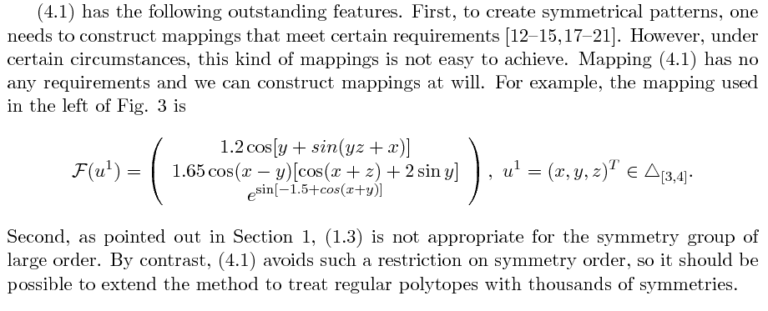
Thanks to the patience of Reviewer 2, for giving so much helpful and constructive suggestion.

