A comparative study of energetics of ferrocenium and ferrocene.
Shawkat Islam and Feng Wang*
Molecular Model Discovery Laboratory, Department of Chemistry and Biotechnology, Faculty of Science, Engineering and Technology, Swinburne University of Technology, Hawthorn, Melbourne, Victoria, 3122, Australia.
E-mail: fwang@swin.edu.au (F. Wang)
Supplementary Materials
Ground electronic state configurations of Fc⁺
The ground electronic state configuration of Fc⁺ in the core regions given by the uB3LYP/m6-31G* model is the same as those of the neutral Fc (D_{5h} and D_{5d}, respectively), indicating that the ionization of one β-electron does not affect the orbital energy ordering of the cation. Like Fc^{[3]}, the current uB3LYP/m6-31G(d) calculations reveal that the first fifteen orbitals (low to high, i.e., MO 1-15) of Fc⁺ are occupied by ten core electrons (i.e. 1s, 2s and 2p) of Fe and followed by the twenty 1s electrons of the 10 carbons in the ligand (Cp). In fact, ionization of a β–electron from Fc affect the configurations of the outer valence as well as inner-valence orbitals (i.e. (7a1')² (3e1'')⁴) for both α and β–electron of Fc⁺. For example, the inner valence space of Fc⁺ exhibits the following change:
The inner valence configurations for eclipsed (D_{5h}) conformer of Fc⁺:
(4a₁')² (3a₂")² (3e₁')⁴ (5a₁')² (4a₂")² (2e₁")⁴ (4e₁')⁴ (2e₂')⁴ (2e₂")⁴ (6a₁')² (5a₂")² ⁻⁻⁻⁻ E-Fc^{[3]} and E-Fc⁺
(7a₁')² (3e₁'')⁴ (5e₁')⁴ ⁻⁻⁻⁻ E-Fc⁺ (X²A₁) (2a)
And the inner valence configurations for staggered (D_{5d}) conformer of Fc⁺:
(4a_{1g})² (3a_{2u})² (3e_{1u})⁴ (5a_{1g})² (4a_{2u})² (2e_{1g})⁴ (4e_{1u})⁴ (2e_{2g})⁴ (2e_{2u})⁴ (6a_{1g})² (5a_{2u})² ⁻⁻⁻⁻ S-Fc^{[3]} and S-Fc⁺
(7a_{1g})² (3e_{1g})⁴ (5e_{1u})⁴ --- S-Fc⁺ (X²A_{1g}) (2b)
Although the α-electrons and β-electrons in Fc⁺ are treated separately in the unrestricted methods, the configurations (i.e., orders of the occupied MOs) of Fc⁺ conformers are the same, so that the complete electronic configurations of Fc⁺ is given by (UB3LYP/m6-31G(d)):
E-Fc⁺ (D_{5h}, X²A₁): (core) ... (3e₂')⁴(3e₂'')⁴(6a₂'')² (8a₁')¹(4e₁'')⁴(6e₁')⁴ (4e₂')⁴(5e₁'')⁰ (3a)
S-Fc⁺ (D_{5d}, X²A_{1g}): (core) ... (3e_{2u})⁴(3e_{2g})⁴ (6a_{2u})²(8a_{1g})¹(4e_{1g})⁴(6e_{1u})⁴(4e_{2g})⁴(5e_{1g})⁰ (3b)

Table S1: Comparision of the calculated IR frequencies for the D_{5h} of ferrocene using the B3LYP/m6-31G(d) and CAM-B3LYP/m6-31G(d) models with experimental measurements.
B3LYP/  m6-31G(d)  υ in cm⁻¹  (intensity in km⋅mol⁻¹) | ∆  = υ_{calc} - υ_{ref} |  | CAM-B3LYP/  m6-31G(d)  υ in cm⁻¹  (intensity in km⋅mol⁻¹) | ∆  = υ_{calc} - υ_{ref} |  |  | Statistical Error^{[35]} |  | Statistical Error^{[36]} |  | Type of Vibration
 |  |  |  |  |  |  | B3LYP/  m6-31G(d) | CAM-B3LYP/  m6-31G(d) | B3LYP/  m6-31G(d) | CAM-B3LYP/  m6-31G(d)
 | Ref^{[35]} | Ref^{[36]} |  |  | Ref^{[35]} | Ref^{[36]}
166 (0.63) |  | -13 | 169 (0.54) |  |  | -10 | MAE (41.50) | MAE(57.63) | MAE(52.90) | MAE(69.50) | Metal-ring (MR)
471 (17.75) | -9 | -7 | 488 (16.09) |  | 8 | 10
488 (22.30) | -8 | -4 | 508 (24.32) |  | 12 | 16 | RMSE_{MR}(8.51) | RMSE_{MR}(10.20) | RMSE_{MR}(8.83) | RMSE_{MR}(12.33)
844(60.31) | 28 | 24 | 860(70.20) |  | 44 | 40 |  |  |  |  | Intra-ring (R)
870 (1.58) | 30 | 15 | 890 (1.69) |  | 50 | 35 | RMSE_{R}(69.25) | RMSE_{R}(88.26) | RMSE_{R}(97.02) | RMSE_{R}(116.71)
1035 (17.04) | 23 | 30 | 1049 (18.32) |  | 37 | 44
1141(20.23) | 29 | 31 | 1165(18.65) |  | 53 | 55 | RMSE(60.12) | RMSE(76.61) | RMSE(81.31) | RMSE(97.88)
1470 (1.55) | 54 | 60 | 1494 (1.76) |  | 78 | 84
3257 (23.63) | 151 | 180 | 3285 (14.27) |  | 179 | 208 | MAPE(3.01) | MAPE(4.39) | MAPE(3.54) | MAPE(4.82)
3268 (2.75) |  | 165 | 3296 (1.25) |  |  | 193
MAE = Mean Absolute Error.
RMSE = Root Mean Square Error.
RMSE_{MR} = Root Mean Square Error of metal-ring (MR) vibration.
RMSE_{R} = Root Mean Square Error of intra-ring (R) vibration.
MAPE = Mean Absolute Percentage Error.

Figure S1: Orbitals levels of Ferrocene and Ferrocenium using uHF/m6-31G(d). The colors red and blue indicate the α and β electrons, respectively, for Fc⁺.
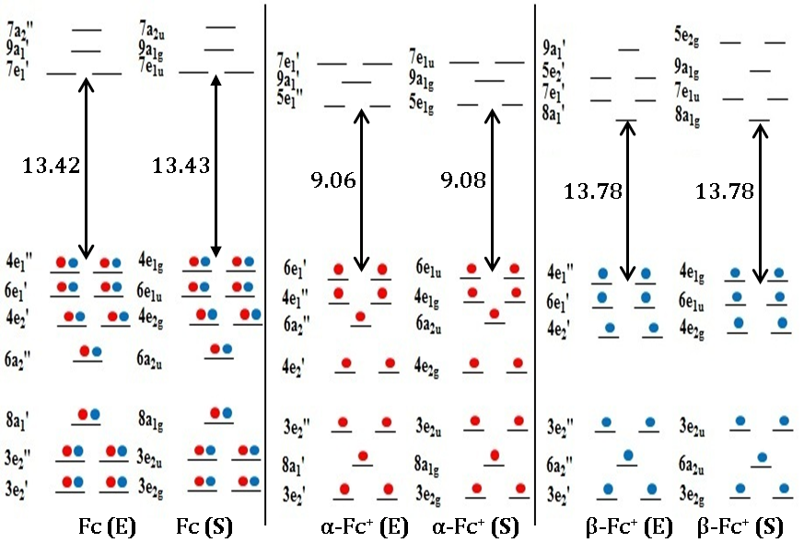

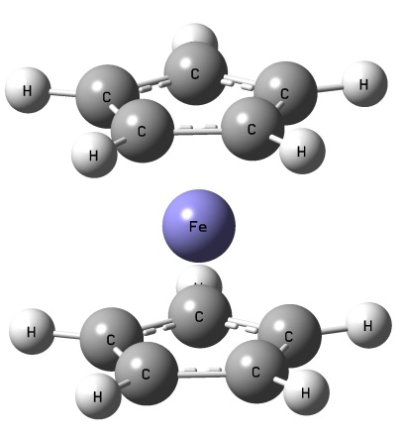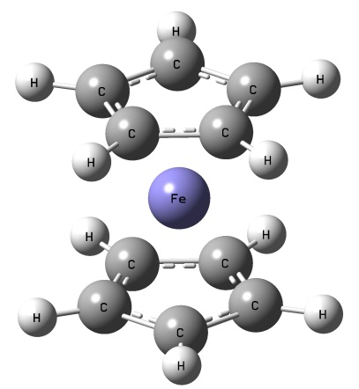

Fc (E) Fc (S)

Figure S2: Comparison of decomposed energies of ΔE_{int} (E-S) of Fc⁺ and Fc, calculated using uB3LYP/TZ2P+ and B3LYP/TZ2P+, respectively.

(a) Differences in principle components of decomposed energy terms

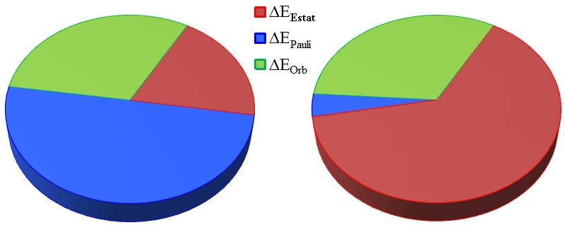

Fc Fc⁺

(b) Differences in total internal energy and steric energy components
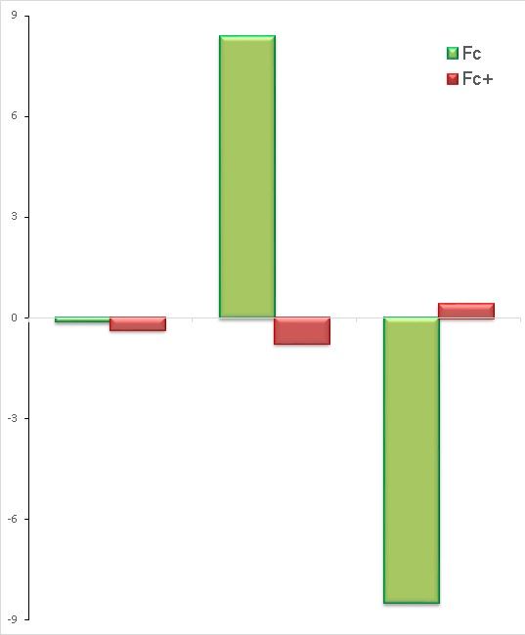
ΔE_{Int} ΔE_{Ster} ΔE_{Orb}

