Supporting Information

Up-Conversion Luminescence Properties of Lanthanide-Gold Hybrid Nanoparticles as Analyzed with Discrete Dipole Approximation
Ruichan Lv ^{1,2,}*, Miao Feng ¹ and Wolfgang J. Parak ^{2,3}

¹ Engineering Research Center of Molecular and Neuro Imaging, Ministry of Education, School of Life Science and Technology, Xidian University, Xi’an, Shanxi 710071, China
² Fachbereich Physik, Philipps Universitat Marburg, 35037 Marburg, Germany
³ CHyN, Universität Hamburg, 22607 Hamburg, Germany

* Correspondence: rclv@xidian.edu.cn

Table S1. The refractive index of NaYF₄. (Re means the real part, and Im means the imaginary part.)

Wavelength (nm) | Re (n) | Im (n) | Wavelength (nm)
450 |  | 1.497505 | 0
500 |  | 1.486588 | 0
550 |  | 1.479867 | 0
600 |  | 1.475527 | 0
650 |  | 1.472612 | 0
700 |  | 1.470586 | 0
750 |  | 1.469138 | 0
800 |  | 1.468075 | 0
850 |  | 1.467279 | 0
900 |  | 1.46667 | 0
950 |  | 1.466197 | 0
1000 |  | 1.465823 | 0

Table S2. The refractive index of SiO₂. (Re means the real part, and Im means the imaginary part.)

Wavelength (nm) | Re (n) | Im (n) | Wavelength (nm) | Re (n) | Im (n)
300 | 1.4878 | 0 | 580 | 1.4587 | 0
305 | 1.4864 | 0 | 585 | 1.4586 | 0
310 | 1.4851 | 0 | 590 | 1.4584 | 0
315 | 1.4839 | 0 | 595 | 1.4582 | 0
320 | 1.4827 | 0 | 600 | 1.458 | 0
325 | 1.4816 | 0 | 605 | 1.4579 | 0
330 | 1.4806 | 0 | 610 | 1.4577 | 0
335 | 1.4796 | 0 | 615 | 1.4576 | 0
340 | 1.4787 | 0 | 620 | 1.4574 | 0
345 | 1.4778 | 0 | 625 | 1.4572 | 0
350 | 1.4769 | 0 | 630 | 1.4571 | 0
355 | 1.4761 | 0 | 635 | 1.457 | 0
360 | 1.4753 | 0 | 640 | 1.4568 | 0
365 | 1.4745 | 0 | 645 | 1.4567 | 0
370 | 1.4738 | 0 | 650 | 1.4565 | 0
375 | 1.4731 | 0 | 655 | 1.4564 | 0
380 | 1.4725 | 0 | 660 | 1.4563 | 0
385 | 1.4719 | 0 | 665 | 1.4561 | 0
390 | 1.4713 | 0 | 670 | 1.456 | 0
395 | 1.4707 | 0 | 675 | 1.4559 | 0
400 | 1.4701 | 0 | 680 | 1.4558 | 0
405 | 1.4696 | 0 | 685 | 1.4556 | 0
410 | 1.4691 | 0 | 690 | 1.4555 | 0
415 | 1.4686 | 0 | 695 | 1.4554 | 0
420 | 1.4681 | 0 | 700 | 1.4553 | 0
425 | 1.4676 | 0 | 710 | 1.4551 | 0
430 | 1.4672 | 0 | 720 | 1.4549 | 0
435 | 1.4668 | 0 | 730 | 1.4546 | 0
440 | 1.4663 | 0 | 740 | 1.4544 | 0
445 | 1.466 | 0 | 750 | 1.4542 | 0
450 | 1.4656 | 0 | 760 | 1.454 | 0
455 | 1.4652 | 0 | 770 | 1.4539 | 0
460 | 1.4648 | 0 | 780 | 1.4537 | 0
465 | 1.4645 | 0 | 790 | 1.4535 | 0
470 | 1.4641 | 0 | 800 | 1.4533 | 0
475 | 1.4638 | 0 | 810 | 1.4531 | 0
480 | 1.4635 | 0 | 820 | 1.453 | 0
485 | 1.4632 | 0 | 830 | 1.4528 | 0
490 | 1.4629 | 0 | 840 | 1.4527 | 0
495 | 1.4626 | 0 | 850 | 1.4525 | 0
500 | 1.4623 | 0 | 860 | 1.4523 | 0
505 | 1.4621 | 0 | 870 | 1.4522 | 0
510 | 1.4618 | 0 | 880 | 1.452 | 0
515 | 1.4615 | 0 | 890 | 1.4519 | 0
520 | 1.4613 | 0 | 900 | 1.4518 | 0
525 | 1.461 | 0 | 910 | 1.4516 | 0
530 | 1.4608 | 0 | 920 | 1.4515 | 0
535 | 1.4606 | 0 | 930 | 1.4513 | 0
540 | 1.4603 | 0 | 940 | 1.4512 | 0
545 | 1.4601 | 0 | 950 | 1.4511 | 0
550 | 1.4599 | 0 | 960 | 1.4509 | 0
555 | 1.4597 | 0 | 970 | 1.4508 | 0
560 | 1.4595 | 0 | 980 | 1.4507 | 0
565 | 1.4593 | 0 | 990 | 1.4505 | 0
570 | 1.4591 | 0 | 1000 | 1.4504 | 0
575 | 1.4589 | 0

Table S3. The refractive index of Au. (Re means the real part, and Im means the imaginary part.)

Wavelength (nm) | Re (n) | Im (n)
331.5 | 1.48 | 1.883
342.5 | 1.48 | 1.871
354.2 | 1.5 | 1.866
367.9 | 1.48 | 1.895
381.5 | 1.46 | 1.933
397.4 | 1.47 | 1.952
413.3 | 1.46 | 1.958
430.5 | 1.45 | 1.948
450.9 | 1.38 | 1.914
471.4 | 1.31 | 1.849
495.9 | 1.04 | 1.833
520.9 | 0.62 | 2.081
548.6 | 0.43 | 2.455
582.1 | 0.29 | 2.863
616.8 | 0.21 | 3.272
659.5 | 0.14 | 3.697
704.5 | 0.13 | 4.103
756 | 0.14 | 4.542
821.1 | 0.16 | 5.083
892 | 0.17 | 5.663
984 | 0.22 | 6.35

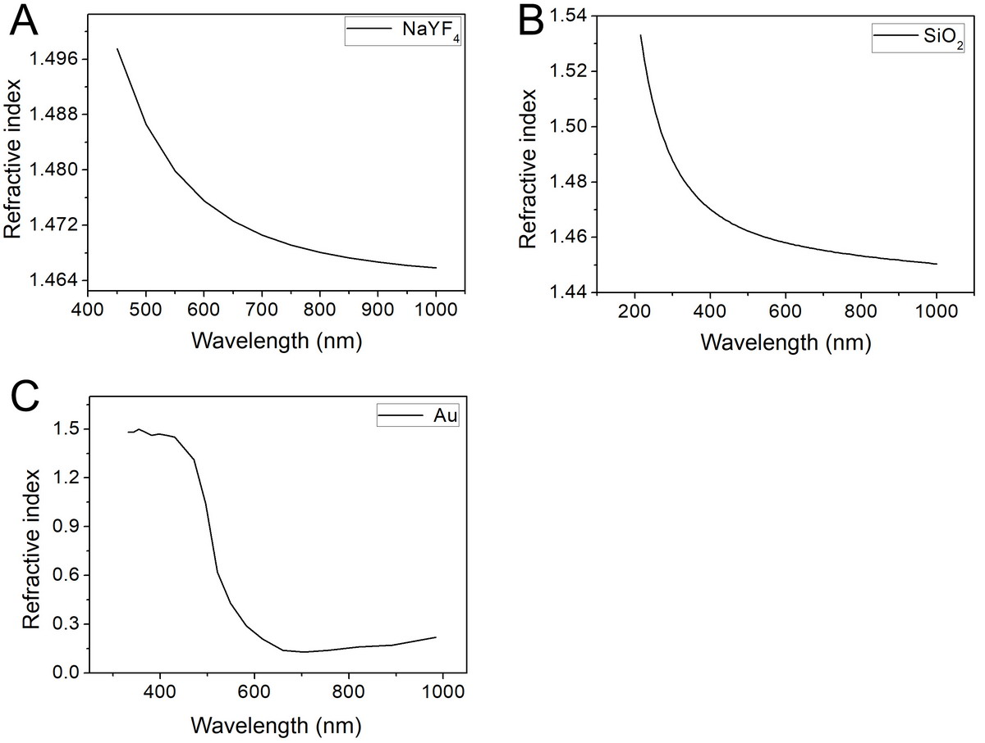

Figure S1. The refractive index of NaYF_{4,} SiO₂, and Au.

