Supplementary materials
Appendix 1: Questionnaire

Respected seniors
Good day. This is a research project entitle “Public Green Space and Mental Health Improving Self-Esteem for Elderly Population in Dhaka”. This research would be conducted in data collected as per the opinion, experience, satisfaction, perception by elderly population about Dhaka City parks. The interview results are anonymous; it will use this information only for research purpose, and keep them strongly confidential.
_________________________________________________________________
Respondent No: ___________ Park Name: __________________
Time: Morning/Afternoon/Evening Date: _____________________
Season: Winter/Summer
_________________________________________________________________

- Please tick one of the following age groups-
- 18-49 years
- 50-59 years
- 60-69 years
- 70 and up
- What is your gender?
- Female
- Male
- What is your occupation?
- Government service
- Private Service
- Business
- Self-employment
- Unemployment
- Other (please write here)______________________________
- What is your approximate average monthly income?
- BDT 0-9,999
- BDT 10,00-19,999
- BDT 20,000-29,999
- BDT 30,000-39,999
- BDT 40,000-49,999
- BDT 50,000 and up
- What is the highest level of education you have completed?
- Primary
- Secondary/higher secondary
- Undergraduate
- Post-graduate
- How far do you live from the park?
- Less than ¼ mile away
- ¼ to ½ mile away
- ½ to ¾ mile away
- ½ to 1 mile away
- More than 1 mile away
- How physically healthy are you?
- Very healthy
- Good healthy
- Somewhat healthy
- Not so Healthy
- Not at all healthy
- How often do you visit the park?
- Everyday
- Around 3 times a week
- Around 6 times a month
- Around 15 times a year
- Once a month
- Never
- How easy is it to access to the park?
- Extremely easy very east
- Very easy easy
- Somewhat easy moderate
- Not so easy difficult
- Not easy at all very difficult
- What types of activity you participate in the park?
- Walking or jogging
- Playing
- Sitting alone for a while
- Meeting the people who are familiar with
- Passing time with family members/friends
- Other (please you can write here)_____________________
- How would you rate the quality of walkway or jogging tracks in the park?
- Very good
- Good
- Moderate
- Poor
- Very poor
- How crowded are the sitting facilities in the park?
- Very crowded
- Crowded
- Neutral
- Spacious
- Very spacious
- How will you evaluate the density of green plants and flower trees?
- Very good
- Good
- Neutral
- Poor
- Very poor
- The park is dedicated to social diversity and inclusiveness-
- Strongly agree
- Agree
- Neutral
- Disagree
- Strongly disagree
- The park positively impacts my health-
- Strongly agree
- Agree
- Neutral
- Disagree
- Strongly disagree
- The park positively impacts my life-
- Strongly agree
- Agree
- Neutral
- Disagree
- Strongly disagree
- How respectful of you is young park visitors?
- Very respectful
- Respectful
- Neutral
- Rude
- Very rude
- How many of your community do you know? (Community refers to the elderly park users who are visiting, having physical exercise, and interacting with each other regularly).
- All of them
- Most of them
- About half of them
- A few of them
- None of them
- How friendly do the members behave within your community?
- Very friendly
- Friendly
- Neutral
- Rude
- Very rude
- How strong is the sense of community in the park?
- Very strong
- Strong
- Neutral
- Weak
- Very weak
- How positively do the neighbors treat your park visit?
- Very positive
- Positive
- Neutral
- Negative
- Very negative
- How noisy do you experience while interacting with your community members?
- Very noisy
- Noisy
- Neutral
- Quiet
- Very quiet
- How safe do you feel in park?
- Very safe
- Safe
- Neutral
- Dangerous
- Very dangerous
- How helpful is the park security staff?
- Very helpful
- Helpful
- Neutral
- Harmful
- Harmful
- Overall, how are the lights maintained in the park?
- Very well-maintained
- Well-maintained
- Neutral
- Poor
- Very poor
- How are the walkways/paths maintained in the park?
- Very well-maintained
- Well-maintained
- Neutral
- Poor
- Very poor
- Overall, how clean is the park?
- Very clean
- Clean
- Neutral
- Dirty
- Very dirty
- In the last 12 months, how many times did you phone the City Corporation Office regarding the park?
- None
- 1 time
- 2 times
- 3 times
- 4 times
- 5 or more times
- How useful are the rules and guidelines for park use set by Dhaka City Corporation?
- Very useful
- Useful
- Neutral
- Not so useful
- Not useful at all
- How are you satisfied with the policies adopted by central government on park management?
- Very satisfied
- Satisfied
- Neutral
- Not so satisfied
- Not satisfied at all
- How would you rate the community recreation programs arranged by government organizations?
- Very good
- Good
- Neutral
- Bad
- Very bad
- How would you rate the community recreation programs arranged by non-government organizations?
- Very good
- Good
- Neutral
- Bad
- Very bad
- In the last 12 months, how many times of community recreation events did you participate? (Community recreation program denotes the activities that refresh mind such as music, drama, cinema, yoga and other trainings, religious festivals, fairs/exhibitions, indoor games, photography show, etc.)
- 5 times
- 4 times
- 3 times
- 2 times
- 1 time
- None
- How much involved have you been in community activities?
- Very often
- Often
- Neutral
- Seldom
- Very seldom
- Should the central government provide more money to improve park facilities?
- Much more money
- More money
- Neutral
- About the same amount of money
- No money at all
- The contribution of a park to social tie and community capital is-
- Extremely satisfied
- Satisfied
- Neutral
- Not so satisfied
- Not satisfied at all

- How do you evaluate about the park’s benefits to your life satisfaction and healthy sleeping?
- Extremely beneficial
- Beneficial
- Neutral
- Not so beneficial
- Not beneficial at all
- How do you opine about park’s role in the decrease of social deviance?
- Extremely satisfied
- Satisfied
- Neutral
- Not so satisfied
- Not satisfied at all
- There is notable contribution to the reduction of surface temperature and air pollution-
- Strongly agree
- Agree
- Neutral
- Not so agree
- Not agree at all

- What are the things that you would most like to improve? Please write here-

Thank you very much for your cooperation and time. If you have any question or comment, you can feel free to contact
At the E-mail: atik73@shu.edu.cn

Appendix 2
Figure 1 presented the triangulation of the association between social service and quality of life (social acceptance or self-esteem). In addition, figures 2 and 3 supports the path model – the association of quality of life for the elderly population in Dhaka with social services and infrastructural measure and safety in parks are statistically significant at 1%. Figure 6.1 showed the same significance and these figures are supporting them. Quality of life (endogenous variable) includes societal acceptance and self-esteem. On the other hand, infrastructural and safety components (exogenous variables) incorporate the availability of toilets, drinking water service, feeling safety, park use rule, quality of walkway and road connectivity. Social facility (exogenous variables) includes user awareness, mental health, cleanliness, recreation programs, social atmosphere young user behavior. Social and infrastructural service in a park has a positive impact on the quality of life for the elderly population.
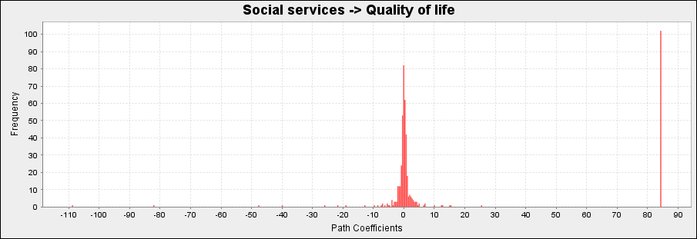
Figure 1: The association between social services and elderly quality of life (mental health and self-esteem)
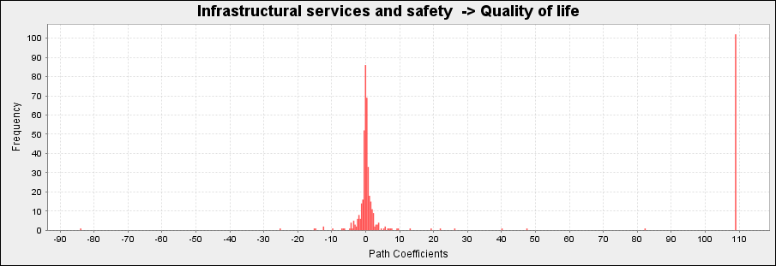
Figure 2: The association between infrastructural services and safety and elderly quality of life (mental health and self-esteem)

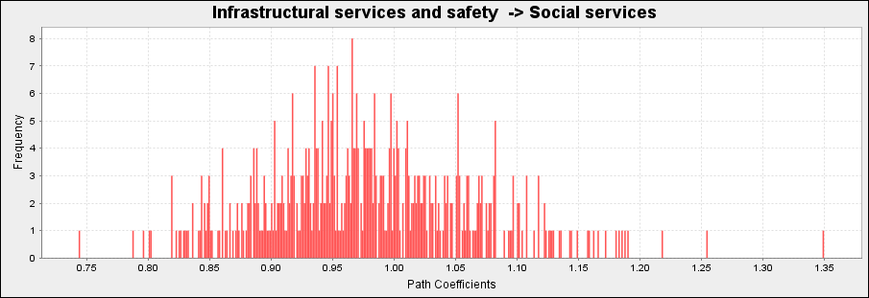
Figure 3: The association between infrastructural services and safety and social services for elderly quality of life (mental health and self-esteem)

