Supplementary material

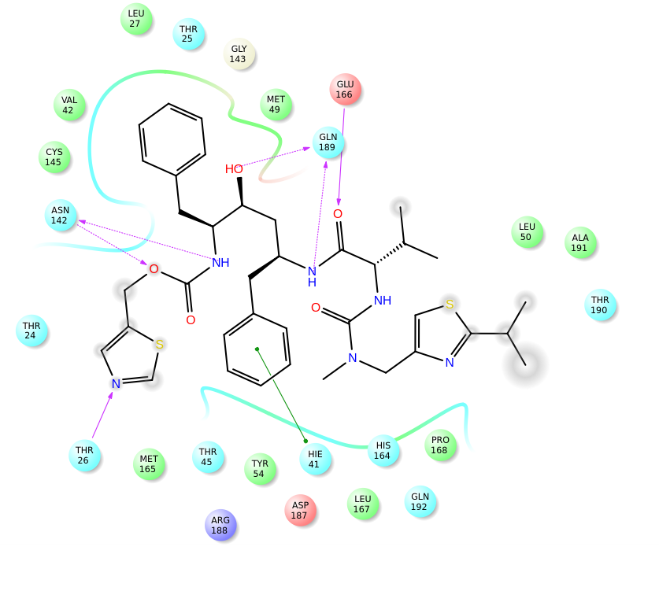
Figure S1: Hydrogen bond interactions between Ritonavir and active site residues

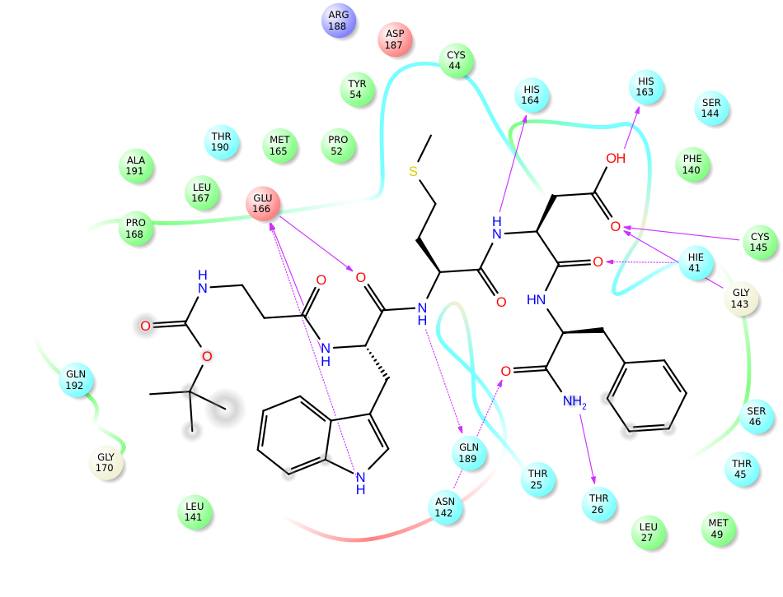
Figure S2: Hydrogen bond interactions between Pentagastrin and active site residues
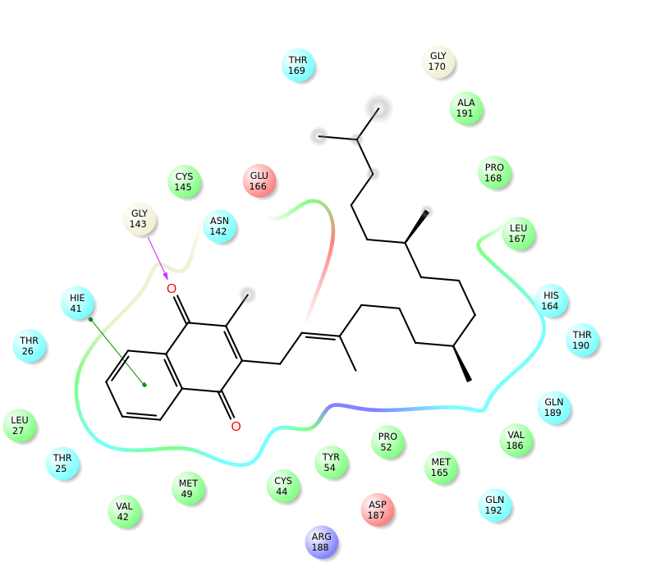
Figure S3: Hydrogen bond interactions between Phytonadione and active site residues

