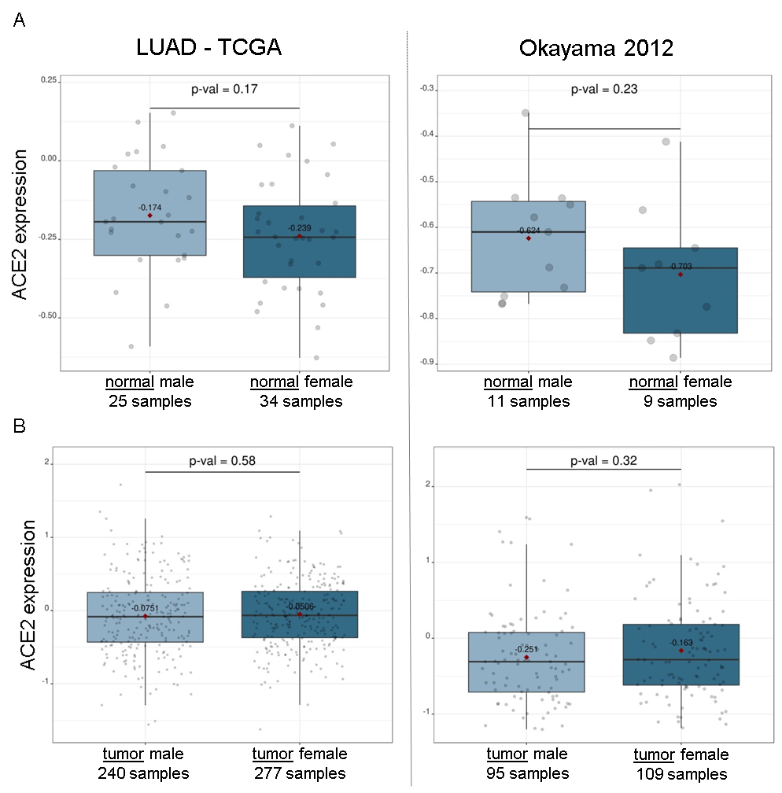

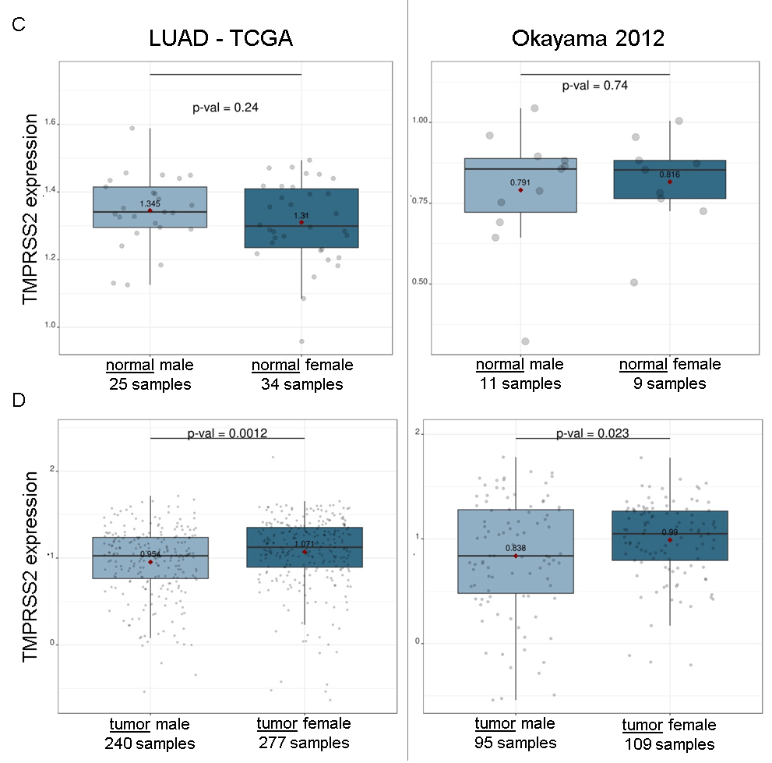
Supplementary figure 1. Sex-dependent expressions of ACE2 and TMPRSS2 in healthy lung and LUAD tissues from TCGA and Okayama 2012 datasets
A, B: Box plots comparing ACE2 gene expression between two groups dichotomized among normal lung (A) or LUAD (B) tissues on sex variable: male vs. female
C, D: Box plots comparing TMPRSS2 gene expression between two groups dichotomized among normal lung (C) or LUAD (D) tissues on sex variable: male vs. female

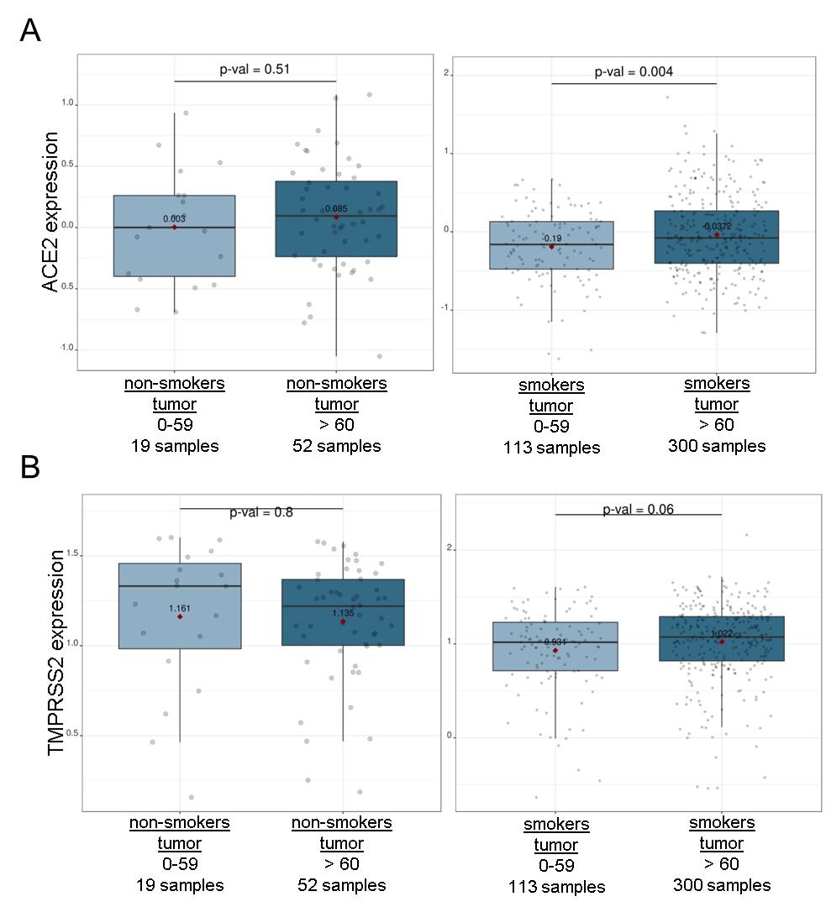
Supplementary figure 2. Combinatorial effects of aging and smoking on ACE2 and TMPRSS2 expressions from LUAD tissues.
A: Box plots comparing ACE2 expression between two groups dichotomized among non-smokers or smokers on single aging variable: 0-59 vs. above 60
B: Box plots comparing TMPRSS2 expression between two groups dichotomized among non-smokers or smokers on single aging variable: 0-59 vs. above 60

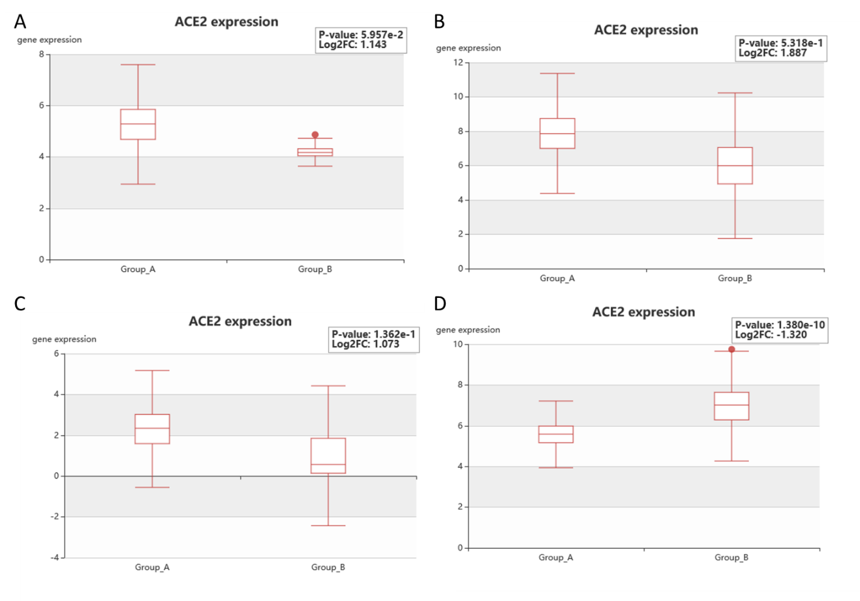
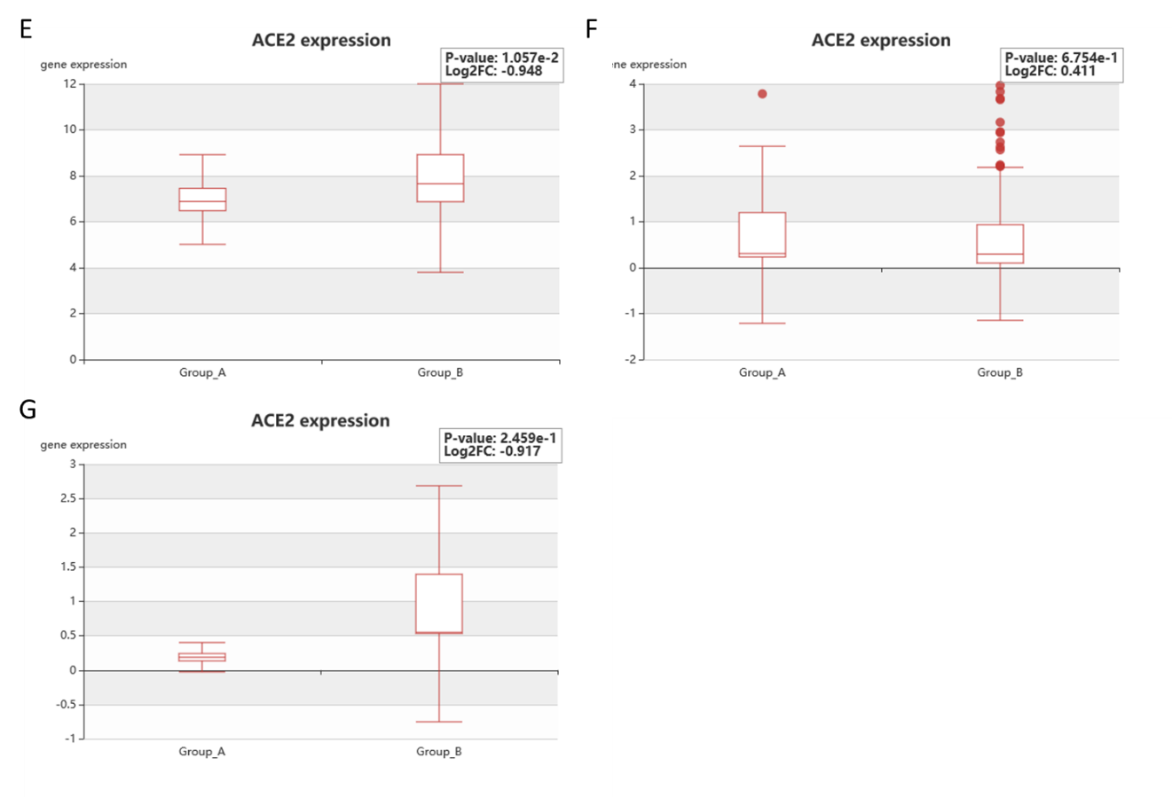
Supplementary figure 3. ACE2 expression on different metastasis sites from GEO and TCGA datasets, which were experimented in HCMDB database
A: Metastasis tumor of breast cancer: lung vs. other metastasis
B: Primary tumor of clear cell renal cell carcinoma: lung vs. lymph node metastasis
C: Metastasis tumor of pancreatic cancer: lung vs. lymph node metastasis
D: Primary tumor of colorectal cancer: no metastasis vs. metastasis (liver and lung)
E: Metastasis tumor of castration resistant prostate cancer: bone vs. lung metastasis
F: Primary tumor of testis: no metastasis vs. metastasis (liver, lung and lymph node)
G: Primary tumor of esophageal carcinoma: brain vs. lung metastasis

