Multi-level convergence of complex traits and the evolution of bioluminescence
Emily S. Lau and Todd H. Oakley

Supporting information

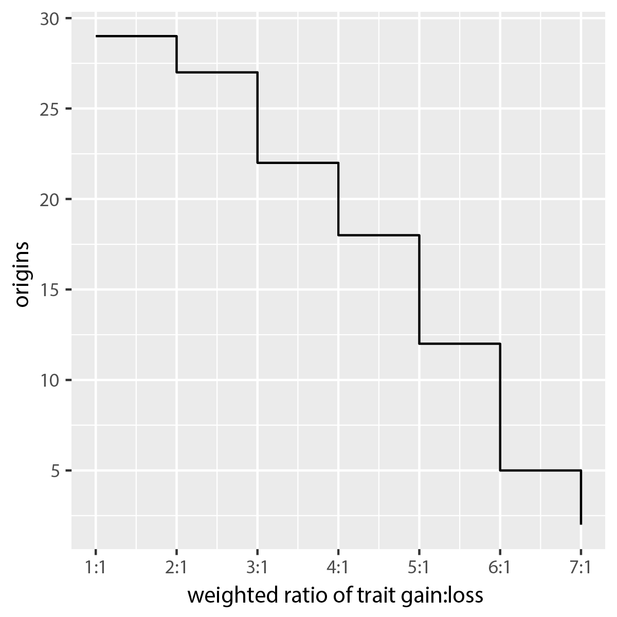

Fig. S1. Using parsimony-based methods in an ancestral reconstruction of bioluminescence in ray-finned fishes produces independent-origin estimates that are dependent on the hypothesized cost of trait gain:loss. As it becomes more costly to gain bioluminescence in ray-finned fishes, bioluminescence is more likely to be lost than gained, and the number of origins decreases. The R package castor’s asr_maximum_parsimony function provided ancestral likelihood calculations for each weighted trait gain to loss ratio and the presented origins for each trait gain:loss represent the most conservative origin estimates (Louca & Doebeli, 2018).

Table S1. Table of bioluminescent taxa with information on type of bioluminescence, known luciferins, and number of origins within a taxonomic group.
Kingdom/Phylum | Taxon as shown on Fig. 2 | Bioluminescence type | Luciferin | No. origins | References
Proteobacteria | Bacteria | bacteriogenic ª | bacterial | 1 | ª Strehler et al. (1954)
Dinoflagellata | Dinoflagellates | autogenic ª | dinoflagellate ^{b} | 1 | ª Herring (1987)  ^{b} Nakamura et al. (1989)
Radiolaria | Polycystine radiolaria | autogenic ª | coelenterazine ^{b} | 1 | ª Haddock et al. (2010)  ^{b} Thomson et al. (1997)
Cercozoa | Phaeodarian radiolaria | autogenic ª | unknown | 1 | ª Herring (1987)
Fungi | Fungi | autogenic ª | fungal ^{b} | 1 ^{c} | ª Herring (1987)  ^{b} Purtov et al. (2015)  ^{c} Purtov et al. (2015)
Porifera | Porifera | autogenic ª | coelenterazine ª | 1 | ª Martini et al. (2020)
Ctenophora | Ctenophora | autogenic ª | coelenterazine ^{b} | 1 | ª Herring (1987)  ^{b} Thomson et al. (1997)
Cnidaria | Anthozoa | autogenic ª | coelenterazine ^{b} | 3 ^{c} | ª Herring (1987)  ^{b} Cormier et al. (1970); Shimomura & Johnson (1979)  ^{c} Bessho-Uehara et al. (2020a)
 | Hydrozoa | autogenic ª | coelenterazine ^{b} | 1 ^{c} | ª Herring (1987)  ^{b} Shimomura & Johnson (1979)  ^{c} Bessho-Uehara et al. (2020a)
 | Scyphozoa | autogenic ª | coelenterazine ^{b} | 2 ^{c} | ª Herring (1987)  ^{b} Shimomura et al. (2001)  ^{c} Bessho-Uehara et al. (2020a)
Chaetognatha | Chaetognatha | autogenic ª | coelenterazine ^{b} | 2 ^{b} | ª Herring (1987)  ^{b} Thuesen et al. (2010)
Mollusca | Decabrachia  Octobrachia | autogenic ª  bacteriogenic ª | coelenterazine ^{b} unknown  bacterial | 10 ^{c} | ª Herring (1987); Robison et al. (2003); Galeazzo et al. (2019)  ^{b} Herring (1987); Robison et al. (2003); Galeazzo et al. (2019)  ^{c} Sanchez et al. (2018)
 | Bivalvia | autogenic ª | coelenterazine ^{b} | 1 | ª Herring (1987)  ^{b} Inouye et al. (2020)
 | Caenogastropoda | autogenic ª | unknown | 1 | ª Herring (1987)
 | Heterobranchia | autogenic ª | unknown  Pholas luciferin ^{b} | 4 | ª Herring (1987)  ^{b} Michelson, (1978); Inouye et al. (2020)
Nemertea | Nemertea | autogenic ª | unknown | 1 | ª Kanda (1939)
Annelida | Chaetopteridae | autogenic ª | unknown | 1 | ª Nishi et al. (2000)
 | Syllidae | autogenic ª | Odontosyllis luciferin ^{b} | 1 | ª Herring (1987)  ^{b} Kotlobay et al. (2019)
 | Polynoidae | autogenic ª | unknown | 1 | ª Plyuscheva et al. (2009)
 | Tomopteridae | autogenic ª | unknown ^{2,b} | 1 | ª Gouveneaux et al. (2017)  ^{b} Thomson et al. (1997)
 | Cirratuliformia | autogenic ª | unknown | 1 | ª Osborn et al. (2009); Francis et al. (2016)
 | Clitellata | autogenic ª | Diplocardia luciferin ^{b}  Fridericia luciferin ^{c}  unknown | 2 ^{b,c} | ª Herring (1987)  ^{b} Ohtsuka et al. (1976); Petushkov et al. (2014)  ^{c} Ohtsuka et al. (1976); Petushkov et al. (2014)
 | Terebelliformia | autogenic ª | unknown | 1 | ª Kin et al. (2019)
Nematoda | Nematoda | bacteriogenic ª | bacterial | 1 | ª Patterson et al. (2015)
Arthropoda | Pycnogonid | autogenic ª | unknown | 1 | ª Herring (1987)
 | Centipedes | autogenic ª | unknown | 1 | ª Anderson (1980)
 | Millipedes | autogenic ª | unknown | 1 | ª Marek & Moore (2015)
 | Cypridinid ostracods | autogenic ª | vargulin | 1 ^{b} | ª Campbell & Herring (1990)  ^{b} Campbell & Herring (1990)
 | Halocyprid ostracods | autogenic ª | coelenterazine ª | 1 | ª Campbell & Herring (1990); Oba et al. (2004)
 | Collembola | autogenic ª | unknown | 1 | ª McElroy et al. (1974)
 | Coleoptera | autogenic ª | firefly luciferin | 2 ^{b} | ª Herring (1987)  ^{b} Fallon et al. (2018)
 | Diptera | autogenic ª | unknown ^{1,b} | 2 ^{b} | ª Herring (1987)  ^{b} Watkins et al. (2018); Viviani et al. (2020)
 | Copepoda | autogenic ª | coelenterazine ^{b} | 1 | ª Herring (1987)  ^{b} Campbell & Herring (1990)
 | Decapod shrimp | autogenic ª | coelenterazine ^{b} | 1 | ª Herring (1987)  ^{b} Thomson et al. (1995)
 | Euphausiacea | autogenic ª | euphausiid luciferin ^{b} | 1 | ª Herring (1987)  ^{b} Nakamura et al. (1988)
 | Lophogastridan shrimp | autogenic ª | coelenterazine ^{b} | 1 | ª Herring (1987)  ^{b} Frank et al. (1984)
 | Amphipoda | autogenic ª | unknown | 1 | ª Bowlby et al. (1991)
Hemichordata | Hemichordata | autogenic ª | Ptychodera luciferin ^{b} | 1 | ª Herring (1987)  ^{b} Kanakubo et al. (2005)
Echinodermata | Crinoids | autogenic ª | unknown | 1 | ª Herring (1987)
 | Ophiuroidea | autogenic ª | coelenterazine ^{b}  unknown | 1 | ª Herring (1987)  ^{b} Shimomura (1986); Herring (1987)
 | Asteroidea | autogenic ª | unknown | 1 | ª Herring (1987)
 | Holothuroidea | autogenic ª | unknown | 1 | ª Herring (1987)
Chordata | Appendicularia | autogenic ª | coelenterazine ª | 1 | ª Galt & Flood (1998); Haddock et al. (2010)
 | Ascidian | autogenic ª | unknown | 1 | ª Aoki et al. (1989)
 | Salp and doliolids | unknown ª | unknown | 1 | ª Herring (1987)
 | Sharks and rays | autogenic ª | unknown | 1 | ª Renwart & Mallefet (2013)
 | Anguilliformes | autogenic ª  bacteriogenic ª | unknown  bacterial | 2 ^{b} | ª Herring (1987)  ^{b} Davis et al. (2016)
 | Alepocephaliformes | autogenic ª | unknown ^{2,b} | 2 ^{c} | ª Herring (1972, 1987); Thomson et al. (1997)  ^{b} Herring (1972, 1987); Thomson et al. (1997)  ^{c} Davis et al. (2016)
 | Clupeiformes | autogenic ª | unknown | 1 ^{b} | ª Herring & Morin (1978); Herring (1987)  ^{b} Davis et al. (2016)
 | Argentiniformes | bacteriogenic ª | bacterial | 2 ª | ª Davis et al. (2016)
 | Stomiiformes | autogenic ª | coelenterazine ^{b}, unknown | 1 ^{c} | ª Herring (1987)  ^{b} Shimomura et al. (1980); Thomson et al. (1997)  ^{c} Davis et al. (2016)
 | Aulopiformes | autogenic ª  bacteriogenic ª | unknown  bacterial | 4 ^{b} | ª Herring & Morin (1978); Herring (1987)  ^{b} Davis et al. (2016)
 | Myctophiformes | autogenic ª | coelenterazine ^{b} | 1 ^{c} | ª Herring (1987)  ^{b} Duchatelet et al. (2019)  ^{c} Davis et al. (2016)
 | Gadiformes | bacteriogenic ª | bacterial | 3 ^{b} | ª Herring & Morin (1978)  ^{b} Davis et al. (2016)
 | Beryciformes | bacteriogenic ª | bacterial | 2 ^{b} | ª Herring & Morin (1978)  ^{b} Davis et al. (2016)
 | Batrachoidiformes | autogenic ª | vargulin ^{b} | 1 ^{c} | ª Herring & Morin (1978)  ^{b} Tsuji et al. (1975)  ^{c} Davis et al. (2016)
 | Scombriformes | autogenic ª | unknown | 1 ^{b} | ª Herring (1987)  ^{b} Davis et al. (2016)
 | Gobiiformes | autogenic ª  bacteriogenic ª | vargulin ^{b}  bacterial | 2 ^{4,c} | ª Herring & Morin (1978); Thacker & Roje (2009)  ^{b} Tsuji et al. (1971)  ^{c} Davis et al. (2016)
 | Acanthuriformes | autogenic ª  bacteriogenic ª | unknown  bacterial | 4 ^{b} | ª Herring (1987)  ^{b} Davis et al. (2016)
 | Acropomatiformes | autogenic ^{3,a}  bacteriogenic ª | vargulin ^{b}, unknown ^{2,c}  bacterial | 3 ^{4,d} | ª Herring (1987); Bessho-Uehara et al. (2020b)  ^{b} Haneda et al. (1966); Thomson et al. (1997)  ^{c} Haneda et al. (1966); Thomson et al. (1997)  ^{d} Davis et al. (2016)

Superscript letters a–d identify the relevant references.
¹ Proposed luciferin structure available.
² Coelenterazine found in organism but not yet demonstrated to be used in its bioluminescence system.
³ Kleptoprotein bioluminescence (found in Parapriacanthus ransonneti).
⁴ Prior estimate from Davis et al. (2016) changed upon conducting parsimony-based ancestral state reconstruction. using updated classifications of autogenic and bacteriogenic bioluminescence.

