CBD-supplemented polishing powder enhances tooth polishing by inhibiting dental plaque bacteria
Kumar Vasudevan¹ and Veronica Stahl¹
¹CannIBite, Mortsel, Antwerp 2640, Belgium.
Kumar Vasudevan Email: labo@euro-dent.be
Veronica Stahl Email (Corresponding author): stahlveronica@euro-dent.be

Supplementary Figure 1
Bacterial culture plates of samples (1 to 6) before vs after CBD-supplemented air-polishing treatments. The green color highlights are generated using automated colony counter aCOLyte3 and each green mark represent single bacterial colony detected by aCOLyte3.
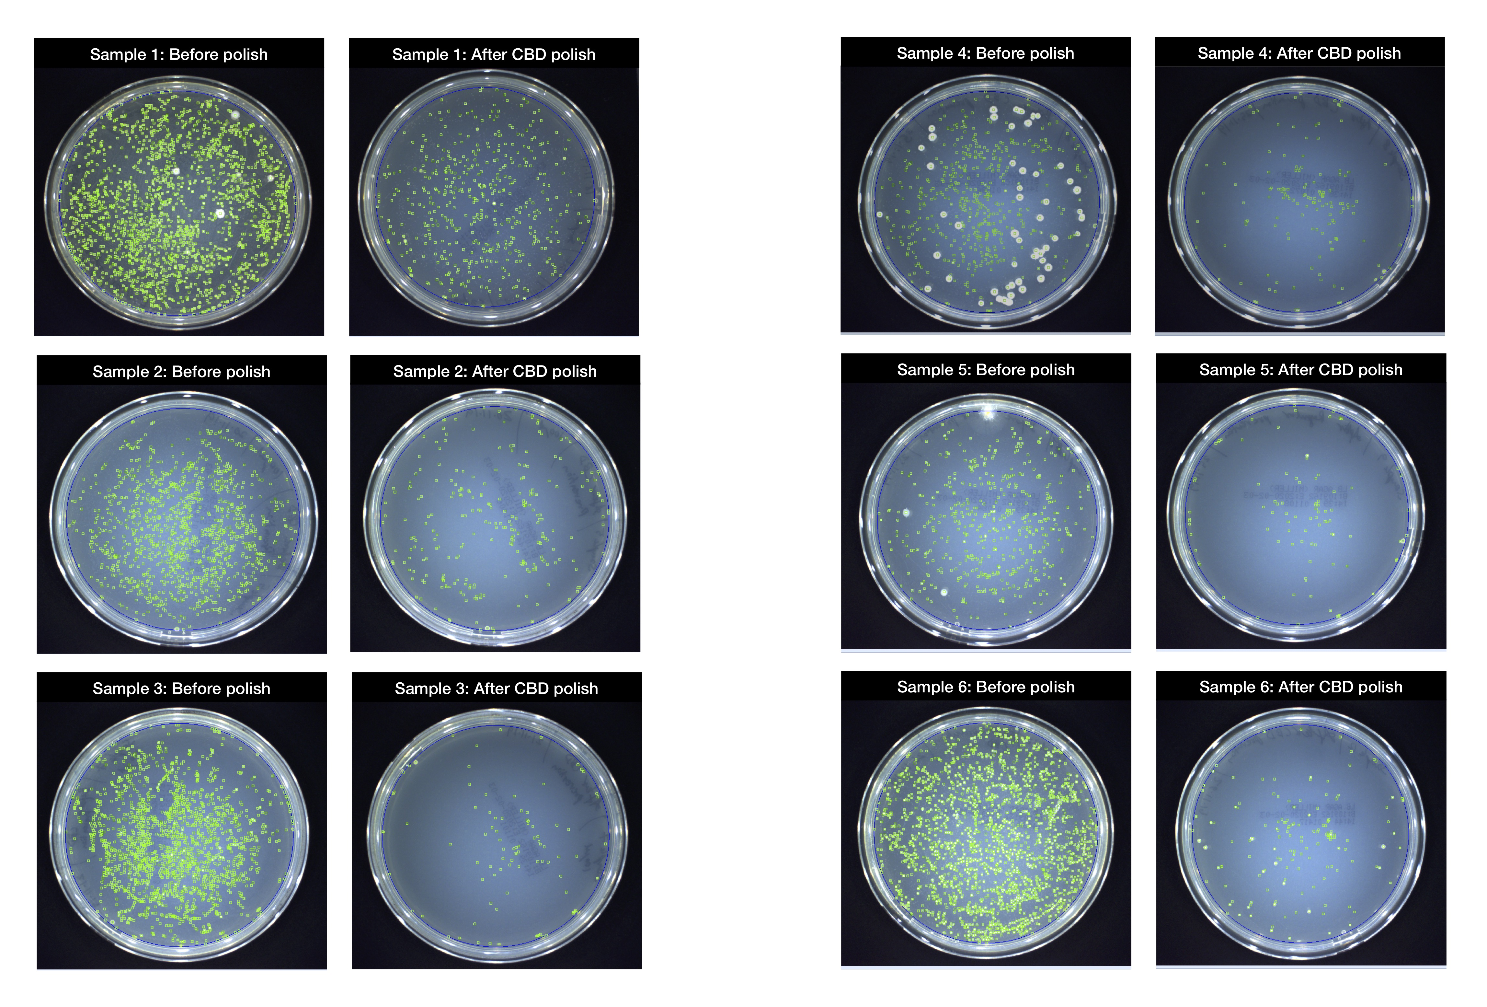
Supplementary Figure 2
Bacterial culture plates of samples (7 to 12) before vs after regular air-polishing treatments. The green color highlights are generated using automated colony counter aCOLyte3 and each green mark represent single bacterial colony detected by aCOLyte3.
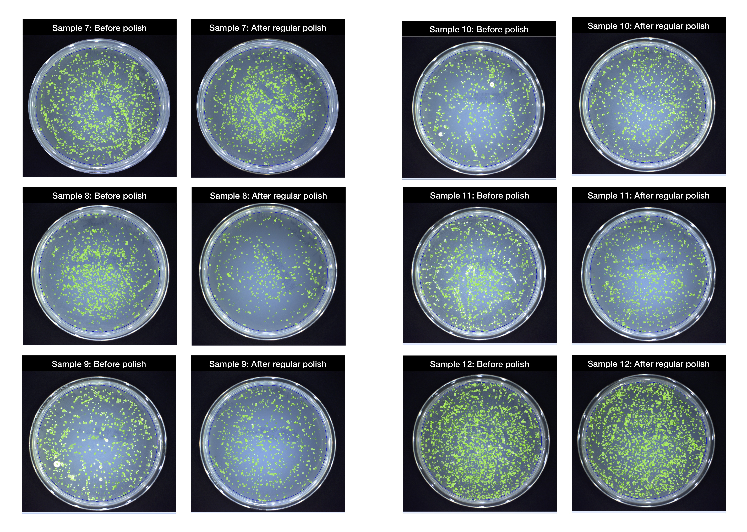

Supplementary Table 1
Colony count measurement data and comparative statistical analysis data
Colony counter (aCOLyte3) settings
aCOLyte3 version 1.3.1.0
Sample volume 100 µL
Exposure Time 0.07-0.09
Sensitivity 95-97
Maximum Colony Size Off
Split Colonies Yes
Media LB agar (90mm plate)

S. Nr. | Gender | Age | Treatment | Count / Plate |  |  | CFU / mL |  |  | Average CFU/mL | SD | Linear Fold change
 |  |  |  | R1 | R2 | R3 | R1 | R2 | R3
1 | M | 30 | Before polisher | 1955 | 1823 | 2101 | 19550 | 18230 | 21010 | 1.96E+04 | 1.39E+03
 |  |  | After CBD polisher | 467 | 502 | 536 | 4670 | 5020 | 5360 | 5.02E+03 | 3.45E+02 | 3.906312292
2 | F | 52 | Before polisher | 1407 | 1322 | 1487 | 14070 | 13220 | 14870 | 1.41E+04 | 8.25E+02
 |  |  | After CBD polisher | 272 | 317 | 296 | 2720 | 3170 | 2960 | 2.95E+03 | 2.25E+02 | 4.763841808
3 | F | 52 | Before polisher | 2042 | 1901 | 2182 | 20420 | 19010 | 21820 | 2.04E+04 | 1.41E+03
 |  |  | After CBD polisher | 110 | 123 | 99 | 1100 | 1230 | 990 | 1.11E+03 | 1.20E+02 | 18.44879518
4 | M | 83 | Before polisher | 712 | 611 | 598 | 7120 | 6110 | 5980 | 6.40E+03 | 6.24E+02
 |  |  | After CBD polisher | 152 | 173 | 164 | 1520 | 1730 | 1640 | 1.63E+03 | 1.05E+02 | 3.928425358
5 | M | 47 | Before polisher | 600 | 721 | 593 | 6000 | 7210 | 5930 | 6.38E+03 | 7.20E+02
 |  |  | After CBD polisher | 97 | 114 | 106 | 970 | 1140 | 1060 | 1.06E+03 | 8.50E+01 | 6.03785489
6 | M | 66 | Before polisher | 2263 | 2175 | 2063 | 22630 | 21750 | 20630 | 2.17E+04 | 1.00E+03
 |  |  | After CBD polisher | 176 | 183 | 166 | 1760 | 1830 | 1660 | 1.75E+03 | 8.54E+01 | 12.38285714
7 | M | 27 | Before polisher | 1887 | 1958 | 2036 | 18870 | 19580 | 20360 | 1.96E+04 | 7.45E+02
 |  |  | After regular polisher | 1859 | 1892 | 1811 | 18590 | 18920 | 18110 | 1.85E+04 | 4.07E+02 | 1.05735347
8 | F | 49 | Before polisher | 1787 | 1746 | 1829 | 17870 | 17460 | 18290 | 1.79E+04 | 4.15E+02
 |  |  | After regular polisher | 753 | 687 | 625 | 7530 | 6870 | 6250 | 6.88E+03 | 6.40E+02 | 2.596610169
9 | F | 24 | Before polisher | 1300 | 1276 | 1334 | 13000 | 12760 | 13340 | 1.30E+04 | 2.91E+02
 |  |  | After regular polisher | 913 | 868 | 890 | 9130 | 8680 | 8900 | 8.90E+03 | 2.25E+02 | 1.463871209
10 | F | 42 | Before polisher | 1207 | 1166 | 1253 | 12070 | 11660 | 12530 | 1.21E+04 | 4.35E+02
 |  |  | After regular polisher | 899 | 928 | 953 | 8990 | 9280 | 9530 | 9.27E+03 | 2.70E+02 | 1.304316547
11 | M | 48 | Before polisher | 1509 | 1398 | 1627 | 15090 | 13980 | 16270 | 1.51E+04 | 1.15E+03
 |  |  | After regular polisher | 1218 | 1096 | 1159 | 12180 | 10960 | 11590 | 1.16E+04 | 6.10E+02 | 1.305499568
12 | F | 38 | Before polisher | 2756 | 2822 | 3036 | 27560 | 28220 | 30360 | 2.87E+04 | 1.46E+03
 |  |  | After regular polisher | 3006 | 2623 | 2652 | 30060 | 26230 | 26520 | 2.76E+04 | 2.13E+03 | 1.040212535

Supplementary Table 2
Comparative statistical analysis
t-Test: Two-Sample Assuming Unequal Variances
 | Before polish | After CBD polish
Mean | 16245.27778 | 2251.666667
Variance | 41393049.41 | 2302016.667
Observations | 12 | 6
Hypothesized Mean Difference | 0
df | 13
t Stat | 7.147518355
P(T<=t) one-tail | 3.75263E-06
t Critical one-tail | 1.770933396
P(T<=t) two-tail | 7.50526E-06
t Critical two-tail | 2.160368656
t-Test: Two-Sample Assuming Unequal Variances
 | Before polish | After regular polish
Mean | 16245.27778 | 13795.55556
Variance | 41393049.41 | 62062287.41
Observations | 12 | 6
Hypothesized Mean Difference | 0
df | 8
t Stat | 0.659607132
P(T<=t) one-tail | 0.264016925
t Critical one-tail | 1.859548038
P(T<=t) two-tail | 0.52803385
t Critical two-tail | 2.306004135
t-Test: Two-Sample Assuming Unequal Variances
 | After CBD polish | After regular polish
Mean | 2251.666667 | 13795.55556
Variance | 2302016.667 | 62062287.41
Observations | 6 | 6
Hypothesized Mean Difference | 0
df | 5
t Stat | -3.524562565
P(T<=t) one-tail | 0.008418509
t Critical one-tail | 2.015048373
P(T<=t) two-tail | 0.016837018
t Critical two-tail | 2.570581836

