Article, Special Issue "Induced Pluripotent Stem Cells in Neurodegenerative Diseases: Application for Therapy and Disease Modeling"
A simple differentiation protocol for generation of induced pluripotent stem cell-derived basal forebrain cholinergic neurons for Alzheimer’s disease and frontotemporal dementia disease modeling
Supplemental information
Reprogramming and characterisation of MBE2960 healthy control iPSC line
The iPSCs were generated using skin fibroblasts obtained from subjects over the age of 18 years by episomal method as described [40]. Briefly, reprogramming was performed on passage 8-10 fibroblasts by nucleofection (Lonza Amaxa Nucleofector) with episomal vectors expressing OCT4, SOX2, KLF4, L-MYC, LIN28 and shRNA against p53 [41] in feeder- and serum- free conditions using TeSR-E7 medium (Stemcell Technologies). Subsequently, reprogrammed colonies were manually dissected to establish clonal cell lines [42]. Three clones were assessed for pluripotency markers via immunocytochemistry (Figure S1A). The iPSC line was expanded and characterised. Embryoid bodies were obtained as described [43] and using tri-lineage differentiation kit (Stemcell Technologies). Germ layer differentiation was assessed by immunochemistry (Figure S1B). Copy number variation (CNV) analysis of original fibroblasts and iPSCs from MBE2960 (Figure S1C) was performed using Illumina HumanCore Beadchip arrays as we described [40]. CNV analyses were performed using PennCNV and QuantiSNP with default parameter settings [44,45]. Chromosomal aberrations were deemed to involve at least 10 contiguous single nucleotide polymorphisms (SNPs) or a genomic region spanning at least 1MB [44,45]. The B allele frequency (BAF) and the log R ratio (LRR) were extracted from GenomeStudio (Illumina) for representation (Figure S1D).

Reprogramming and characterization of a late-onset (sporadic) Alzheimer’s disease iPSC line UOWi006-A and a frontotemporal dementia / amyotrophic lateral sclerosis (FTD/ALS C9orf72 expansion) UOWi008-A iPSC line
A skin biopsy was obtained from an 83-year-old female with sporadic Alzheimer’s disease (APOE ε4/4 genotype) (RB7-11 clone) and a 66-year-old female patient with diagnosed with frontotemporal dementia / amyotrophic lateral sclerosis (FTD/ALS, caused by a C9orf72 expansion) (C-10 clone), following informed consent from the donor. The study was approved by the University of Wollongong Human Ethics Committee (HE13/299). Dermal fibroblasts were cultured at 37°C and 5% CO₂ in Dulbecco's Modiﬁed Eagle Medium F12 (DMEM/F12) supplemented with 1x Non-Essential Amino Acids (Thermo Fisher Scientific) and 10% foetal bovine serum (Interpath). Fibroblasts were reprogrammed using Stemgent microRNA-Enhanced mRNA Reprogramming kit (Stemgent) with pluripotency transcription factors Oct4, Klf4, Sox2, c-Myc, Lin28 and Nanog, following the manufacture’s protocol. Prior to reprogramming, Pluriton reprogramming medium was conditioned using new-born human foreskin fibroblasts (Global Stem), as per the reprogramming protocol. Spontaneous iPSC colonies were isolated on day 14 for expansion into individual iPSC lines (clones). Established iPSC clones were maintained at 37°C and 5% CO₂ on Matrigel-coated plates in TeSR-E8 and were split 1:5 using dispase on reaching 70% confluence.
The first iPSC colonies appeared on day 10 and were isolated on day 14 for expansion and characterisation, with clone 11 selected following confirmation of pluripotency. The iPSC colonies had normal morphology (Figure S2A) and karyotype (Figure S2B), with no abnormalities detected in 15 cells at 400 bands per haploid set. The identity of iPSCs was authenticated against its parental fibroblast line via short tandem repeat (STR) profiling. Transcription of endogenous pluripotency genes NANOG and POU5F1 increased by 210 and 1,300-fold, respectively, in comparison to parental fibroblasts (Figure S2C) and immunocytochemical analysis demonstrated expression of pluripotency markers Oct4, SSEA-4 and TRA-1-60 (Figure S2D). Differentiation potential into the three-germ layers was confirmed using the hPSC Scorecard assay (Figure S2E).
Characterisation of iPSC colonies via karyotyping, STR analysis, qPCR, immunofluorescence and hPSC Scorecard analysis was performed as previously described [15].

List of genes
Table S1. List of genes analysed in Nanostring for iPSC and BFCN cultures.
Gene name | Approved name | Accession | Position | Category
AARS | Alanyl-tRNA synthetase | NM_001605.2 | 836-935 | Housekeeper
ACHE | Acetylcholinesterase | NM_000665.3 | 1058-1157 | BFCN
ALDOC | Aldolase, fructose-bisphosphate C | NM_005165.2 | 261-360 | Astrocytes
ASB7 | Ankyrin repeat and SOCS box containing 7 | NM_024708.3 | 1281-1380 | Housekeeper
ASCL1 | Achaete-scute homolog 1 | NM_004316.3 | 1651-1750 | Neuronal progenitor
CCDC127 | Coiled-coil domain-containing 127 | NM_145265.2 | 295-394 | Housekeeper
CHAT | Choline O-acetyltransferase | NM_020549.4 | 1106-1205 | BFCN
SLC5A7 (CHT1) | Solute carrier family 5 member 7 (choline transporter 1) | NM_021815.2 | 956-1055 | BFCN
CNOT10 | CCR4-NOT transcription complex subunit 10 | NM_001256741.1 | 1963-2062 | Housekeeper
SLC6A3 (DAT1) | Solute carrier family 6 member 3 (dopamine transporter 1) | NM_001044.3 | 1549-1648 | Neuronal
DLX1 | Distal-less homeobox 1 | NM_001038493.1 | 1336-1435 | Neuronal progenitor
DLX2 | Distal-less homeobox 2 | NM_004405.3 | 591-690 | Neuronal progenitor
SLC1A3 (EAAT1) | Solute carrier family 1 member 3 (glial high affinity glutamate transporter 1) | NM_004172.4 | 559-658 | Astrocytes
EID2 | EP3000-interacting inhibitor of differentiation 2 | NM_153232.3 | 566-665 | Housekeeper
EMX1 | Empty-spiracles homeobox 1 | NM_004097.2 | 1747-1846 | Neuronal progenitor
FOXG1 | Forkhead box protein G1 | NM_005249.3 | 1401-1500 | BFCN progenitor
GAD2 | Glutamate decarboxylase 2 | NM_000818.2 | 1246-1345 | Neuronal
GRIA1 | Glutamate ionotropic receptor AMPA type subunit 1 | NM_000827.3 | 2841-2940 | Neuronal
GRIA2 | Glutamate ionotropic receptor AMPA type subunit 2 | NM_001083620.1 | 866-965 | Neuronal
GRIN1 | Glutamate ionotropic receptor NMDA type subunit 1 | NM_000832.5 | 1291-1390 | Neuronal
ISL1 | Insulin Enhancer protein (ISL) LIM homeobox 1 | NM_002202.2 | 1376-1475 | BFCN progenitor
LHX8 | LIM homeobox 8 | NM_001001933.1 | 1301-1400 | BFCN progenitor
MAP2 | Microtubule associated protein 2 | NM_031845.2 | 5171-5270 | Neuronal
MTO1 | Mitochondrial tRNA translation optimization 1 | NM_133645.2 | 1466-1565 | Housekeeper
NANOG | Nanog homeobox | NM_024865.2 | 1101-1200 | Pluripotency
NFIA | Nuclear factor I A | NM_001134673.2 | 1086-1185 | Astrocytes
NGFR | Nerve growth factor receptor | NM_002507.3 | 2731-2830 | BFCN
NKX2-1 | NK2 homeobox 1 | NM_003317.3 | 2012-2111 | BFCN progenitor
NTRK1 (TRKA) | Neurotrophic receptor tyrosine kinase 1 | NM_001012331.1 | 1366-1465 | BFCN
PAX6 | Paired box 6 | NM_000280.3 | 1174-1273 | Neuronal progenitor
POUF51 | POU class 5 homeobox 1 | NM_002701.4 | 1226-1325 | Pluripotency
DLG4 (PSD95) | Disc large MAGUK scaffold protein 4 (post-synaptic density protein 95) | NM_001365.3 | 2461-2560 | Neuronal
RABEP2 | Rabaptin, RAB GTPase-binding effector protein 2 | NM_024816.2 | 1783-1882 | Housekeeper
S100B | S100 calcium binding protein B | NM_006272.2 | 305-404 | Astrocytes
SOX1 | SRY-box 1 | NM_005986.2 | 1496-1595 | Neuronal progenitor
SUPT7L | SPT7 like, STAGA complex gamma subunit | NM_014860.2 | 1171-1270 | Housekeeper
SYN1 | Synapsin I | NM_006950.3 | 566-665 | Neuronal
TADA2B | Transcriptional adaptor 2B | NM_152293.2 | 1589-1688 | Housekeeper
TH | Tyrosine hydroxylase | NM_000360.3 | 1307-1406 | Neuronal
TUBB3 | Tubulin beta 3 class III | NM_006086.2 | 1538-1637 | Neuronal
SL18A3 (VACHT) | Solute carrier family 18 member A3 (vesicular acetylcholine transporter) | NM_003055.2 | 1651-1750 | BFCN
ZNF324B | Zinc finger protein 324B | NM_207395.2 | 2821-2920 | Housekeeper

Figure S1. Confirmation of pluripotency of iPSCs MBE2960 healthy control. A. iPSC colonies were positive for the immunocytochemical staining for pluripotency markers TRA-1-60 (Red) and Oct-4 (Green) with DAPI (Blue). B. iPSCs were differentiated into the three germ layers and confirmed via immunocytochemical staining for AFP (Endoderm), SMA (Mesoderm) and Nestin (Ectoderm) with DAPI. C. Copy number variation (CNV) analysis of original fibroblasts and iPSCs from MBE2960 D. Representation of the B allele frequency (BAF) and the log R ratio (LRR) of the fibroblasts and the iPSC clones. Scale bars = 20 μm.
Figure S2. Confirmation of pluripotency and three germ layer differentiation of iPSCs RB7-11 late-onset Alzheimer’s disease (UOWi006-A). iPSC colonies showed normal A. morphology and B. karyotype. C. RT-qPCR analysis demonstrated fold change in expression of pluripotency transcription factors NANOG and POU5F1 to parental fibroblasts. D. Immunocytochemical staining for pluripotency markers Oct4, SSEA-4 and TRA-1-60 (green) with RedDot2 nuclear marker (red) or brightfield. E. Three germ layer differentiation showed fold change (fc) in expression for specific sets of genes for self-renewal and ectoderm, mesoderm and endoderm germ layers based on TaqMan hPSC Scorecard. Data points on graph represent technical replicates on RT-qPCR. Scale bars = 50 μm.
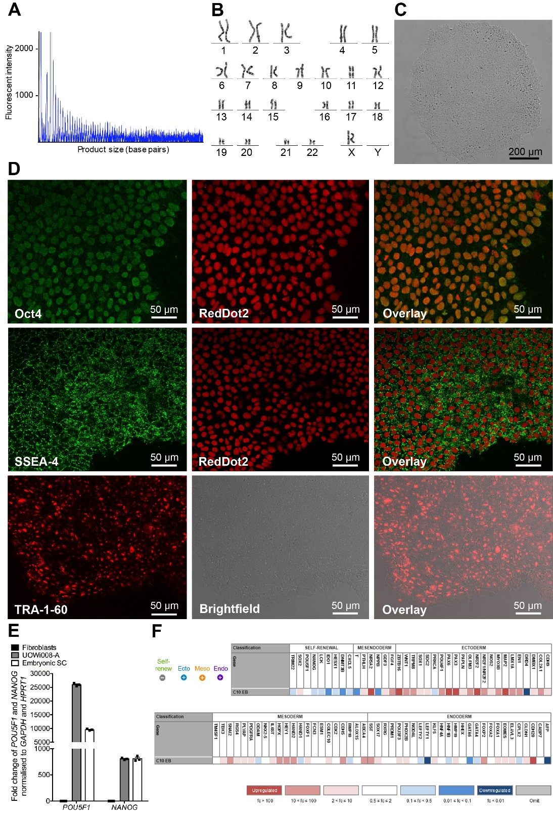
Figure S3. Confirmation of pluripotency and three germ layer differentiation of iPSCs C-10 FTD/ALS (UOWi008-A). The hexanucleotide repeat in C9orf72 was genotyped using the repeat primed polymerase chain reaction (PCR) method described by Renton et al. (2011), with a pathogenic expansion defined as more than 30 repeat units. Fragment length analysis was performed by Macrogen Inc (South Korea) using the ABI 3730XL DNA analyser (Applied Biosystems, CA, USA) and data were analysed using Peak Scanner 2 (Life Technologies) A. Cells showed normal karyotype B. and morphology C. Immunocytochemical staining for pluripotency markers Oct4, SSEA-4 and TRA-1-60 (green) with RedDot2 nuclear marker (red) or brightfield D.. RT-qPCR analysis demonstrated fold change in expression of pluripotency transcription factors NANOG and POU5F1 to parental fibroblasts. E. Three germ layer differentiation showed fold change (fc) in expression for specific sets of genes for self-renewal and ectoderm, mesoderm and endoderm germ layers based on TaqMan hPSC Scorecard F. Data points on graph represent technical replicates on RT-qPCR. Scale bars = 50 μm.
Figure S4. RNA molecule count of housekeeper genes. iPSCs, NPCs and BFCNs samples were analysed by nCounter (Nanostring) and results are shown as RNA molecule count after internal quality control and normalisation to a reference sample used on the PlexSet. The ten housekeeper genes AARS, ASB7, CCDC127, CNOT10, EID2, MTO1, RABEP2, SUPT7L, TADA2B and ZNF324B were analysed. The overall housekeeper expression between iPSCs, NPCs and BFCNs shows no significant difference.
Figure S5. RNA molecule count of pluripotency markers. iPSCs, NPCs and BFCNs samples were analysed by nCounter (Nanostring) and results are shown as RNA molecule count after normalisation of total amount of RNA molecules to the housekeeper genes. The pluripotency markers NANOG and POU5F1 were analysed.
Figure S6. RNA molecule count of developmental markers. iPSCs, NPCs and BFCNs samples were analysed by nCounter (Nanostring) and results are shown as RNA molecule count after normalisation of total amount of RNA molecules to the housekeeper genes. The developmental markers ASLC1, DLX1, DLX2, EMX1, PAX6 an SOX1 were analysed.
Figure S7. RNA molecule count of cholinergic developmental markers. iPSCs, NPCs and BFCNs samples were analysed by nCounter (Nanostring) and results are shown as RNA molecule count after normalisation of total amount of RNA molecules to the housekeeper genes. The cholinergic developmental markers FOXG1, ISL1, LHX8 and NKX2-1 were analysed.
Figure S8. RNA molecule count of neuronal markers. iPSCs, NPCs and BFCNs samples were analysed by nCounter (Nanostring) and results are shown as RNA molecule count after normalisation of total amount of RNA molecules to the housekeeper genes. The neuronal markers SLC6A3 (DAT1), GAD2, GRIA1, GRIA2, GRIN1, MAP2, DLG4 (PSD95), SYN1, TH and TUBB3 were analysed.
Figure S9. RNA molecule count of cholinergic neuron markers. iPSCs, NPCs and BFCNs samples were analysed by nCounter (Nanostring) and results are shown as RNA molecule count after normalisation of total amount of RNA molecules to the housekeeper genes. The cholinergic neuronal markers ACHE, CHAT, SLC5A7 (CHT1), NGFR, NTRK1 (TRKA) and SLC18A3 (VACHT) were analysed.
Figure S10. RNA molecule count of astrocytic markers. iPSCs, NPCs and BFCNs samples were analysed by nCounter (Nanostring) and results are shown as RNA molecule count after normalisation of total amount of RNA molecules to the housekeeper genes. The astrocytic markers ALDOC, SLC1A3 (EAAT1), NFIA and S100B were analysed.

© 2020 by the authors. Submitted for possible open access publication under the terms and conditions of the Creative Commons Attribution (CC BY) license (http://creativecommons.org/licenses/by/4.0/).

