Appendix A
Typography of approaches to delayed antibiotic prescription

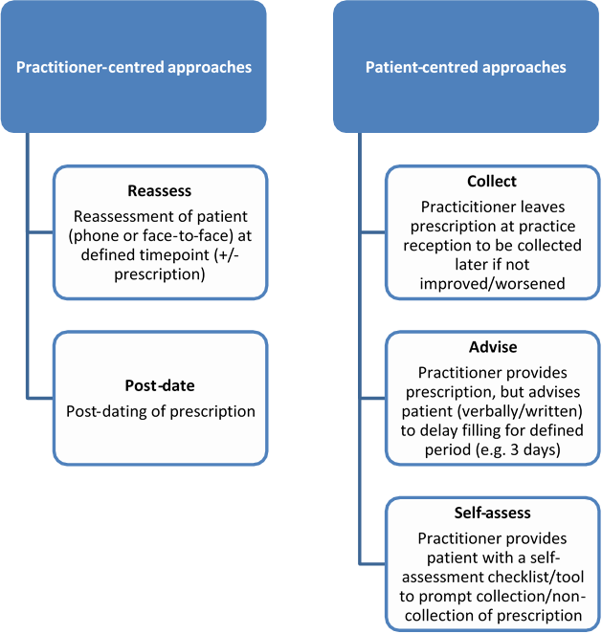

Appendix B

Patient pathways for project of delayed prescribing in LEKMA Hospital outpatients’ department, Ghana

