Supplemental materials for

Optically modulated resistance switching polarities in BaTiO₃ thin film

Jing Wang,^{1,2,3} Bailey Keith Bedford,² Changle Chen,¹ Ludi Miao,² Bingcheng Luo¹
¹School of Science, Northwestern Polytechnical University, Xi’an, 710072, China
²Department of Physics, The Pennsylvania State University, University Park, Pennsylvania 16802, USA
³Department of mathematical and Physics, Weinan Normal University, Weinan, 714000,China

The XRD spectrum for a representative BTO film grown on Pt/TiO₂/SiO₂/Si substrates is shown in Figure s1. We observed the expected characteristic peaks corresponding to (100), (200), (220), (221) and (311) planes of the BTO thin film. The BTO films are observed to be polycrystalline and the (111) peak is from the Pt substrate.
One establishes ferroelectricity by the reversible switching of the polarization of the film. Using PFM, we observed ferroelectric polarization switching in BTO film, as shown in Figure s2. The amplitude and phase image were written in the film surface under a dc bias ±8V. Square shaped 10µm and 5µm patterns were written on the BTO surface using -8V and 8V, respectively. The profiles of the amplitude and the phase across the poled area are also shown in Figure s2c-d. Notably, the PFM phase image shown in Figure s2b demonstrates the phase change between the poled regions. These results demonstrate that the ferroelectric films are of good quality, although the application of a large voltage could lead to irreversible surface deformation.
In order to demonstrate the change of ferroelectricity in our film, typical P-V loops at 1kHz were measured at dark (black line) and under 365 nm light illumination (red line), as illustrated in Figure s3.. The loops clearly confirm the robust ferroelectricity at 2V. Obviously, the remnant polarization of film under UV light is bigger than that of dark. It can be attributed to the increase of carrier concentration under UV illumination condition, which is consistent with resistance changes in Figure 2. The loops also support our results that ferroelecticity of film plays an important role in RS effect under UV light illumination.

Figure Captions

Figure S1. Room temperature XRD diffracts gram of Pt/BTO/Pt device.

Figure S2. The ferroelectric nature of the BTO films with an applied tip bias voltage of ±8V over a 100 µm² area measured by PFM writing is shown. (a) Amplitude of film surface, (b) Phase change of film surface, (c) and (d) were the amplitude and phase profile of surface along the crossing line respectively.

Figure S3. A P-V hysteresis loops of BTO at room temperature, measured with 1 kHz frequency with the value of + or -2 V. Black line is a normal hysteresis loop, and red line is a hysteresis loop under UV light.

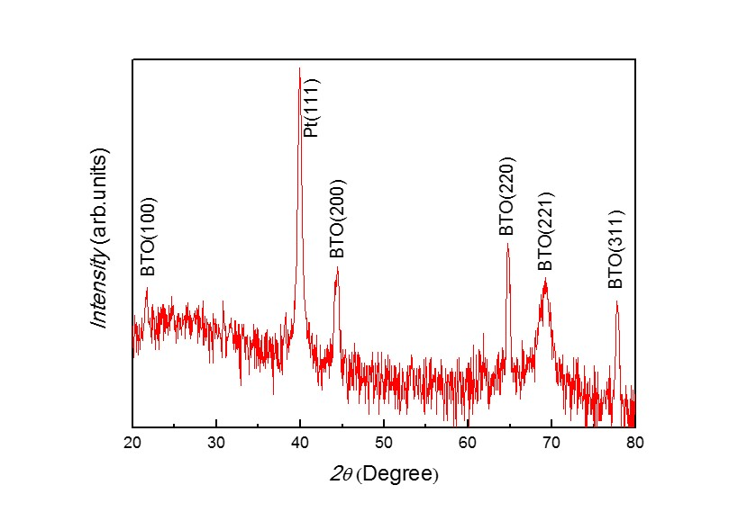

Figure S1, Jing et al.

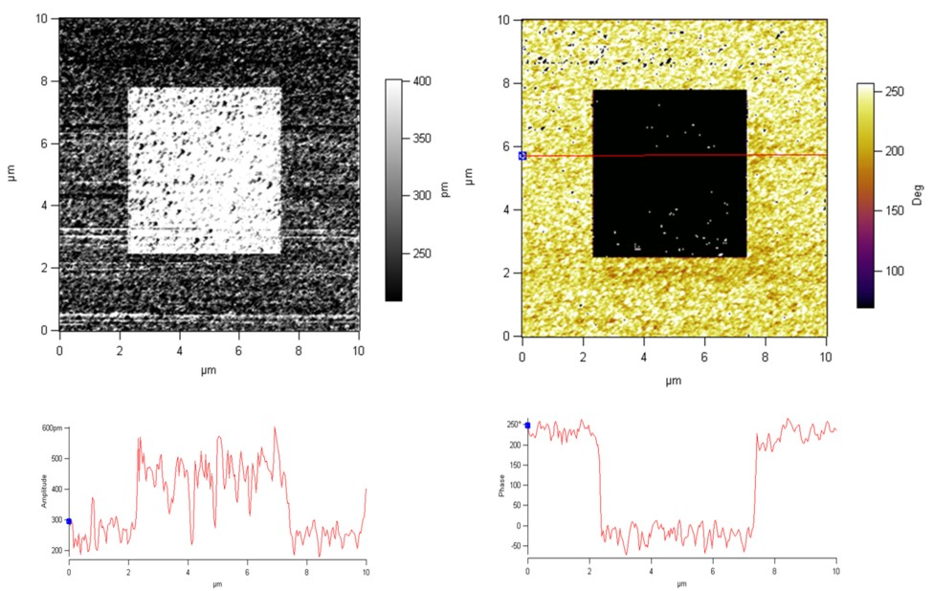

Figure S2, Jing et al.

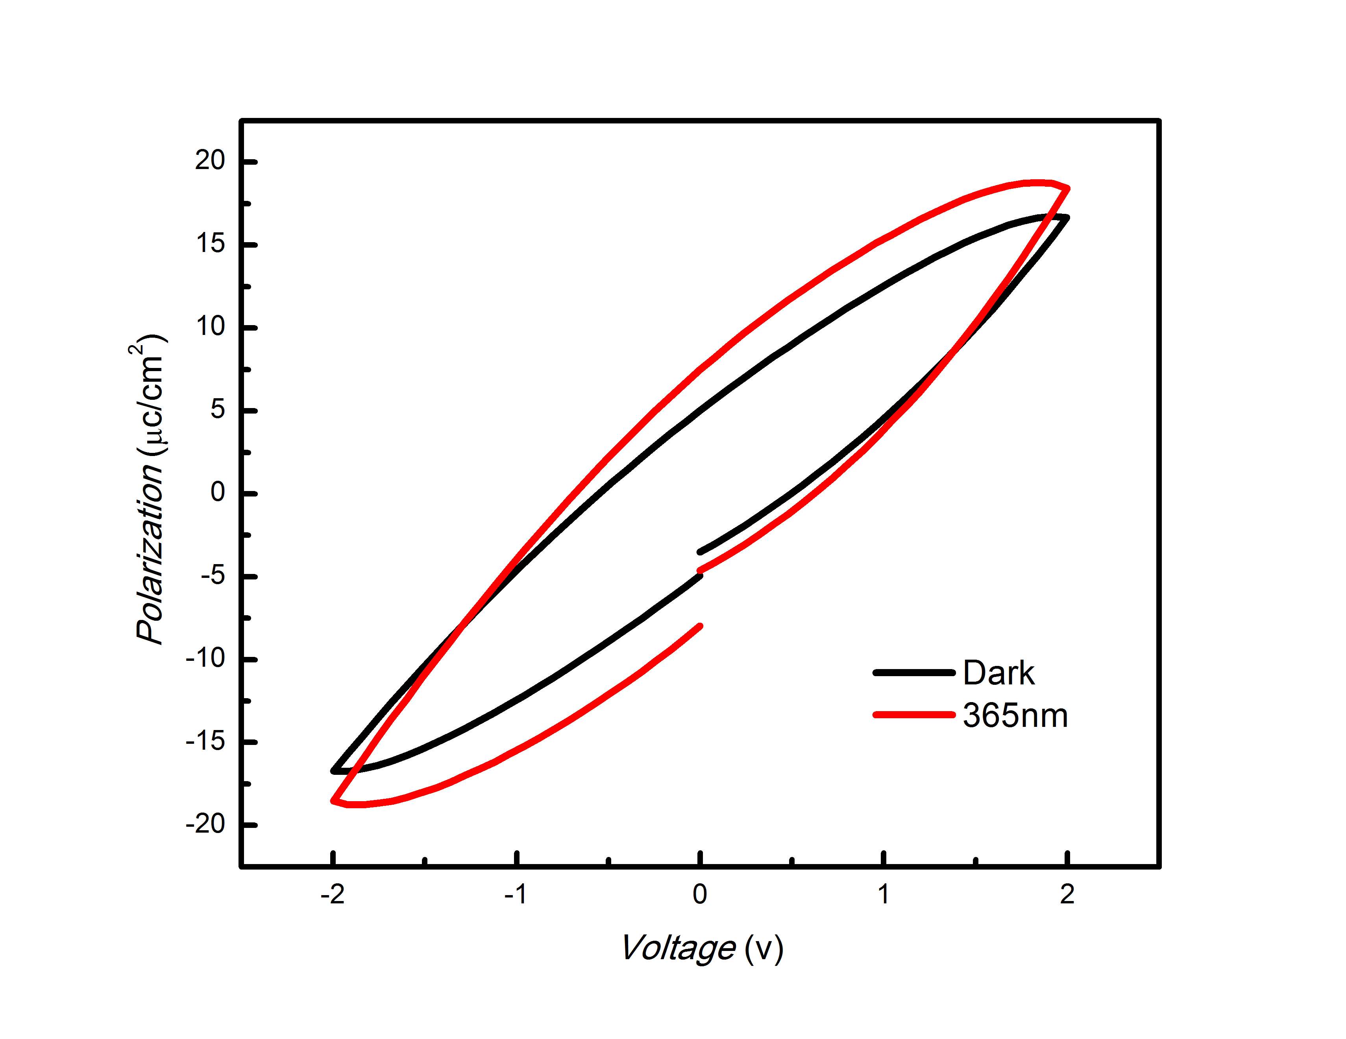

Figure S3, Jing et al.

