Supplementary Figure
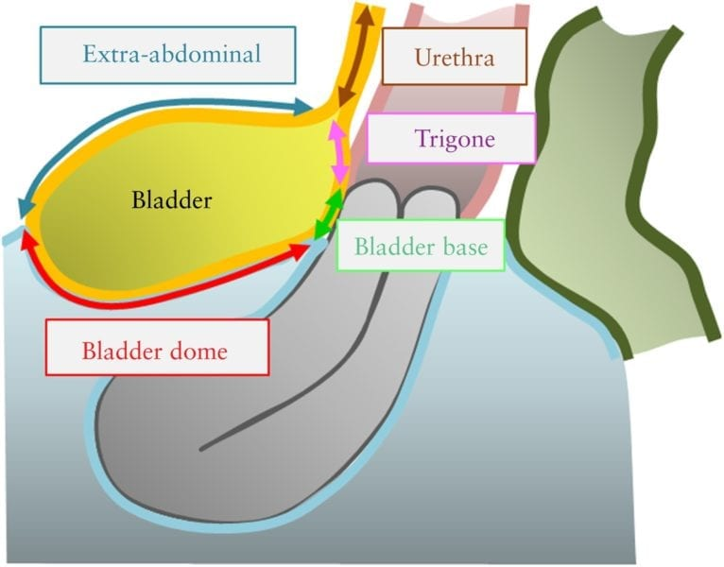
Supplementary Figure 1: Schematic drawing illustrating the four bladder zones: trigone, bladder base, bladder.dome and extra‐abdominal bladder. The demarcation point between the base and the dome of the bladder is the uterovesical pouch. Reprinted with permission from John Wiley and Sons.
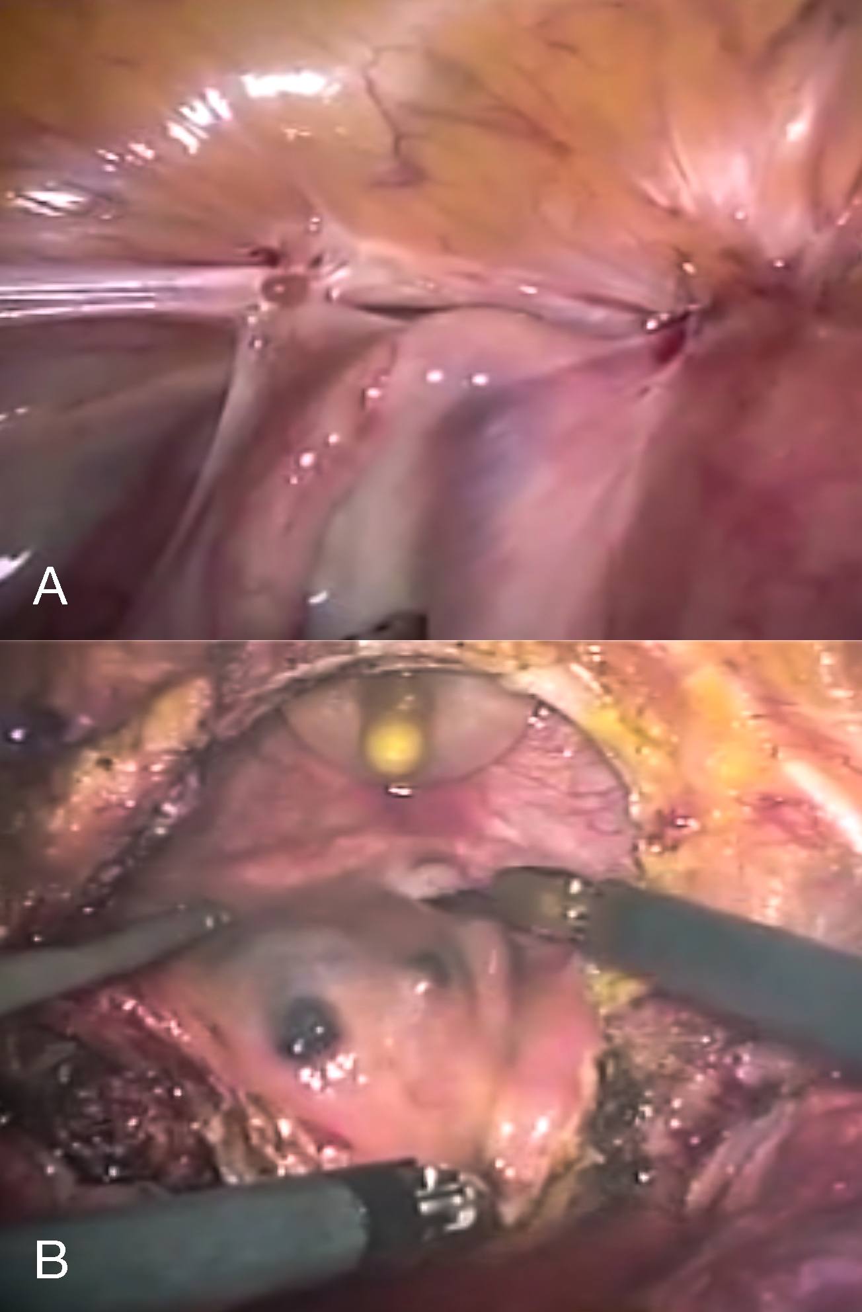
Supplementary Figure 2: Laparoscopic depiction of bladder deep endometriosis before (A) and during (B) full-thickness resection.
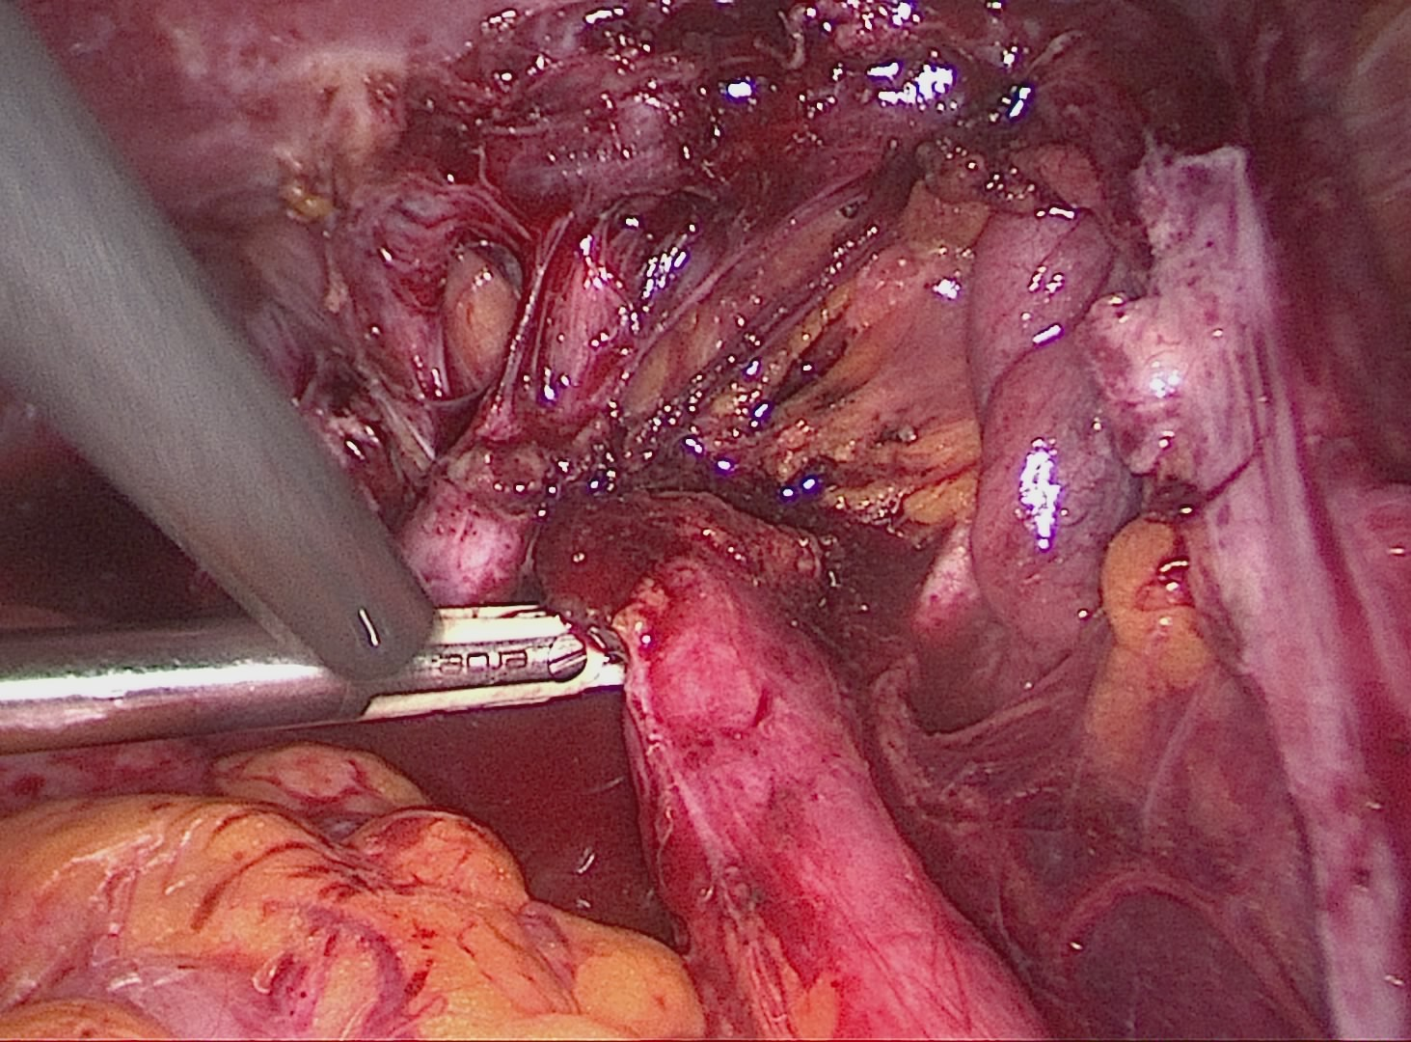Supplementary Figure 3: Laparoscopic depiction of right ureteral deep endometriosis leading to hydroureter.
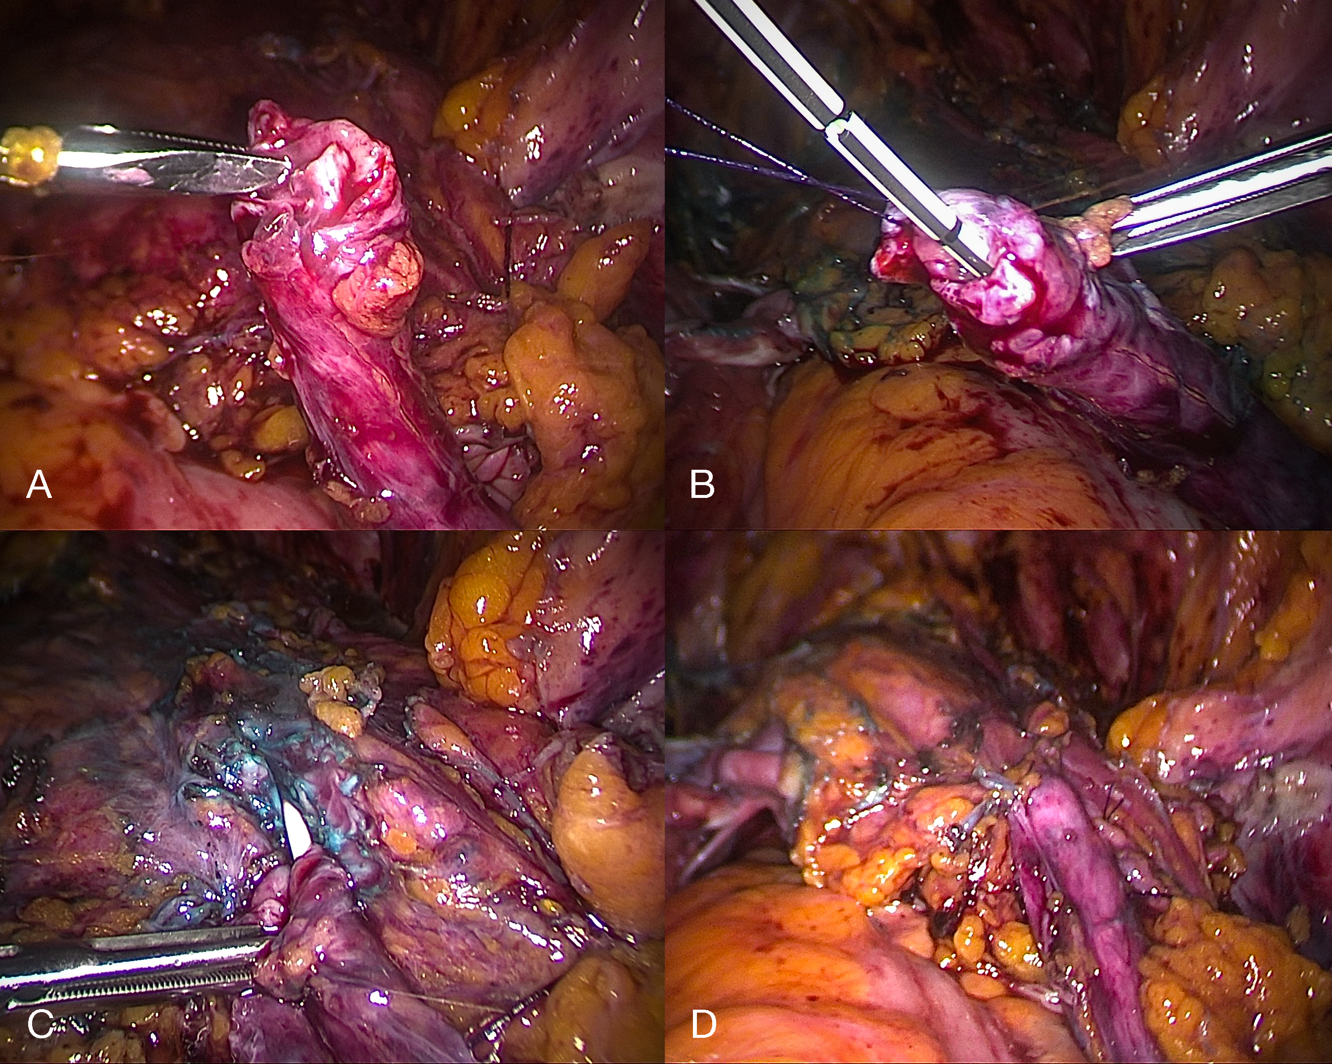
Supplementary Figure 4: Laparoscopic depiction of ureteroneocystostomy secondary to ureteral deep endometriosis.

