Appendix 1. Protocol for Student Submission of Annotations to WormBase

This protocol outlines how to provide information about genotype/phenotypes to the scientific community by describing individual published data points. For this assignment, you will use your instructor’s WormBase Person ID to enter your annotations; you will use the Comments box (see below) to make sure that we know what individuals annotated which data. An annotation for a piece of data is made up of the collected information that is assembled by filling out the appropriate text boxes using gene/allele names, short phrases, suggestions from drop down menus, and quoted text from the primary literature (scientific manuscript) that is being annotated.

Open your paper and Wormbase.
On the Wormbase front page navigate to:
Wormbase->submit data (under search bar)-> Phenotype data submission (under community curation)>submit online form

For your name: enter InstructorsLastName
Email: (will autofill)
PubMed ID: Pull from the paper (PMID)
[Alternatively: use the last author’s name in the “your name” box; then click on the link to “review your publications and see which are in need of phenotype curation” and find your paper in the pop-up table. Once you have the PubMed ID, don’t forget to switch “my name” back to InstructorsLastName!]

GENETIC PERTURBATION(S)
- RNAi target gene: N/A
- Allele name: Type in the name of the allele you are working with.
  - When entering allele name, click on the dropdown suggestion so the website recognizes it as more than plain text (if no suggestion pops up that’s fine, continue with submission)
  - Only enter one allele per submission
and/or
- Overexpression transgene: Type in the transgene allele (use the Ex or Is nomenclature) you are working with. Important: transcriptional reporters and background genotypes (for example fusion proteins like GLR-1::GFP) that do not cause a phenotype should NOT be entered here. That information can go in the "Control genotype" field (see OPTIONAL, below).
  - Click on the dropdown suggestion so the website recognizes it as more than plain text (if no suggestion pops up that’s fine, continue with submission)
  - Only enter one transgene per submission
Note from WormBase: If the strain with the phenotype had both an allele (e.g. a deletion allele) and a transgene and BOTH were causative, both will get simultaneously submitted as Multiple Perturbations, which appears after entering 2 or more genetic perturbations. This would be a complex genotype experiment.

PHENOTYPES
- Observed Phenotypes: this is what is described in the published data. There is an entire ontology (vocabulary) of phenotypes, and WormBase would like to fit your description to that. Try out some key words and see what pops up!
  - To enter the phenotype(s), click the autofill suggestions after you’ve entered a bit of text or a key word.
  - After the phenotype is entered, a new box will open called ‘phenotype remarks’
  - Copy and paste the quote you pulled the phenotype from (please add quotation marks)
  - If the quote refers to multiple phenotypes, fill in another phenotype box, and copy and paste the same quote into the new phenotype remarks box

- Not observed Phenotypes: For our purposes, these are phenotypes that might have been expected but were not observed, or “negative results”. This is often low priority, and you can ignore for the time being unless you are confident that a phenotype would have been expected or if the authors specifically note its absence.

For the “OPTIONAL” section

Click on the Optional header to enter other information that you feel is important.
- Add Control Genotype/strain details and any other information you feel confident about
- Add your name into the comments box at the bottom (this information is kept internal)
Press preview to check the information is entered properly (allele should have a WB# next to it)
**Take a screenshot of your page for your records and to turn in as a Canvas assignment) **

Press submit, then reset to start a new entry

Appendix 2. Examples of student submissions and instructor comments.

Names and WormBaseIDs have been removed; used with permission.

- Image of compiled student screen shots for the submission. These were turned in by the student via Canvas.
- Image of instructor comments on the same student submission. These were uploaded for student review.
- Example of student revision for the third submission. The student addresses the instructor comments and describes what changes were made. This student re-submitted the annotation, which was noted by the WormBase administrator.

Appendix 3. Quiz to assess student learning.

This three-question quiz was administered using the Canvas LMS. Multiple choice (question 1) and fill in the blank (question 3) answers were provided as selections or drop-down options, respectively. The short answer question (question 2) was graded by the instructor.

The graph below shows that wild type C. elegans move away from high salt (a negative chemotaxis index) after training with an aversive stimulus; however animals lacking nmr-1 (ak4) are attracted to salt (a positive chemotaxis index) even after the same training. (From Kano, et al., 2008).

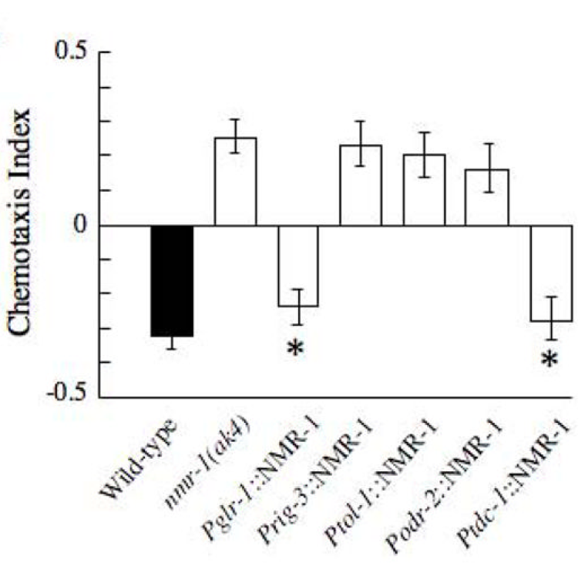

1. Which of the following is most likely to be true?

- rig-3 is expressed in the same cells as nmr-1.

- The nmr-1 promoter drives glr-1 expression.

- Both tdc-1 and glr-1 are expressed in at least some of the cells that express nmr-1.

- Both tol-1 and odr-2 are expressed in at least some of the cells that express nmr-1.

(Correct answer: C)

2. Briefly, explain your choice.

The nmr-1 mutant has a distinct chemotaxis defect that is only rescued when NMR-1 is expressed under the glr-1 or tdc-1 promoters.

3. Choose from the following choices to Fill in the blanks to complete a Wormbase data annotation for nmr-1 (ak4) based on the data from Kano, et al, 2008, above . The image below is for reference.

- Allele.
- nmr-1
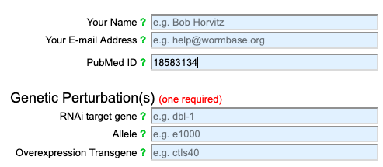
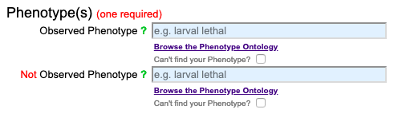
- ak4
(Correct answer: 2)

- Overexpression transgene
- No transgene (you would leave this blank)
- Pglr-1::NMR-1
(Correct answer: 1)

- Observed phenotype
- Thermotaxis variant
- Sodium chloride chemotaxis variant

(Correct answer: 2)

- Not observed phenotype
- Positive chemotaxis variant
- No phenotype (you would leave this blank)

(Correct answer: 2)

Appendix 4. Papers annotated by students and URLs of student annotations

- Papers annotated by students are shown here by WormBase Paper ID and by PubMed ID
WBPaper ID | PubMed ID
WBPaper00002341 | 8601480
WBPaper00003257 | 9789046
WBPaper00005349 | 12123612
WBPaper00005404 | 12075001
WBPaper00006159 | 14573539
WBPaper00030893 | 17671168
WBPaper00031151 | 17972877
WBPaper00035944 | 20105303
WBPaper00041586 | 23013276
WBPaper00044602 | 24356955
WBPaper00046107 | 25469499
WBPaper00046459 | 25688864
WBPaper00049647 | 27223098
WBPaper00049891 | 27462879
WBPaper00050092 | 27593554
WBPaper00052970 | 28844202
WBPaper00055101 | 30147641
WBPaper00056441 | 30908491
WBPaper00057204 | 31413197
WBPaper00058677 | 31570707
WBPaper00058974 | 31740450
WBPaper00059155 | 31950452
WBPaper00059641 | 32350283

- URLs of accepted student annotations.
These URLs are currently not shown for purposes of blinding. 23 unique papers were represented; the URLs will be provided following blinded review.

Appendix 5. Example of WormBase curation spreadsheet for student annotations.

Key to terminology:
"good" = validated annotation; will go into WormBase if it is not redundant
"dump" = will get 'dumped' out of the curation database and into the official WormBase database
"no dump" = will not get 'dumped' out of the curation database and into the official WormBase database; this annotation will remain internally in the curation database.

For this iteration of the CURE, 126 individual annotations were received and validated by WormBase.
Appendix 6. Prompts for student survey following the three annotation assignments.

Students were asked to answer the following questions using an anonymous Qualtrics survey. No student identifiers were collected.

Q1. Compared with experiences in other Biology courses, did annotating data in Wormbase help you distinguish between genotype and phenotype? In what way(s)?

Q2. Compared with experiences in other Biology courses, did annotating
data in Wormbase help you distinguish between control and experimental conditions? In what way(s)?

Q3. Compared with experiences in other Biology courses, did annotating
data in Wormbase help you identify different alleles? In what way(s)?

Q4. Compared with experiences in other Biology courses, did annotating
data in Wormbase help you distinguish between transgenic organisms and genetic mutants? In what way(s)?

Q5. Is there anything else that the annotating data in Wormbase helped you learn? Anything that became more difficult for you?

Appendix 7. Code book for analysis of student descriptions of the activity

Examples for each code described in the codebook, Table 2.

A.1. Making connections
“… you are understanding the experiment that is being performed as well as concepts in genetics and C. elegans biology.”
“[C]omparing the experimental conditions to the control and seeing the data that the different procedures produced helped me connect the two.”

A.2. Deeper or better understanding
“[D]oing annotations helped me create a deeper understanding of what alleles are and how to identify them within a publication.”
“When annotating, I had to determine if the genotypes were transgenic or mutants which is something I've never had to consider in any of my classes.”

A.3. Proficiency
“I think I had a pretty good understanding of control and experimental conditions, but annotating definitely solidified my knowledge on the subject.”
“I think in other courses I always assumed there was only one important allele for each gene, but this experience has helped my learning and understanding of alleles.”

A.4. Skills and Competency
“It helped me learn to quickly span many papers searching for the "needs annotation" quote on wb [WormBase]. After that it is just comprehension and followup [sic].”
“This was a little tricky for me, but I think that over time and doing multiple annotations I was able to distinguish between [transgenics and genetic mutations]. Learning in the annotations beforehand helped me distinguish between the two.’

B.1. Different perspective.
“[The activity] helped me realize what I did and did not know about the paper I had just read.”
“I think WormBase primarily helped me understand how to find important information rather than just reading through an article and not actually understanding what was being said.”

B.2. New use of resources.
“I never knew where to look in the paper for controls, but after annotating data for Wormbase I was able to learn to look at supplementary data in order to learn more about the control used.”
“It was very difficult at times to find papers with PMIDs and not just PMCs or DOIs. It was also difficult to find worm papers that were not already annotated and were digesible at our level of knowledge.”

B.3. Emotion
“No, I honestly had a really hard time with this. It often felt unclear and like I was left to my own devices with this set of assignment.”
“We did not touch on [differentiating alleles] much in class, but I figured it out.”

C.1. Community
“I was able to learn more about specific nomenclature [notation] within the C. elegans community.”
“It gives a deeper connection with the scientific community because you can be annotating a gene of interest from a paper, then when you see that author or gene of interest again you will be able to remember what the paper is talking about.”

C.2. Real-world application
“[I]t required me to look and find and understand in papers what someones [sic] control and experimental conditions were and why they were like that.”
“[W]orking with [J.] Rose's data/paper was especially illuminating [regarding] associated conditioning, and experimental conditions in the real world.

