Figure S1. Missing pattern and proportions of extracted data from included studies.
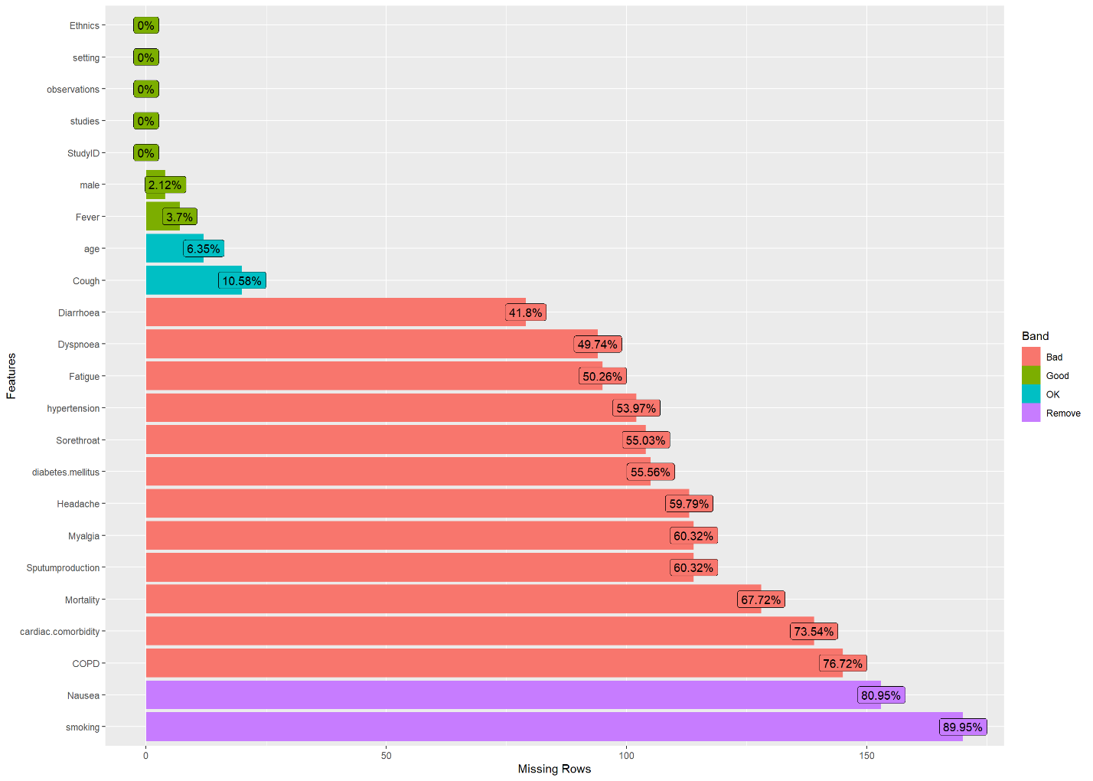
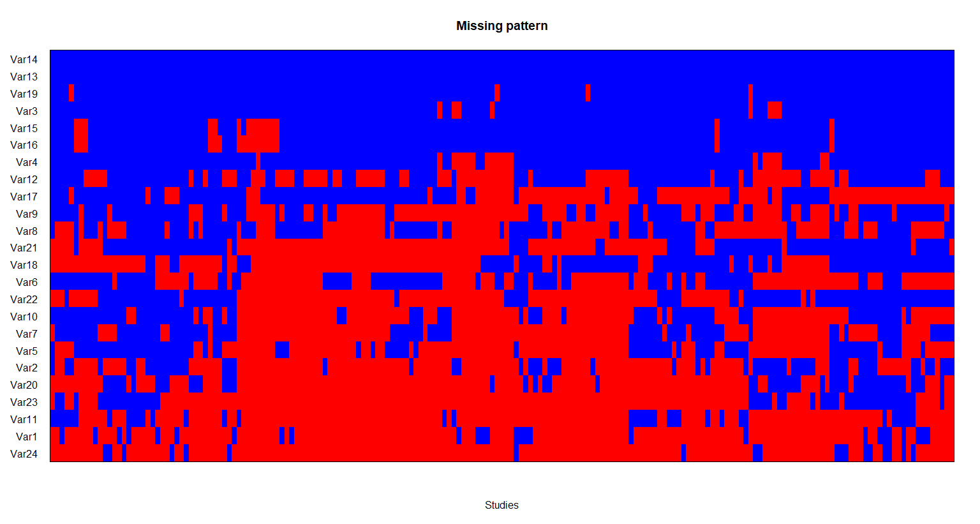
Note: Var1: Severity, Var2: Mortality, Var3: Fever, Var4: Cough, Var5: Sputum production, Var6: Sore throat, Var7: Myalgia, Var8: Fatigue, Var9: Dyspnoea, Var10: Headache, Var11: Nausea, Var12: diarrhoea, Var13: Setting, Var14: Ethnics, Var15: Data_first, Var16: Data_last, Var17: age (mean), Var18: age (median), Var19: Gender, Var20: Cardiac comorbidity, Var21: Hypertension, Var22: Diabetes mellitus, Var23: COPD, Var24: Smoking
Figure S2a. Forest plot for the proportion of symptoms and outcomes in COVID-19 patients among different study design groups.
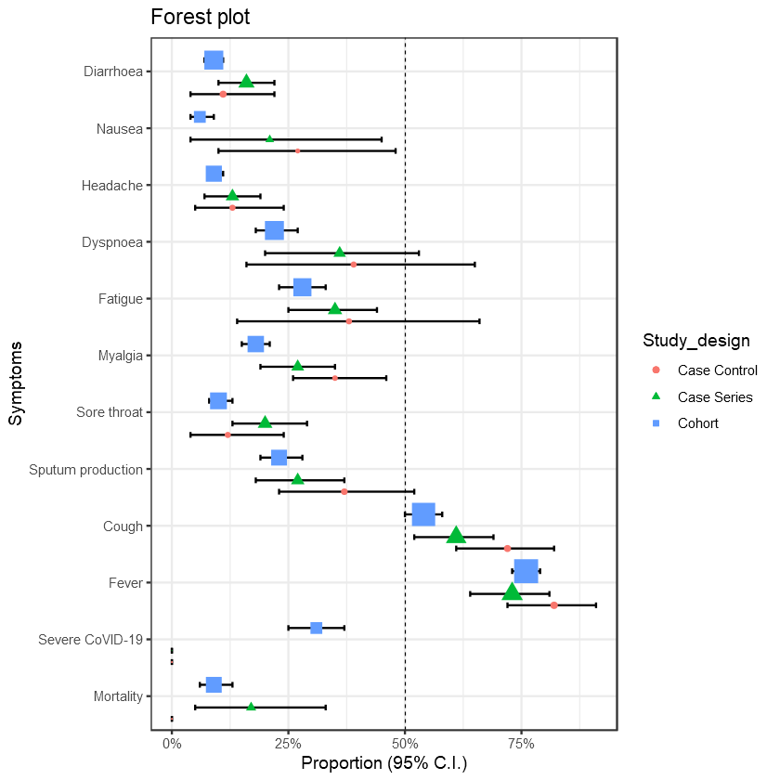

Figure S2b. Forest plot for the proportion of symptoms and outcomes in COVID-19 patients among different ethnicity groups.
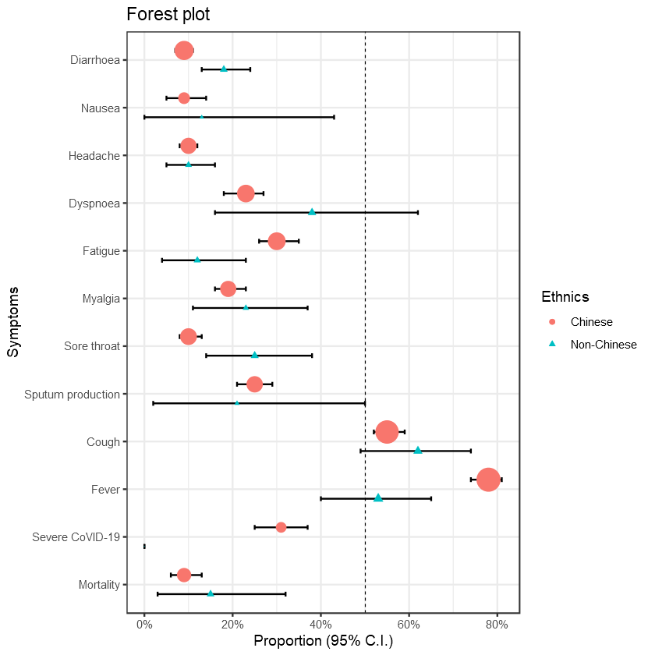

Figure S3a. Forest plot of pooled mean white blood cell counts among severe and non-severe COVID-19 patients.
Severe COVID-19 group | Non-severe COVID-19 group
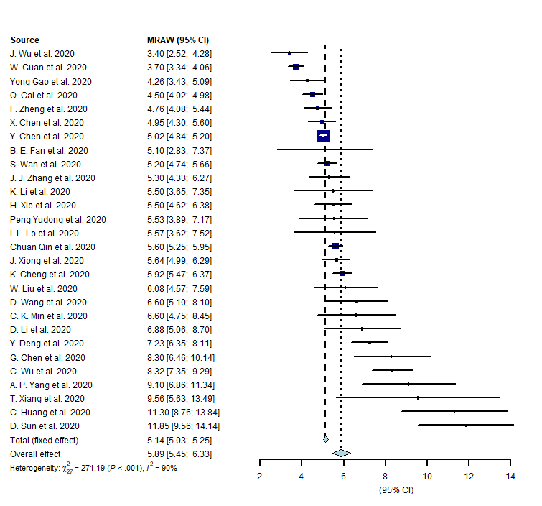 | 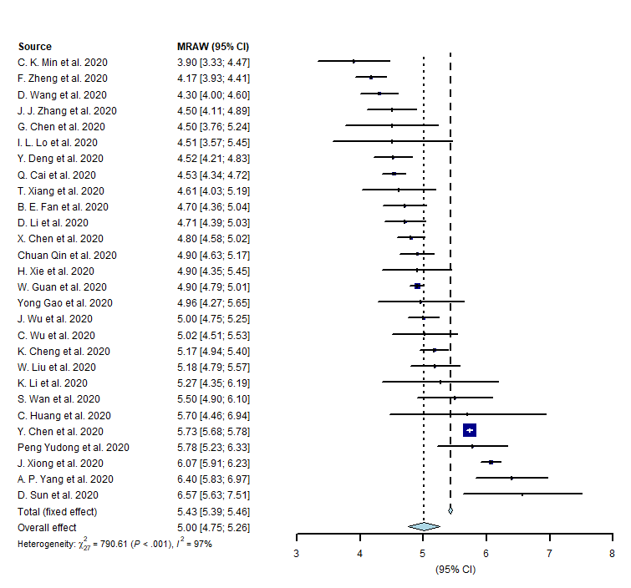

Figure S3b. Forest plot of pooled mean lymphocyte counts among severe and non-severe COVID-19 patients.
Severe COVID-19 group | Non-severe COVID-19 group
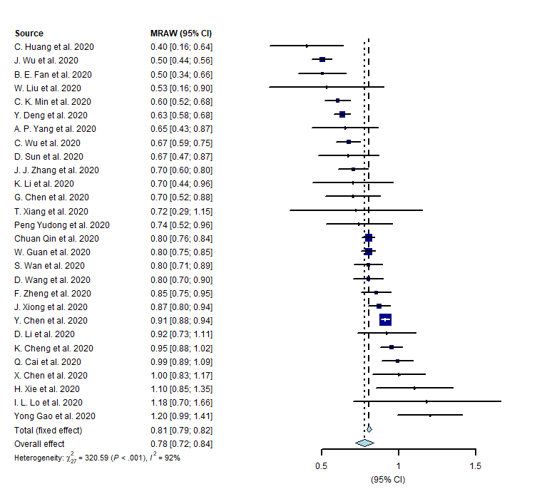 | 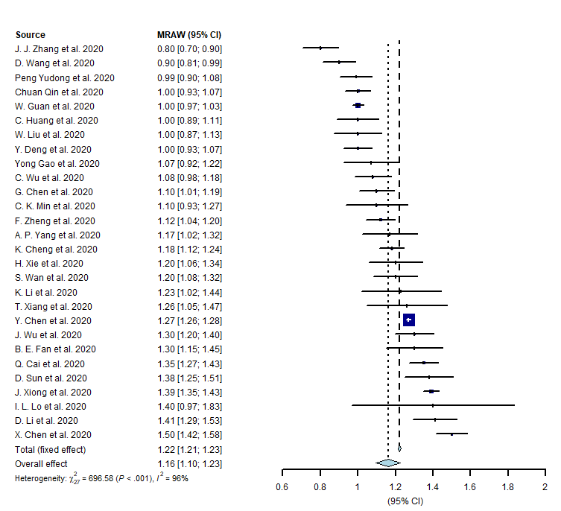

Figure S4a. Effect of stage of the outbreak in proportion of symptoms in COVID-19 patients.
Fever: 85% to 60% (p for trend <0.001) | Cough: 60% to 50% (p for trend <0.001)
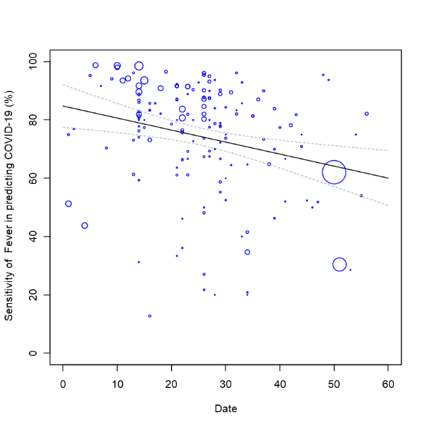 | 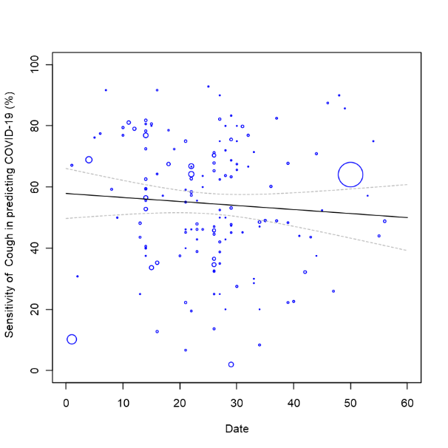
Fatigue: 50% to 10% (p for trend <0.001) | Dyspnoea: 40% to 20% (p for trend <0.001)
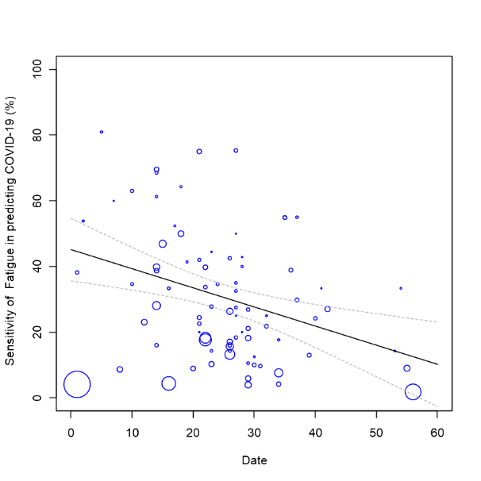 | 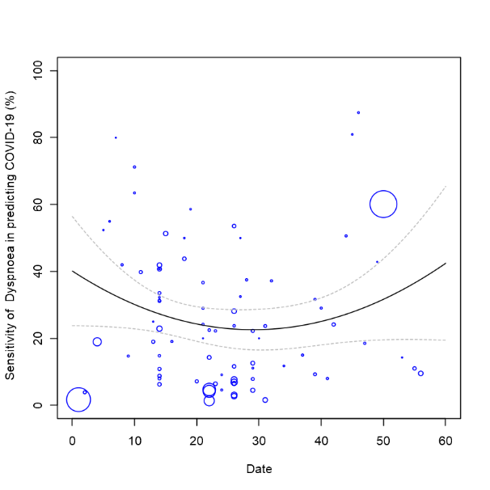

Figure S4b. Effect of age in proportion of symptoms in COVID-19 patients.
Fever: 50% to 85% (p for trend <0.001) | Cough: 45% to 60% (p for trend <0.001)
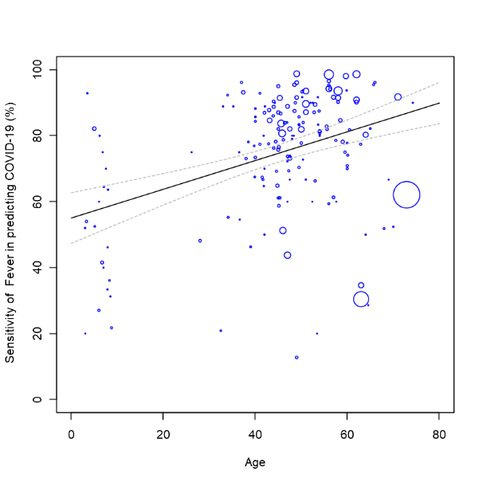 | 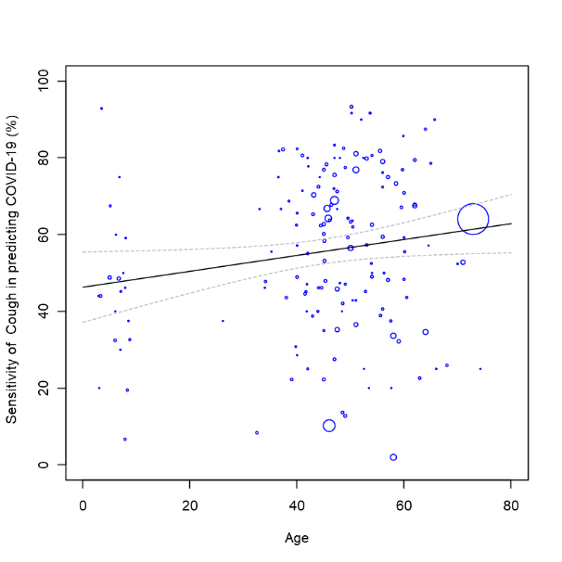
Fatigue: 5% to 45% (p for trend <0.001) | Dyspnoea: 0% to 50% (p for trend <0.001)
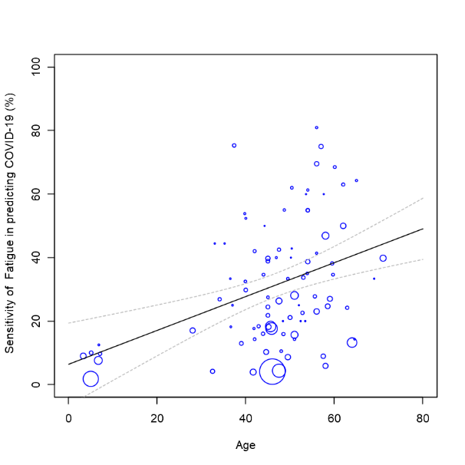 | 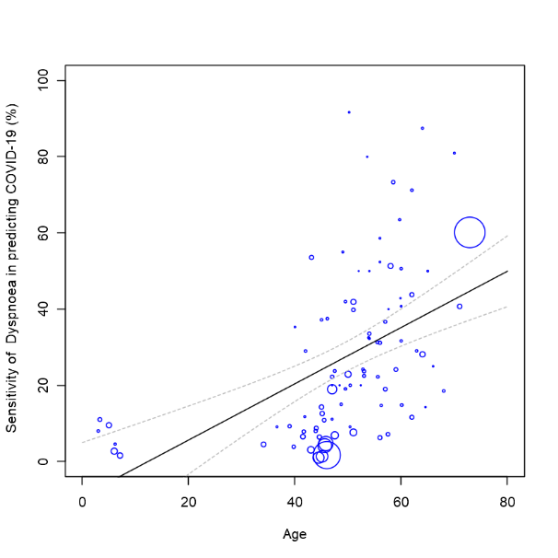

Figure S4c. Effect of stage of the outbreak in proportion of symptoms in severe COVID-19 patients.
Fever | Cough
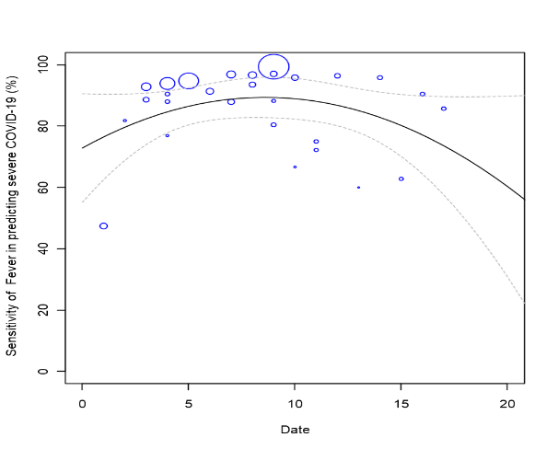 | 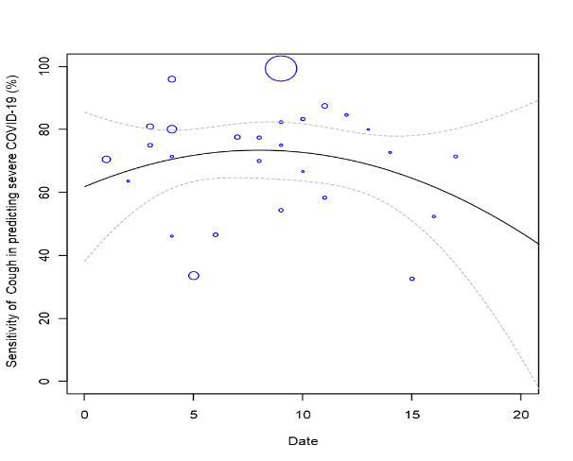
Sputum production | Sore throat
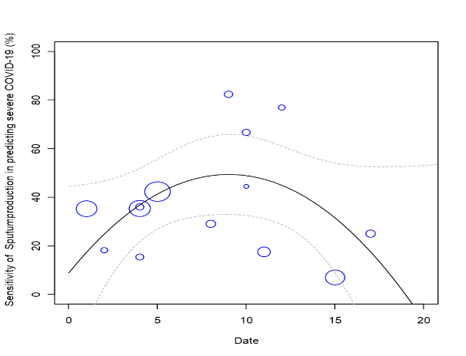 | 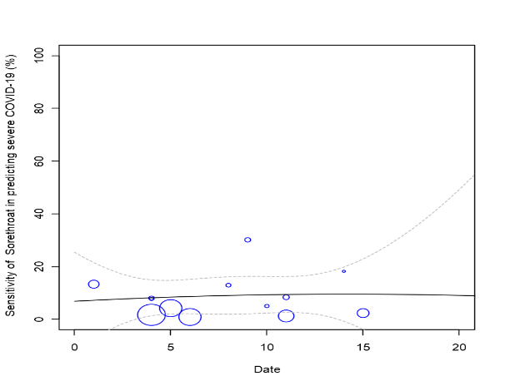
Myalgia | Fatigue
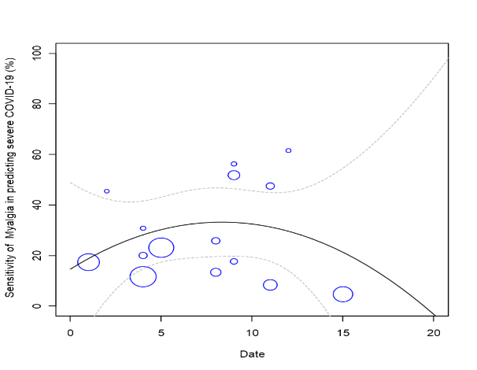 | 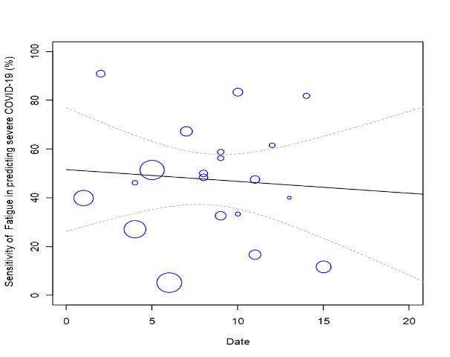
Note: The size of each circle has represented the inverse of the square root of effect size for each study. Date was represented the beginning enrolled day for each study (From 2019/12/1 to 2020/1/31).
Figure S5. Meta-regression results. Number inside presenting coefficients of the confounders including age, cardiac comorbidity, hypertension, diabetes mellitus (D.M.), chronic obstructive pulmonary disease (COPD), smoking and stage of the outbreak
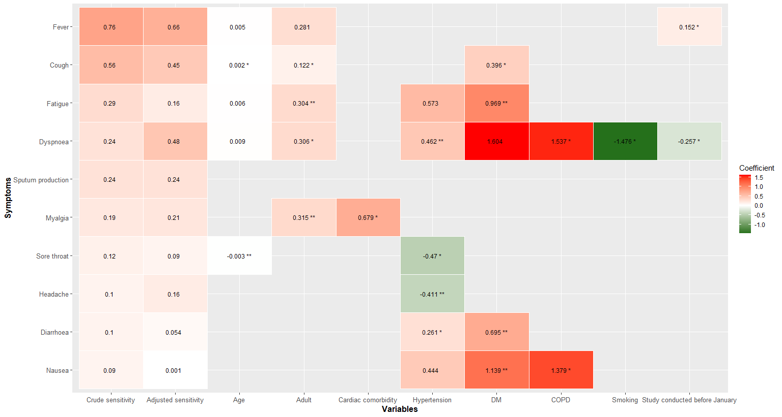

Figure S6-1. Funnel plot of Egger's test to detecting publication bias for mortality.
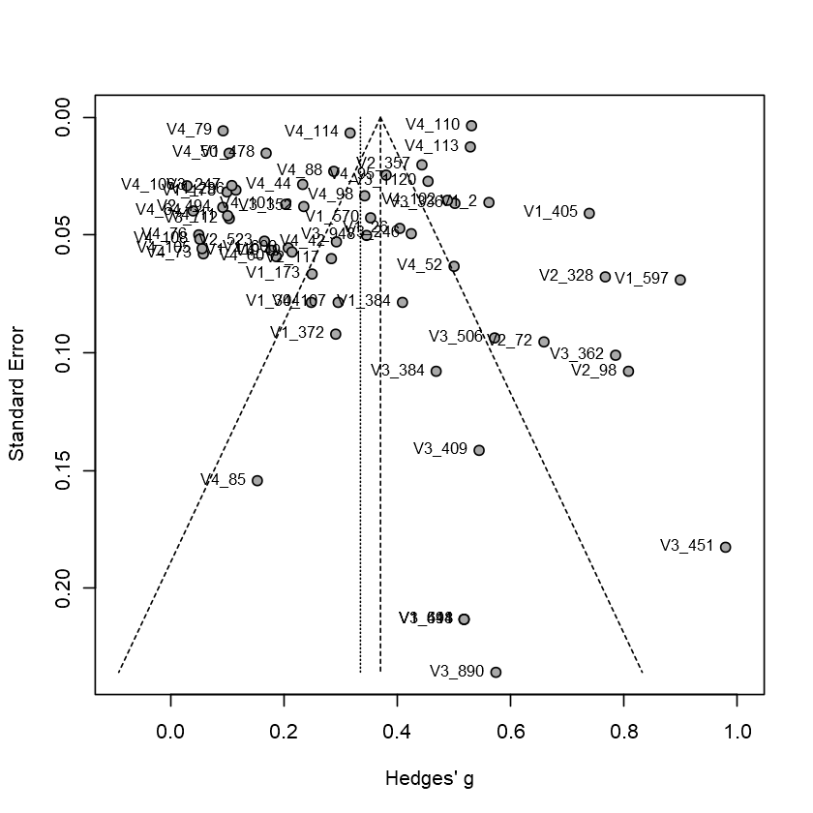

Figure S6-2. Funnel plot by Egger's test to detecting publication bias for severity.
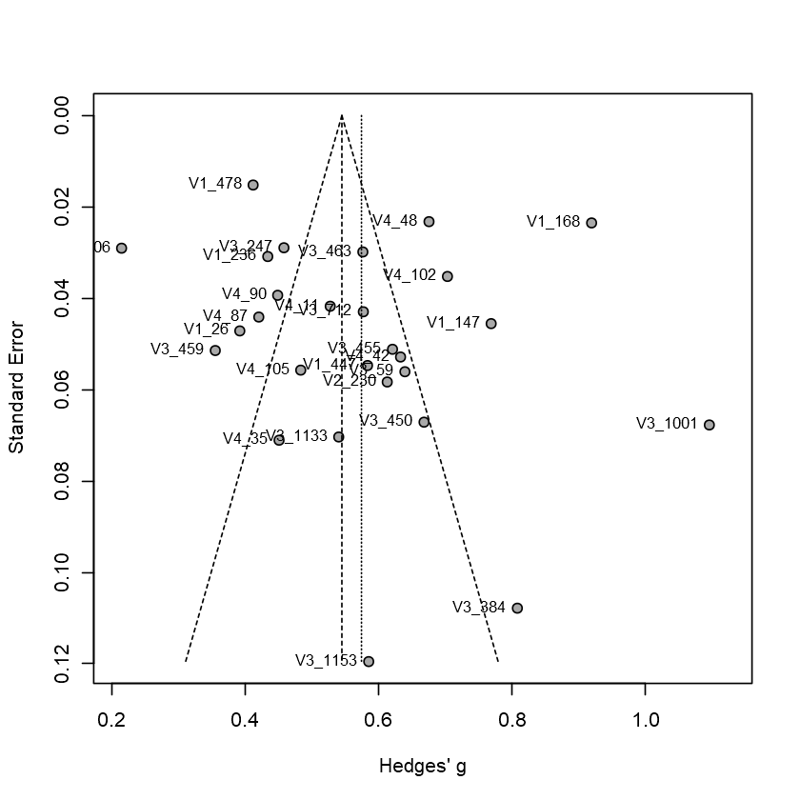

Figure S6-3. Funnel plot by Egger's test to detecting publication bias for fever.
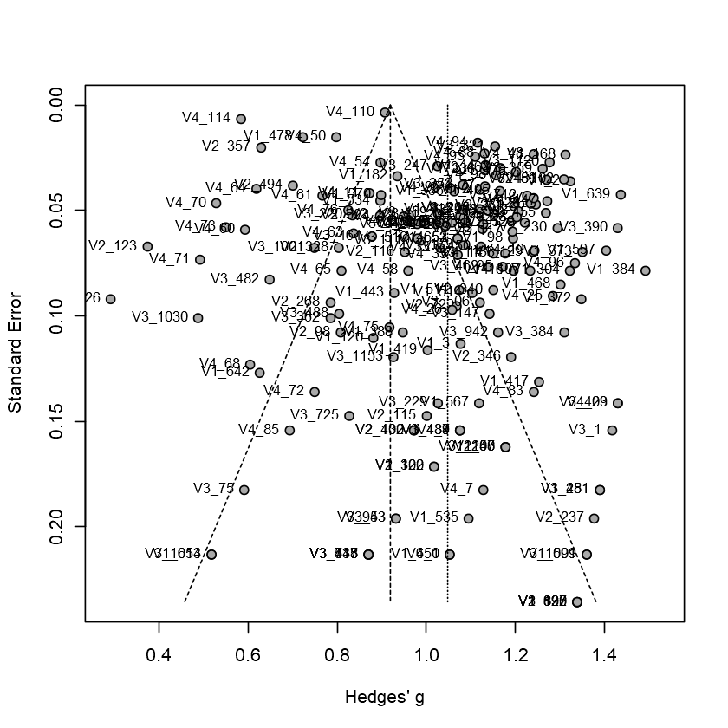

Figure S6-4. Funnel plot by Egger's test to detecting publication bias for cough.
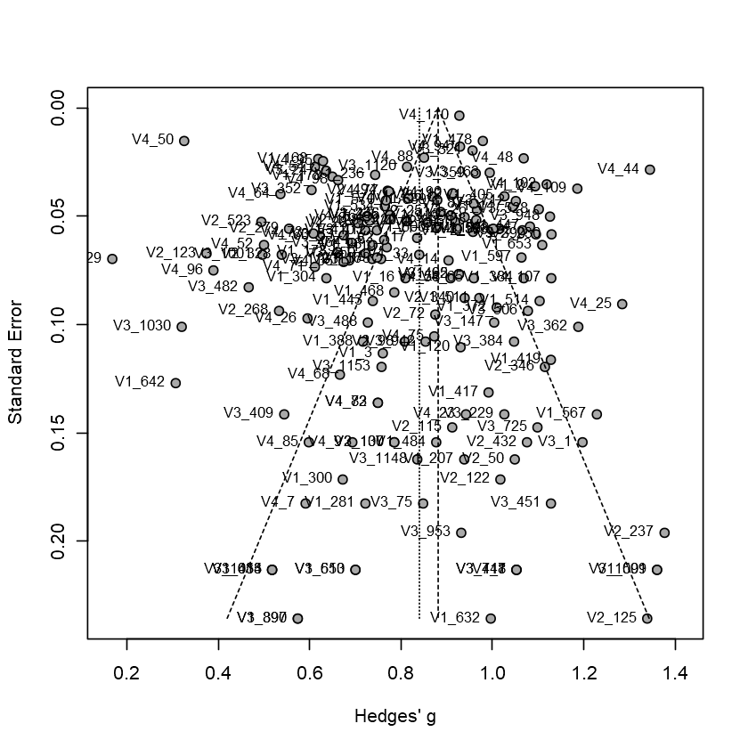

Figure S6-5. Funnel plot by Egger's test to detecting publication bias for sputum production.
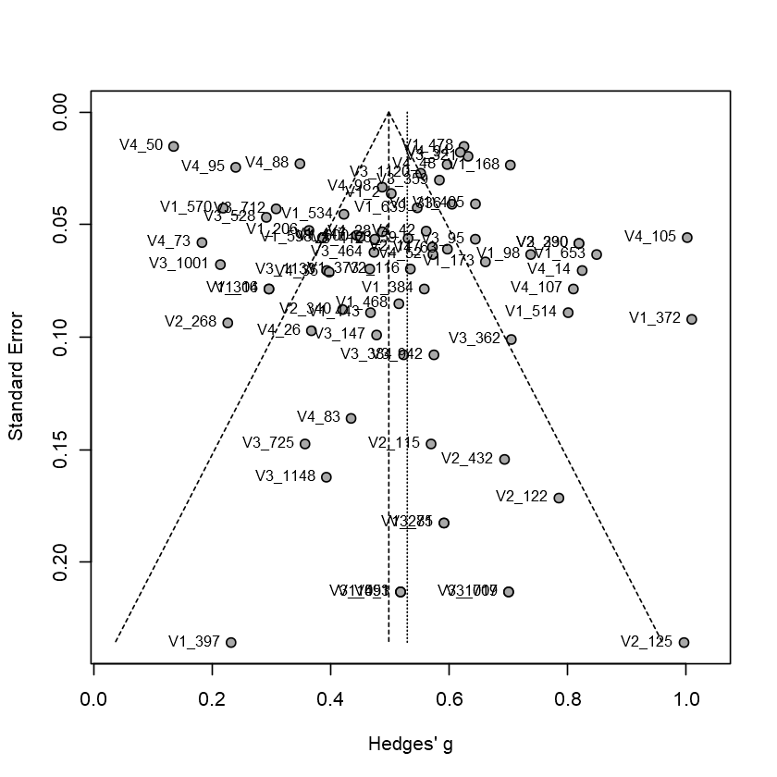

Figure S6-6. Funnel plot by Egger's test to detecting publication bias for sore throat.
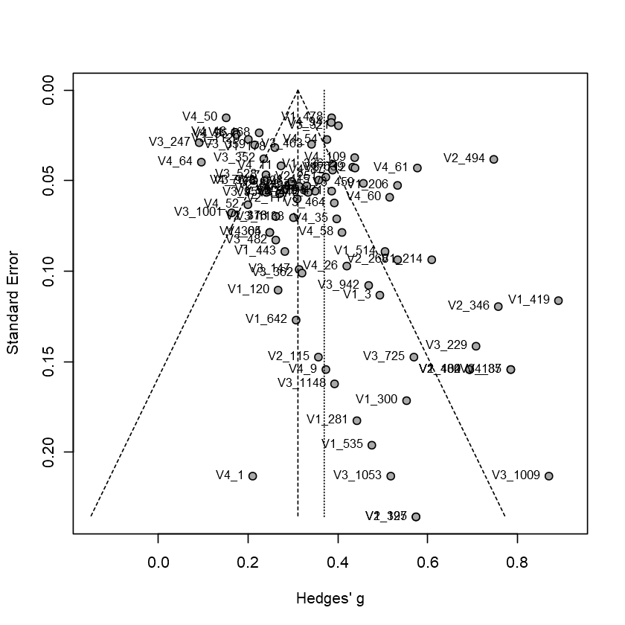

Figure S6-7. Funnel plot by Egger's test to detecting publication bias for myalgia.
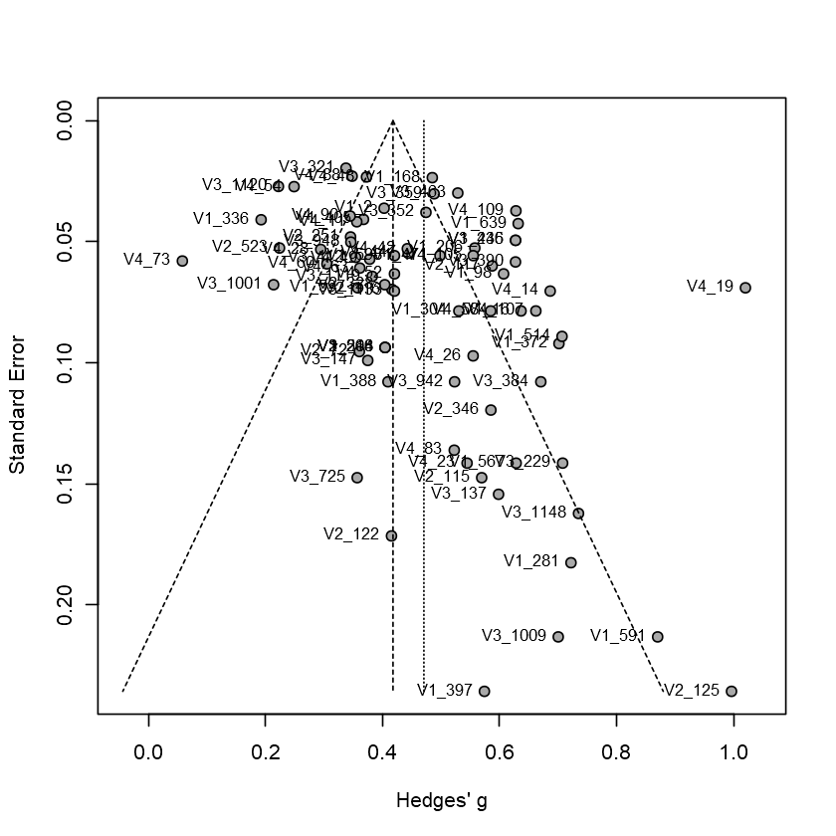

Figure S6-8. Funnel plot by Egger's test to detecting publication bias for fatigue.
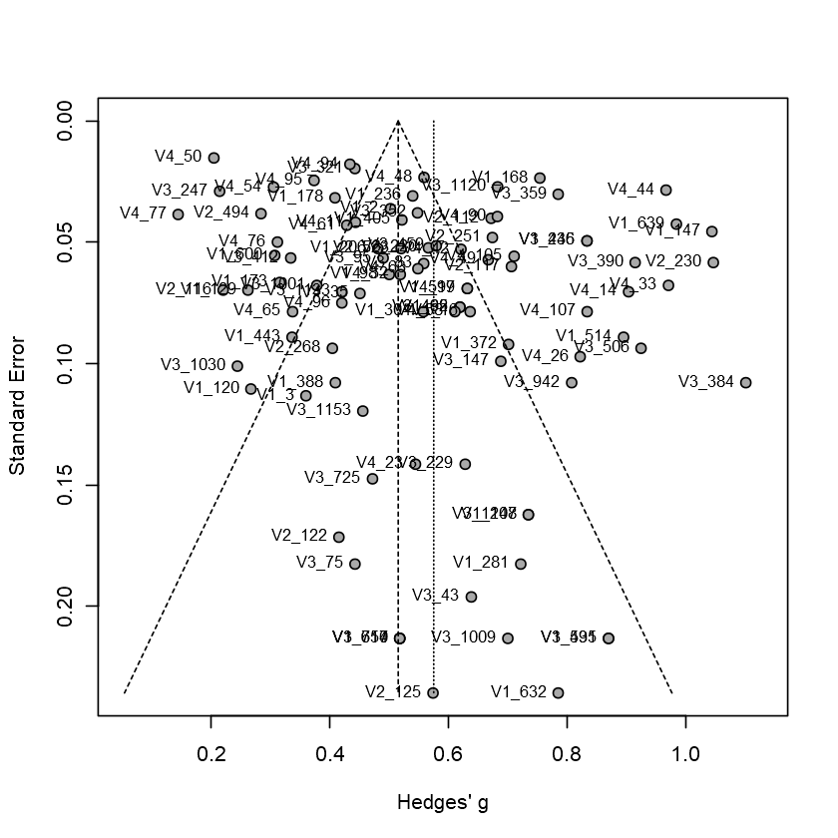

Figure S6-9. Funnel plot by Egger's test to detecting publication bias for dyspnoea.
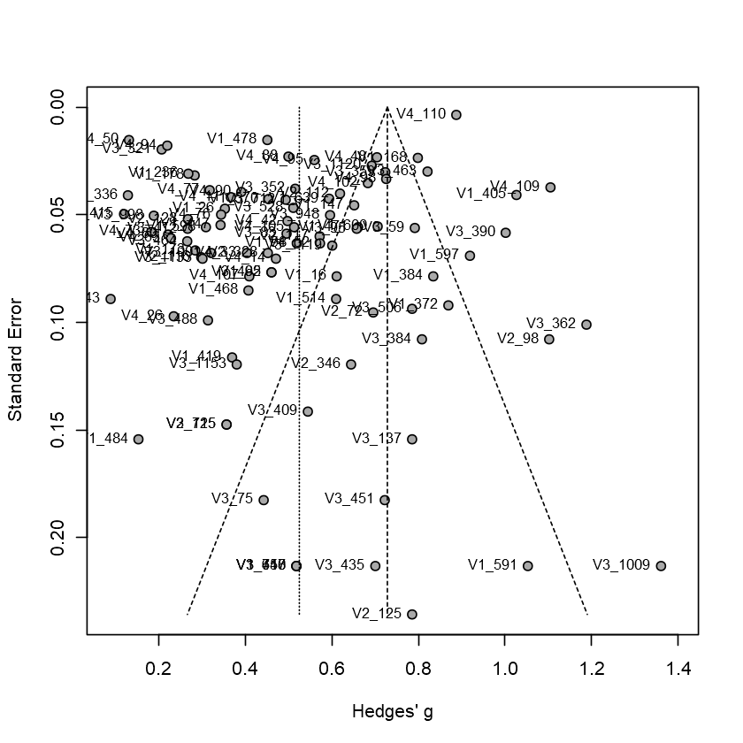

Figure S6-10. Funnel plot by Egger's test to detecting publication bias for headache.
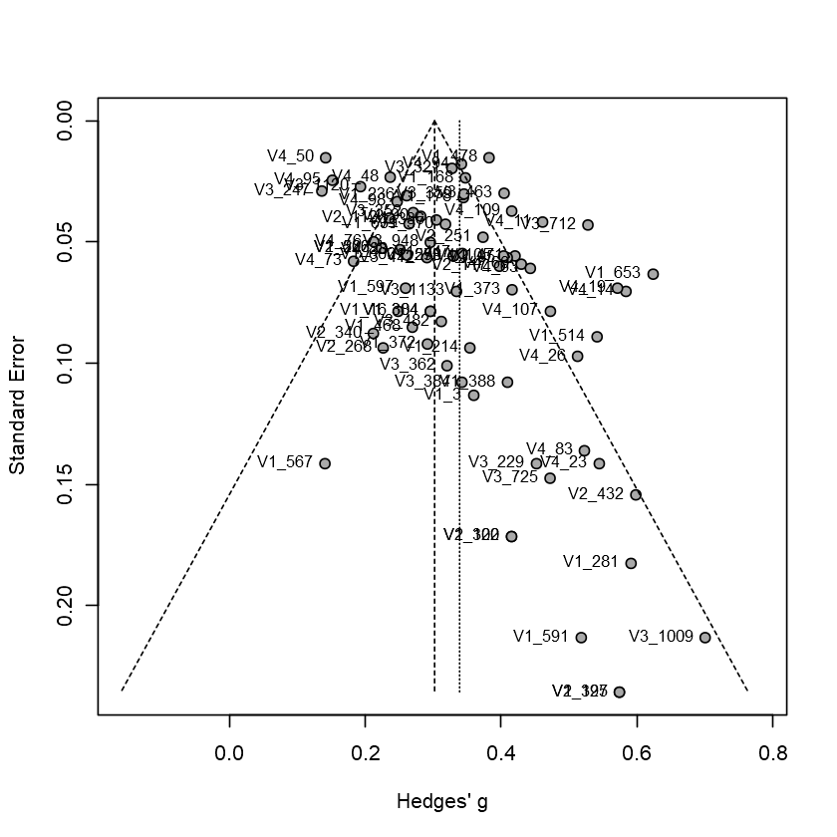

Figure S6-11. Funnel plot by Egger's test to detecting publication bias for nausea.
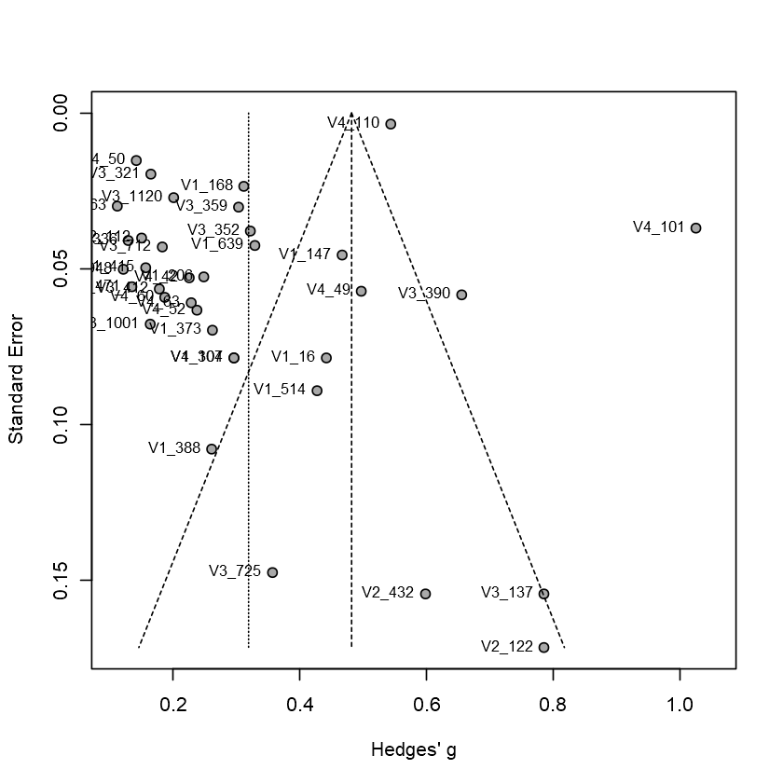

Figure S6-12. Funnel plot by Egger's test to detecting publication bias for diarrhoea.
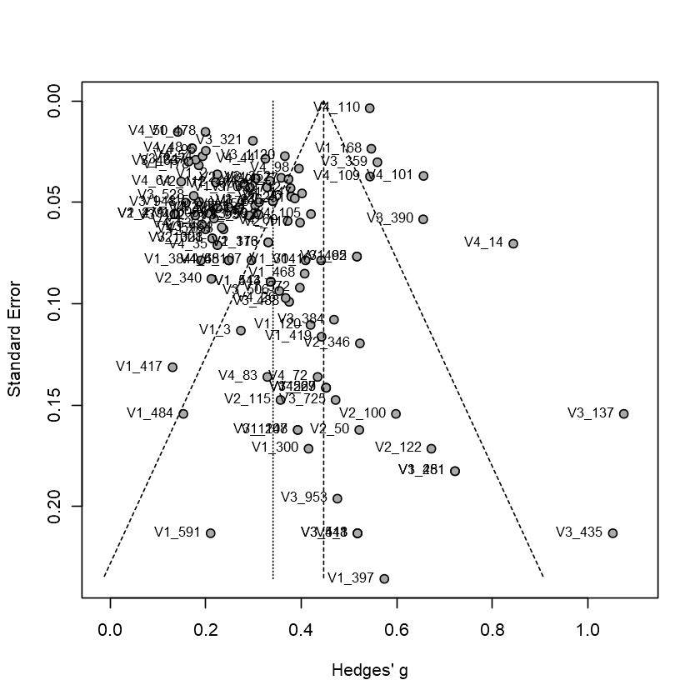

Figure S7a. Graphical Display of quality assessment for cohort study.
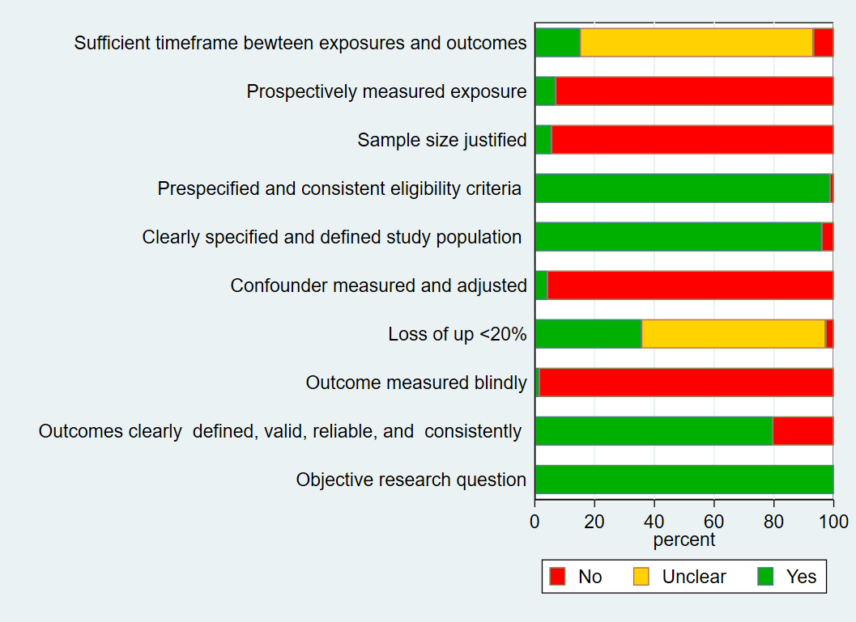

Figure S7b. Graphical Display of quality assessment for case series study.
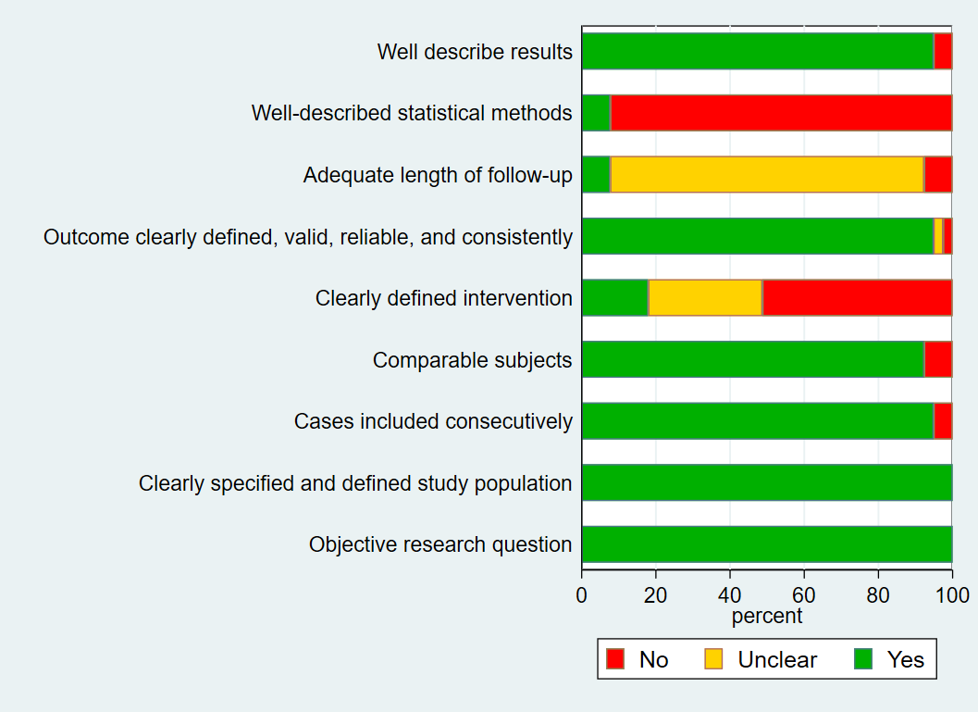
Figure S7c. Graphical Display of quality assessment for case control study.
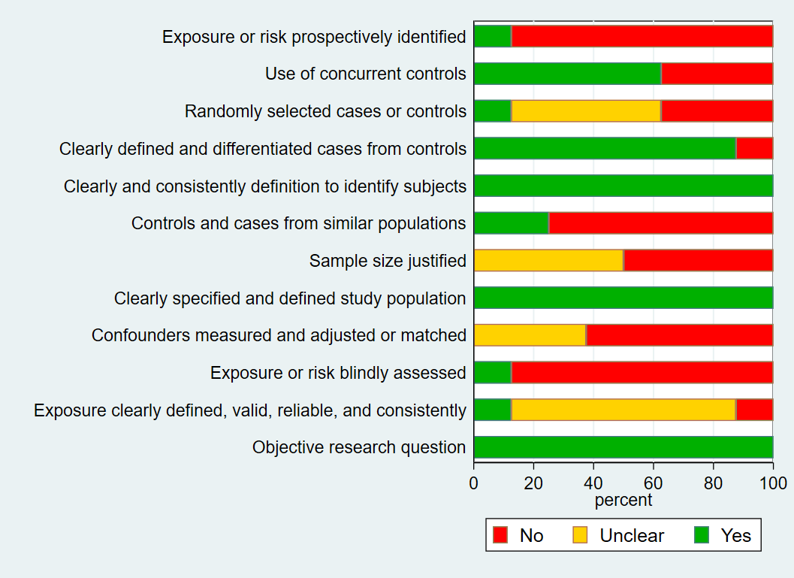
Table S1. Search Strategy to Identify Relevant Articles.
S/N | Concept | Search Terms
#1 | Disease | ("Coronavirus"[Mesh] OR coronavirus disease[tw] OR coronavirus[tw] OR 2019-nCov[tw] OR SARS-CoV-2[tw] OR COVID-19[tw] OR new coronary pneumonia[tw] OR corona virus[tw] OR novel coronavirus[tw] OR nCov[tw] OR SARS-2-CoV[tw] OR wuhan coronavirus[tw] OR wuhan pneumonia[tw])
#2 | Clinical, Laboratory, Radiologic Characteristics, and Outcomes | (symptom*[tw] OR clinical characteristic*[tw] OR co-morbidit*[tw] OR comorbidit*[tw] OR epidemiolog*[tw] OR inciden*[tw] OR "Radiology"[Mesh] OR radiologic features[tw] OR chest x-ray[tw] OR chest CT[tw] OR Lung ultrasound[tw] OR "Ultrasonography"[Mesh] OR "Tomography, X-Ray Computed"[Mesh] OR ultrasound[tw] OR sonography[tw] OR ultrasonography[tw] OR radiography[tw] OR chest film[tw] OR chest radiograph[tw] risk factors[tw] OR "Diagnosis"[Mesh] OR cases[tw] OR "Mortality"[Mesh] OR death[tw] OR case fatality rate[tw] OR case fatality ratio[tw] OR "Physical Examination"[Mesh] OR "Clinical Laboratory Techniques"[Mesh] OR "Diagnostic Tests, Routine"[Mesh] OR clinical laboratory [tw] OR laboratory characteristics [tw] OR laboratory panel [tw] OR laboratory values [tw] OR "Critical Care"[Mesh] OR "Intensive Care Units"[Mesh] OR Intensive Care Units[tw] OR "Hospitalization"[Mesh] OR "Sepsis"[Mesh])
#3 | Publication period | ("2019/12/31"[PDAT] : "2020/03/31"[PDAT])
#4 | Publication type | (Review[ptyp] OR Practice Guideline[ptyp] OR Letter[ptyp] OR Guideline[ptyp] OR Editorial[ptyp] OR Comment[ptyp])
#5 | Species | animals[mh] NOT humans[mh]
#6 | #1 AND #2 AND #3 NOT #4
Strategy | #6 NOT #5

Table S2. The National Institute of Health in the U.S. (NIH) Quality Assessment Tool.
Study Design | Criteria | Yes | No | Unclear
Cohort Study | 1. Was the research question or objective in this paper clearly stated?
 | 2. Was the study population clearly specified and defined?
 | 3. Were all the subjects selected or recruited from the same or similar populations (including the same time period)? Were inclusion and exclusion criteria for being in the study pre-specified and applied uniformly to all participants?
 | 4. Was a sample size justification, power description, or variance and effect estimates provided?
 | 5. For the analyses in this paper, were the exposure(s) of interest measured prior to the outcome(s) being measured?
 | 6. Was the timeframe sufficient so that one could reasonably expect to see an association between exposure and outcome if it existed?
 | 7. Were the outcome measures (dependent variables) clearly defined, valid, reliable, and implemented consistently across all study participants?
 | 8. Were the outcome assessors blinded to the exposure status of participants?
 | 9. Was loss to follow-up after baseline 20% or less?
 | 10. Were key potential confounding variables measured and adjusted statistically for their impact on the relationship between exposure(s) and outcome(s)?
Case Series Study | 1. Was the study question or objective clearly stated?
 | 2. Was the study population clearly and fully described, including a case definition?
 | 3. Were the cases consecutive?
 | 4. Were the subjects comparable?
 | 5. Was the intervention clearly described?
 | 6. Were the outcome measures clearly defined, valid, reliable, and implemented consistently across all study participants?
 | 7. Was the length of follow-up adequate?
 | 8. Were the statistical methods well-described?
 | 9. Were the results well-described?
Case Control Study | 1. Was the research question or objective in this paper clearly stated and appropriate?
 | 2. Was the study population clearly specified and defined?
 | 3. Did the authors include a sample size justification?
 | 4. Were controls selected or recruited from the same or similar population that gave rise to the cases (including the same timeframe)?
 | 5. Were the definitions, inclusion and exclusion criteria, algorithms or processes used to identify or select cases and controls valid, reliable, and implemented consistently across all study participants?
 | 6. Were the cases clearly defined and differentiated from controls?
 | 7. If less than 100 percent of eligible cases and/or controls were selected for the study, were the cases and/or controls randomly selected from those eligible?
 | 8. Was there use of concurrent controls?
 | 9. Were the investigators able to confirm that the exposure/risk occurred prior to the development of the condition or event that defined a participant as a case?
 | 10. Were the assessors of exposure/risk blinded to the case or control status of participants?
 | 11. Were key potential confounding variables measured and adjusted statistically in the analyses? If matching was used, did the investigators account for matching during study analysis?

Table S3. Study characteristics of included studies.
Authors | Year | Country | Study Design | First date of  enrollment | Number of observations | Average of age | Severity (%) | Mortality (%) | Male (%) | Cardiac comorbidity (%) | Hypertension (%) | Diabetes mellitus (%) | COPD (%) | Smoking (%) | Symptoms
Xia et al.¹ | 2020 | China | Cohort | 2020/1/23 | 20 | NA | NA | NA | 65.0 | 30.0 | NA | NA | NA | NA | fever; cough; sore throat; fatigue; diarrhoea
Li et al.² | 2020 | China | Cohort | 2020/1/23 | 51 | 58 | NA | NA | 54.9 | NA | NA | NA | NA | NA | fever; cough; fatigue
Zhu et al.³ | 2020 | China | Case control | 2019/12/1 | 12 | 52 | NA | NA | 66.7 | 16.7 | NA | NA | NA | NA | NA
Zhang et al.⁴ | 2020 | China | Cohort | 2020/1/16 | 120 | 57 | 48.3 | NA | 59.2 | 10.0 | 35.0 | 14.2 | 1.7 | 7.5 | fever; cough; fatigue; shortness of breath; nausea; diarrhoea
Yao et al.⁵ | 2020 | China | Cohort | 2020/1/21 | 40 | 53.87 | NA | NA | 60.0 | NA | NA | NA | NA | NA | fever; cough; sputum production; myalgia; fatigue; shortness of breath; headache; nausea; diarrhoea
Qin et al.⁶ | 2020 | China | Cohort | 2020/1/10 | 452 | 58 | 63.3 | NA | 52.0 | 6.0 | 29.9 | 16.6 | 2.7 | 1.5 | fever; cough; sputum production; sore throat; myalgia; fatigue; shortness of breath; headache; nausea; diarrhoea
Liu et al.⁷ | 2020 | China | Cohort | 2020/1/15 | 56 | 57.5 | NA | 5.4 | 55.4 | 5.4 | 17.9 | 7.1 | NA | 39.3 | fever; cough; sputum production; fatigue; shortness of breath
Chen et al.⁸ | 2020 | China | Cohort | 2020/1/20 | 249 | 51 | NA | 0.8 | 50.6 | 22.1 | NA | NA | NA | NA | fever; cough; sore throat; fatigue; shortness of breath; headache; diarrhoea
Bai et al.⁹ | 2020 | China | Case control | 2020/1/6 | 219 | 44.8 | NA | NA | 54.3 | 5.5 | 14.2 | 8.2 | 4.1 | NA | fever
Zhou et al.¹⁰ | 2020 | China | Cohort | 2019/12/29 | 191 | 56 | NA | 28.3 | 62.3 | 7.9 | 30.4 | 18.8 | 3.1 | 5.8 | fever; cough; sputum production; myalgia; fatigue; diarrhoea
Xu et al.¹¹ | 2020 | China | Cohort | 2020/1/23 | 90 | 50 | NA | NA | 43.3 | 3.3 | 18.9 | 5.6 | 1.1 | NA | fever; cough; sputum production; sore throat; myalgia; fatigue; headache; nausea; diarrhoea
Xie et al.¹² | 2020 | China | Case Series | NA | 9 | 33 | NA | NA | 44.4 | NA | NA | NA | NA | NA | fever; cough; fatigue; diarrhoea
Korea Centers¹³ | 2020 | Korea & China | Cohort | 2020/1/20 | 28 | 42.6 | NA | NA | 53.6 | NA | NA | NA | NA | NA | sore throat; myalgia; headache
Tian et al.¹⁴ | 2020 | China | Cohort | 2020/1/20 | 262 | 47.5 | 17.6 | 1.2 | 48.5 | NA | NA | NA | NA | NA | fever; cough; fatigue; shortness of breath; headache
Peng et al.¹⁵ | 2020 | China | Cohort | 2020/1/20 | 112 | 62 | 14.3 | 15.2 | 47.3 | 55.4 | 82.1 | 20.5 | NA | NA | fever; cough; shortness of breath; diarrhoea
Guan et al.¹⁶ | 2020 | China | Case Series | 2020/1/22 | 7 | 50.37 | NA | NA | 42.9 | NA | NA | NA | NA | NA | fever; cough; sputum production; sore throat; myalgia; fatigue; headache; diarrhoea
Zhao et al.¹⁷ | 2020 | China | Case control | 2020/1/23 | 19 | 48 | NA | NA | 57.9 | NA | 10.5 | NA | NA | NA | fever; cough; sore throat; fatigue; headache; diarrhoea
Qiu et al.¹⁸ | 2020 | China | Case Series | 2020/2/2 | 8 | 26.142 | NA | NA | 50.0 | NA | NA | NA | NA | NA | fever; cough; sore throat; headache; diarrhoea
Wu et al.¹⁹ | 2020 | China | Cohort | 2020/1/21 | 40 | 45 | NA | 5.0 | 32.5 | NA | NA | NA | NA | NA | fever; cough; sputum production; sore throat; myalgia; fatigue; headache; nausea; diarrhoea
Yang et al.²⁰ | 2020 | China | Cohort | 2020/1/17 | 149 | 45.11 | NA | NA | 54.4 | NA | NA | NA | NA | NA | fever; cough; sputum production; sore throat; myalgia; shortness of breath; headache; nausea; diarrhoea
Chen et al.²¹ | 2020 | China | Cohort | 2020/1/14 | 29 | 56 | NA | 6.9 | 72.4 | NA | 27.6 | 17.2 | NA | 6.9 | fever; cough; sputum production; myalgia; fatigue; shortness of breath; headache; diarrhoea
Song et al.²² | 2020 | China | Cohort | 2020/1/20 | 51 | 49 | NA | NA | 49.0 | 2.0 | 9.8 | 5.9 | 2.0 | 5.9 | fever; cough; sputum production; sore throat; headache; nausea; diarrhoea
Huang et al.²³ | 2020 | China | Cohort | 2019/12/16 | 40 | 49 | NA | 15.0 | 75.0 | 15.0 | 15.0 | 20.0 | 2.5 | 7.5 | fever; cough; sputum production; shortness of breath; headache; diarrhoea
Chung et al.²⁴ | 2020 | China | Cohort | 2020/1/18 | 21 | 51 | NA | NA | 61.9 | NA | NA | NA | NA | NA | fever; cough; myalgia; fatigue; headache; nausea
Dai et al.²⁵ | 2020 | China | Case Series | NA | 4 | 52.5 | NA | NA | 100.0 | NA | NA | NA | NA | NA | fever; cough; sputum production; sore throat; myalgia; headache; diarrhoea
Ruan et al.²⁶ | 2020 | China | Cohort | NA | 150 | 58.5 | NA | 45.3 | 68.0 | 8.7 | 34.7 | 16.7 | 2.0 | NA | fever; cough; sputum production; myalgia; fatigue; shortness of breath
Liu et al.²⁷ | 2020 | China | Cohort | 2019/12/30 | 78 | 38 | NA | 2.6 | 50.0 | NA | 10.3 | 6.4 | 2.6 | 6.4 | fever; cough
Zhao et al.²⁸ | 2020 | China | Cohort | NA | 101 | 44.44 | NA | NA | 55.5 | NA | NA | NA | NA | NA | fever; cough; sore throat; shortness of breath; nausea; diarrhoea
Zhang et al.²⁹ | 2020 | China | Cohort | 2020/1/27 | 14 | 41 | NA | NA | 50.0 | NA | NA | NA | NA | NA | fever; cough; diarrhoea
Young et al.³⁰ | 2020 | Singapore | Case Series | 2020/1/23 | 18 | 47 | NA | NA | 50.0 | NA | NA | NA | NA | NA | fever; cough; sore throat; shortness of breath; diarrhoea
Cao et al.³¹ | 2020 | China | Case Series | 2020/1/3 | 102 | 54 | NA | NA | 52.0 | 4.9 | 27.5 | 10.8 | NA | NA | fever; cough; myalgia; fatigue; diarrhoea
Wang et al.³² | 2020 | China | Cohort | 2020/1/25 | 31 | 7.08 | NA | NA | 48.4 | NA | NA | NA | NA | NA | fever; cough; sputum production; sore throat; fatigue; shortness of breath; diarrhoea
Li et al.³³ | 2020 | China | Cohort | 2020/1/1 | 83 | 45.5 | 30.1 | NA | 53.0 | 1.2 | 6.0 | 8.4 | 6.0 | NA | fever; cough; sputum production; sore throat; myalgia; shortness of breath; headache; diarrhoea
Huang et al.³⁴ | 2020 | China | Cohort | 2019/12/21 | 34 | 56.24 | NA | NA | 41.2 | 17.6 | 23.5 | 11.8 | 2.9 | NA | fever; cough; sputum production; shortness of breath; headache; diarrhoea
Wu et al.³⁵ | 2020 | China | Cohort | 2020/1/22 | 80 | 46.1 | NA | NA | 48.8 | NA | NA | NA | 0.0 | NA | fever; cough; sore throat; myalgia; shortness of breath; headache; nausea; diarrhoea
Guan et al.³⁶ | 2020 | China | Cohort | 2019/12/11 | 1081 | 47 | 16.0 | 2.8 | 58.9 | 2.5 | 15.3 | 7.5 | 1.1 | 14.6 | fever; cough; sputum production; sore throat; shortness of breath; headache; diarrhoea
Cai et al.³⁷ | 2020 | China | Case Series | 2020/1/19 | 10 | 6.167 | NA | NA | 40.0 | NA | NA | NA | NA | NA | fever; cough; sore throat; shortness of breath; diarrhoea
Liu et al.³⁸ | 2020 | China | Cohort | 2020/1/23 | 32 | 38.5 | NA | NA | 62.5 | 3.1 | 3.1 | NA | NA | NA | fever; cough
Li et al.³⁹ | 2020 | China | Case control | 2020/1/1 | 31 | 54 | NA | NA | 48.4 | NA | NA | NA | NA | NA | fever; cough; sputum production; sore throat; myalgia; fatigue; shortness of breath; headache; nausea; diarrhoea
Bernheim et al.⁴⁰ | 2020 | China | Cohort | 2020/1/18 | 121 | 45.3 | NA | NA | 50.4 | NA | NA | NA | NA | NA | fever; cough; sputum production
Bai et al.⁴¹ | 2020 | China | Case Series | 2020/1/26 | 6 | 49.5 | NA | NA | NA | NA | NA | NA | NA | NA | fever; sore throat
Liu et al.⁴² | 2020 | China | Case Series | 2020/1/11 | 12 | 53.67 | NA | NA | 66.7 | 33.3 | 25.0 | 16.7 | NA | NA | fever; cough; myalgia; headache; diarrhoea
Kui et al.⁴³ | 2020 | China | Cohort | 2019/12/30 | 137 | 57 | NA | 11.7 | 44.5 | 7.3 | 9.5 | 10.2 | 1.5 | NA | fever; cough; sputum production; shortness of breath; headache; diarrhoea
Ren et al.⁴⁴ | 2020 | China | Case Series | 2019/12/18 | 5 | 53.6 | NA | 20.0 | 60.0 | NA | 20.0 | NA | NA | NA | fever; cough; sputum production; myalgia; fatigue; shortness of breath; headache; diarrhoea
Yang et al.⁴⁵ | 2020 | China | Cohort | 2019/12/24 | 52 | 59.7 | NA | 61.5 | 67.3 | 9.6 | NA | 17.3 | NA | 3.8 | fever; cough; myalgia; fatigue; shortness of breath; headache
Wu et al.⁴⁶ | 2020 | China | Cohort | 2020/1/1 | 80 | 44 | NA | NA | 52.5 | 1.3 | 5.0 | 5.0 | 3.8 | 32.5 | fever; cough; sputum production; sore throat; myalgia; shortness of breath; headache; diarrhoea
Shi et al.⁴⁷ | 2020 | China | Cohort | 2019/12/20 | 81 | 49.5 | NA | 3.7 | 51.9 | 9.9 | 14.8 | 12.3 | NA | NA | fever; cough; sputum production; fatigue; shortness of breath; headache; diarrhoea
Bai et al.⁴⁸ | 2020 | China | Case Series | 2020/1/22 | 5 | 53.42 | NA | 20.0 | 60.0 | 20.0 | 20.0 | 40.0 | NA | NA | fever; cough; fatigue
Wang et al.⁴⁹ | 2020 | China | Case Series | 2020/1/21 | 4 | 44.25 | NA | NA | 75.0 | NA | NA | NA | NA | NA | fever; cough; fatigue; headache
Wang et al.⁵⁰ | 2020 | China | Case Series | 2020/1/1 | 138 | 56 | NA | NA | 54.4 | 14.5 | 31.2 | 10.1 | 2.9 | NA | fever; cough; sputum production; sore throat; myalgia; fatigue; shortness of breath; headache; nausea; diarrhoea
Feng et al.⁵¹ | 2020 | China | Case Series | 2020/1/16 | 15 | 7.86 | NA | NA | 33.3 | NA | NA | NA | NA | NA | fever; cough; sore throat
Xie et al.⁵² | 2020 | China | Case Series | 2020/1/16 | 5 | 48.4 | NA | NA | 100.0 | NA | NA | NA | NA | NA | fever; cough; fatigue; shortness of breath
Xu et al.⁵³ | 2020 | China | Case Series | 2020/1/10 | 62 | 41 | NA | NA | 56.5 | NA | 8.1 | 1.6 | 1.6 | NA | fever; cough; sputum production; headache; diarrhoea
Xiong et al.⁵⁴ | 2020 | China | Cohort | 2020/1/11 | 42 | 49.5 | NA | NA | 59.5 | NA | NA | NA | NA | NA | fever; cough; fatigue; shortness of breath; diarrhoea
Zhou et al.⁵⁵ | 2020 | China | Cohort | 2020/1/16 | 62 | 52.8 | NA | NA | 62.9 | NA | 6.5 | 6.5 | NA | NA | fever; cough; sputum production; myalgia; fatigue; shortness of breath
Xu et al.⁵⁶ | 2020 | China | Case Series | 2020/1/22 | 10 | 7.543 | NA | NA | 60.0 | NA | NA | NA | NA | NA | fever; cough; sore throat; diarrhoea
Mo et al.⁵⁷ | 2020 | China | Cohort | 2020/1/1 | 155 | 54 | NA | NA | 55.5 | NA | 23.9 | 9.7 | 3.2 | NA | fever; cough; fatigue; shortness of breath; headache; nausea; diarrhoea
Cheng et al.⁵⁸ | 2020 | China | Case control | 2020/1/19 | 11 | 50.36 | NA | NA | 72.7 | NA | NA | NA | NA | NA | fever; cough; sputum production; sore throat; myalgia; shortness of breath; diarrhoea
Xu et al.⁵⁹ | 2020 | China | Cohort | 2020/1/23 | 51 | 41.67 | NA | NA | 98.0 | NA | NA | 7.8 | NA | NA | fever; cough; sputum production; sore throat; myalgia; fatigue; shortness of breath; diarrhoea
Wang et al.⁶⁰ | 2020 | China | Cohort | 2020/1/16 | 69 | 42 | NA | 7.3 | 46.4 | NA | 13.0 | 10.1 | 5.8 | NA | fever; cough; sputum production; sore throat; myalgia; fatigue; shortness of breath; headache; diarrhoea
Sun et al.⁶¹ | 2020 | China | Case Series | 2020/1/24 | 8 | 6.81 | NA | NA | 75.0 | NA | NA | NA | NA | NA | fever; cough; sputum production; myalgia; fatigue; headache; nausea; diarrhoea
Wang et al.⁶² | 2020 | China | Cohort | 2020/1/11 | 55 | 49 | NA | NA | 40.0 | NA | 14.5 | NA | NA | NA | fever; cough
Zhang et al.⁶³ | 2020 | China | Case Series | 2020/1/21 | 4 | 52 | NA | NA | 25.0 | NA | NA | NA | NA | NA | fever; cough; sputum production; sore throat; myalgia; fatigue; shortness of breath; headache
Lin et al.⁶⁴ | 2020 | China | Cohort | 2020/1/20 | 92 | 41.5 | NA | NA | NA | NA | NA | NA | NA | NA | fever; cough; shortness of breath
Liu et al.⁶⁵ | 2020 | China | Cohort | 2020/1/21 | 73 | 37.38 | 32.9 | NA | 56.2 | NA | NA | NA | NA | NA | fever; cough; sputum production; fatigue
Liu et al.⁶⁶ | 2020 | China | Case Series | 2020/1/2 | 6 | 3.5 | NA | NA | 33.3 | NA | NA | NA | NA | NA | fever; cough
Han et al.⁶⁷ | 2020 | China | Cohort | 2020/1/4 | 108 | 45 | NA | NA | 35.2 | NA | NA | NA | NA | NA | fever; cough; sore throat; myalgia; fatigue; headache; diarrhoea
Ki et al.⁶⁸ | 2020 | Korea | Case Series | 2020/1/20 | 28 | 42 | NA | NA | 53.6 | NA | NA | NA | NA | NA | fever; cough; sputum production; sore throat; myalgia; fatigue; headache
Cai et al.⁶⁹ | 2020 | China | Cohort | 2020/1/24 | 80 | 47 | NA | NA | 43.8 | NA | NA | NA | NA | NA | fever; cough; sore throat; headache; diarrhoea
He et al.⁷⁰ | 2020 | China | Cohort | 2020/2/3 | 54 | 68 | NA | 48.2 | 63.0 | 14.8 | 44.4 | 24.1 | 3.7 | NA | fever; cough; myalgia; shortness of breath; diarrhoea
Zhu et al.⁷¹ | 2020 | China | Case control | 2020/1/24 | 32 | 40 | NA | NA | 46.9 | 15.6 | 68.8 | 31.3 | 18.8 | NA | fever; cough; sputum production; headache; diarrhoea
Pung et al.⁷² | 2020 | Singapore | Cohort | NA | 17 | 40 | NA | NA | 41.2 | NA | 5.9 | NA | NA | NA | fever; cough; sore throat; myalgia; shortness of breath; diarrhoea
Cheng et al.⁷³ | 2020 | China | Cohort | 2020/1/28 | 615 | 63 | NA | 18.4 | 59.7 | NA | 37.9 | 16.3 | 2.1 | NA | fever
Liu et al.⁷⁴ | 2020 | China | Case Series | 2020/1/22 | 10 | 42 | NA | NA | 40.0 | NA | 10.0 | NA | NA | NA | fever; cough; sputum production; sore throat; headache; nausea
Lu et al.⁷⁵ | 2020 | China | Cohort | 2020/1/28 | 171 | 6.7 | NA | 0.6 | 60.8 | NA | NA | NA | NA | NA | fever; cough; sore throat; fatigue; diarrhoea
Chen et al.⁷⁶ | 2020 | China | Case Series | NA | 9 | 42.11 | NA | NA | 55.6 | NA | NA | NA | NA | NA | fever; cough; diarrhoea
Cao et al.⁷⁷ | 2020 | China | Cohort | 2020/1/18 | 199 | 58 | NA | NA | 60.3 | NA | NA | 11.6 | NA | NA | fever
Wang et al.⁷⁸ | 2020 | China | Cohort | 2020/1/16 | 90 | 45 | NA | 2.2 | 36.7 | NA | NA | NA | NA | NA | fever; cough; sore throat; myalgia; fatigue; headache; diarrhoea
Zhao et al.⁷⁹ | 2020 | China | Cohort | 2020/1/1 | 80 | 44 | NA | NA | 53.8 | NA | NA | NA | NA | NA | fever
Yuan et al.⁸⁰ | 2020 | China | Cohort | 2020/1/1 | 27 | 60 | NA | 37.0 | 44.4 | NA | 18.5 | 22.2 | NA | NA | fever; cough; myalgia; shortness of breath
Arentz et al.⁸¹ | 2020 | American | Cohort | 2020/2/20 | 21 | 70 | NA | 52.4 | 52.4 | 52.4 | NA | 33.3 | 33.3 | NA | fever; cough; shortness of breath
Qiu et al.⁸² | 2020 | China | Case Series | 2020/2/4 | 10 | 65.7 | NA | NA | 0.0 | NA | 30.0 | 30.0 | NA | NA | fever; cough
Chu et al.⁸³ | 2020 | China | Cohort | 2020/1/7 | 54 | 39 | 79.6 | NA | 66.7 | NA | NA | NA | NA | NA | fever; cough; sputum production; sore throat; myalgia; fatigue; shortness of breath; nausea; diarrhoea
Qiang Ding et al.⁸⁴ | 2020 | China | Case Series | NA | 5 | 50.2 | NA | NA | 40.0 | NA | NA | NA | NA | NA | fever; cough; sputum production; sore throat; myalgia; fatigue; shortness of breath; headache
Hu et al.⁸⁵ | 2020 | China | Case Series | 2020/1/28 | 24 | 32.5 | NA | NA | 33.3 | NA | NA | NA | NA | NA | fever; cough; fatigue
Li et al.⁸⁶ | 2020 | China | Case Series | 2020/1/28 | 5 | 3.05 | NA | NA | 80.0 | NA | NA | NA | NA | NA | fever; cough; sputum production; sore throat
Wang et al.⁸⁷ | 2020 | China | Cohort | 2020/1/7 | 60 | 60 | NA | NA | 36.7 | NA | 15.0 | 10.0 | NA | NA | fever; cough; myalgia; shortness of breath
Wang et al.⁸⁸ | 2020 | China | Cohort | 2020/1/1 | 339 | 71 | NA | 19.2 | 49.0 | NA | 40.7 | 15.9 | 6.2 | NA | fever; cough; sputum production; sore throat; myalgia; fatigue; shortness of breath; headache; nausea; diarrhoea
Xu et al.⁸⁹ | 2020 | China | Cohort | 2020/1/1 | 50 | 43.9 | 26.0 | NA | 58.0 | NA | NA | NA | NA | NA | fever; cough; sputum production; sore throat; myalgia; fatigue; shortness of breath; headache
Zhang et al.⁹⁰ | 2020 | China | Case Series | 2020/1/18 | 9 | 35.22 | NA | NA | 55.6 | NA | NA | 11.1 | NA | NA | fever; cough; sputum production; sore throat; myalgia; fatigue; diarrhoea
Zhou et al.⁹¹ | 2020 | China | Cohort | 2020/1/28 | 17 | 41.84 | 29.4 | NA | 35.3 | NA | NA | NA | NA | NA | fever; cough; fatigue; shortness of breath
Tolia et al.⁹² | 2020 | America | Cohort | 2020/3/10 | 29 | NA | NA | NA | 55.2 | NA | NA | NA | NA | NA | fever
Lo et al.⁹³ | 2020 | China | Cohort | 2020/1/21 | 10 | 54 | NA | NA | 30.0 | NA | 30.0 | NA | NA | NA | fever; cough; sore throat; myalgia; shortness of breath; nausea; diarrhoea
Huang et al.⁹⁴ | 2020 | China | Cohort | 2020/1/22 | 25 | 46.9 | NA | NA | 56.0 | NA | NA | NA | NA | NA | fever; cough; sputum production; sore throat; myalgia; fatigue
Gou et al.⁹⁵ | 2020 | China | Cohort | NA | 91 | NA | NA | NA | 42.9 | NA | NA | NA | NA | NA | fever; cough; fatigue
Escalera-Antezana et al.⁹⁶ | 2020 | Bolivia | Case Series | 2020/3/2 | 12 | 36.5 | NA | NA | 50.0 | NA | 8.3 | NA | NA | NA | fever; cough; sore throat; myalgia; fatigue; headache; diarrhoea
Cao et al.⁹⁷ | 2020 | China | Cohort | 2020/1/3 | 102 | 54 | NA | 16.7 | 52.0 | NA | 27.5 | 10.8 | NA | NA | fever; cough; myalgia; fatigue; diarrhoea
Cai et al.⁹⁸ | 2020 | China | Cohort | 2020/1/11 | 298 | 47.5 | 19.5 | 1.0 | 48.7 | NA | 15.8 | 6.0 | NA | NA | fever; cough; sore throat; fatigue; headache; diarrhoea
Jin et al.⁹⁹ | 2020 | China | Cohort | 2020/1/17 | 651 | 45.615 | NA | NA | 50.8 | NA | 15.4 | 7.4 | 0.2 | NA | fever; cough; sputum production; sore throat; myalgia; fatigue; shortness of breath; headache; nausea; diarrhoea
Guo et al.¹⁰⁰ | 2020 | China | Cohort | 2020/1/23 | 187 | 58.5 | NA | 23.0 | 48.7 | 11.2 | 32.6 | 15.0 | 2.1 | NA | NA
Guo et al.¹⁰¹ | 2020 | China | Cohort | 2020/2/10 | 174 | 59 | NA | 5.2 | 43.7 | NA | 24.7 | 21.3 | NA | NA | fever; cough; sore throat; myalgia; fatigue; shortness of breath; headache; nausea; diarrhoea
Chen et al.¹⁰² | 2020 | China | Case Series | 2020/1/13 | 274 | 62 | NA | NA | 62.4 | NA | 33.9 | 17.2 | NA | NA | fever; cough; sputum production; sore throat; myalgia; fatigue; shortness of breath; headache; nausea; diarrhoea
Bhatraju et al.¹⁰³ | 2020 | USA | Case Series | 2020/2/24 | 24 | 64 | NA | 50.0 | 62.5 | NA | NA | 58.3 | 4.2 | NA | fever; cough; sputum production; sore throat; shortness of breath; headache
Chen et al.¹⁰⁴ | 2020 | China | Cohort | 2019/12/15 | 21 | 56 | 52.4 | 19.1 | 81.0 | NA | 23.8 | 14.3 | NA | NA | fever; cough; sputum production; myalgia; fatigue; shortness of breath; headache; diarrhoea
Tang et al.¹⁰⁵ | 2020 | China | Case control | 2019/12/24 | 73 | 62 | NA | NA | 61.6 | NA | 95.9 | 47.9 | NA | NA | fever; cough; sputum production; myalgia; fatigue; shortness of breath; nausea; diarrhoea
Yu et al.¹⁰⁶ | 2020 | China | Cohort | 2019/12/30 | 12 | 66 | NA | 25.0 | 83.3 | NA | NA | NA | NA | NA | fever; cough; shortness of breath
Li et al.¹⁰⁷ | 2020 | China | Cohort | 2020/1/18 | 78 | 44.6 | NA | NA | 48.7 | NA | 12.8 | 5.1 | 11.5 | NA | fever; cough; sputum production; sore throat; myalgia; fatigue; shortness of breath; headache; nausea; diarrhoea
Iwasawa et al.¹⁰⁸ | 2020 | Japan | Case Series | 2020/2/1 | 6 | 69 | NA | NA | 33.3 | NA | 16.7 | 16.7 | NA | NA | fever; fatigue
Wang et al.¹⁰⁹ | 2020 | China | Case Series | NA | 5 | 57.6 | NA | NA | 60.0 | NA | 80.0 | 20.0 | NA | NA | fever; cough; fatigue; shortness of breath; diarrhoea
Lescure et al.¹¹⁰ | 2020 | China | Case Series | 2020/1/24 | 5 | 47 | NA | 20.0 | 60.0 | NA | 20.0 | NA | NA | NA | fever; cough; shortness of breath; diarrhoea
Zheng et al.¹¹¹ | 2020 | China | Cohort | 2020/2/15 | 55 | 60.5 | 38.2 | NA | 43.6 | NA | NA | NA | NA | NA | fever; cough
Zhang et al.¹¹² | 2020 | China | Case Series | 2020/2/5 | 7 | 59.85 | NA | 71.4 | 57.1 | NA | 42.9 | 28.6 | NA | NA | fever; cough; shortness of breath; diarrhoea
Zhang et al.¹¹³ | 2020 | China | Cohort | 2020/1/16 | 95 | 49 | 33.7 | NA | 55.8 | NA | NA | NA | NA | NA | fever
Yuan et al.¹¹⁴ | 2020 | China | Cohort | 2020/1/5 | 94 | 40 | 11.7 | NA | 44.7 | 6.4 | 9.6 | 5.3 | NA | NA | fever; cough; sore throat; fatigue; diarrhoea
Wu et al.¹¹⁵ | 2020 | China | Cohort | 2020/1/20 | 280 | 43.12 | 29.6 | NA | 53.9 | NA | NA | NA | 0.4 | NA | fever; cough; sore throat; myalgia; shortness of breath; headache; nausea; diarrhoea
Wong et al.¹¹⁶ | 2020 | China | Cohort | 2020/1/1 | 64 | 56 | NA | NA | 40.6 | NA | 20.3 | 12.5 | NA | NA | fever; cough; sputum production; sore throat; shortness of breath; diarrhoea
Qiu et al.¹¹⁷ | 2020 | China | Cohort | 2020/1/17 | 36 | 8.3 | NA | NA | 63.9 | NA | NA | NA | NA | NA | fever; cough; sore throat; headache
Zheng et al.¹¹⁸ | 2020 | China | Cohort | 2020/2/1 | 25 | 3 | NA | NA | 56.0 | NA | NA | NA | NA | NA | fever; cough; shortness of breath; diarrhoea
Zhang et al.¹¹⁹ | 2020 | China | Cohort | 2020/1/18 | 199 | 45.33 | NA | NA | 46.7 | NA | 50.3 | 24.1 | 0.5 | NA | fever
Zhang et al.¹²⁰ | 2020 | China | Cohort | 2020/1/13 | 28 | 65 | NA | 28.6 | 60.7 | NA | NA | 14.3 | NA | NA | fever; cough; myalgia; fatigue; shortness of breath; diarrhoea
Zhou et al.¹²¹ | 2020 | China | Cohort | 2020/1/21 | 62 | 47.26 | NA | NA | 54.8 | NA | NA | NA | NA | NA | fever
Liu et al.¹²² | 2020 | China | Case Series | NA | 5 | 6.036 | NA | NA | 80.0 | NA | NA | NA | NA | NA | fever; cough; diarrhoea
Wang et al.¹²³ | 2020 | China | Cohort | 2020/1/25 | 114 | 53 | NA | NA | 50.9 | NA | 28.9 | NA | NA | NA | fever; cough; sputum production; sore throat; shortness of breath; diarrhoea
Xie et al.¹²⁴ | 2020 | China | Cohort | 2020/2/2 | 79 | 60 | 35.4 | NA | 55.7 | 8.9 | 17.7 | 10.1 | NA | NA | fever; cough; sputum production; shortness of breath; diarrhoea
Wan et al.¹²⁵ | 2020 | China | Cohort | 2020/1/23 | 135 | 47 | 29.6 | 0.7 | 53.3 | NA | 9.6 | 8.9 | NA | NA | fever; cough; sputum production; sore throat; shortness of breath; headache; nausea; diarrhoea
Lu et al.¹²⁶ | 2020 | China | Case Series | NA | 5 | 52.4 | NA | NA | 20.0 | NA | NA | NA | NA | NA | fever; cough; sputum production; fatigue; shortness of breath
Dong et al.¹²⁷ | 2020 | China | Case Series | NA | 11 | 36.63 | NA | NA | 45.5 | NA | 9.1 | NA | 9.1 | NA | fever; cough; sputum production; sore throat; myalgia; fatigue; shortness of breath; headache; nausea; diarrhoea
Albano et al.¹²⁸ | 2020 | Italy | Case Series | 2020/3/16 | 7 | 64.57 | NA | NA | 28.6 | NA | NA | NA | NA | NA | fever; cough; sputum production; fatigue; shortness of breath
Zhu et al.¹²⁹ | 2020 | China | Cohort | 2020/1/18 | 72 | 55.6 | NA | NA | 58.3 | NA | NA | NA | NA | NA | fever; cough; fatigue; shortness of breath
Yu et al.¹³⁰ | 2020 | China | Case Series | 2020/1/21 | 4 | 74.25 | NA | 25.0 | 100.0 | NA | 25.0 | NA | 25.0 | NA | fever; cough
Pan et al.¹³¹ | 2020 | China | Cohort | 2020/1/12 | 21 | 40 | NA | NA | 28.6 | NA | NA | NA | NA | NA | fever; cough; sputum production; sore throat; myalgia; fatigue
Chen et al.¹³² | 2020 | China | Case Series | 2020/1/1 | 99 | 55.5 | NA | 11.1 | 67.7 | NA | NA | 12.1 | NA | NA | fever; cough; sore throat; myalgia; shortness of breath; headache; nausea; diarrhoea
Chen et al.¹³³ | 2020 | China | Case control | 2020/1/26 | 78 | 45 | NA | NA | 50.0 | NA | NA | 1.3 | NA | NA | fever; cough; sputum production; sore throat; fatigue; shortness of breath; headache; diarrhoea
Diao et al.¹³⁴ | 2020 | China | Case Series | 2020/1/17 | 6 | 47.5 | NA | NA | 50.0 | NA | NA | NA | NA | NA | fever; cough; diarrhoea
Z. F. Chen et al.¹³⁵ | 2020 | China | Cohort | 2020/1/20 | 98 | 43 | NA | NA | 53.1 | NA | NA | NA | NA | NA | fever; cough; sore throat; shortness of breath
Chan JF et al.¹³⁶ | 2020 | China | Case Series | 2020/1/10 | 5 | 48 | NA | NA | 60.0 | NA | 40.0 | 20.0 | NA | NA | fever; cough; sputum production; sore throat; diarrhoea
Luo S et al.¹³⁷ | 2020 | China | Case Series | 2020/1/1 | 183 | 53.8 | NA | 3.8 | 55.7 | NA | NA | NA | NA | NA | nausea; diarrhoea
Wu C et al.¹³⁸ | 2020 | China | Cohort | 2019/12/25 | 201 | 51 | 41.8 | 21.9 | 63.7 | NA | 19.4 | 10.9 | NA | NA | fever; cough; shortness of breath
Li et al.¹³⁹ | 2020 | China | Cohort | 2020/1/20 | 80 | 47.5 | 21.3 | 0.0 | 50.0 | 6.3 | 17.5 | 12.5 | 3.8 | NA | fever; cough; sputum production; myalgia; fatigue; shortness of breath; headache; diarrhoea
Chen et al.¹⁴⁰ | 2020 | China | Cohort | 2020/1/27 | 296 | NA | 10.1 | 0.0 | 46.3 | NA | NA | NA | NA | NA | NA
Jing Liu et al.¹⁴¹ | 2020 | China | Cohort | 2020/1/5 | 40 | 48.7 | NA | 7.5 | 37.5 | NA | 15.0 | 15.0 | NA | 12.5 | fever; cough; sputum production; myalgia; fatigue; shortness of breath; headache; nausea; diarrhoea
Yang et al.¹⁴² | 2020 | China | Cohort | 2020/1/7 | 93 | 46.4 | NA | 0.0 | 60.2 | 14.0 | 24.7 | 22.6 | NA | NA | fever; cough
Gang et al.¹⁴³ | 2020 | United States | Cohort | 2020/3/1 | 180 | NA | NA | NA | NA | 25.0 | 43.9 | 26.1 | 9.4 | NA | cough; sore throat; myalgia; shortness of breath; headache; diarrhoea
Chen et al.¹⁴⁴ | 2020 | China | Cohort | 2020/1/23 | 143 | 45.13 | 25.2 | 0.7 | 51.1 | 3.5 | 11.9 | 7.0 | NA | NA | fever; cough; sore throat; myalgia; fatigue; shortness of breath; headache
Annemarie et al.¹⁴⁵ | 2020 | British | Cohort | 2020/2/6 | 20133 | 72.9 | NA | 25.7 | 59.9 | 27.2 | NA | 18.1 | 15.5 | 4.2 | fever; cough; shortness of breath; nausea; diarrhoea
Giacomo et al.¹⁴⁶ | 2020 | Italy | Cohort | 2020/2/20 | 1591 | 63 | NA | 25.5 | 82.0 | 14.0 | 32.0 | 11.3 | 2.6 | NA | NA
Safiya et al.¹⁴⁷ | 2020 | America | Case Series | 2020/3/1 | 5700 | 63 | NA | 9.7 | 60.3 | 16.9 | 53.1 | 31.7 | 5.0 | 9.8 | fever
L YF et al.¹⁴⁸ | 2020 | China | Cohort | NA | 50 | 50.4 | NA | NA | 56.0 | NA | 16.0 | 6.0 | NA | NA | fever; cough; sputum production; myalgia; fatigue; shortness of breath; headache; diarrhoea
W J et al.¹⁴⁹ | 2020 | China | Cohort | 2020/1/19 | 52 | 44 | NA | NA | 55.8 | NA | NA | NA | NA | NA | fever; cough; myalgia; fatigue; headache
Li X et al.¹⁵⁰ | 2020 | China | Case Series | 2020/1/26 | 12 | 37 | NA | NA | 66.7 | NA | 16.7 | NA | NA | 33.3 | fever; cough; myalgia; fatigue; headache; diarrhoea
Z FY et al.¹⁵¹ | 2020 | China | Cohort | NA | 30 | 50.17 | NA | NA | 60.0 | NA | NA | NA | NA | NA | fever; cough
Z YJ et al.¹⁵² | 2020 | China | Cohort | 20-Jan | 26 | 39.77 | NA | NA | 69.2 | NA | 15.4 | 11.5 | NA | NA | fever; cough; sputum production; sore throat; myalgia; fatigue; shortness of breath; headache; diarrhoea
Sun HY et al.¹⁵³ | 2020 | China | Cohort | 2020/1/21 | 88 | 48.52 | NA | NA | 55.7 | 6.8 | 25.0 | 11.4 | NA | NA | fever; cough; sputum production; sore throat; myalgia; headache
Cheng DZ et al.¹⁵⁴ | 2020 | China | Cohort | 2020/1/1 | 54 | 60.1 | NA | NA | 53.7 | 13.0 | 38.9 | 18.5 | NA | NA | fever; cough; fatigue; shortness of breath
Xiang TX et al.¹⁵⁵ | 2020 | China | Cohort | 2020/1/21 | 49 | 42.9 | 18.4 | NA | 67.4 | NA | 12.2 | 4.1 | NA | 6.1 | fever; cough; sputum production; sore throat; fatigue; diarrhoea
Xiong J et al.¹⁵⁶ | 2020 | China | Cohort | 2020/1/17 | 89 | 53 | 34.8 | 7.9 | 46.1 | NA | 29.2 | 15.7 | 5.6 | NA | fever; cough; sputum production; sore throat; myalgia; fatigue; shortness of breath; nausea; diarrhoea
Fang L et al.¹⁵⁷ | 2020 | China | Cohort | 2020/1/25 | 308 | NA | NA | 5.2 | 49.4 | NA | NA | NA | NA | NA | fever; cough; fatigue; diarrhoea
Cheng KB et al.¹⁵⁸ | 2020 | China | Cohort | 2020/1/1 | 463 | 51 | 39.1 | NA | 52.7 | 6.0 | 23.1 | 8.6 | 4.1 | 4.5 | fever; cough; sputum production; sore throat; myalgia; fatigue; shortness of breath; headache; diarrhoea
Chen T et al.¹⁵⁹ | 2020 | China | Cohort | NA | 76 | 59.5 | NA | 4.0 | 52.6 | 6.6 | 30.3 | 17.1 | NA | NA | fever; cough; sore throat; myalgia; fatigue; nausea
Cheng JL et al.¹⁶⁰ | 2020 | China | Cohort | NA | 1079 | 46 | NA | 1.0 | 53.1 | NA | NA | NA | NA | NA | fever; cough; sputum production; sore throat; fatigue; shortness of breath; headache; nausea; diarrhoea
Xu S et al.¹⁶¹ | 2020 | China | Cohort | 2020/1/8 | 62 | 62.9 | NA | 22.6 | 62.9 | 17.7 | 41.9 | 14.5 | 8.1 | NA | fever; cough; sputum production; sore throat; myalgia; fatigue; shortness of breath; nausea; diarrhoea
Sun WW et al.¹⁶² | 2020 | China | Cohort | NA | 337 | NA | NA | NA | 47.8 | NA | NA | NA | NA | NA | fever; cough; sore throat; myalgia; fatigue; diarrhoea
SM Y et al.¹⁶³ | 2020 | China | Cohort | 2020/1/21 | 40 | 39.9 | NA | NA | 65.0 | NA | NA | NA | NA | NA | fever; cough; sore throat; myalgia; fatigue; diarrhoea
COVID-19 National Incident Room Surveillance T¹⁶⁴ | 2020 | Australia | Cohort | NA | 71 | NA | NA | 2.8 | NA | NA | NA | NA | NA | NA | fever; cough; sore throat; myalgia; shortness of breath; headache; nausea; diarrhoea
Lin M et al.¹⁶⁵ | 2020 | Canadian | Cohort | 2020/1/20 | 135 | 28 | NA | NA | 43.7 | NA | NA | NA | NA | NA | fever; sore throat; fatigue
Du W et al.¹⁶⁶ | 2020 | China | Cohort | 2020/1/23 | 67 | 34.1 | NA | NA | 47.8 | NA | NA | NA | NA | NA | fever; cough; sputum production; myalgia; fatigue; shortness of breath; headache; nausea; diarrhoea
Ma H et al.¹⁶⁷ | 2020 | China | Cohort | 2020/1/21 | 158 | NA | NA | 0.0 | 26.6 | 5.1 | NA | NA | NA | NA | fever; cough; sore throat; diarrhoea
Li H et al.¹⁶⁸ | 2020 | China | Cohort | 2020/1/24 | 40 | 5.09 | NA | NA | 57.5 | NA | NA | NA | NA | NA | fever; cough; sore throat; fatigue; diarrhoea
Song W et al.¹⁶⁹ | 2020 | China | Case Series | 2020/1/1 | 16 | 8.5 | NA | NA | 62.5 | NA | NA | NA | NA | NA | fever; cough; sore throat
D YH et al.¹⁷⁰ | 2020 | China | Case Series | 2020/1/27 | 7 | 40 | NA | NA | 57.1 | NA | NA | NA | NA | NA | fever; cough
Yaoling M et al.¹⁷¹ | 2020 | China | Cohort | NA | 115 | NA | NA | NA | 63.5 | NA | NA | NA | NA | NA | fever
Zhang B et al.¹⁷² | 2020 | China | Cohort | 2020/1/20 | 46 | 8.75 | NA | NA | 63.0 | NA | NA | NA | NA | NA | fever; cough
Xin T et al.¹⁷³ | 2020 | China | Case Series | 2020/1/17 | 13 | 7.90769 | NA | NA | 30.8 | NA | NA | NA | NA | NA | fever; cough; diarrhoea
Wu Q et al.¹⁷⁴ | 2020 | China | Cohort | 2020/1/20 | 74 | 6 | NA | 0.0 | 59.5 | NA | NA | NA | NA | NA | fever; cough; sputum production; myalgia; shortness of breath; headache; diarrhoea
Li B et al.¹⁷⁵ | 2020 | China | Cohort | 2020/1/16 | 22 | 8 | NA | NA | 54.6 | NA | NA | NA | NA | NA | fever; cough
Parri N et al.¹⁷⁶ | 2020 | Italy | Cohort | 2020/3/3 | 100 | 3.3 | NA | 0.0 | 57.0 | NA | NA | NA | NA | NA | fever; cough; sore throat; fatigue; shortness of breath; headache; diarrhoea
Garazzino S et al.¹⁷⁷ | 2020 | Italy | Cohort | 2020/4/10 | 168 | 5 | NA | NA | 56.0 | NA | NA | NA | NA | NA | fever; cough; fatigue; shortness of breath; diarrhoea
COVID-19 National Emergency Response Center¹⁷⁸ | 2020 | Korea | Cohort | 2020/1/20 | 7755 | 77 | NA | 0.9 | 0.5 | 0.1 | 0.4 | 0.3 | NA | NA | NA
Chang D et al.¹⁷⁹ | 2020 | China | Case Series | 2020/1/16 | 13 | 34 | NA | NA | 76.9 | NA | NA | NA | NA | NA | fever; cough; sputum production; myalgia; headache; diarrhoea
Tan YP et al.¹⁸⁰ | 2020 | China | Case Series | 2020/1/27 | 10 | 7 | NA | 0.0 | 30.0 | NA | NA | NA | NA | NA | fever; cough; sore throat
Cao et al.¹⁸¹ | 2020 | China | Cohort | 2020/1/1 | 128 | NA | 16.4 | NA | 46.9 | NA | NA | NA | NA | NA | fever; cough; sore throat
Feng et al.¹⁸² | 2020 | China | Cohort | 2020/1/1 | 476 | 50 | NA | 8.0 | 56.9 | 8.0 | 23.7 | 10.3 | 4.6 | 9.2 | fever; cough; sputum production; myalgia; shortness of breath
G L et al.¹⁸³ | 2020 | China | Case Series | 2020/1/1 | 10 | 41.8 | NA | NA | 60.0 | NA | NA | NA | NA | NA | fever; cough; sore throat
Zheng et al.¹⁸⁴ | 2020 | China | Cohort | 2020/1/17 | 161 | 45 | 18.6 | NA | 49.7 | 2.5 | 13.7 | 4.3 | 3.7 | NA | fever; cough; myalgia; fatigue; shortness of breath; headache; diarrhoea
Lian J et al.¹⁸⁵ | 2020 | China | Cohort | 2020/1/17 | 788 | 45.83 | NA | NA | 51.8 | 1.4 | 16.0 | 7.2 | 0.4 | 6.9 | fever; cough; sputum production; sore throat; fatigue; shortness of breath; headache
Shi S et al.¹⁸⁶ | 2020 | China | Cohort | 2020/1/20 | 416 | 64 | NA | 13.7 | 49.3 | 10.6 | 30.5 | 14.4 | 2.9 | NA | fever; cough; sputum production; sore throat; fatigue; shortness of breath; headache; diarrhoea
Yang S et al.¹⁸⁷ | 2020 | China | Cohort | 2020/1/20 | 44 | 48.5 | NA | NA | 56.8 | NA | NA | NA | NA | NA | fever; cough; fatigue
Deng Y et al.¹⁸⁸ | 2020 | China | Cohort | 2020/1/1 | 225 | NA | NA | 11.1 | 55.1 | 7.6 | 25.8 | 11.6 | NA | NA | fever; cough; sputum production; shortness of breath; headache; diarrhoea

Table S4. The pooled proportion of symptoms and outcomes in COVID-19 patients among the overall, different study design groups, different age groups, and different ethnicity groups.
Symptoms | Group | Number of Studies | Proportion  (95% C.I.) | Q | I² | p-value
Mortality | Overall | 61 | 0.10 (0.06-0.14) | 6342.74 | 99.1%
 | Study Design
 | Cohort | 51 | 0.09 (0.06-0.13) | 6213.29 | 99.2% | 0.101
 | Case Series | 10 | 0.17 (0.05-0.33) | 49.49 | 81.8%
 | Case Control | 0 | NA | NA | NA
 | Age of participant
 | Adult | 52 | 0.12 (0.08-0.17) | 5966.21 | 99.1% | <0.0001
 | Children | 4 | 0.00 (0.00-0.005) | 0.80 | 0.0%
 | Ethnics
 | Chinese | 53 | 0.09 (0.06-0.13) | 1118.57 | 95.4% | 0.462
 | Non-Chinese | 8 | 0.15 (0.03-0.32) | 4668.46 | 99.9%
Severity | Overall | 27 | 0.31 (0.25-0.37) | 548.58 | 95.3%
 | Study Design
 | Cohort | 27 | 0.31 (0.25-0.37) | 548.58 | 95.3% | N.A.
 | Case Series | NA | NA | NA | NA
 | Case Control | NA | NA | NA | NA
 | Age of participant
 | Adult | 25 | 0.31 (0.25-0.38) | 537.07 | 95.5% | N.A.
 | Children | NA | NA | NA | NA
 | Ethics
 | Chinese | 27 | 0.31 (0.25-0.37) | 548.58 | 95.3% | NA
 | Non-Chinese | NA | NA | NA | NA
Fever | Overall | 182 | 0.76 (0.72-0.79) | 7618.08 | 97.6%
 | Study Design
 | Cohort | 123 | 0.76 (0.73-0.79) | 3645.58 | 96.7% | 0.256
 | Case Series | 52 | 0.73 (0.64-0.81) | 1663.15 | 96.9%
 | Case Control | 7 | 0.82 (0.72-0.91) | 56.11 | 89.3%
 | Age of participant
 | Adult | 152 | 0.80 (0.77-0.83) | 7068.88 | 97.9% | <0.0001
 | Children | 20 | 0.52 (0.41-0.62) | 145.16 | 86.9%
 | Ethics
 | Chinese | 167 | 0.78 (0.74-0.81) | 3951.68 | 95.8% | <0.0001
 | Non-Chinese | 15 | 0.53 (0.40-0.65) | 1984.65 | 99.3%
Cough | Overall | 169 | 0.56 (0.52-0.59) | 3778.37 | 95.6%
 | Study Design
 | Cohort | 115 | 0.54 (0.50-0.58) | 3548.34 | 96.8% | 0.006
 | Case Series | 48 | 0.61 (0.52-0.69) | 193.48 | 75.7%
 | Case Control | 6 | 0.72 (0.61-0.82) | 9.72 | 48.5%
 | Age of participant
 | Adult | 140 | 0.57 (0.53-0.61) | 3071.04 | 95.5% | 0.018
 | Children | 20 | 0.44 (0.34-0.54) | 57.80 | 67.1%
 | Ethics
 | Chinese | 157 | 0.55 (0.52-0.59) | 3246.54 | 95.2% | 0.343
 | Non-Chinese | 12 | 0.62 (0.49-0.74) | 138.82 | 92.1%
Sputum production | Overall | 75 | 0.24 (0.21-0.29) | 1486.46 | 95.0%
 | Study Design
 | Cohort | 51 | 0.23 (0.19-0.28) | 1366.32 | 96.3% | 0.108
 | Case Series | 19 | 0.27 (0.18-0.37) | 47.42 | 62.0%
 | Case Control | 5 | 0.37 (0.23-0.52) | 17.24 | 76.8%
 | Age of participant
 | Adult | 70 | 0.25 (0.21-0.29) | 1453.37 | 95.3% | 0.514
 | Children | 4 | 0.16 (0.01-0.41) | 16.57 | 81.9%
 | Ethics
 | Chinese | 72 | 0.25 (0.21-0.29) | 1473.56 | 95.2% | 0.817
 | Non-Chinese | 3 | 0.21 (0.02-0.50) | 12.62 | 84.2%
Sore throat | Overall | 85 | 0.12 (0.09-0.14) | 781.72 | 89.3%
 | Study Design
 | Cohort | 58 | 0.10 (0.08-0.13) | 667.92 | 91.5% | 0.003
 | Case Series | 23 | 0.20 (0.13-0.29) | 96.84 | 77.3%
 | Case Control | 4 | 0.12 (0.04-0.24) | 8.38 | 64.2%
 | Age of participant
 | Adult | 69 | 0.11 (0.08-0.14) | 557.09 | 87.8% | 0.228
 | Children | 10 | 0.17 (0.07-0.31) | 108.14 | 91.7%
 | Ethics
 | Chinese | 76 | 0.10 (0.08-0.13) | 660.39 | 88.6% | 0.011
 | Non-Chinese | 9 | 0.25 (0.14-0.38) | 58.69 | 86.4%
Myalgia | Overall | 75 | 0.19 (0.16-0.23) | 575.81 | 87.1%
 | Study Design
 | Cohort | 55 | 0.18 (0.15-0.21) | 466.29 | 88.4% | 0.0002
 | Case Series | 17 | 0.27 (0.19-0.35) | 40.61 | 60.6%
 | Case Control | 3 | 0.35 (0.26-0.46) | 0.83 | 0.0%
 | Age of participant
 | Adult | 70 | 0.20 (0.17-0.24) | 460.93 | 85.0% | 0.091
 | Children | 2 | 0.01 (0.00-0.23) | 3.90 | 74.4%
 | Ethics
 | Chinese | 70 | 0.19 (0.16-0.23) | 533.54 | 87.1% | 0.584
 | Non-Chinese | 5 | 0.23 (0.11-0.37) | 25.01 | 84.0%
Fatigue | Overall | 94 | 0.29 (0.25-0.33) | 2157.66 | 95.7%
 | Study Design
 | Cohort | 68 | 0.28 (0.23-0.33) | 1806.42 | 96.3% | 0.203
 | Case Series | 22 | 0.35 (0.25-0.44) | 91.01 | 76.9%
 | Case Control | 4 | 0.38 (0.14-0.66) | 41.30 | 92.7%
 | Age of participant
 | Adult | 84 | 0.31 (0.27-0.35) | 1681.59 | 95.1% | <0.0001
 | Children | 6 | 0.06 (0.03-0.10) | 12.96 | 61.4%
 | Ethics
 | Chinese | 87 | 0.30 (0.26-0.35) | 2037.29 | 95.8% | 0.004
 | Non-Chinese | 7 | 0.12 (0.04-0.23) | 35.59 | 83.1%
Dyspnoea | Overall | 95 | 0.24 (0.20-0.29) | 8293.53 | 98.9%
 | Study Design
 | Cohort | 75 | 0.22 (0.18-0.27) | 8177.59 | 99.1% | 0.084
 | Case Series | 16 | 0.36 (0.20-0.53) | 74.37 | 79.8%
 | Case Control | 4 | 0.39 (0.16-0.65) | 30.78 | 90.3%
 | Age of participant
 | Adult | 86 | 0.25 (0.21-0.30) | 7769.77 | 98.9% | <0.0001
 | Children | 6 | 0.05 (0.01-0.10) | 10.82 | 53.8%
 | Ethics
 | Chinese | 85 | 0.23 (0.18-0.27) | 2498.05 | 96.6% | 0.202
 | Non-Chinese | 10 | 0.38 (0.16-0.62) | 535.92 | 98.3%
Headache | Overall | 76 | 0.10 (0.08-0.12) | 465.78 | 83.9%
 | Study Design
 | Cohort | 53 | 0.09 (0.08-0.11) | 399.19 | 87.0% | 0.071
 | Case Series | 19 | 0.13 (0.07-0.19) | 42.01 | 57.2%
 | Case Control | 4 | 0.13 (0.05-0.24) | 7.19 | 58.3%
 | Age of participant
 | Adult | 69 | 0.10 (0.08-0.12) | 441.14 | 84.6% | 0.048
 | Children | 4 | 0.04 (0.005-0.09) | 2.93 | 0.0%
 | Ethics
 | Chinese | 70 | 0.10 (0.08-0.12) | 446.60 | 84.5% | 0.99
 | Non-Chinese | 6 | 0.10 (0.05-0.16) | 14.88 | 66.4%
Nausea | Overall | 36 | 0.09 (0.05-0.14) | 2176.27 | 98.4%
 | Study Design
 | Cohort | 27 | 0.06 (0.04-0.09) | 1845.77 | 98.6% | 0.008
 | Case Series | 7 | 0.21 (0.04-0.45) | 321.15 | 98.1%
 | Case Control | 2 | 0.27 (0.10-0.48) | 4.60 | 78.3%
 | Age of participant
 | Adult | 34 | 0.09 (0.05-0.13) | 2148.13 | 98.5% | 0.007
 | Children | 1 | 0.5 (0.15-0.85) | 0.00 | NA
 | Ethics
 | Chinese | 34 | 0.09 (0.05-0.14) | 715.09 | 95.4% | 0.767
 | Non-Chinese | 2 | 0.13 (0.00-0.43) | 36.32 | 97.2%
Diarrhoea | Overall | 110 | 0.10 (0.08-0.12) | 2885.30 | 96.2%
 | Study Design
 | Cohort | 75 | 0.09 (0.07-0.11) | 2728.63 | 97.3% | 0.003
 | Case Series | 29 | 0.16 (0.10-0.22) | 124.58 | 77.5%
 | Case Control | 6 | 0.11 (0.04-0.22) | 29.38 | 83.0%
 | Age of participant
 | Adult | 91 | 0.10 (0.07-0.12) | 2648.50 | 96.6% | 0.946
 | Children | 12 | 0.09 (0.04-0.15) | 16.57 | 33.6%
 | Ethics
 | Chinese | 102 | 0.09 (0.07-0.11) | 860.88 | 88.3% | 0.004
 | Non-Chinese | 8 | 0.18 (0.13-0.24) | 49.87 | 86.0%

Table S5. Sensitivity analysis of outlier's analysis and publication bias.
Symptoms | Number of Studies | Pooled proportion before remove outlier | Number of removed Studies | Pooled proportion  after remove outlier | Publication bias  (Egger's test)
Mortality | 61 | 0.10 (0.06-0.14) | 31 | 0.09 (0.07-0.12) | p=0.145
Fever | 182 | 0.76 (0.72-0.79) | 82 | 0.78 (0.76-0.80) | p<0.05
Cough | 169 | 0.56 (0.52-0.59) | 68 | 0.55 (0.52-0.58) | p<0.05
Sputum production | 75 | 0.24 (0.21-0.29) | 25 | 0.24 (0.21-0.27) | p=0.270
Sore throat | 85 | 0.12 (0.09-0.14) | 23 | 0.11 (0.09-0.13) | p<0.05
Myalgia | 75 | 0.19 (0.16-0.23) | 22 | 0.20 (0.17-0.22) | p<0.05
Fatigue | 94 | 0.29 (0.25-0.33) | 38 | 0.29 (0.26-0.32) | p<0.05
Dyspnoea | 95 | 0.24 (0.20-0.29) | 49 | 0.24 (0.21-0.27) | p<0.05
Headache | 76 | 0.10 (0.08-0.12) | 12 | 0.10 (0.08-0.11) | p<0.05
Nausea | 36 | 0.09 (0.05-0.14) | 12 | 0.07 (0.05-0.10) | p<0.05
Diarrhoea | 110 | 0.10 (0.08-0.12) | 26 | 0.09 (0.08-0.11) | p<0.05

Table S6. Sensitivity analysis of different thresholds for fever. Each study could report results from more than one threshold
Definition | Number of Studies | Proportion (%, 95% C.I.) | Q | I²
Without temperature | 126 | 76 (72-80) | 6362.54 | 98.0%
Temperature >37.3ºC | 42 | 75 (68-81) | 444.94 | 90.8%
Temperature >38ºC | 47 | 45 (38-52) | 979.58 | 95.3%
Temperature >39ºC | 35 | 16 (11-22) | 525.80 | 93.5%

Table S7. Sensitivity analysis of different transformation methods.
Symptoms | Number of Studies | Raw proportion (P.R.) | Logit transformed (PLO) | Arcsine transformation (PAS) | Freeman-Tukey double arcsine transform (PFT) | GLMM
Mortality | 61 | 0.13 (0.09-0.17) | 0.08 (0.06-0.12) | 0.10 (0.07-0.14) | 0.10 (0.06-0.14) | 0.07 (0.04-0.10)
Fever | 182 | 0.74 (0.71-0.77) | 0.76 (0.73-0.79) | 0.76 (0.73-0.79) | 0.76 (0.72-0.79) | 0.77 (0.74-0.80)
Cough | 169 | 0.56 (0.53-0.59) | 0.56 (0.52-0.59) | 0.56 (0.52-0.60) | 0.56 (0.52-0.59) | 0.56 (0.52-0.60)
Sputum production | 75 | 0.26 (0.22-0.30) | 0.24 (0.20-0.29) | 0.25 (0.21-0.29) | 0.24 (0.21-0.29) | 0.23 (0.19-0.28)
Sore throat | 85 | 0.13 (0.10-0.15) | 0.12 (0.10-0.15) | 0.12 (0.10-0.15) | 0.12 (0.09-0.14) | 0.11 (0.09-0.14)
Myalgia | 75 | 0.21 (0.17-0.24) | 0.20 (0.17-0.23) | 0.20 (0.17-0.23) | 0.19 (0.16-0.23) | 0.19 (0.16-0.22)
Fatigue | 94 | 0.30 (0.26-0.34) | 0.28 (0.24-0.33) | 0.29 (0.25-0.33) | 0.29 (0.25-0.33) | 0.27 (0.23-0.32)
Dyspnoea | 95 | 0.27 (0.22-0.31) | 0.23 (0.18-0.28) | 0.25 (0.20-0.29) | 0.24 (0.20-0.29) | 0.22 (0.17-0.27)
Headache | 76 | 0.10 (0.09-0.12) | 0.10 (0.09-0.12) | 0.10 (0.09-0.12) | 0.10 (0.08-0.12) | 0.10 (0.08-0.12)
Nausea | 36 | 0.11 (0.06-0.16) | 0.08 (0.05-0.12) | 0.09 (0.06-0.14) | 0.09 (0.05-0.14) | 0.07 (0.05-0.11)
Diarrhoea | 110 | 0.11 (0.09-0.13) | 0.10 (0.08-0.12) | 0.10 (0.08-0.12) | 0.10 (0.08-0.12) | 0.09 (0.08-0.11)

Table S8. The pooled proportion of symptoms in COVID-19 patients among the subgroup according to the criteria Q6 of the cohort study quality assessment.
Symptoms | Subgroup | Number of Studies | Proportion (95% C.I.) | Q | I² | p-value
Fever | Q6. Prospectively measured exposure
 | Yes | 5 | 0.46 (0.22-0.71) | 414.78 | 99.0% | 0.015
 | No | 65 | 0.77 (0.73-0.81) | 1273.35 | 95.0%
Cough | Q6. Prospectively measured exposure
 | Yes | 3 | 0.59 (0.44-0.73) | 26.34 | 92.4% | 0.351
 | No | 62 | 0.51 (0.46-0.57) | 2338.47 | 97.4%
Sputum production | Q6. Prospectively measured exposure
 | Yes | 0 | N.A. | N.A. | N.A. | NA
 | No | 31 | 0.20 (0.14-0.26) | 1044.85 | 97.1%
Sore throat | Q6. Prospectively measured exposure
 | Yes | 2 | 0.08 (0.01-0.21) | 4.48 | 77.7% | 0.715
 | No | 35 | 0.10 (0.08-0.13) | 244.29 | 86.1%
Myalgia | Q6. Prospectively measured exposure
 | Yes | 1 | 0.30 (0.17-0.45) | 0.00 | NA | 0.064
 | No | 30 | 0.17 (0.12-0.22) | 315.01 | 90.8%
Fatigue | Q6. Prospectively measured exposure
 | Yes | 2 | 0.19 (0.02-0.45) | 10.36 | 90.3% | 0.564
 | No | 42 | 0.26 (0.20-0.32) | 1352.84 | 97.0%
Dyspnoea | Q6. Prospectively measured exposure
 | Yes | 2 | 0.39 (0.00-0.94) | 174.47 | 99.4% | 0.488
 | No | 12 | 0.18 (0.07-0.32) | 1130.08 | 99.0%
Headache | Q6. Prospectively measured exposure
 | Yes | 1 | 0.04 (0.01-0.09) | 0.00 | NA | 0.020
 | No | 31 | 0.10 (0.08-0.13) | 275.96 | 89.1%
Nausea | Q6. Prospectively measured exposure
 | Yes | 0 | N.A. | N.A. | N.A. | NA
 | No | 15 | 0.06 (0.03-0.10) | 53.49 | 73.8%
Diarrhoea | Q6. Prospectively measured exposure
 | Yes | 2 | 0.08 (0.03-0.13) | 0.46 | 0.0% | 0.487
 | No | 40 | 0.10 (0.07-0.13) | 398.90 | 90.2%
Table S9. The pooled proportion of symptoms in COVID-19 patients among the subgroup according to the criteria Q8 of the cohort study quality assessment.
Symptoms | Subgroup | Number of Studies | Proportion (95% C.I.) | Q | I² | p-value
Fever | Q8. Use of concurrent controls
 | Yes | 4 | 0.81 (0.72-0.89) | 0.82 | 0.0% | 0.0087
 | No | 2 | 0.61 (0.49-0.72) | 2.16 | 53.6%
Cough | Q8. Use of concurrent controls
 | Yes | 4 | 0.66 (0.51-0.80) | 5.85 | 48.7% | 0.86
 | No | 1 | 0.68 (0.52-0.81) | 0.00 | NA
Sputum production | Q8. Use of concurrent controls
 | Yes | 0 | N.A. | N.A. | N.A. | NA
 | No | 3 | 0.31 (0.12-0.54) | 9.34 | 78.6%
Sore throat | Q8. Use of concurrent controls
 | Yes | 3 | 0.19 (0.09-0.31) | 0.79 | 0.0% | 0.0304
 | No | 1 | 0.05 (0.0009-0.14) | 0.00 | NA
Myalgia | Q8. Use of concurrent controls
 | Yes | 2 | 0.37 (0.21-0.55) | 0.64 | 0.0% | NA
 | No | 0 | N.A. | N.A. | N.A.
Fatigue | Q8. Use of concurrent controls
 | Yes | 2 | 0.34 (0.001-0.84) | 13.84 | 92.8% | 0.278
 | No | 1 | 0.10 (0.02-0.22) | 0.00 | NA
Dyspnoea | Q8. Use of concurrent controls
 | Yes | 1 | 0.09 (0.00-0.35) | N.A. | N.A. | NA
 | No | 0 | N.A. | N.A. | N.A.
Headache | Q8. Use of concurrent controls
 | Yes | 3 | 0.12 (0.02-0.28) | 6.96 | 71.2% | NA
 | No | 0 | N.A. | N.A. | N.A.
Nausea | Q8. Use of concurrent controls
 | Yes | 1 | 0.16 (0.05-0.31) | N.A. | N.A. | NA
 | No | 0 | N.A. | N.A. | N.A.
Diarrhoea | Q8. Use of concurrent controls
 | Yes | 4 | 0.06 (0.01-0.13) | 1.27 | 0.0% | 0.708
 | No | 1 | 0.05 (0.0009-0.14) | 0.00 | NA

References-Supplement
1. Xia W, Shao J, Guo Y, Peng X, Li Z, Hu D. Clinical and CT features in pediatric patients with COVID-19 infection: Different points from adults. Pediatr Pulmonol 2020; 55(5): 1169-74.
2. Li Y, Xia L. Coronavirus Disease 2019 (COVID-19): Role of Chest CT in Diagnosis and Management. AJR Am J Roentgenol 2020; 214(6): 1280-6.
3. Zhu ZW, Tang JJ, Chai XP, et al. [Comparison of heart failure and COVID-19 in chest CT features and clinical characteristics]. Zhonghua Xin Xue Guan Bing Za Zhi 2020; 48(6): 467-71.
4. Zhang JJ, Dong X, Cao YY, et al. Clinical characteristics of 140 patients infected with SARS-CoV-2 in Wuhan, China. Allergy 2020; 75(7): 1730-41.
5. Yao N, Wang SN, Lian JQ, et al. [Clinical characteristics and influencing factors of patients with novel coronavirus pneumonia combined with liver injury in Shaanxi region]. Zhonghua Gan Zang Bing Za Zhi 2020; 28(3): 234-9.
6. Qin C, Zhou L, Hu Z, et al. Dysregulation of Immune Response in Patients With Coronavirus 2019 (COVID-19) in Wuhan, China. Clin Infect Dis 2020; 71(15): 762-8.
7. Liu K, Chen Y, Lin R, Han K. Clinical features of COVID-19 in elderly patients: A comparison with young and middle-aged patients. J Infect 2020; 80(6): e14-e8.
8. Chen J, Qi T, Liu L, et al. Clinical progression of patients with COVID-19 in Shanghai, China. J Infect 2020; 80(5): e1-e6.
9. Bai HX, Hsieh B, Xiong Z, et al. Performance of Radiologists in Differentiating COVID-19 from Non-COVID-19 Viral Pneumonia at Chest CT. Radiology 2020; 296(2): E46-E54.
10. Zhou F, Yu T, Du R, et al. Clinical course and risk factors for mortality of adult inpatients with COVID-19 in Wuhan, China: a retrospective cohort study. Lancet 2020; 395(10229): 1054-62.
11. Xu X, Yu C, Qu J, et al. Imaging and clinical features of patients with 2019 novel coronavirus SARS-CoV-2. Eur J Nucl Med Mol Imaging 2020; 47(5): 1275-80.
12. Xie C, Jiang L, Huang G, et al. Comparison of different samples for 2019 novel coronavirus detection by nucleic acid amplification tests. Int J Infect Dis 2020; 93: 264-7.
13. Covid-19 National Emergency Response Center E, Case Management Team KCfDC, Prevention. Early Epidemiological and Clinical Characteristics of 28 Cases of Coronavirus Disease in South Korea. Osong Public Health Res Perspect 2020; 11(1): 8-14.
14. Tian S, Hu N, Lou J, et al. Characteristics of COVID-19 infection in Beijing. J Infect 2020; 80(4): 401-6.
15. Peng YD, Meng K, Guan HQ, et al. [Clinical characteristics and outcomes of 112 cardiovascular disease patients infected by 2019-nCoV]. Zhonghua Xin Xue Guan Bing Za Zhi 2020; 48(6): 450-5.
16. Guan Q, Liu M, Zhuang YJ, et al. [Epidemiological investigation of a family clustering of COVID-19]. Zhonghua Liu Xing Bing Xue Za Zhi 2020; 41(5): 629-33.
17. Zhao D, Yao F, Wang L, et al. A Comparative Study on the Clinical Features of Coronavirus 2019 (COVID-19) Pneumonia With Other Pneumonias. Clin Infect Dis 2020; 71(15): 756-61.
18. Qiu YY, Wang SQ, Wang XL, et al. [Epidemiological analysis on a family cluster of COVID-19]. Zhonghua Liu Xing Bing Xue Za Zhi 2020; 41(4): 494-7.
19. Wu WS, Li YG, Wei ZF, et al. [Investigation and analysis on characteristics of a cluster of COVID-19 associated with exposure in a department store in Tianjin]. Zhonghua Liu Xing Bing Xue Za Zhi 2020; 41(4): 489-93.
20. Yang W, Cao Q, Qin L, et al. Clinical characteristics and imaging manifestations of the 2019 novel coronavirus disease (COVID-19):A multi-center study in Wenzhou city, Zhejiang, China. J Infect 2020; 80(4): 388-93.
21. Chen L, Liu HG, Liu W, et al. [Analysis of clinical features of 29 patients with 2019 novel coronavirus pneumonia]. Zhonghua Jie He He Hu Xi Za Zhi 2020; 43(3): 203-8.
22. Song F, Shi N, Shan F, et al. Emerging 2019 Novel Coronavirus (2019-nCoV) Pneumonia. Radiology 2020; 295(1): 210-7.
23. Huang C, Wang Y, Li X, et al. Clinical features of patients infected with 2019 novel coronavirus in Wuhan, China. Lancet 2020; 395(10223): 497-506.
24. Chung M, Bernheim A, Mei X, et al. CT Imaging Features of 2019 Novel Coronavirus (2019-nCoV). Radiology 2020; 295(1): 202-7.
25. Dai WC, Zhang HW, Yu J, et al. CT Imaging and Differential Diagnosis of COVID-19. Can Assoc Radiol J 2020; 71(2): 195-200.
26. Ruan Q, Yang K, Wang W, Jiang L, Song J. Clinical predictors of mortality due to COVID-19 based on an analysis of data of 150 patients from Wuhan, China. Intensive Care Med 2020; 46(5): 846-8.
27. Liu W, Tao ZW, Wang L, et al. Analysis of factors associated with disease outcomes in hospitalized patients with 2019 novel coronavirus disease. Chin Med J (Engl) 2020; 133(9): 1032-8.
28. Zhao W, Zhong Z, Xie X, Yu Q, Liu J. Relation Between Chest CT Findings and Clinical Conditions of Coronavirus Disease (COVID-19) Pneumonia: A Multicenter Study. AJR Am J Roentgenol 2020; 214(5): 1072-7.
29. Zhang J, Wang S, Xue Y. Fecal specimen diagnosis 2019 novel coronavirus-infected pneumonia. J Med Virol 2020; 92(6): 680-2.
30. Young BE, Ong SWX, Kalimuddin S, et al. Epidemiologic Features and Clinical Course of Patients Infected With SARS-CoV-2 in Singapore. JAMA 2020; 323(15): 1488-94.
31. Cao J, Hu X, Cheng W, Yu L, Tu WJ, Liu Q. Clinical features and short-term outcomes of 18 patients with corona virus disease 2019 in intensive care unit. Intensive Care Med 2020; 46(5): 851-3.
32. Wang D, Ju XL, Xie F, et al. [Clinical analysis of 31 cases of 2019 novel coronavirus infection in children from six provinces (autonomous region) of northern China]. Zhonghua Er Ke Za Zhi 2020; 58(4): 269-74.
33. Li K, Wu J, Wu F, et al. The Clinical and Chest CT Features Associated With Severe and Critical COVID-19 Pneumonia. Invest Radiol 2020; 55(6): 327-31.
34. Huang Y, Tu M, Wang S, et al. Clinical characteristics of laboratory confirmed positive cases of SARS-CoV-2 infection in Wuhan, China: A retrospective single center analysis. Travel Med Infect Dis 2020; 36: 101606.
35. Wu J, Liu J, Zhao X, et al. Clinical Characteristics of Imported Cases of Coronavirus Disease 2019 (COVID-19) in Jiangsu Province: A Multicenter Descriptive Study. Clin Infect Dis 2020; 71(15): 706-12.
36. Guan WJ, Ni ZY, Hu Y, et al. Clinical Characteristics of Coronavirus Disease 2019 in China. N Engl J Med 2020; 382(18): 1708-20.
37. Jiehao C, Jin X, Daojiong L, et al. A Case Series of Children With 2019 Novel Coronavirus Infection: Clinical and Epidemiological Features. Clin Infect Dis 2020; 71(6): 1547-51.
38. Liu C, Jiang ZC, Shao CX, et al. [Preliminary study of the relationship between novel coronavirus pneumonia and liver function damage: a multicenter study]. Zhonghua Gan Zang Bing Za Zhi 2020; 28(2): 107-11.
39. Li YY, Wang WN, Lei Y, et al. [Comparison of the clinical characteristics between RNA positive and negative patients clinically diagnosed with coronavirus disease 2019]. Zhonghua Jie He He Hu Xi Za Zhi 2020; 43(5): 427-30.
40. Bernheim A, Mei X, Huang M, et al. Chest CT Findings in Coronavirus Disease-19 (COVID-19): Relationship to Duration of Infection. Radiology 2020; 295(3): 200463.
41. Bai Y, Yao L, Wei T, et al. Presumed Asymptomatic Carrier Transmission of COVID-19. JAMA 2020; 323(14): 1406-7.
42. Liu Y, Yang Y, Zhang C, et al. Clinical and biochemical indexes from 2019-nCoV infected patients linked to viral loads and lung injury. Sci China Life Sci 2020; 63(3): 364-74.
43. Liu K, Fang YY, Deng Y, et al. Clinical characteristics of novel coronavirus cases in tertiary hospitals in Hubei Province. Chin Med J (Engl) 2020; 133(9): 1025-31.
44. Ren LL, Wang YM, Wu ZQ, et al. Identification of a novel coronavirus causing severe pneumonia in human: a descriptive study. Chin Med J (Engl) 2020; 133(9): 1015-24.
45. Yang X, Yu Y, Xu J, et al. Clinical course and outcomes of critically ill patients with SARS-CoV-2 pneumonia in Wuhan, China: a single-centered, retrospective, observational study. Lancet Respir Med 2020; 8(5): 475-81.
46. Wu J, Wu X, Zeng W, et al. Chest CT Findings in Patients With Coronavirus Disease 2019 and Its Relationship With Clinical Features. Invest Radiol 2020; 55(5): 257-61.
47. Shi H, Han X, Jiang N, et al. Radiological findings from 81 patients with COVID-19 pneumonia in Wuhan, China: a descriptive study. Lancet Infect Dis 2020; 20(4): 425-34.
48. Bai SL, Wang JY, Zhou YQ, et al. [Analysis of the first cluster of cases in a family of novel coronavirus pneumonia in Gansu Province]. Zhonghua Yu Fang Yi Xue Za Zhi 2020; 54(0): E005.
49. Wang Z, Chen X, Lu Y, Chen F, Zhang W. Clinical characteristics and therapeutic procedure for four cases with 2019 novel coronavirus pneumonia receiving combined Chinese and Western medicine treatment. Biosci Trends 2020; 14(1): 64-8.
50. Wang D, Hu B, Hu C, et al. Clinical Characteristics of 138 Hospitalized Patients With 2019 Novel Coronavirus-Infected Pneumonia in Wuhan, China. JAMA 2020; 323(11): 1061-9.
51. Feng K, Yun YX, Wang XF, et al. [Analysis of CT features of 15 Children with 2019 novel coronavirus infection]. Zhonghua Er Ke Za Zhi 2020; 58(0): E007.
52. Xie X, Zhong Z, Zhao W, Zheng C, Wang F, Liu J. Chest CT for Typical Coronavirus Disease 2019 (COVID-19) Pneumonia: Relationship to Negative RT-PCR Testing. Radiology 2020; 296(2): E41-E5.
53. Xu XW, Wu XX, Jiang XG, et al. Clinical findings in a group of patients infected with the 2019 novel coronavirus (SARS-Cov-2) outside of Wuhan, China: retrospective case series. BMJ 2020; 368: m606.
54. Xiong Y, Sun D, Liu Y, et al. Clinical and High-Resolution CT Features of the COVID-19 Infection: Comparison of the Initial and Follow-up Changes. Invest Radiol 2020; 55(6): 332-9.
55. Zhou S, Wang Y, Zhu T, Xia L. CT Features of Coronavirus Disease 2019 (COVID-19) Pneumonia in 62 Patients in Wuhan, China. AJR Am J Roentgenol 2020; 214(6): 1287-94.
56. Xu Y, Li X, Zhu B, et al. Characteristics of pediatric SARS-CoV-2 infection and potential evidence for persistent fecal viral shedding. Nat Med 2020; 26(4): 502-5.
57. Mo P, Xing Y, Xiao Y, et al. Clinical characteristics of refractory COVID-19 pneumonia in Wuhan, China. Clin Infect Dis 2020.
58. Cheng Z, Lu Y, Cao Q, et al. Clinical Features and Chest CT Manifestations of Coronavirus Disease 2019 (COVID-19) in a Single-Center Study in Shanghai, China. AJR Am J Roentgenol 2020; 215(1): 121-6.
59. Xu T, Chen C, Zhu Z, et al. Clinical features and dynamics of viral load in imported and non-imported patients with COVID-19. Int J Infect Dis 2020; 94: 68-71.
60. Wang Z, Yang B, Li Q, Wen L, Zhang R. Clinical Features of 69 Cases With Coronavirus Disease 2019 in Wuhan, China. Clin Infect Dis 2020; 71(15): 769-77.
61. Sun D, Li H, Lu XX, et al. Clinical features of severe pediatric patients with coronavirus disease 2019 in Wuhan: a single center's observational study. World J Pediatr 2020; 16(3): 251-9.
62. Wang Y, Liu Y, Liu L, Wang X, Luo N, Li L. Clinical Outcomes in 55 Patients With Severe Acute Respiratory Syndrome Coronavirus 2 Who Were Asymptomatic at Hospital Admission in Shenzhen, China. J Infect Dis 2020; 221(11): 1770-4.
63. Zhang Q, Pan J, Zhao MX, Lu YQ. Clinical value of the emergency department in screening and diagnosis of COVID-19 in China. J Zhejiang Univ Sci B 2020; 21(5): 388-93.
64. Lin D, Liu L, Zhang M, et al. Co-infections of SARS-CoV-2 with multiple common respiratory pathogens in infected patients. Sci China Life Sci 2020; 63(4): 606-9.
65. Liu KC, Xu P, Lv WF, et al. CT manifestations of coronavirus disease-2019: A retrospective analysis of 73 cases by disease severity. Eur J Radiol 2020; 126: 108941.
66. Liu W, Zhang Q, Chen J, et al. Detection of Covid-19 in Children in Early January 2020 in Wuhan, China. N Engl J Med 2020; 382(14): 1370-1.
67. Han R, Huang L, Jiang H, Dong J, Peng H, Zhang D. Early Clinical and CT Manifestations of Coronavirus Disease 2019 (COVID-19) Pneumonia. AJR Am J Roentgenol 2020; 215(2): 338-43.
68. Ki M, Task Force for -nCo V. Epidemiologic characteristics of early cases with 2019 novel coronavirus (2019-nCoV) disease in Korea. Epidemiol Health 2020; 42: e2020007.
69. Cai Q, Yang M, Liu D, et al. Experimental Treatment with Favipiravir for COVID-19: An Open-Label Control Study. Engineering (Beijing) 2020.
70. He XW, Lai JS, Cheng J, et al. [Impact of complicated myocardial injury on the clinical outcome of severe or critically ill COVID-19 patients]. Zhonghua Xin Xue Guan Bing Za Zhi 2020; 48(6): 456-60.
71. Zhu W, Xie K, Lu H, Xu L, Zhou S, Fang S. Initial clinical features of suspected coronavirus disease 2019 in two emergency departments outside of Hubei, China. J Med Virol 2020.
72. Pung R, Chiew CJ, Young BE, et al. Investigation of three clusters of COVID-19 in Singapore: implications for surveillance and response measures. Lancet 2020; 395(10229): 1039-46.
73. Cheng Y, Luo R, Wang K, et al. Kidney disease is associated with in-hospital death of patients with COVID-19. Kidney Int 2020; 97(5): 829-38.
74. Liu F, Xu A, Zhang Y, et al. Patients of COVID-19 may benefit from sustained Lopinavir-combined regimen and the increase of Eosinophil may predict the outcome of COVID-19 progression. Int J Infect Dis 2020; 95: 183-91.
75. Lu X, Zhang L, Du H, et al. SARS-CoV-2 Infection in Children. N Engl J Med 2020; 382(17): 1663-5.
76. Chen Q, Quan B, Li X, et al. A report of clinical diagnosis and treatment of nine cases of coronavirus disease 2019. J Med Virol 2020; 92(6): 683-7.
77. Cao B, Wang Y, Wen D, et al. A Trial of Lopinavir-Ritonavir in Adults Hospitalized with Severe Covid-19. N Engl J Med 2020; 382(19): 1787-99.
78. Wang Y, Dong C, Hu Y, et al. Temporal Changes of CT Findings in 90 Patients with COVID-19 Pneumonia: A Longitudinal Study. Radiology 2020; 296(2): E55-E64.
79. Zhao X, Liu B, Yu Y, et al. The characteristics and clinical value of chest CT images of novel coronavirus pneumonia. Clin Radiol 2020; 75(5): 335-40.
80. Yuan M, Yin W, Tao Z, Tan W, Hu Y. Association of radiologic findings with mortality of patients infected with 2019 novel coronavirus in Wuhan, China. PLoS One 2020; 15(3): e0230548.
81. Arentz M, Yim E, Klaff L, et al. Characteristics and Outcomes of 21 Critically Ill Patients With COVID-19 in Washington State. JAMA 2020; 323(16): 1612-4.
82. Qiu L, Liu X, Xiao M, et al. SARS-CoV-2 Is Not Detectable in the Vaginal Fluid of Women With Severe COVID-19 Infection. Clin Infect Dis 2020; 71(15): 813-7.
83. Chu J, Yang N, Wei Y, et al. Clinical characteristics of 54 medical staff with COVID-19: A retrospective study in a single center in Wuhan, China. J Med Virol 2020; 92(7): 807-13.
84. Ding Q, Lu P, Fan Y, Xia Y, Liu M. The clinical characteristics of pneumonia patients coinfected with 2019 novel coronavirus and influenza virus in Wuhan, China. J Med Virol 2020.
85. Hu Z, Song C, Xu C, et al. Clinical characteristics of 24 asymptomatic infections with COVID-19 screened among close contacts in Nanjing, China. Sci China Life Sci 2020; 63(5): 706-11.
86. Li W, Cui H, Li K, Fang Y, Li S. Chest computed tomography in children with COVID-19 respiratory infection. Pediatr Radiol 2020; 50(6): 796-9.
87. Wang F, Nie J, Wang H, et al. Characteristics of Peripheral Lymphocyte Subset Alteration in COVID-19 Pneumonia. J Infect Dis 2020; 221(11): 1762-9.
88. Wang L, He W, Yu X, et al. Coronavirus disease 2019 in elderly patients: Characteristics and prognostic factors based on 4-week follow-up. J Infect 2020; 80(6): 639-45.
89. Xu YH, Dong JH, An WM, et al. Clinical and computed tomographic imaging features of novel coronavirus pneumonia caused by SARS-CoV-2. J Infect 2020; 80(4): 394-400.
90. Zhang MQ, Wang XH, Chen YL, et al. [Clinical features of 2019 novel coronavirus pneumonia in the early stage from a fever clinic in Beijing]. Zhonghua Jie He He Hu Xi Za Zhi 2020; 43(3): 215-8.
91. Zhou Y, Zhang Z, Tian J, Xiong S. Risk factors associated with disease progression in a cohort of patients infected with the 2019 novel coronavirus. Ann Palliat Med 2020; 9(2): 428-36.
92. Tolia VM, Chan TC, Castillo EM. Preliminary Results of Initial Testing for Coronavirus (COVID-19) in the Emergency Department. West J Emerg Med 2020; 21(3): 503-6.
93. Lo IL, Lio CF, Cheong HH, et al. Evaluation of SARS-CoV-2 RNA shedding in clinical specimens and clinical characteristics of 10 patients with COVID-19 in Macau. Int J Biol Sci 2020; 16(10): 1698-707.
94. Huang G, Gong T, Wang G, et al. Timely Diagnosis and Treatment Shortens the Time to Resolution of Coronavirus Disease (COVID-19) Pneumonia and Lowers the Highest and Last CT Scores From Sequential Chest CT. AJR Am J Roentgenol 2020; 215(2): 367-73.
95. Gou FX, Zhang XS, Yao JX, et al. [Epidemiological characteristics of COVID-19 in Gansu province]. Zhonghua Liu Xing Bing Xue Za Zhi 2020; 41(0): E032.
96. Escalera-Antezana JP, Lizon-Ferrufino NF, Maldonado-Alanoca A, et al. Clinical features of the first cases and a cluster of Coronavirus Disease 2019 (COVID-19) in Bolivia imported from Italy and Spain. Travel Med Infect Dis 2020; 35: 101653.
97. Cao J, Tu WJ, Cheng W, et al. Clinical Features and Short-term Outcomes of 102 Patients with Coronavirus Disease 2019 in Wuhan, China. Clin Infect Dis 2020; 71(15): 748-55.
98. Cai Q, Huang D, Ou P, et al. COVID-19 in a designated infectious diseases hospital outside Hubei Province, China. Allergy 2020; 75(7): 1742-52.
99. Jin X, Lian JS, Hu JH, et al. Epidemiological, clinical and virological characteristics of 74 cases of coronavirus-infected disease 2019 (COVID-19) with gastrointestinal symptoms. Gut 2020; 69(6): 1002-9.
100. Guo T, Fan Y, Chen M, et al. Cardiovascular Implications of Fatal Outcomes of Patients With Coronavirus Disease 2019 (COVID-19). JAMA Cardiol 2020; 5(7): 811-8.
101. Guo W, Li M, Dong Y, et al. Diabetes is a risk factor for the progression and prognosis of COVID-19. Diabetes Metab Res Rev 2020: e3319.
102. Chen T, Wu D, Chen H, et al. Clinical characteristics of 113 deceased patients with coronavirus disease 2019: retrospective study. BMJ 2020; 368: m1091.
103. Bhatraju PK, Ghassemieh BJ, Nichols M, et al. Covid-19 in Critically Ill Patients in the Seattle Region - Case Series. N Engl J Med 2020; 382(21): 2012-22.
104. Chen G, Wu D, Guo W, et al. Clinical and immunological features of severe and moderate coronavirus disease 2019. J Clin Invest 2020; 130(5): 2620-9.
105. Tang X, Du RH, Wang R, et al. Comparison of Hospitalized Patients With ARDS Caused by COVID-19 and H1N1. Chest 2020; 158(1): 195-205.
106. Yu J, Ouyang W, Chua MLK, Xie C. SARS-CoV-2 Transmission in Patients With Cancer at a Tertiary Care Hospital in Wuhan, China. JAMA Oncol 2020; 6(7): 1108-10.
107. Li K, Fang Y, Li W, et al. CT image visual quantitative evaluation and clinical classification of coronavirus disease (COVID-19). Eur Radiol 2020; 30(8): 4407-16.
108. Iwasawa T, Sato M, Yamaya T, et al. Ultra-high-resolution computed tomography can demonstrate alveolar collapse in novel coronavirus (COVID-19) pneumonia. Jpn J Radiol 2020; 38(5): 394-8.
109. Wang R, Liao C, He H, et al. COVID-19 in Hemodialysis Patients: A Report of 5 Cases. Am J Kidney Dis 2020; 76(1): 141-3.
110. Lescure FX, Bouadma L, Nguyen D, et al. Clinical and virological data of the first cases of COVID-19 in Europe: a case series. Lancet Infect Dis 2020; 20(6): 697-706.
111. Zheng C, Wang J, Guo H, et al. Risk-adapted Treatment Strategy For COVID-19 Patients. Int J Infect Dis 2020; 94: 74-7.
112. Zhang Y, Cao W, Xiao M, et al. [Clinical and coagulation characteristics of 7 patients with critical COVID-2019 pneumonia and acro-ischemia]. Zhonghua Xue Ye Xue Za Zhi 2020; 41(0): E006.
113. Zhang G, Zhang J, Wang B, Zhu X, Wang Q, Qiu S. Analysis of clinical characteristics and laboratory findings of 95 cases of 2019 novel coronavirus pneumonia in Wuhan, China: a retrospective analysis. Respir Res 2020; 21(1): 74.
114. Yuan J, Zou R, Zeng L, et al. The correlation between viral clearance and biochemical outcomes of 94 COVID-19 infected discharged patients. Inflamm Res 2020; 69(6): 599-606.
115. Wu J, Li W, Shi X, et al. Early antiviral treatment contributes to alleviate the severity and improve the prognosis of patients with novel coronavirus disease (COVID-19). J Intern Med 2020; 288(1): 128-38.
116. Wong HYF, Lam HYS, Fong AH, et al. Frequency and Distribution of Chest Radiographic Findings in Patients Positive for COVID-19. Radiology 2020; 296(2): E72-E8.
117. Qiu H, Wu J, Hong L, Luo Y, Song Q, Chen D. Clinical and epidemiological features of 36 children with coronavirus disease 2019 (COVID-19) in Zhejiang, China: an observational cohort study. Lancet Infect Dis 2020; 20(6): 689-96.
118. Zheng F, Liao C, Fan QH, et al. Clinical Characteristics of Children with Coronavirus Disease 2019 in Hubei, China. Curr Med Sci 2020; 40(2): 275-80.
119. Zhang X, Cai H, Hu J, et al. Epidemiological, clinical characteristics of cases of SARS-CoV-2 infection with abnormal imaging findings. Int J Infect Dis 2020; 94: 81-7.
120. Zhang L, Zhu F, Xie L, et al. Clinical characteristics of COVID-19-infected cancer patients: a retrospective case study in three hospitals within Wuhan, China. Ann Oncol 2020; 31(7): 894-901.
121. Zhou Z, Guo D, Li C, et al. Coronavirus disease 2019: initial chest CT findings. Eur Radiol 2020; 30(8): 4398-406.
122. Liu M, Song Z, Xiao K. High-Resolution Computed Tomography Manifestations of 5 Pediatric Patients With 2019 Novel Coronavirus. J Comput Assist Tomogr 2020; 44(3): 311-3.
123. Wang K, Kang S, Tian R, Zhang X, Zhang X, Wang Y. Imaging manifestations and diagnostic value of chest CT of coronavirus disease 2019 (COVID-19) in the Xiaogan area. Clin Radiol 2020; 75(5): 341-7.
124. Xie H, Zhao J, Lian N, Lin S, Xie Q, Zhuo H. Clinical characteristics of non-ICU hospitalized patients with coronavirus disease 2019 and liver injury: A retrospective study. Liver Int 2020; 40(6): 1321-6.
125. Wan S, Xiang Y, Fang W, et al. Clinical features and treatment of COVID-19 patients in northeast Chongqing. J Med Virol 2020; 92(7): 797-806.
126. Lu T, Pu H. Computed Tomography Manifestations of 5 Cases of the Novel Coronavirus Disease 2019 (COVID-19) Pneumonia From Patients Outside Wuhan. J Thorac Imaging 2020; 35(3): W90-W3.
127. Dong X, Cao YY, Lu XX, et al. Eleven faces of coronavirus disease 2019. Allergy 2020; 75(7): 1699-709.
128. Albano D, Bertagna F, Bertoli M, et al. Incidental Findings Suggestive of COVID-19 in Asymptomatic Patients Undergoing Nuclear Medicine Procedures in a High-Prevalence Region. J Nucl Med 2020; 61(5): 632-6.
129. Zhu T, Wang Y, Zhou S, Zhang N, Xia L. A Comparative Study of Chest Computed Tomography Features in Young and Older Adults With Corona Virus Disease (COVID-19). J Thorac Imaging 2020; 35(4): W97-W101.
130. Yu P, Zhu J, Zhang Z, Han Y. A Familial Cluster of Infection Associated With the 2019 Novel Coronavirus Indicating Possible Person-to-Person Transmission During the Incubation Period. J Infect Dis 2020; 221(11): 1757-61.
131. Pan F, Ye T, Sun P, et al. Time Course of Lung Changes at Chest CT during Recovery from Coronavirus Disease 2019 (COVID-19). Radiology 2020; 295(3): 715-21.
132. Chen N, Zhou M, Dong X, et al. Epidemiological and clinical characteristics of 99 cases of 2019 novel coronavirus pneumonia in Wuhan, China: a descriptive study. Lancet 2020; 395(10223): 507-13.
133. Chen X, Yang Y, Huang M, et al. Differences between COVID-19 and suspected then confirmed SARS-CoV-2-negative pneumonia: A retrospective study from a single center. J Med Virol 2020.
134. Diao K, Han P, Pang T, Li Y, Yang Z. HRCT imaging features in representative imported cases of 2019 novel coronavirus pneumonia. Precision Clinical Medicine 2020; 3(1): 9-13.
135. Chen Z, Fan H, Cai J, et al. High-resolution computed tomography manifestations of COVID-19 infections in patients of different ages. Eur J Radiol 2020; 126: 108972.
136. Chan JF, Yuan S, Kok KH, et al. A familial cluster of pneumonia associated with the 2019 novel coronavirus indicating person-to-person transmission: a study of a family cluster. Lancet 2020; 395(10223): 514-23.
137. Luo S, Zhang X, Xu H. Don't Overlook Digestive Symptoms in Patients With 2019 Novel Coronavirus Disease (COVID-19). Clin Gastroenterol Hepatol 2020; 18(7): 1636-7.
138. Wu C, Chen X, Cai Y, et al. Risk Factors Associated With Acute Respiratory Distress Syndrome and Death in Patients With Coronavirus Disease 2019 Pneumonia in Wuhan, China. JAMA Intern Med 2020; 180(7): 934-43.
139. 傅京力. 李龙黄郭吴周. Clinical Characteristics of 80 Patients with COVID-19 in Zhuzhou City. 中国感染控制杂志 2020; 19(3): 227-33.
140. CHEN Xing OJ, HUANG Ying, TAN Mingkai, CHEN Jiabin, LIN Luping, LIANG Zhiwei, SHI Yaling. iagnostic roles of several parameters in corona virus disease 2019. Labratory Medicine 2020; 35(4): 295-9.
141. Liu J, Li S, Liu J, et al. Longitudinal characteristics of lymphocyte responses and cytokine profiles in the peripheral blood of SARS-CoV-2 infected patients. EBioMedicine 2020; 55: 102763.
142. Yang AP, Liu JP, Tao WQ, Li HM. The diagnostic and predictive role of NLR, d-NLR and PLR in COVID-19 patients. Int Immunopharmacol 2020; 84: 106504.
143. Garg S, Kim L, Whitaker M, et al. Hospitalization Rates and Characteristics of Patients Hospitalized with Laboratory-Confirmed Coronavirus Disease 2019 - COVID-NET, 14 States, March 1-30, 2020. MMWR Morb Mortal Wkly Rep 2020; 69(15): 458-64.
144. Chen YS, Lili; Pang, XiaoHua; Mou, HuaMing; Wang, JianBing; Lang, ChunHui; Lyu, JingLong; Sun, Kai; Li, WenFa; Xiao, KaiHu. Clinical features of coronavirus disease 2019 in northeast area of Chongqing: analysis of 143 cases. Journal of Third Military Medical University 2020; 42(06): 549-54.
145. Docherty AB, Harrison EM, Green CA, et al. Features of 20 133 UK patients in hospital with covid-19 using the ISARIC WHO Clinical Characterisation Protocol: prospective observational cohort study. BMJ 2020; 369: m1985.
146. Grasselli G, Zangrillo A, Zanella A, et al. Baseline Characteristics and Outcomes of 1591 Patients Infected With SARS-CoV-2 Admitted to ICUs of the Lombardy Region, Italy. JAMA 2020; 323(16): 1574-81.
147. Richardson S, Hirsch JS, Narasimhan M, et al. Presenting Characteristics, Comorbidities, and Outcomes Among 5700 Patients Hospitalized With COVID-19 in the New York City Area. JAMA 2020; 323(20): 2052-9.
148. LU Yunfei YZ, WANG Mei,SHI Jia,WANG Zhenwei,LYU Ying,TANG Bozong,YE Chen,XU Qingnian,YIN Keshan. Analysis on Chinese medical clinical characteristics of 50 patients with novel coronavirus-infected pneumonia. Academic Journal of Shanghai University of Traditional Chinese Medicine 2020; 34(2): 1-5.
149. Wang J, Liu J, Wang Y, et al. [Dynamic changes of chest CT imaging in patients with corona virus disease-19 (COVID-19)]. Zhejiang Da Xue Xue Bao Yi Xue Ban 2020; 49(1): 191-7.
150. 李小虎;潘红利;束晶苇;钱银锋;吴兴旺;王海宝;李晓舒;束宏敏;李仁民;刘咸英;王玉萍;刘斌;余永强. 输入性新型冠状病毒肺炎临床和CT特征. 中国医学影像技术2020年第02期 2020; 36: 248-51.
151. 钟飞扬, 张寒菲, 王彬宸, 安文婷, 廖美焱. 新型冠状病毒肺炎的 CT 影像学表现. 武汉大学学报 (医学版) 2020; (3): 1.
152. 庄英杰, 陈竹, 李进, et al. 26 例新型冠状病毒肺炎确诊病例临床和流行病学特征. 中华医院感染学杂志 2020; (6): 8.
153. 孙宏源, 毕颖斐, 朱振刚, et al. 天津地区 88 例新型冠状病毒肺炎患者中医证候特征初探. 中医杂志 2020; 61(10): 837-41.
154. Technology CDLYTPaHoWUoSa. 连花清瘟颗粒治疗54例新型冠状病毒肺炎患者临床分析及典型病例报道. 世界中医药 2020; 15: 150-4.
155. XIANG Tianxin LJ, XU Fei, CHENG Na, LIU Yang, QIAN Kejian, ZHANG Wei. Analysis of clinical characteristics of 49 patients with coronavirus disease 2019 in Jaingxi. Chinese Journal of Respiratory and Critical Care Medicine 2020; 19: 154-60.
156. Xiong J, Jiang W, Zhou Q, Hu X, Liu C. Clinical characteristics, treatment, and prognosis in 89 cases of COVID-19. Medical Journal of Wuhan University 2020.
157. Min FLZQCWZCFXGCLZYFF. Ｒetrospective analysis on 308 cases of COVID-19 and clinical application protocol of Kangyi Qiangshen Gong exercise prescription. SH．J．TCM 2020; 54: 40-5.
158. CHENG Kebin WM, SHEN Hong, WU Chaomin,CHEN Dechang, XIONG Weining, ZHOU Xin, ZHANG Dingyu, ZHENG Junhua . Clinical characteristics of 463 patients with common and severe type coronavirus disease 2019. Shanghai Medical Journal 2020.
159. CHEN Tian JZ, XU Wei, ZHANG Qing Clinical features and CT imaging analysis of 76 patiens with Corona Virus Disease 2019. Journal of Jinan University 2020.
160. Cheng J, Huang C, Zhang G, et al. Epidemiological characteristics of novel coronavirus pneumonia in Henan. Zhonghua jie he he hu xi za zhi= Zhonghua Jiehe he Huxi Zazhi= Chinese Journal of Tuberculosis and Respiratory Diseases 2020; 43: E027-E.
161. Xu S, Hu H, Hu Y, Shui H. Clinical features of 62 cases of coronavirus disease 2019 complicated with acute renal injury. Med J Wuhan Univ 2020: 537-41.
162. Sun W, Ling F, Pan J, et al. Epidemiological characteristics of 2019 novel coronavirus family clustering in Zhejiang Province. Zhonghua yu Fang yi xue za zhi [Chinese Journal of Preventive Medicine] 2020; 54: E027-E.
163. 余思邈, 崔延飞, 王仲霞, et al. 新型冠状病毒肺炎患者 40 例临床特点与舌象关系研究. 北京中医药 2020; 39(2): 111-4.
164. Team C-NIRS. COVID-19, Australia: Epidemiology Report 6 (Reporting week ending 19:00 AEDT 7 March 2020). Commun Dis Intell (2018) 2020; 44.
165. Lin M, Beliavsky A, Katz K, et al. What can early Canadian experience screening for COVID-19 teach us about how to prepare for a pandemic? CMAJ 2020; 192(12): E314-E8.
166. Du W, Yu J, Wang H, et al. Clinical characteristics of COVID-19 in children compared with adults in Shandong Province, China. Infection 2020; 48(3): 445-52.
167. Ma H, Hu J, Tian J, et al. A single-center, retrospective study of COVID-19 features in children: a descriptive investigation. BMC Med 2020; 18(1): 123.
168. Li H, Chen K, Liu M, Xu H, Xu Q. The profile of peripheral blood lymphocyte subsets and serum cytokines in children with 2019 novel coronavirus pneumonia. J Infect 2020; 81(1): 115-20.
169. Song W, Li J, Zou N, Guan W, Pan J, Xu W. Clinical features of pediatric patients with coronavirus disease (COVID-19). J Clin Virol 2020; 127: 104377.
170. 杜永浩, 金晨望, 杨健, et al. 家庭聚集性早期新型冠状病毒肺炎的临床与 CT 表现初步探讨. 西安交通大学学报 (医学版) 2020; (2): 16.
171. 马耀玲, 夏胜英, 王敏, 张思敏, 杜文辉, 陈琼. 115 例新型冠状病毒感染儿童的临床特点分析. 中国当代儿科杂志 2020; 22(4): 290-3.
172. Zhang B, Liu S, Zhang J, et al. Children hospitalized for coronavirus disease 2019 (COVID-19): A multicenter retrospective descriptive study. J Infect 2020; 81(2): e74-e5.
173. 谭鑫, 黄娟, 赵芬, 周燕, 李洁琼, 王香云. 长沙市儿童新型冠状病毒感染 13 例临床特征分析. 中国当代儿科杂志 2020; 22(4): 294-8.
174. Wu Q, Xing Y, Shi L, et al. Coinfection and Other Clinical Characteristics of COVID-19 in Children. Pediatrics 2020; 146(1).
175. Li B, Shen J, Li L, Yu C. Radiographic and Clinical Features of Children With Coronavirus Disease (COVID-19) Pneumonia. Indian Pediatr 2020; 57(5): 423-6.
176. Parri N, Lenge M, Buonsenso D, Coronavirus Infection in Pediatric Emergency Departments Research G. Children with Covid-19 in Pediatric Emergency Departments in Italy. N Engl J Med 2020; 383(2): 187-90.
177. Garazzino S, Montagnani C, Dona D, et al. Multicentre Italian study of SARS-CoV-2 infection in children and adolescents, preliminary data as at 10 April 2020. Euro Surveill 2020; 25(18).
178. Covid-19 National Emergency Response Center E, Case Management Team KCfDC, Prevention. Coronavirus Disease-19: The First 7,755 Cases in the Republic of Korea. Osong Public Health Res Perspect 2020; 11(2): 85-90.
179. Chang, Lin M, Wei L, et al. Epidemiologic and Clinical Characteristics of Novel Coronavirus Infections Involving 13 Patients Outside Wuhan, China. JAMA 2020; 323(11): 1092-3.
180. Tan YP, Tan BY, Pan J, Wu J, Zeng SZ, Wei HY. Epidemiologic and clinical characteristics of 10 children with coronavirus disease 2019 in Changsha, China. J Clin Virol 2020; 127: 104353.
181. Cao W. Clinical features and laboratory inspection of novel coronavirus pneumonia (COVID-19) in Xiangyang, Hubei. medRxiv 2020: 2020.02.23.20026963.
182. Feng Y, Ling Y, Bai T, et al. COVID-19 with Different Severities: A Multicenter Study of Clinical Features. Am J Respir Crit Care Med 2020; 201(11): 1380-8.
183. 高璐, 张静平, 杜永浩, et al. 输入性新型冠状病毒肺炎的 CT 表现. 西安交通大学学报: 医学版 2020; 41(2): 187-.
184. Zheng F, Tang W, Li H, Huang YX, Xie YL, Zhou ZG. Clinical characteristics of 161 cases of corona virus disease 2019 (COVID-19) in Changsha. Eur Rev Med Pharmacol Sci 2020; 24(6): 3404-10.
185. Lian J, Jin X, Hao S, et al. Analysis of Epidemiological and Clinical Features in Older Patients With Coronavirus Disease 2019 (COVID-19) Outside Wuhan. Clin Infect Dis 2020; 71(15): 740-7.
186. Shi S, Qin M, Shen B, et al. Association of Cardiac Injury With Mortality in Hospitalized Patients With COVID-19 in Wuhan, China. JAMA Cardiol 2020; 5(7): 802-10.
187. Yang S, Shi Y, Lu H, et al. Clinical and CT features of early stage patients with COVID-19: a retrospective analysis of imported cases in Shanghai, China. Eur Respir J 2020; 55(4).
188. Deng Y, Liu W, Liu K, et al. Clinical characteristics of fatal and recovered cases of coronavirus disease 2019 in Wuhan, China: a retrospective study. Chin Med J (Engl) 2020; 133(11): 1261-7.

