Electronic Supporting Information (ESI)

Microfluidic preparation of ⁸⁹Zr-radiolabeled proteins by flow photochemistry

Daniel F. Earley,¹ Amaury Guillou,¹ Dion van der Born,², Alex J. Poot,³ and Jason P. Holland¹*

- Department of Chemistry, University of Zurich, Winterthurerstrasse 190, CH-8057, Zurich, Switzerland
- FutureChemistry Agro Business Park 10, 6708 PW, Wageningen, The Netherlands
- Department of Radiology and Nuclear Medicine, UMC Utrecht, Heidelberglaan 100, 3584 CX Utrecht, The Netherlands

* Corresponding Author:
Prof. Dr Jason P. Holland
Tel: +41.44.63.53.990
E-mail: jason.holland@chem.uzh.ch
Website: www.hollandlab.org

First Author:
Daniel F. Earley
Email: daniel.earley@chem.uzh.ch

Table of Contents

Figure S1. ¹H (400 MHz, CDCl₃, 298 K) NMR spectrum of compound 2 3
Figure S2. ¹³C{¹H} (101 MHz, CDCl₃, 298 K) NMR spectrum of compound 2 3
Figure S3. HRMS (negative mode) spectrum of compound 2 3
Figure S4. ¹H (400 MHz, CDCl₃, 298 K) NMR spectrum of compound 4 4
Figure S5. ¹³C{¹H} (101 MHz, CDCl₃, 298 K) NMR spectrum of compound 4 4
Figure S6. HRMS spectrum of compound 4 4
Figure S7. ¹H (400 MHz, CDCl₃, 298 K) NMR spectrum of compound 5 5
Figure S8. ¹³C{¹H} (101 MHz, CDCl₃, 298 K) NMR spectrum of compound 5 5
Figure S9. HRMS spectrum of compound 5 5
Figure S10. ¹H (400 MHz, MeOD, 298 K) NMR spectrum of compound 6 6
Figure S11. ¹³C{¹H} (101 MHz, MeOD, 298 K) NMR spectrum of compound 6 6
Figure S12. HRMS (negative mode) spectrum of compound 6 6
Figure S13. ¹H (500 MHz, DMSO-d⁶, 298 K) NMR spectrum of compound 1 7
Figure S14. ¹³C{¹H} (125 MHz, DMSO-d⁶, 298 K) NMR spectrum of compound 1 7
Figure S15. 2D-COSY (DMSO-d⁶) NMR spectrum of compound 1 8
Figure S16. 2D-hetereonuclear HSQC (DMSO-d⁶) NMR spectrum of compound 1 8
Figure S17. HRMS spectrum of compound 1 9
Supporting Results 9
⁸⁹Zr-Radiolabelling of DFO-PEG₃-Et-ArN₃ (1) 9
Figure S18. Characterisation data for the radiochemical synthesis of [⁸⁹Zr]ZrDFO-PEG₃-Et-ArN₃. A) Radio-iTLC chromatograms of ‘free’ ⁸⁹Zr complexed as [⁸⁹Zr]Zr-DTPA (blue) and [⁸⁹Zr]ZrDFO-PEG₃-Et-ArN₃ (black); B) HPLC chromatograms of the ligand (compound 1; blue), [^{nat}Zr]ZrDFO-PEG₃-Et-ArN₃ (green) and [⁸⁹Zr]ZrDFO-PEG₃-Et-ArN₃ (black). 9
References 10

Figure S1. ¹H (400 MHz, CDCl₃, 298 K) NMR spectrum of compound 2

Figure S2. ¹³C{¹H} (101 MHz, CDCl₃, 298 K) NMR spectrum of compound 2

Figure S3. HRMS (negative mode) spectrum of compound 2

Figure S4. ¹H (400 MHz, CDCl₃, 298 K) NMR spectrum of compound 4

Figure S5. ¹³C{¹H} (101 MHz, CDCl₃, 298 K) NMR spectrum of compound 4

Figure S6. HRMS spectrum of compound 4

Figure S7. ¹H (400 MHz, CDCl₃, 298 K) NMR spectrum of compound 5

Figure S8. ¹³C{¹H} (101 MHz, CDCl₃, 298 K) NMR spectrum of compound 5

Figure S9. HRMS spectrum of compound 5

Figure S10. ¹H (400 MHz, MeOD, 298 K) NMR spectrum of compound 6

Figure S11. ¹³C{¹H} (101 MHz, MeOD, 298 K) NMR spectrum of compound 6

Figure S12. HRMS (negative mode) spectrum of compound 6
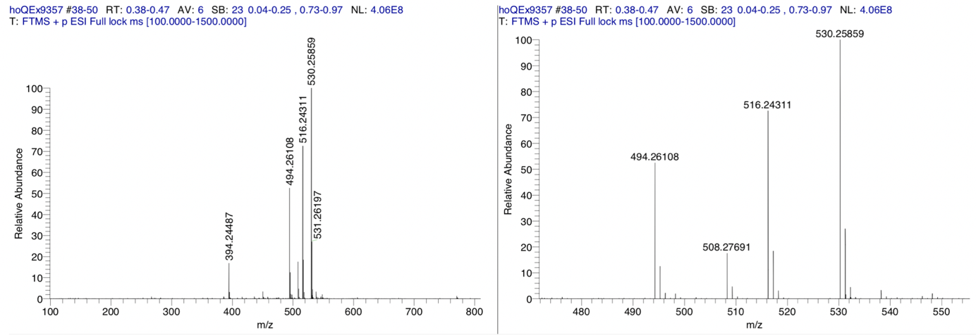

Figure S13. ¹H (500 MHz, dmso-d⁶, 298 K) NMR spectrum of compound 1
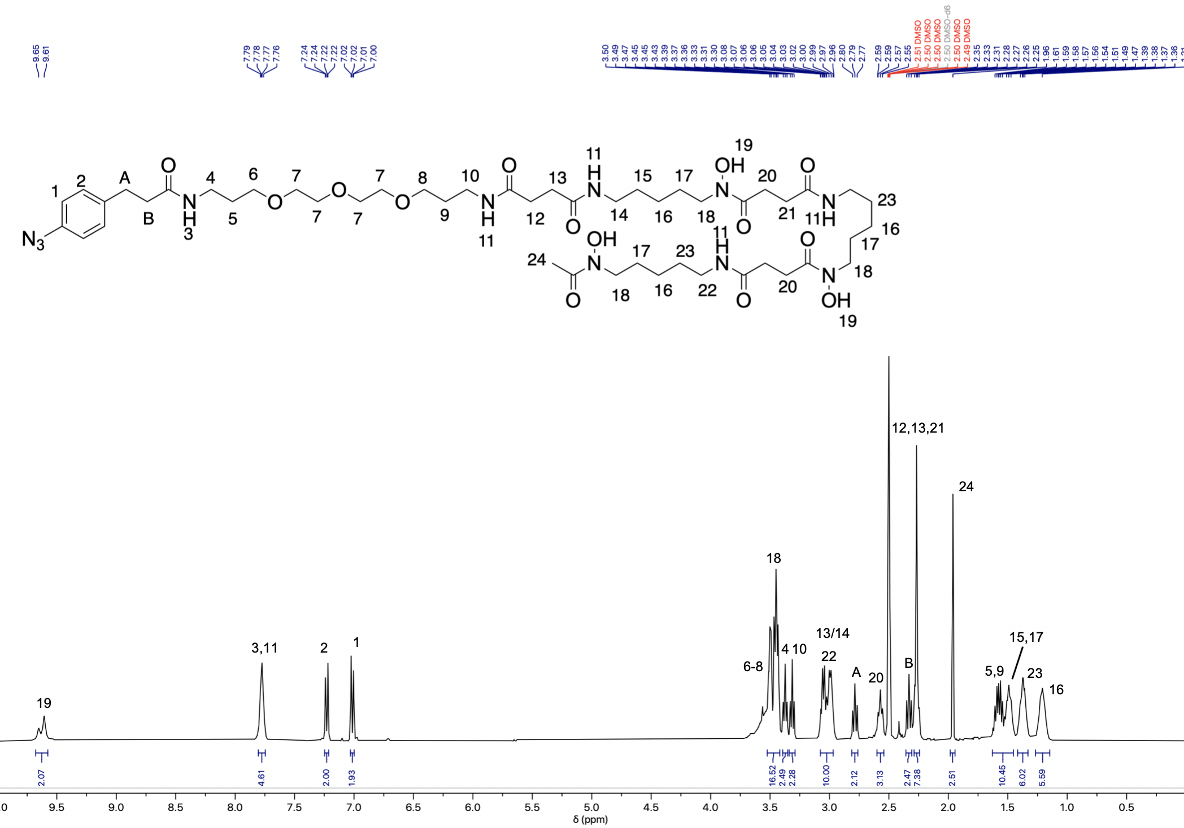

Figure S14. ¹³C{¹H} (125 MHz, dmso-d⁶, 298 K) NMR spectrum of compound 1

Figure S15. 2D-COSY (dmso-d⁶) NMR spectrum of compound 1
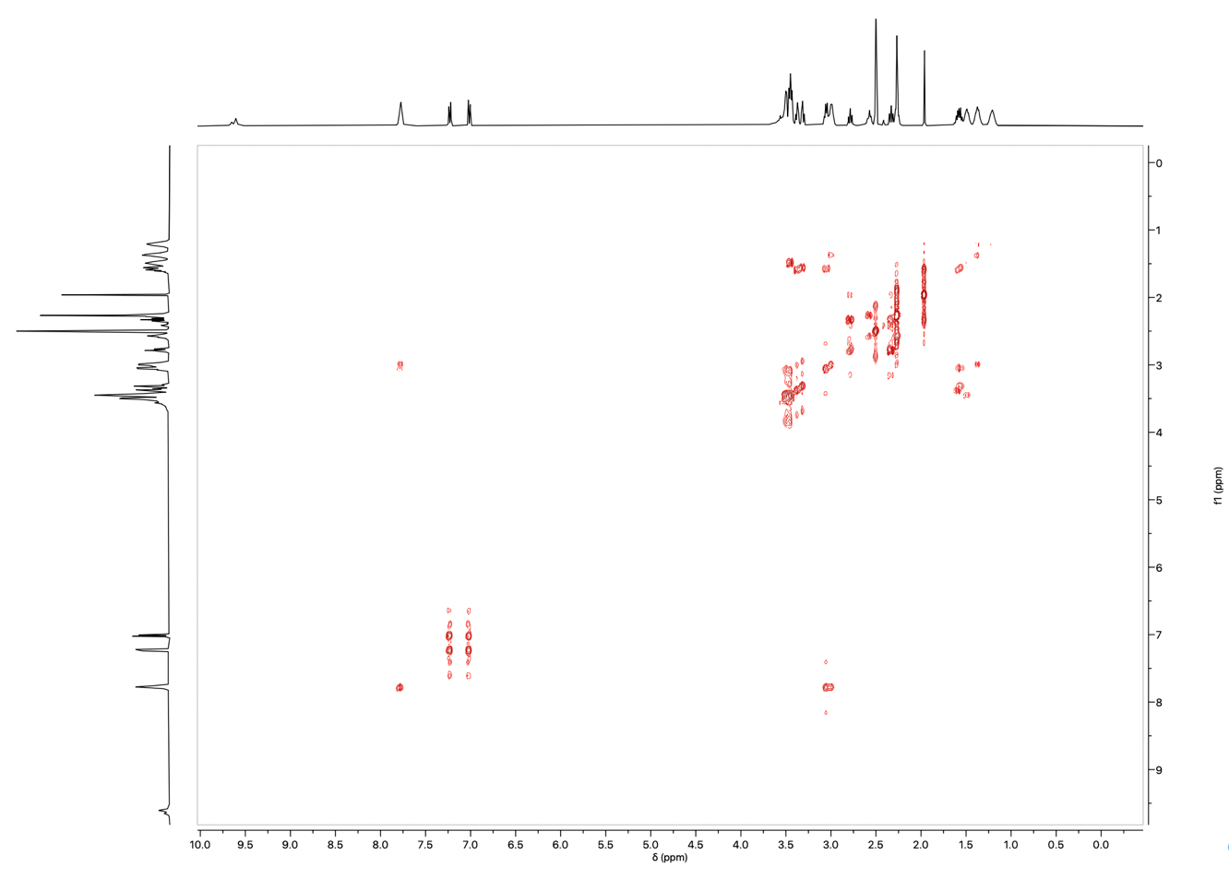

Figure S16. 2D-hetereonuclear HSQC (dmso-d⁶) NMR spectrum of compound 1
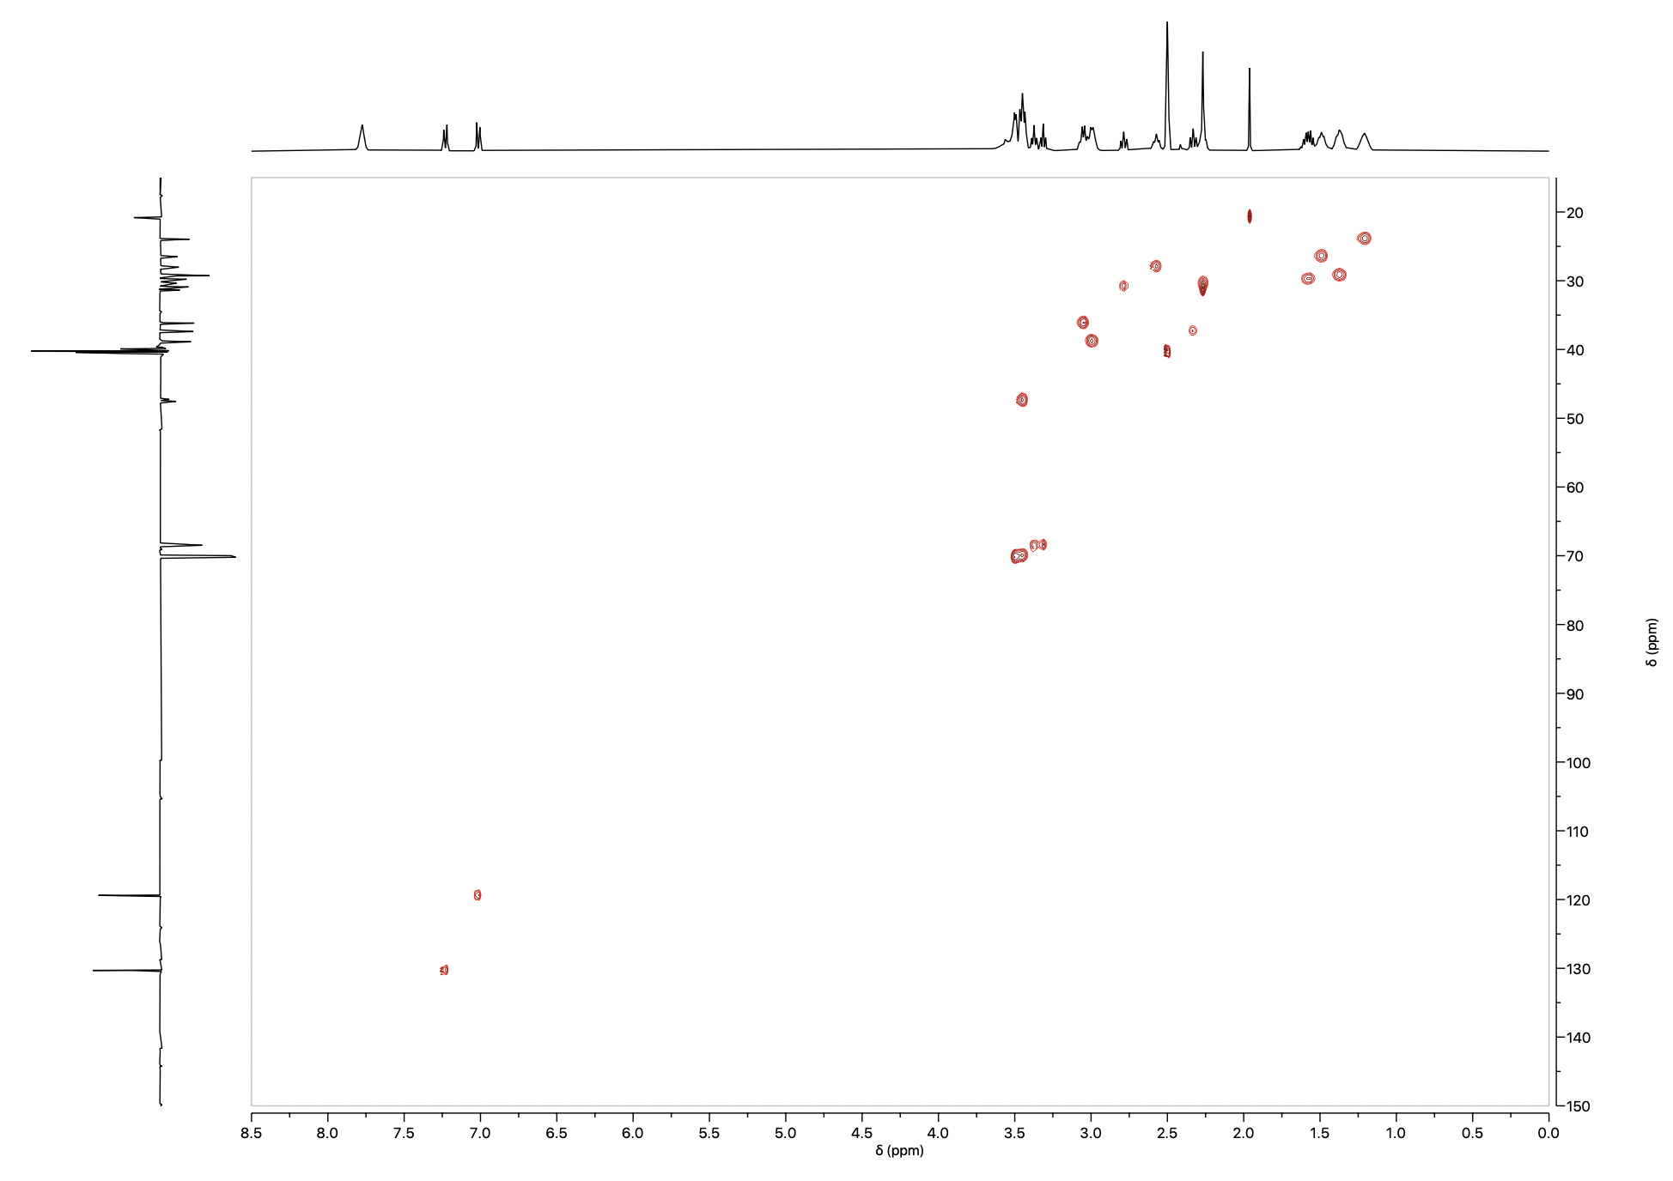

Figure S17. HRMS spectrum of compound 1
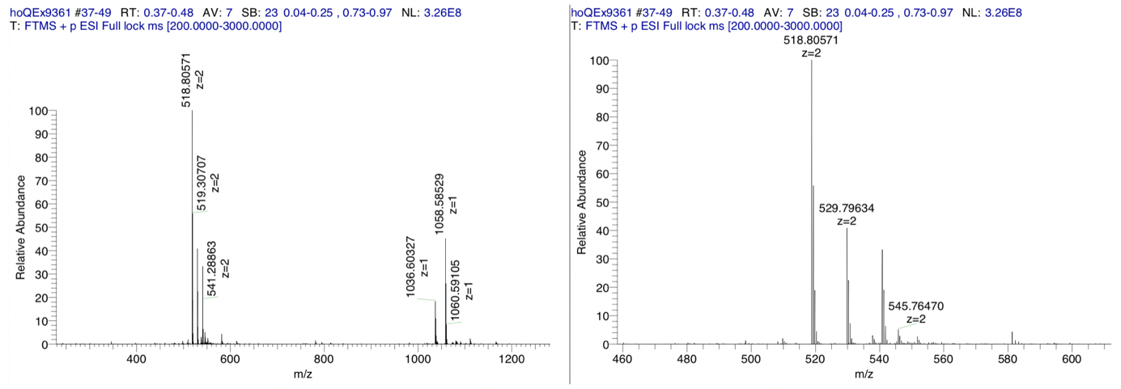

Supporting Results

⁸⁹Zr-Radiolabelling of DFO-PEG₃-Et-ArN₃ (1)
The [⁸⁹Zr]Zr-radiolabelling of DFO-PEG₃-Et-ArN₃, compound 1 to give the [⁸⁹Zr]Zr-radiolabelled complex [⁸⁹Zr]ZrDFO-PEG₃-Et-ArN₃ (⁸⁹Zr-1⁺) was performed in triplicate. As an example, incubation of ligand 1 (20 μL; 2 mM stock solution; MW = 1036.22) with [⁸⁹Zr]Zr-oxalate (40 μl; 5.532 MBq) in Chelex® H₂O (40 μl) was performed in the dark for 10 mins at pH 8.0. The formation of ⁸⁹Zr-1⁺ was confirmed by radio iTLC and radio HPLC analysis (Figure S18).

Figure S18. Characterisation data for the radiochemical synthesis of [⁸⁹Zr]ZrDFO-PEG₃-Et-ArN₃. A) Radio-iTLC chromatograms of ‘free’ ⁸⁹Zr complexed as [⁸⁹Zr]Zr-DTPA (blue) and [⁸⁹Zr]ZrDFO-PEG₃-Et-ArN₃ (black); B) HPLC chromatograms of the ligand (compound 1; blue), [^{nat}Zr]ZrDFO-PEG₃-Et-ArN₃ (green) and [⁸⁹Zr]ZrDFO-PEG₃-Et-ArN₃ (black).

