Supplementary Information

Supplementary Information table S1
Sequence data quality parameters and reads per sample:

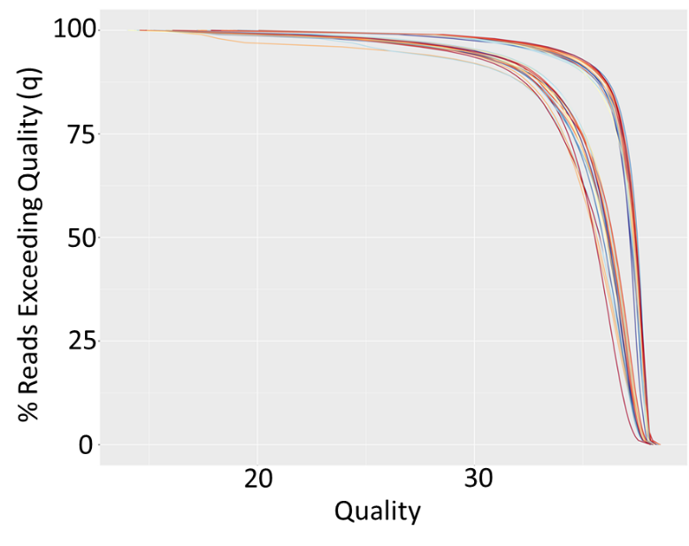

Overall quality of data

Supplementary Information table S2

OTUs with Differential abundance between groups.

Supplementary Information
Figure S1

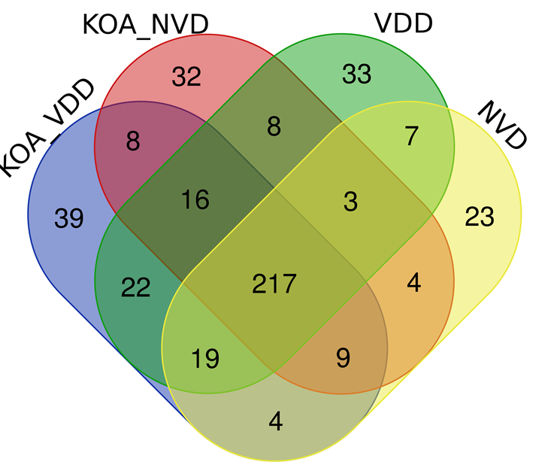
Venn diagram with excluding zero counts to OTUs in each of the groups.

Supplementary Information table S3

OTUs that are predominant in various study groups. This classification is based on excluding OTUs with counts less than 50 in each of the groups.

KOA KOA_VDD NVD VDD | 4 | Bifidobacterium
 |  | Faecalibacterium
 |  | Collinsella
 |  | Blautia
KOA KOA_VDD VDD | 2 | Prevotella_9
 |  | Lachnospiraceae_unclassified
KOA KOA_VDD NVD | 2 | Bacteroides
 |  | Subdoligranulum
KOA KOA_VDD | 2 | Dorea
 |  | Catenibacterium
KOA VDD | 4 | Alloprevotella
 |  | Dialister
 |  | [Eubacterium]_coprostanoligenes_group
 |  | Ruminococcaceae_UCG-002
KOA_VDD VDD | 1 | Pseudobutyrivibrio
KOA | 14 | Coriobacteriaceae_unclassified
 |  | Streptococcus
 |  | Olsenella
 |  | Coprococcus_2
 |  | Ruminococcaceae_UCG-005
 |  | Anaerotruncus
 |  | Christensenellaceae_R-7_group
 |  | Prevotellaceae_unclassified
 |  | Peptostreptococcaceae_unclassified
 |  | Lachnospiraceae_NK4A136_group
 |  | Ruminococcus_2
 |  | Ruminococcaceae_UCG-014
 |  | Ruminococcus_1
 |  | Senegalimassilia
KOA_VDD | 2 | Parabacteroides
 |  | Escherichia-Shigella
VDD | 1 | Lachnospiraceae_UCG-005

LEfSe (Linear discriminant analysis effect size)

Figure S2
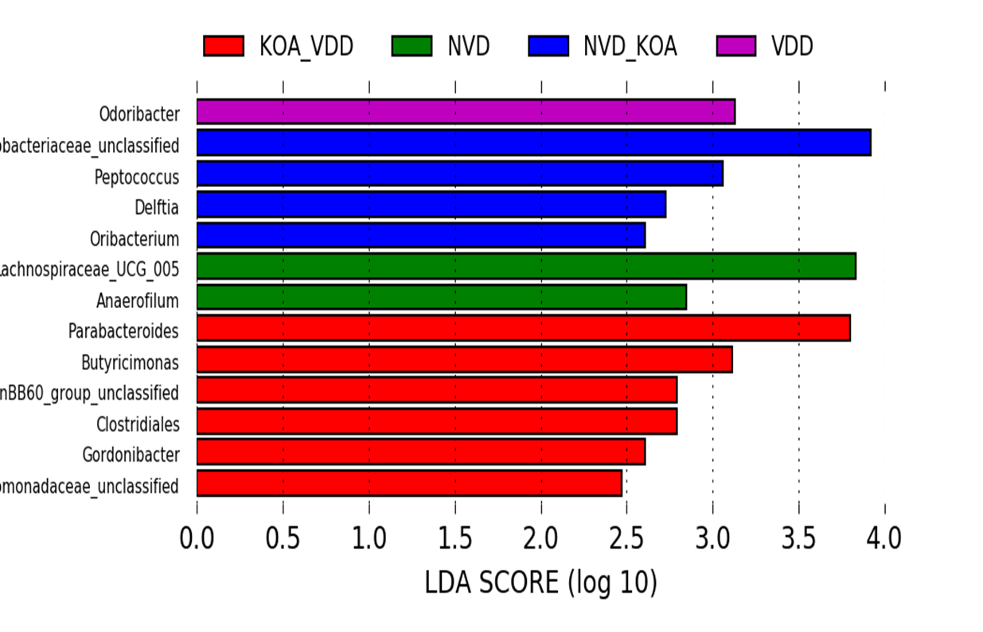

Figure S3
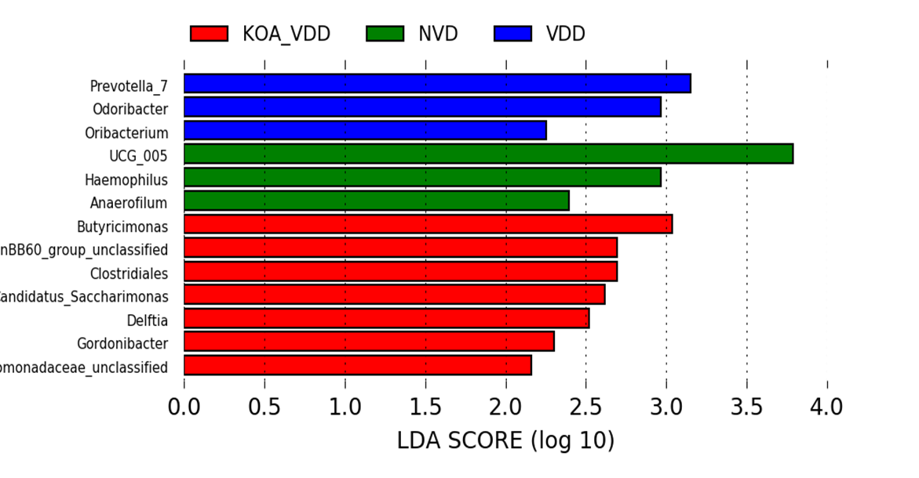

Figure S4
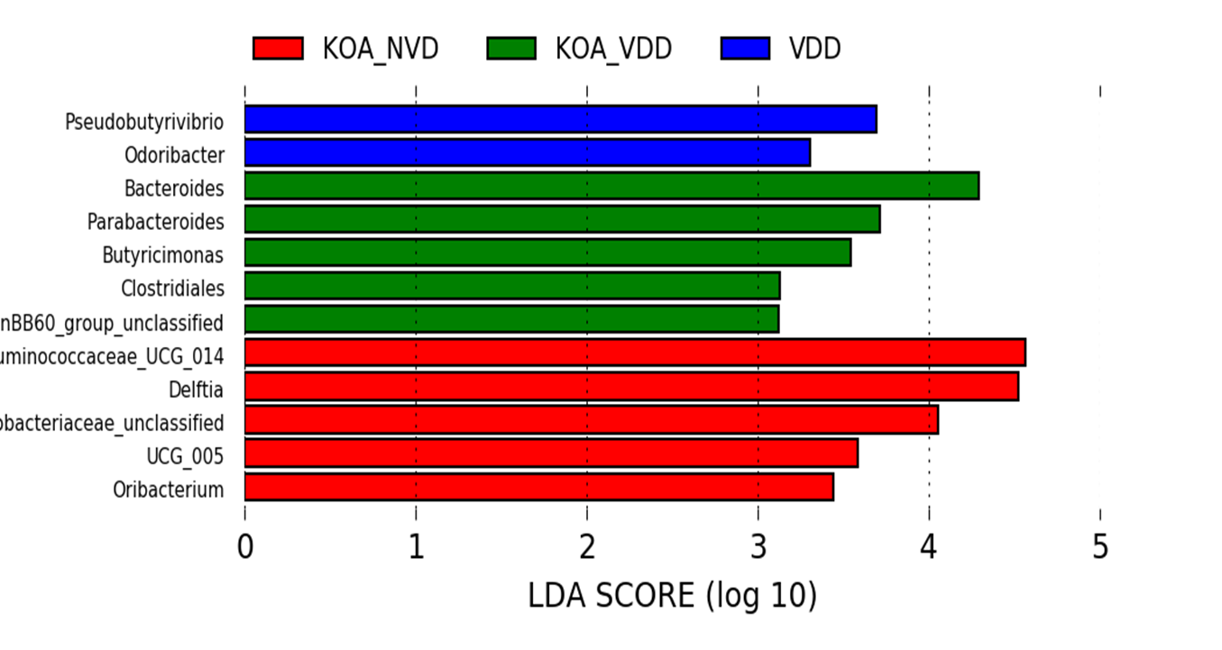

Figure S5
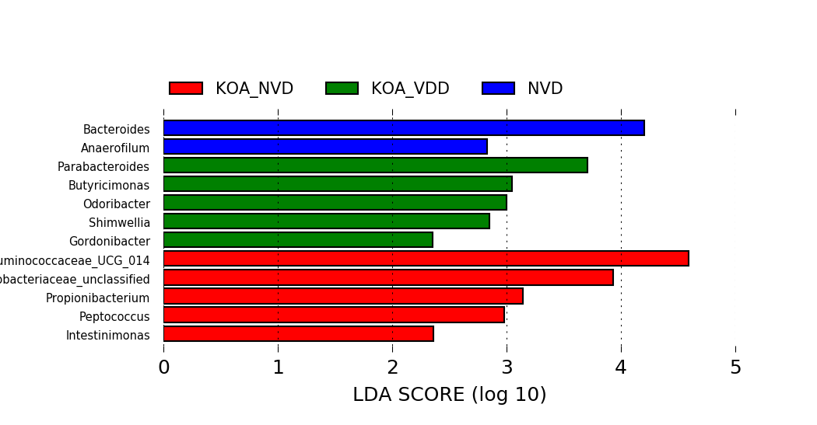

PiCRUSt

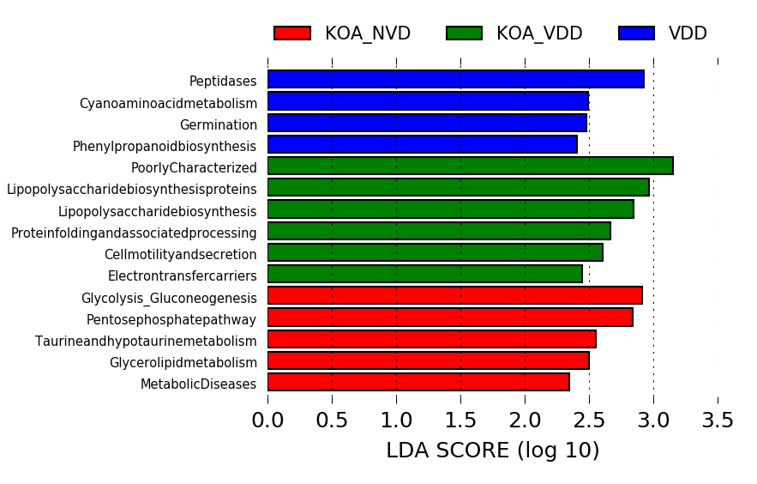
Figure S6

