Supplementary Material

# Supplementary Figures and Tables

## Supplementary Figures

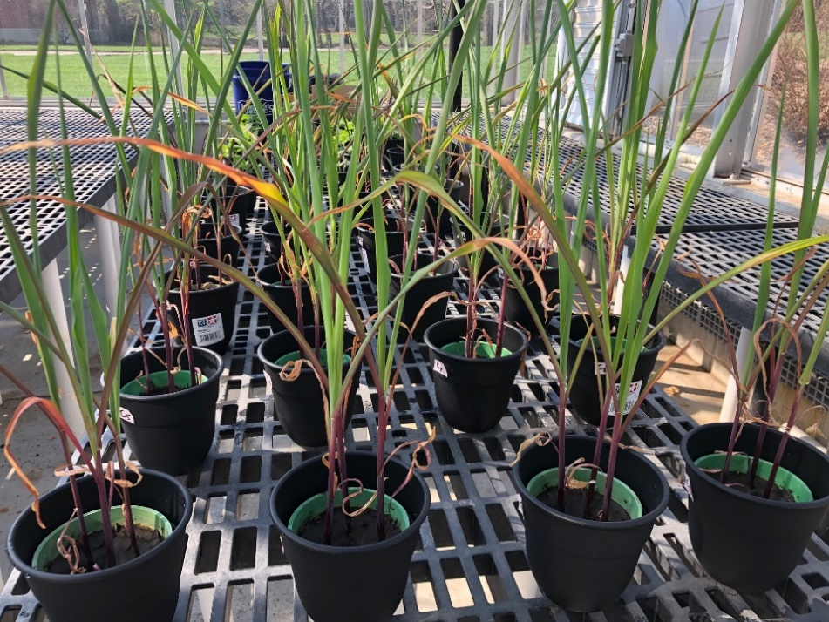

**Figure S1.** All corn plants displayed; soil trial row is closest to the camera.

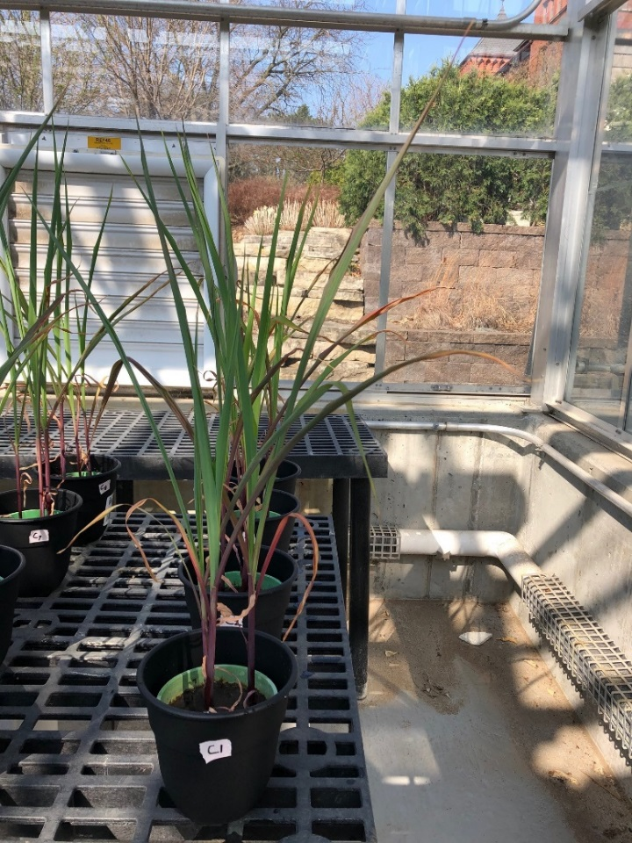

**Figure S2.** Corn pots 1-4; soil control trial group.

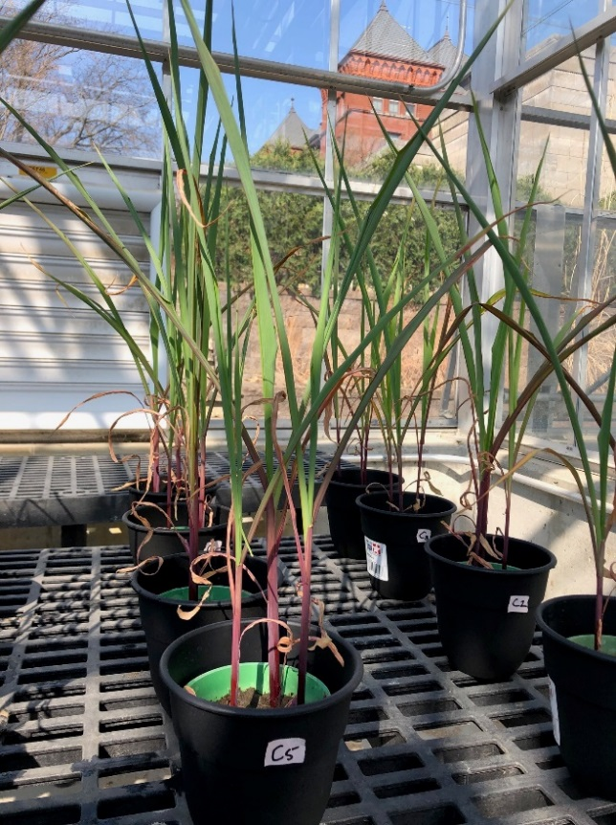

**Figure S3.** Corn pots 5-8; manure control trial group.

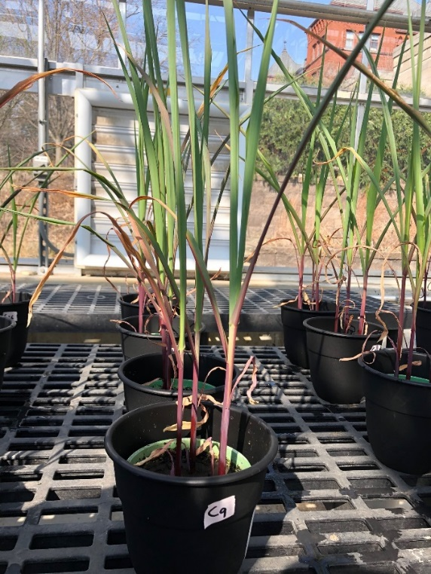

**Figure S4.** Corn pots 9-12; MRO trial group.

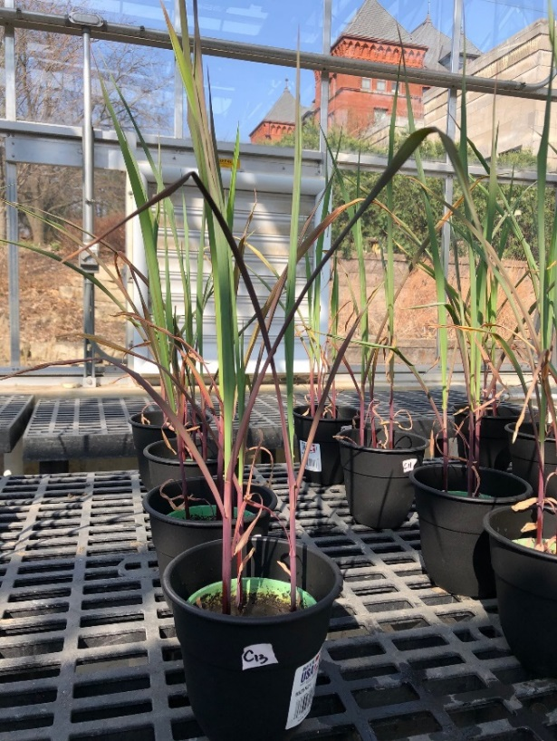

**Figure S5.** Corn pots 13-16; MHAP trial group.

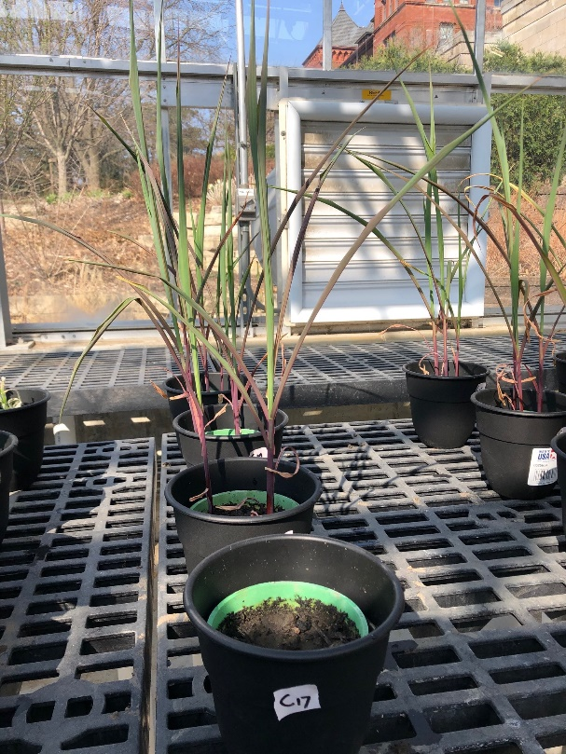

**Figure S6.** Corn pots 17-20; MHAPE trial group.

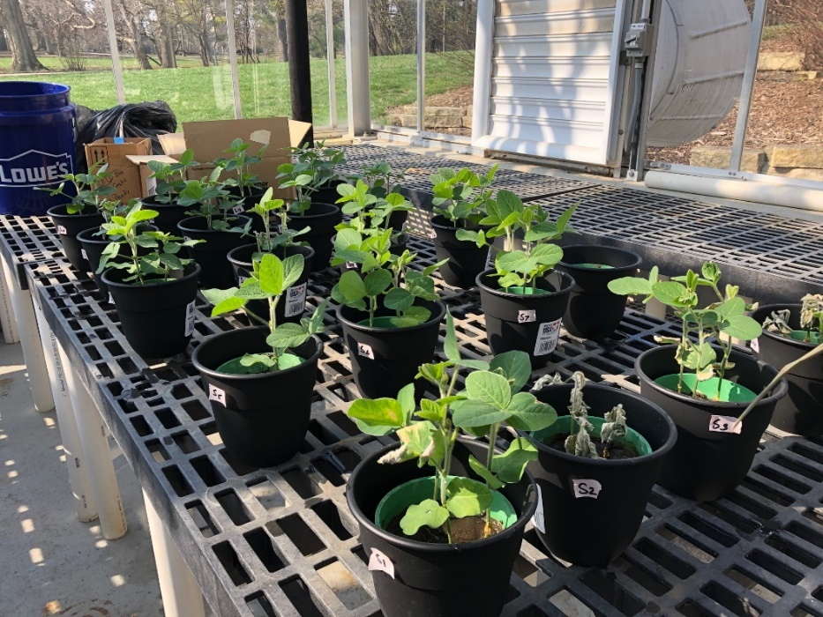

**Figure S7.** All soybean pots displayed; soil trial row is closest to camera.

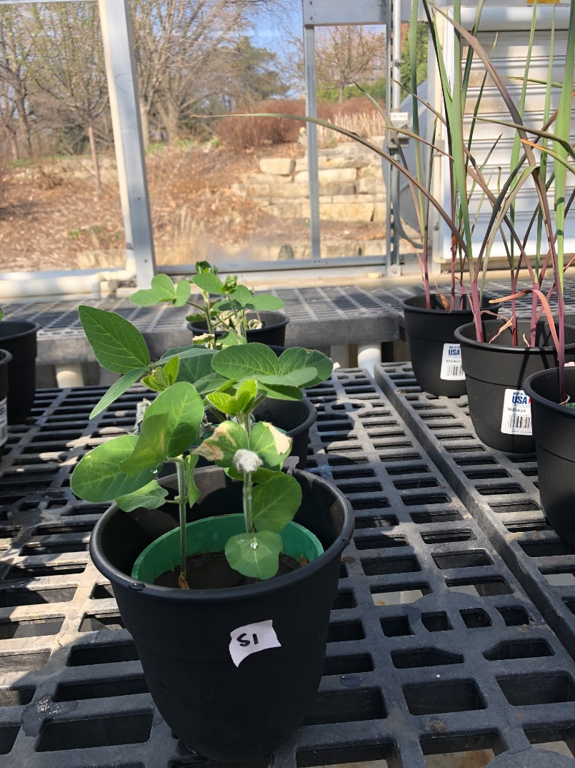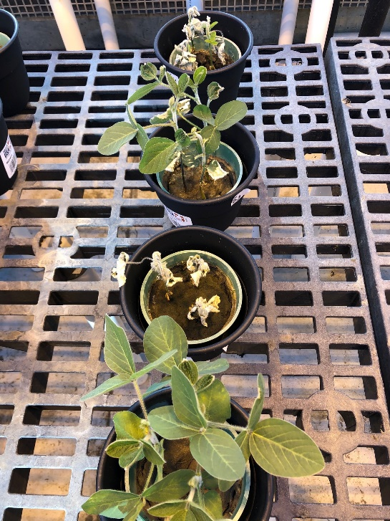

**Figure S8.** Soybean pots 1-4 in front view (left) and top view (right); soil control trial group.

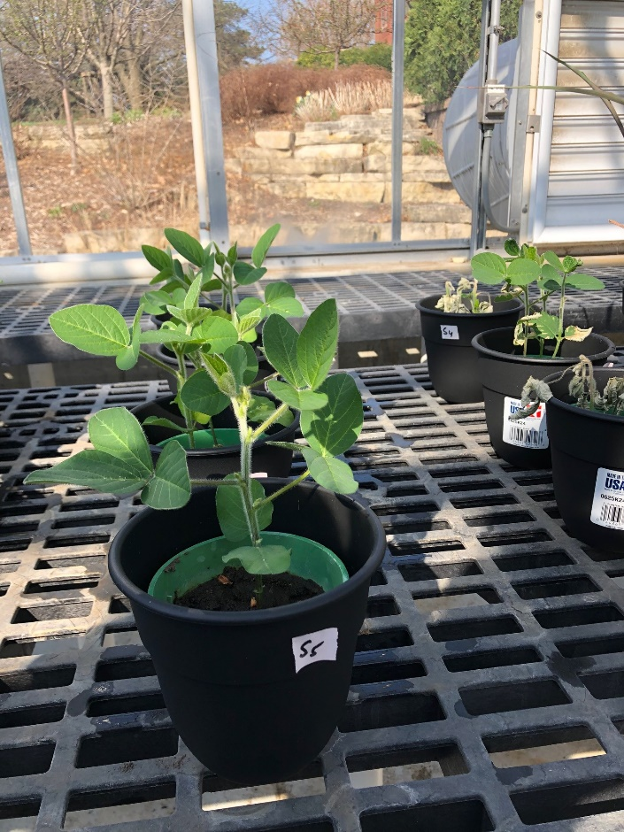

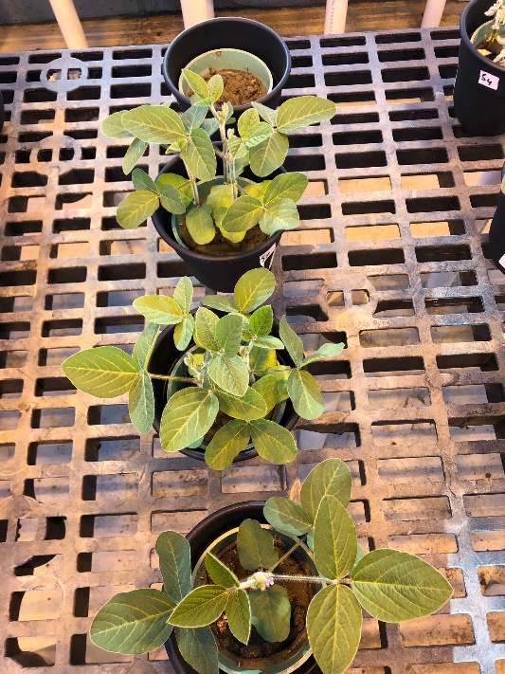

**Figure S9.** Soybean pots 5-8 in front view (left) and top view (right); manure control trial group.

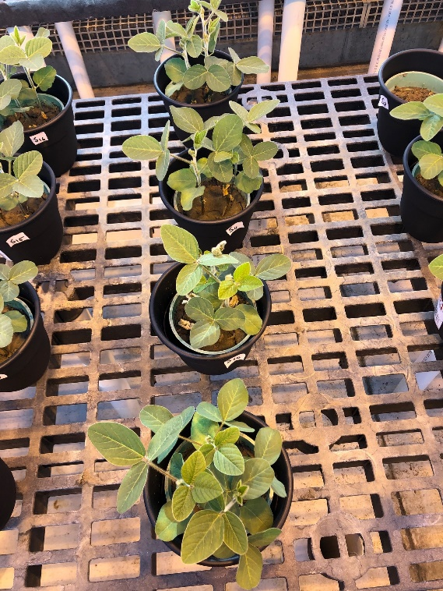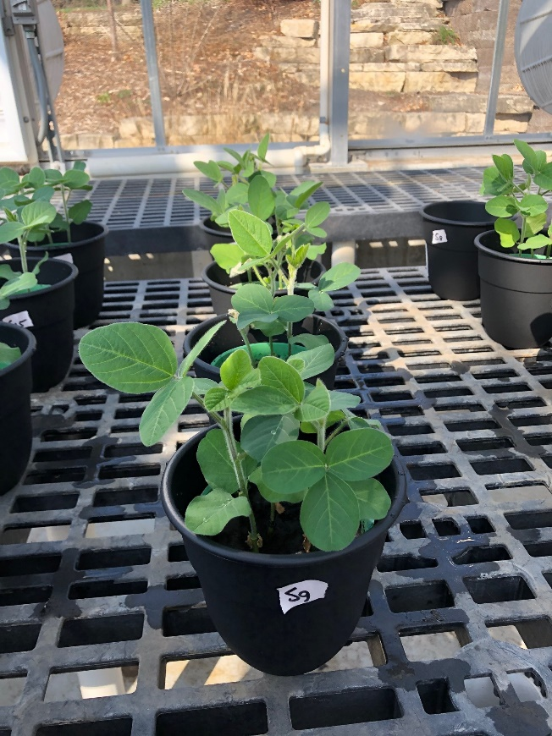

**Figure S10.** Soybean pots 9-12 in front view (left) and top view (right); MRO trial group.

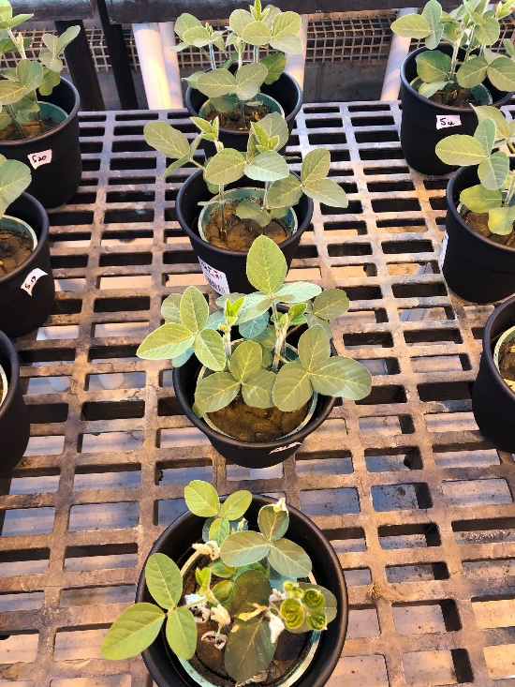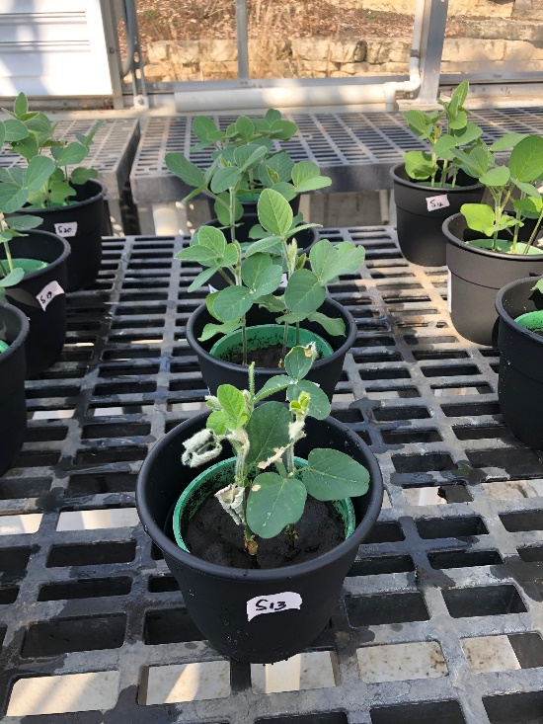

**Figure S11.** Soybean pots 13-16 in front view (left) and top view (right); MHAP trial group.

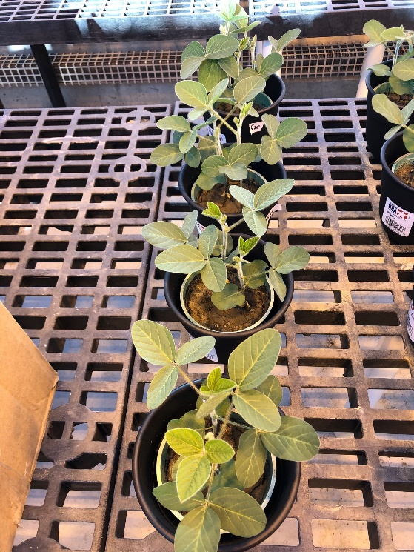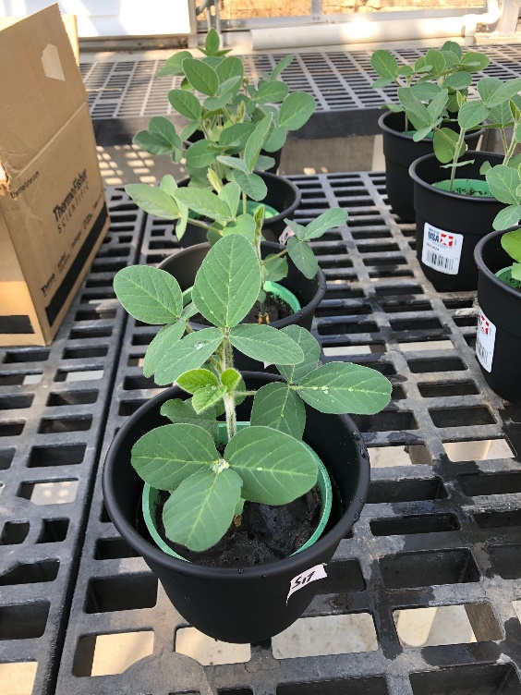

**Figure S12.** Soybean pots 17-20 in front view (left) and top view (right); MHAPE trial group.



**Figure S14.** The effect of soil treatment on the nitrogen uptake for both corn (left) and soybean (right) biomass. Each bar represents an average of 4 replications ± standard deviation. S = soil control; M = manure control; MRO = manure + red oak biochar; MHAP = manure + highly alkaline porous biochar; MHAPE = manure + corn feedstock autothermal porous Fe- engineered biochar.



**Figure S15.** The effect of soil treatment on the phosphorus nutrient biomass for both corn (left) and soybean (right) biomass. Each bar represents an average of 4 replications ± standard deviation. S = soil control; M = manure control; MRO = manure + red oak biochar; MHAP = manure+ highly alkaline porous biochar; MHAPE = manure + corn feedstock autothermal porous Fe- engineered biochar.



**Figure S16.** The effect of soil treatment on the potassium nutrient biomass for both corn (left) and soybean (right) biomass. Each bar represents an average of 4 replications ± standard deviation. S = soil control; M = manure control; MRO = manure + red oak biochar; MHAP = manure + highly alkaline porous biochar; MHAPE = manure + corn feedstock autothermal porous Fe- engineered biochar.



**Figure S17.** The effect of soil treatment on the calcium nutrient for both corn (left) and soybean (right) biomass. Each bar represents an average of 4 replications ± standard deviation. S = soil control; M = manure control; MRO = manure + red oak biochar; MHAP = manure + highly alkaline porous biochar; MHAPE = manure + corn feedstock autothermal porous Fe- engineered biochar.



**Figure S18.** The effect of soil treatment on the magnesium nutrient for both corn (left) and soybean (right) biomass. Each bar represents an average of 4 replications ± standard deviation. S = soil control; M = manure control; MRO = manure + red oak biochar; MHAP = manure + highly alkaline porous biochar; MHAPE = manure + corn feedstock autothermal porous Fe- engineered biochar.



**Figure S19.** The effect of soil treatment on the sulfur nutrient for both corn (left) and soybean (right) biomass. Each bar represents an average of 4 replications ± standard deviation. S = soil control; M = manure control; MRO = manure + red oak biochar; MHAP = manure + highly alkaline porous biochar; MHAPE = manure + corn feedstock autothermal porous Fe- engineered biochar.



**Figure S20.** The effect of soil treatment on the carbon nutrient for both corn (left) and soybean (right) biomass. Each bar represents an average of 4 replications ± standard deviation. S = soil control; M = manure control; MRO = manure + red oak biochar; MHAP = manure + highly alkaline porous biochar; MHAPE = manure + corn feedstock autothermal porous Fe- engineered biochar.



**Figure S21.** The effect of soil treatment on the amount of copper present for both corn (left) and soybean (right) biomass. Each bar represents an average of 4 replications ± standard deviation. S = soil control; M = manure control; MRO = manure + red oak biochar; MHAP = manure + highly alkaline porous biochar; MHAPE = manure + corn feedstock autothermal porous Fe- engineered biochar.



**Figure S22.** The effect of soil treatment on the amount of zinc present for both corn (left) and soybean (right) biomass. Each bar represents an average of 4 replications ± standard deviation. S = soil control; M = manure control; MRO = manure + red oak biochar; MHAP = manure + highly alkaline porous biochar; MHAPE = manure + corn feedstock autothermal porous Fe- engineered biochar.