Multiscale very-high resolution topographic models in Alpine ecology: pros and cons of airborne LiDAR and drone-based stereo-photogrammetry technologies
Annie S. Guillaume, Kevin Leempoel, Estelle Rochat, Aude Rogivue, Michel Kasser, Felix Gugerli, Christian Parisod, Stéphane Joost

Supplementary material
Summary of supplementary figures and tables
Table S1: Description and parameters for Elevation and 23 digital elevation model (DEM)-derived variables
Table S2: Student t-tests for MaxEnt analyses
Figure S1: Quantile-quantile (Q-Q) plots for digital elevation model (DEM) vertical error
Table S3: Summary results ranking MaxEnt species distribution models (SDM) to determine optimal parameters
Table S4: Summary statistics of digital elevation models (DEM) vertical error
Figure S2: Normalized median absolute deviation (NMAD) of digital elevation model (DEM) vertical error
Table S5: Spearman correlation r_{s} between pairs of independent derived variables
Figure S3: Scatterplots of Elevation and derived variables from LiDAR and photogrammetry.

Table S1: Description and parameters for Elevation and 23 digital elevation model (DEM)-derived variables. These variables were selected due to their common usage in ecological studies. Aspect was converted into Eastness and Northness. Each variable was computed at each resolution for LiDAR (50cm, 1m, 2m, 4m, 8m, 16m, 32m) and photogrammetry (6.25cm, 12.5cm, 25cm, 50cm, 1m, 2m, 4m, 8m). Abbreviations with an asterisk (*) in bold type indicate variables that were assessed as uncorrelated at most resolutions with a |r| > 0.8 threshold.
 | Variable | Abbv. | Description | Units | Parameters/Reference
Primary attributes | Elevation | Elev * | Elevation obtained from DEMs. | m | Interpolated from LiDAR or PG point cloud files; generalized using B-spline wavelet transforms.
 | Slope | Slope* | Morphometry. Local morphometric terrain parameters; proxies for water flow, snow movements, erosion, solar radiation, etc. Eastness and Northness represent the sine and cosine of Aspect, respectively. Curvature is important for understanding variations in terrain. | radians | Method = 9 parameter 2nd order polynomial; unit slope = radian; unit aspect = radian
 | Aspect | Asp |  | radians
 | Eastness | East* |  | radians
 | Northness | North* |  | radians
 | Profile curvature | Vcu |  | 1/m
 | Plan curvature | Hcu* |  | 1/m
 | Total Curvature | Tcu |  | 1/m
Secondary attributes | Downslope distance gradient | DDG | Morphometry. Quantify downslope controls on local drainage | gradient (degree) | Vertical distance = 5m
 | Vector ruggedness measure | VRM* | Morphometry. Quantifies rugosity with less correlation to slope, indicating a combined variability in slope and aspect. | No unit.  0 = no var  1= complete terrain var | Radius = 1 cell
 | Topographic Openness Positive | TOP | Lighting. Expresses the dominance (positive) or enclosure (negative) of a landscape location, to describe how wide a landscape can be viewed from any position. | radians | Radius = 1000; Method = sectors; Multiscale Factor = 3; Number of sectors =16
 | Topographic Openness Negative | TON
 | Fill Sinks XXL | FIL | Preprocessing. To identify and fill surface depressions in DEMs; for use in hydrologic analyses and modelling. | m | Min. slope degree = 0.1
 | Total Catchment Area | TCa | Hydrology. For use in calculating SWI. | m² | Suction = 10; Type of Area = square root of TCa; Slope type = Catchment slope; Min Slope = 0; Offset Slope = 0.1; Slope Weighting = 1
 | Catchment Slope | Cslo |  | %
 | Modified Catchment Area | MCa |  | m²
 | SAGA Wetness Index | SWI* | Hydrology. Modified version of Topographic Wetness Index (TWI), which is a calculation of the slope and MCa. It predicts soil moisture for cells situated on the valley floor. | MCa/Slo
 | Sky view factor | SVF* | Lighting. Ratio of the radiation received by a planar surface to the radiation emitted by the entire hemispheric environment | no unit | Max search radius = 10000; Method = sectors; Multi Scale Factor = 3; Number of sectors = 8
 | Visible Sky | Vis | Lighting. Ratio of the sky area over the obstructed area | no unit
 | Diffuse Solar radiation in June/December | Df06/  Df12 | Lighting. Diffuse insolation in summer | kWh/m² | Solar Constant = 1367 W/m²; Shadow = flat; Location = constant lat; Latitude=46.407047°; Atmosphere method = Height of Atmosphere and Vapor Pressure; Atmosphere = 12000m; Time period = 30 days; Day step = 6 days; Hour range = 0-24h; Hour step = 1.  June date range: 01-30 June 2015  December data range: 01-30 December 2015
 | Direct Solar radiation in June/December | Di06/  Di12 | Lighting. Direct insolation in summer
 | Total Solar radiation in June/December | Ti6*/  Ti12 | Lighting. Sum of direct and diffuse insolation in summer
 | Wind Exposition Index | WEX | Climate. Calculates the average wind effect for all directions using an angular step. | No unit.  <1 = sheltered; >1 = exposed | Search distance = 300km; Angular step size=15.0deg; Acceleration = 1.5

Table S2: Student t-tests for MaxEnt analyses. These were used to determine the technology-resolution combination that is able to best discriminate plant occurrence points (Para: n=146; Martinets: n=100) from 10 000 random background points for each variable at each site. Values indicated are T-values, with significance represented by: p≤0.05 = *; p≤0.01 = **; p≤0.001 = ***. The most significant technology-resolution combination for each variable is highlighted with a grey background.
Photogrammetry |  |  |  |  |  |  |  |  | LiDAR
 | 6.25cm | 12.5cm | 25cm | 50cm | 1m | 2m | 4m | 8m | 50cm | 1m | 2m | 4m | 8m | 16m | 32m
Para
Elev | -6.23*** | -6.23*** | -6.23*** | -6.22*** | -6.21*** | -6.2*** | -6.19*** | -6.19*** | -6.21*** | -6.2*** | -6.2*** | -6.19*** | -6.22*** | -6.25*** | -6.5***
East | 3.44*** | 3.59*** | 3.69*** | 3.65*** | 3.39*** | 3.6*** | 2.95** | 2.03* | 4.8*** | 5.17*** | 4.36*** | 3.14** | 1.92 | 1.67 | 2.51*
Hcu | 0.92 | 2.03* | 3.48*** | 2.82** | 1.67 | 6.22*** | 7.75*** | 9.57*** | -0.53 | 2.75** | 7.02*** | 7.2*** | 11.05*** | 10.35*** | 6.41***
North | -8.06*** | -8.3*** | -8.39*** | -8.59*** | -9.55*** | -9.64*** | -8.82*** | -5.41*** | -11.35*** | -14.1*** | -11.04*** | -9.91*** | -6.54*** | -6.17*** | -4.38***
Slope | -1.1 | -1.84 | -2.77** | -3.32** | -3.88*** | -4.94*** | -6.14*** | -7.49*** | -3.03** | -3.85*** | -5.19*** | -6.41*** | -7.05*** | -7.38*** | -8.83***
SVF | 4.43*** | 4.69*** | 5.03*** | 5.22*** | 6.03*** | 6.35*** | 6.24*** | 7.22*** | 5.35*** | 5.84*** | 8.56*** | 9.33*** | 11.34*** | 10.34*** | 7.9***
SWI | -2.59* | -3.32** | -3.52*** | -3.87*** | -3.24** | -3.28** | -3.5*** | -2.16* | -2.87** | -4.04*** | -4.27*** | -4.85*** | -5.06*** | -4.96*** | -1.03
Ti06 | 7.94*** | 8.36*** | 8.97*** | 9.32*** | 9.48*** | 9.18*** | 8.9*** | 7.59*** | 10.14*** | 11.15*** | 11.19*** | 11.42*** | 10.29*** | 8.76*** | 7.88***
VRM | -1.16 | -1.58 | -1.19 | -0.29 | 0.11 | -2.37* | -5.28*** | -6.47*** | 0.18 | 0.48 | -1.74 | -4.96*** | -6.84*** | -10.18*** | -7.24***
Martinets
Elev | -3.21** | -3.21** | -3.21** | -3.21** | -3.21** | -3.21** | -3.23** | -3.29** | -3.29** | -3.29** | -3.28** | -3.28** | -3.31** | -3.41*** | -3.74***
East | 0.07 | -0.11 | -0.18 | 0.02 | 0.08 | -0.2 | -0.14 | -0.21 | 1.06 | 1.37 | 1.29 | 0.86 | 0.59 | -1.24 | -7.34***
Hcu | -2.78** | 1.37 | 1.55 | 1.08 | 2.55* | 3.27** | 4.37*** | 4.91*** | 0.24 | 2.23* | 2.77** | 6.01*** | 4.76*** | 10.42*** | 11.91***
North | -2.48* | -3.22** | -2.87** | -2.76** | -2.81** | -2.41* | -1.52 | -1.15 | -4.61*** | -4.62*** | -3.78*** | -2.64** | -1.67 | -0.77 | 3.32**
Slope | 0.17 | 0.25 | -0.15 | -0.03 | -0.79 | -2.06* | -2.6* | -0.48 | 2.09* | 1.76 | 1.03 | -0.18 | 0.75 | 1.35 | 3.45***
SVF | 2.34* | 2.67** | 3.33** | 3.84*** | 4.47*** | 6.08*** | 6.99*** | 6.05*** | -0.98 | 0.08 | 2.19* | 3.72*** | 3.08** | 2.04* | -1.32
SWI | -1.28 | -5.42*** | -4.99*** | -4.4*** | -5.39*** | -4.37*** | -3.42*** | -4.64*** | -8.87*** | -7.68*** | -6.26*** | -4.08*** | -5.53*** | -9.04*** | -6.53***
Ti06 | 2.1* | 2.54* | 2.8** | 2.88** | 3.41*** | 3.82*** | 3.46*** | 1.82 | 1.55 | 2.41* | 2.66** | 2.62* | 1.21 | -1.15 | -5.51***
VRM | 0.14 | 1.75 | 4.7*** | 5.73*** | 3.8*** | 4.94*** | 2.93** | -2.54* | 10.02*** | 22.6*** | 9.98*** | 0.92 | -2.07* | -4.14*** | -3.95***

Figure S1: Quantile-quantile (Q-Q) plots for digital elevation model (DEM) vertical error. Error (Δh; meters) was calculated as the difference between the elevation measured at ground points at a) Para (n=181) and b) Martinets (n=123) with the elevation estimated from the DEMs acquired from LiDAR or photogrammetry (PHOTO) technologies generalized to multiple resolutions. The technology and resolution for the DEM is noted at the top of each Q-Q plot.
a) Para | 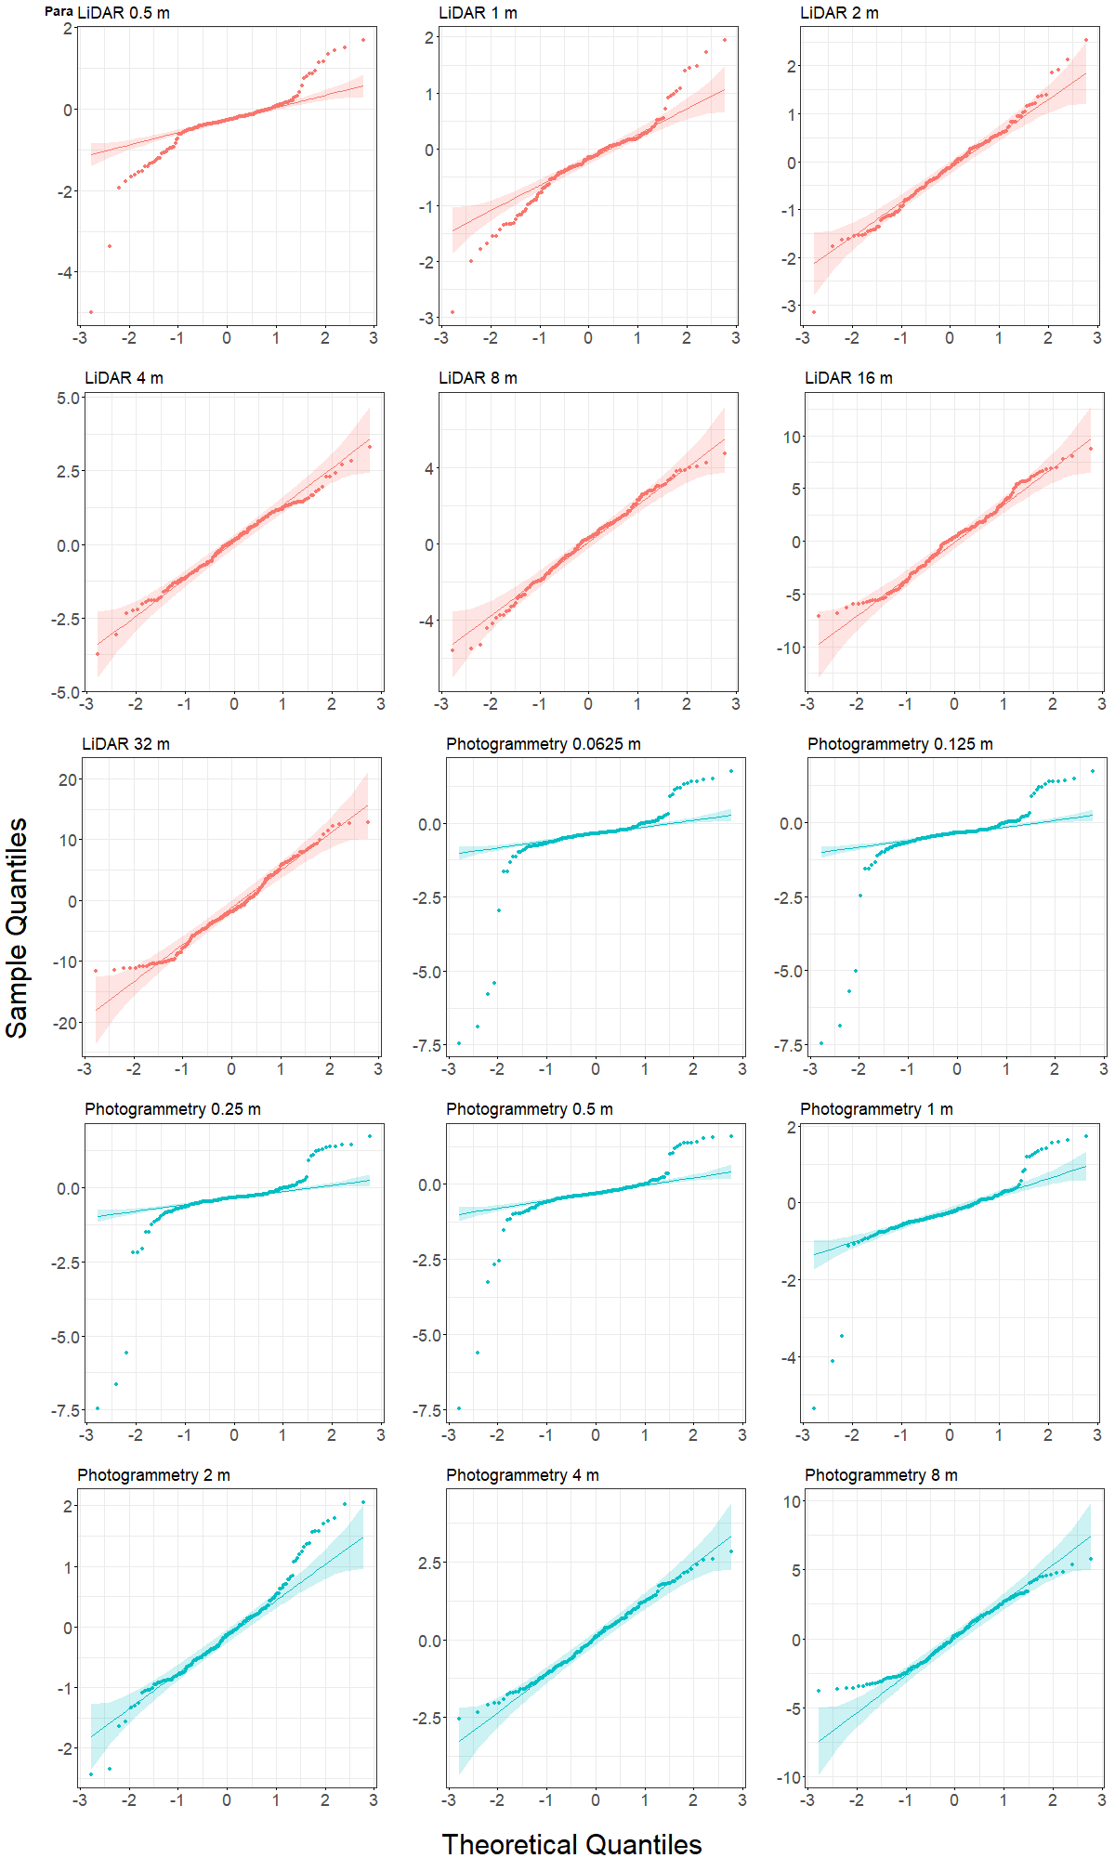
b) Martinets | 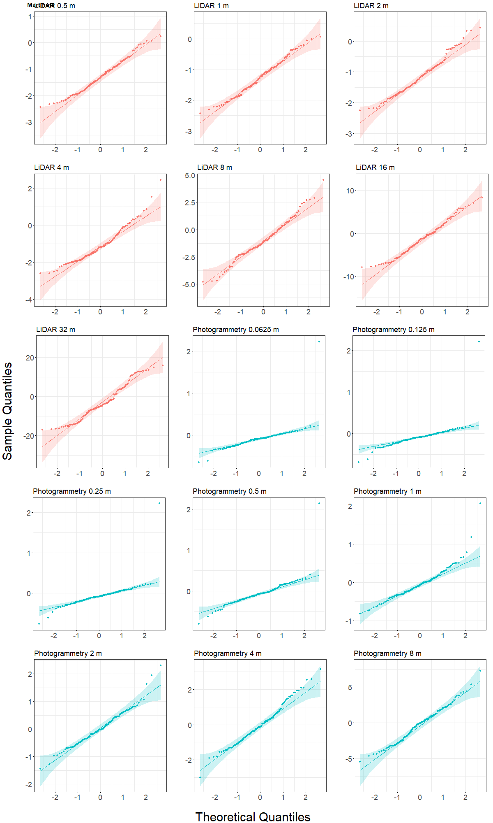

Table S3: Summary results ranking MaxEnt species distribution models (SDM) to determine optimal parameters. Feature class (FC: L = linear only; LP = linear and product; LQ = linear and quadratic; LPQ =linear, product and quadratic) and regularization multiplier (RM: 1, 2, 5 and 10) were assessed. Arabis alpina distribution across the Para and Martinets sites were predicted based on plant presence-only points (Para: n=146; Martinets: n=100) and 10 000 random background points at each site. The optimal spatial resolution for each variable as determined in Table S2 was used as input environmental variables. Each MaxEnt model was run 20 times (75% training points, 25% testing points) and mean diagnostic values are shown here. Models were assessed using the mean Area Under the Receiver Operating Curve (Fielding and Bell, 1997) based on the test data (AUC_{test}), as well mean sample size corrected Akaike Information Criterion (AICc; Akaike, 1974). For each site, we ranked the FC-RM combination by AUC_{test} and AICc separately, then determined the optimal FC-RM combination as the model resulting in the lowest sum of these ranks (Overall Rank). The top three ranked models at each site are highlighted in yellow.
 |  |  | AUC_{test} |  | AICc |  | Rank AUC_{test} | Rank  AICc | Sum of ranks | Overall Rank
Site | FC | RM | mean | sd | mean | sd
Para | L | 1 | 0.860 | 0.027 | 1768.9 | 12.9 | 14 | 13 | 27 | 13
 | L | 2 | 0.861 | 0.030 | 1768.9 | 11.5 | 13 | 14 | 27 | 13
 | L | 5 | 0.853 | 0.039 | 1768.5 | 15.2 | 16 | 12 | 28 | 15
 | L | 10 | 0.856 | 0.033 | 1782.9 | 12.9 | 15 | 16 | 31 | 16
 | LP | 1 | 0.906 | 0.022 | 1710.5 | 14.1 | 3 | 6 | 9 | 4
 | LP | 2 | 0.886 | 0.025 | 1721.3 | 14.3 | 6 | 8 | 14 | 7
 | LP | 5 | 0.874 | 0.029 | 1748.7 | 12.8 | 8 | 11 | 19 | 10
 | LP | 10 | 0.867 | 0.032 | 1772.6 | 13.5 | 11 | 15 | 26 | 12
 | LQ | 1 | 0.887 | 0.030 | 1677.8 | 13.8 | 5 | 3 | 8 | 3
 | LQ | 2 | 0.884 | 0.030 | 1681.5 | 15.2 | 7 | 4 | 11 | 6
 | LQ | 5 | 0.869 | 0.026 | 1713.6 | 12.2 | 10 | 7 | 17 | 8
 | LQ | 10 | 0.865 | 0.040 | 1743.6 | 18.4 | 12 | 10 | 22 | 11
 | LPQ | 1 | 0.933 | 0.028 | 1631.8 | 11.8 | 1 | 1 | 2 | 1
 | LPQ | 2 | 0.922 | 0.028 | 1664.7 | 12.8 | 2 | 2 | 4 | 2
 | LPQ | 5 | 0.902 | 0.027 | 1705.4 | 13.6 | 4 | 5 | 9 | 4
 | LPQ | 10 | 0.874 | 0.033 | 1734.1 | 13.7 | 9 | 9 | 18 | 9
Martinets | L | 1 | 0.887 | 0.027 | 1178.7 | 11.3 | 10 | 10 | 20 | 11
 | L | 2 | 0.886 | 0.028 | 1181.0 | 9.2 | 12 | 11 | 23 | 12
 | L | 5 | 0.892 | 0.028 | 1189.1 | 9.3 | 5 | 12 | 17 | 9
 | L | 10 | 0.876 | 0.030 | 1192.2 | 9.8 | 15 | 14 | 29 | 14
 | LP | 1 | 0.887 | 0.020 | 1153.9 | 9.3 | 9 | 2 | 11 | 5
 | LP | 2 | 0.892 | 0.017 | 1169.3 | 10.6 | 6 | 6 | 12 | 6
 | LP | 5 | 0.889 | 0.018 | 1175.5 | 9.4 | 8 | 8 | 16 | 7
 | LP | 10 | 0.878 | 0.023 | 1197.7 | 9.0 | 13 | 16 | 29 | 14
 | LQ | 1 | 0.905 | 0.022 | 1156.3 | 9.1 | 3 | 4 | 7 | 2
 | LQ | 2 | 0.907 | 0.024 | 1161.2 | 11.4 | 2 | 5 | 7 | 2
 | LQ | 5 | 0.887 | 0.022 | 1172.6 | 7.7 | 11 | 7 | 18 | 10
 | LQ | 10 | 0.877 | 0.031 | 1192.0 | 10.0 | 14 | 13 | 27 | 13
 | LPQ | 1 | 0.913 | 0.023 | 1150.2 | 12.3 | 1 | 1 | 2 | 1
 | LPQ | 2 | 0.903 | 0.019 | 1154.2 | 12.7 | 4 | 3 | 7 | 2
 | LPQ | 5 | 0.892 | 0.027 | 1178.2 | 12.6 | 7 | 9 | 16 | 7
 | LPQ | 10 | 0.868 | 0.029 | 1193.1 | 10.5 | 16 | 15 | 31 | 16

Table S4: Summary statistics of digital elevation model (DEM) vertical error. DEMs were produced using either LiDAR or photogrammetry technologies and generalized to different spatial resolutions, where DEM vertical error was calculated as the difference between the elevation measured at ground points at a) Para (n=181) and b) Martinets (n=123) with the elevation estimated from the DEMs. All values are in meters. Measures of statistics assuming a normal distribution were recalculated with outliers removed, using an outlier threshold of 3*RMSE.
St dev = standard deviation. RMSE = root mean square error. NMAD = normalized median absolute deviation. Q68.3% = 68.3% quantile of the absolute errors. Q95% = 95% quantile of the absolute errors.

a) Para
Technology | LiDAR |  |  |  |  |  |  | Photogrammetry
Resolution (m) | 0.5 | 1 | 2 | 4 | 8 | 16 | 32 | 0.0625 |  | 0.125 | 0.25 | 0.5 | 1 | 2 | 4 | 8
Sample size | 181 | 181 | 181 | 181 | 181 | 181 | 181 | 181 |  | 181 | 181 | 181 | 181 | 181 | 181 | 181
Outliers (n) | 2 | 1 | 2 | 1 | 0 | 0 | 0 | 4 |  | 4 | 3 | 3 | 3 | 2 | 0 | 0
Accuracy measures (m)
Minimum | -4.99 | -2.91 | -3.15 | -3.73 | -5.65 | -7.15 | -11.64 | -7.45 |  | -7.46 | -7.47 | -7.47 | -5.37 | -2.43 | -2.56 | -3.82
Maximum | 1.68 | 1.94 | 2.53 | 3.30 | 4.74 | 8.74 | 12.78 | 1.74 |  | 1.74 | 1.72 | 1.57 | 1.71 | 2.05 | 2.82 | 5.77
Mean | -0.33 | -0.22 | -0.13 | 0.07 | 0.12 | 0.13 | -1.35 | -0.43 |  | -0.42 | -0.39 | -0.33 | -0.22 | -0.11 | 0.05 | 0.16
Mean  (no outliers) | -0.28 | -0.21 | -0.13 | 0.09 | - | - | - | -0.30 |  | -0.29 | -0.29 | -0.25 | -0.15 | -0.08 | - | -
Mean absolute | 0.51 | 0.48 | 0.63 | 0.95 | 1.64 | 2.83 | 5.05 | 0.62 |  | 0.61 | 0.59 | 0.54 | 0.49 | 0.57 | 0.92 | 1.92
Mean absolute  (no outliers) | 0.46 | 0.47 | 0.61 | 0.94 | - | - | - | 0.49 |  | 0.49 | 0.49 | 0.45 | 0.43 | 0.55 | - | -
St dev | 0.70 | 0.65 | 0.81 | 1.17 | 2.05 | 3.52 | 5.98 | 1.06 |  | 1.05 | 0.98 | 0.90 | 0.76 | 0.74 | 1.12 | 2.28
St dev  (no outliers) | 0.57 | 0.62 | 0.76 | 1.14 | - | - | - | 0.58 |  | 0.56 | 0.58 | 0.57 | 0.54 | 0.71 | - | -
RMSE | 0.77 | 0.69 | 0.82 | 1.17 | 2.05 | 3.51 | 6.11 | 1.14 |  | 1.13 | 1.06 | 0.96 | 0.79 | 0.75 | 1.12 | 2.28
RMSE  (no outliers) | 0.63 | 0.65 | 0.76 | 1.14 | - | - | - | 0.63 |  | 0.62 | 0.63 | 0.62 | 0.55 | 0.71 | - | -
Median (Q50%) | -0.27 | -0.15 | -0.14 | 0.12 | 0.30 | 0.35 | -1.86 | -0.35 |  | -0.34 | -0.33 | -0.31 | -0.27 | -0.14 | 0.09 | 0.19
NMAD | 0.31 | 0.42 | 0.73 | 1.27 | 1.83 | 3.41 | 5.85 | 0.24 |  | 0.25 | 0.23 | 0.26 | 0.37 | 0.61 | 1.22 | 2.73
Q68.3% (abs) | 0.48 | 0.52 | 0.76 | 1.17 | 2.04 | 3.87 | 6.56 | 0.53 |  | 0.53 | 0.49 | 0.46 | 0.49 | 0.70 | 1.18 | 2.51
Q95% (abs) | 1.50 | 1.45 | 1.55 | 2.26 | 3.94 | 6.49 | 11.14 | 1.45 |  | 1.43 | 1.46 | 1.40 | 1.35 | 1.57 | 2.10 | 4.20

b) Martinets
Technology | LiDAR |  |  |  |  |  |  | Photogrammetry
Resolution (m) | 0.5 | 1 | 2 | 4 | 8 | 16 | 32 | 0.0625 |  | 0.125 | 0.25 | 0.5 | 1 | 2 | 4 | 8
Sample size | 123 | 123 | 123 | 123 | 123 | 123 | 123 | 123 |  | 123 | 123 | 123 | 123 | 123 | 123 | 123
Outliers (n) | 0 | 0 | 0 | 0 | 0 | 0 | 0 | 1 |  | 1 | 1 | 1 | 2 | 2 | 0 | 1
Accuracy measures (m)
Minimum | -4.99 | -2.91 | -3.15 | -3.73 | -5.65 | -7.15 | -11.64 | -7.45 |  | -7.46 | -7.47 | -7.47 | -5.37 | -2.43 | -2.56 | -3.82
Maximum | 1.68 | 1.94 | 2.53 | 3.30 | 4.74 | 8.74 | 12.78 | 1.74 |  | 1.74 | 1.72 | 1.57 | 1.71 | 2.05 | 2.82 | 5.77
Mean | -1.29 | -1.26 | -1.16 | -1.08 | -1.02 | -1.32 | -3.24 | -0.09 |  | -0.08 | -0.08 | -0.07 | -0.03 | 0.03 | 0.00 | -0.22
Mean  (no outliers) | - | - | - | - | - | - | - | -0.11 |  | -0.10 | -0.10 | -0.08 | -0.06 | 0.00 | - | -0.29
Mean absolute | 1.30 | 1.26 | 1.18 | 1.22 | 1.61 | 3.16 | 7.59 | 0.15 |  | 0.15 | 0.15 | 0.18 | 0.27 | 0.45 | 0.84 | 1.86
Mean absolute  (no outliers) | - | - | - | - | - | - | - | 0.13 |  | 0.13 | 0.14 | 0.17 | 0.25 | 0.42 | - | 1.81
St dev | 0.60 | 0.56 | 0.58 | 0.88 | 1.68 | 3.70 | 8.31 | 0.25 |  | 0.25 | 0.26 | 0.28 | 0.37 | 0.59 | 1.07 | 2.34
St dev  (no outliers) | - | - | - | - | - | - | - | 0.14 |  | 0.14 | 0.16 | 0.20 | 0.31 | 0.53 | - | 2.25
RMSE | 1.42 | 1.38 | 1.29 | 1.39 | 1.96 | 3.91 | 8.88 | 0.27 |  | 0.26 | 0.27 | 0.29 | 0.37 | 0.59 | 1.07 | 2.34
RMSE  (no outliers) | - | - | - | - | - | - | - | 0.18 |  | 0.17 | 0.18 | 0.22 | 0.31 | 0.53 | - | 2.25
Median (Q50%) | -1.30 | -1.24 | -1.19 | -1.18 | -1.18 | -1.24 | -4.56 | -0.09 |  | -0.09 | -0.09 | -0.07 | -0.07 | -0.03 | -0.13 | -0.01
NMAD | 0.64 | 0.57 | 0.55 | 0.82 | 1.47 | 3.72 | 8.26 | 0.12 |  | 0.11 | 0.14 | 0.18 | 0.29 | 0.58 | 0.98 | 2.55
Q68.3% (abs) | 1.63 | 1.57 | 1.49 | 1.62 | 1.91 | 4.35 | 10.07 | 0.16 |  | 0.15 | 0.16 | 0.20 | 0.32 | 0.56 | 1.13 | 2.50
Q95% (abs) | 2.20 | 2.15 | 2.01 | 2.21 | 3.91 | 7.08 | 15.40 | 0.33 |  | 0.34 | 0.35 | 0.46 | 0.65 | 1.03 | 1.94 | 4.35

a) Para
b) Martinets
Figure S2: Normalized median absolute deviation (NMAD; meters) of digital elevation model (DEM) vertical error. Error (Δh; meters) was calculated as the difference between the elevation measured at ground points at a) Para (n=181) and b) Martinets (n=123) with the elevation estimated from the DEMs acquired from LiDAR or photogrammetry technologies generalized to multiple resolutions.

Table S5: Spearman correlation r_{s} between pairs of independent derived variables. Variables were derived from LiDAR and photogrammetry DEMs, at a range of spatial resolutions for a) Para and b) Martinets. Abbreviations are as follows: eastness (East), plan curvature (Hcu), northness (Nrth), slope (Slo), sky view factor (SVF), SAGA wetness index (SWI), total irradiance in June (Ti6), and vector ruggedness measure (VRM). Correlations |r_{s}|≥0.8 are highlighted in yellow.
a) Para
 |  | LiDAR |  |  |  |  |  |  |  | Photogrammetry
Resolution (m) |  | 0.5 | 1 | 2 | 4 | 8 | 16 | 32 | 0.0625 |  | 0.125 | 0.25 | 0.5 | 1 | 2 | 4 | 8
east | Hcu | 0.00 | 0.02 | 0.05 | 0.06 | 0.06 | 0.07 | 0.11 | 0.00 |  | 0.00 | 0.01 | 0.01 | 0.02 | 0.03 | 0.03 | 0.04
east | north | -0.62 | -0.69 | -0.72 | -0.76 | -0.82 | -0.88 | -0.94 | -0.64 |  | -0.65 | -0.66 | -0.66 | -0.68 | -0.72 | -0.76 | -0.81
east | Slo | -0.05 | -0.06 | -0.06 | -0.06 | -0.04 | 0.00 | 0.07 | -0.05 |  | -0.06 | -0.07 | -0.08 | -0.08 | -0.08 | -0.07 | -0.06
east | SVF | 0.14 | 0.16 | 0.16 | 0.12 | 0.11 | 0.02 | -0.16 | 0.10 |  | 0.12 | 0.13 | 0.15 | 0.19 | 0.14 | 0.05 | 0.02
east | SWI | 0.18 | 0.18 | 0.15 | 0.14 | 0.12 | -0.04 | -0.22 | 0.19 |  | 0.19 | 0.19 | 0.19 | 0.18 | 0.16 | 0.13 | 0.10
east | Ti06 | 0.49 | 0.55 | 0.58 | 0.60 | 0.62 | 0.64 | 0.64 | 0.39 |  | 0.42 | 0.45 | 0.49 | 0.50 | 0.52 | 0.53 | 0.55
east | VRM | -0.14 | -0.22 | -0.30 | -0.34 | -0.37 | -0.45 | -0.33 | -0.03 |  | -0.01 | -0.06 | -0.19 | -0.28 | -0.35 | -0.38 | -0.38
Hcu | north | -0.02 | -0.02 | -0.06 | -0.07 | -0.07 | -0.07 | -0.06 | -0.01 |  | -0.02 | -0.02 | -0.02 | -0.03 | -0.05 | -0.04 | -0.05
Hcu | Slo | 0.02 | 0.05 | 0.06 | 0.09 | 0.10 | 0.09 | 0.05 | 0.01 |  | 0.03 | 0.05 | 0.05 | 0.07 | 0.05 | 0.06 | 0.09
Hcu | SVF | 0.05 | 0.03 | 0.04 | 0.05 | 0.11 | 0.17 | 0.26 | 0.01 |  | 0.03 | 0.03 | 0.04 | 0.04 | 0.06 | 0.06 | 0.09
Hcu | SWI | -0.23 | -0.27 | -0.34 | -0.42 | -0.50 | -0.51 | -0.38 | -0.10 |  | -0.17 | -0.24 | -0.30 | -0.33 | -0.36 | -0.41 | -0.48
Hcu | Ti06 | 0.02 | 0.01 | 0.04 | 0.04 | 0.06 | 0.08 | 0.12 | 0.01 |  | 0.02 | 0.01 | 0.01 | 0.01 | 0.04 | 0.03 | 0.04
Hcu | VRM | 0.00 | -0.02 | -0.04 | -0.06 | -0.08 | -0.17 | -0.39 | 0.01 |  | 0.01 | 0.02 | 0.01 | -0.01 | -0.04 | -0.05 | -0.07
north | Slo | 0.04 | 0.06 | 0.06 | 0.06 | 0.06 | 0.01 | -0.10 | 0.07 |  | 0.07 | 0.08 | 0.09 | 0.09 | 0.09 | 0.08 | 0.08
north | SVF | 0.16 | 0.12 | 0.07 | 0.08 | 0.04 | 0.09 | 0.25 | 0.10 |  | 0.11 | 0.11 | 0.07 | -0.01 | 0.07 | 0.13 | 0.11
north | SWI | -0.01 | -0.04 | -0.04 | -0.03 | -0.03 | 0.11 | 0.25 | -0.04 |  | -0.03 | -0.03 | -0.03 | -0.04 | -0.04 | -0.03 | -0.02
north | Ti06 | -0.59 | -0.63 | -0.64 | -0.65 | -0.66 | -0.65 | -0.61 | -0.52 |  | -0.54 | -0.58 | -0.61 | -0.62 | -0.63 | -0.62 | -0.62
north | VRM | -0.03 | 0.06 | 0.15 | 0.23 | 0.29 | 0.37 | 0.24 | 0.03 |  | 0.02 | 0.03 | 0.03 | 0.12 | 0.22 | 0.27 | 0.30
Slo | SVF | -0.69 | -0.66 | -0.69 | -0.67 | -0.65 | -0.67 | -0.68 | -0.75 |  | -0.76 | -0.76 | -0.75 | -0.77 | -0.76 | -0.76 | -0.77
Slo | SWI | -0.36 | -0.44 | -0.45 | -0.45 | -0.40 | -0.30 | -0.29 | -0.28 |  | -0.31 | -0.35 | -0.41 | -0.44 | -0.46 | -0.46 | -0.40
Slo | Ti06 | -0.64 | -0.62 | -0.62 | -0.62 | -0.61 | -0.59 | -0.56 | -0.75 |  | -0.74 | -0.72 | -0.70 | -0.70 | -0.70 | -0.71 | -0.72
Slo | VRM | 0.22 | 0.15 | 0.09 | 0.05 | 0.02 | -0.06 | -0.06 | 0.55 |  | 0.29 | 0.20 | 0.14 | 0.09 | 0.06 | 0.05 | 0.02
SVF | SWI | 0.34 | 0.30 | 0.29 | 0.24 | 0.13 | 0.05 | 0.04 | 0.27 |  | 0.30 | 0.32 | 0.34 | 0.37 | 0.30 | 0.26 | 0.17
SVF | Ti06 | 0.54 | 0.54 | 0.57 | 0.54 | 0.55 | 0.52 | 0.38 | 0.64 |  | 0.62 | 0.60 | 0.59 | 0.64 | 0.56 | 0.52 | 0.54
SVF | VRM | -0.36 | -0.24 | -0.17 | -0.10 | -0.09 | -0.07 | -0.19 | -0.42 |  | -0.24 | -0.22 | -0.25 | -0.24 | -0.18 | -0.09 | -0.07
SWI | Ti06 | 0.27 | 0.29 | 0.27 | 0.25 | 0.19 | 0.01 | -0.12 | 0.25 |  | 0.26 | 0.27 | 0.29 | 0.30 | 0.30 | 0.29 | 0.25
SWI | VRM | -0.30 | -0.25 | -0.23 | -0.16 | -0.08 | 0.03 | 0.09 | -0.19 |  | -0.17 | -0.19 | -0.26 | -0.24 | -0.22 | -0.16 | -0.08
Ti06 | VRM | -0.21 | -0.17 | -0.19 | -0.20 | -0.22 | -0.25 | -0.24 | -0.45 |  | -0.24 | -0.18 | -0.16 | -0.18 | -0.21 | -0.21 | -0.20

b) Martinets
 |  | LiDAR |  |  |  |  |  |  |  | Photogrammetry
Resolution (m) |  | 0.5 | 1 | 2 | 4 | 8 | 16 | 32 | 0.0625 |  | 0.125 | 0.25 | 0.5 | 1 | 2 | 4 | 8
east | Hcu | 0.00 | 0.00 | 0.00 | 0.00 | 0.01 | 0.00 | 0.02 | -0.02 |  | 0.00 | -0.01 | -0.01 | -0.01 | 0.00 | 0.00 | 0.01
east | north | -0.46 | -0.51 | -0.55 | -0.59 | -0.65 | -0.73 | -0.85 | -0.38 |  | -0.41 | -0.43 | -0.45 | -0.49 | -0.53 | -0.57 | -0.63
east | Slo | 0.00 | -0.02 | -0.06 | -0.10 | -0.14 | -0.17 | -0.26 | 0.01 |  | 0.00 | 0.00 | -0.01 | -0.03 | -0.07 | -0.09 | -0.14
east | SVF | -0.01 | -0.06 | -0.02 | 0.02 | 0.01 | 0.03 | 0.11 | 0.07 |  | 0.06 | 0.05 | 0.06 | 0.06 | 0.08 | 0.10 | 0.12
east | SWI | -0.08 | -0.03 | 0.03 | 0.07 | 0.08 | 0.10 | 0.17 | -0.08 |  | -0.05 | -0.04 | -0.01 | 0.02 | 0.06 | 0.07 | 0.08
east | Ti06 | 0.36 | 0.40 | 0.45 | 0.50 | 0.54 | 0.59 | 0.62 | 0.32 |  | 0.37 | 0.39 | 0.42 | 0.46 | 0.50 | 0.53 | 0.58
east | VRM | 0.13 | 0.17 | 0.20 | 0.16 | 0.10 | 0.10 | 0.15 | -0.02 |  | 0.05 | 0.09 | 0.08 | 0.08 | 0.10 | 0.10 | 0.07
Hcu | north | -0.01 | -0.02 | -0.02 | -0.02 | -0.03 | -0.01 | -0.02 | 0.00 |  | -0.01 | -0.01 | -0.01 | 0.00 | -0.01 | -0.02 | -0.03
Hcu | Slo | 0.04 | 0.06 | 0.11 | 0.10 | 0.08 | 0.08 | 0.08 | 0.00 |  | 0.03 | 0.03 | 0.04 | 0.02 | 0.04 | 0.05 | 0.07
Hcu | SVF | 0.03 | 0.01 | 0.00 | 0.04 | 0.08 | 0.13 | 0.11 | 0.06 |  | 0.03 | 0.04 | 0.05 | 0.06 | 0.08 | 0.11 | 0.12
Hcu | SWI | -0.23 | -0.29 | -0.38 | -0.42 | -0.43 | -0.45 | -0.47 | -0.22 |  | -0.25 | -0.32 | -0.35 | -0.34 | -0.35 | -0.39 | -0.43
Hcu | Ti06 | -0.01 | -0.01 | -0.03 | -0.01 | 0.01 | 0.03 | 0.03 | 0.02 |  | 0.01 | 0.01 | 0.01 | 0.01 | 0.01 | 0.02 | 0.02
Hcu | VRM | 0.01 | 0.00 | 0.00 | 0.00 | -0.02 | -0.01 | -0.04 | 0.00 |  | 0.01 | 0.03 | 0.03 | 0.01 | 0.00 | -0.01 | -0.04
north | Slo | -0.07 | -0.07 | -0.04 | 0.00 | 0.05 | 0.13 | 0.26 | 0.01 |  | -0.02 | -0.02 | -0.02 | -0.02 | -0.02 | 0.01 | 0.04
north | SVF | 0.33 | 0.34 | 0.29 | 0.25 | 0.22 | 0.11 | -0.06 | 0.17 |  | 0.21 | 0.22 | 0.21 | 0.20 | 0.17 | 0.15 | 0.10
north | SWI | 0.23 | 0.22 | 0.17 | 0.13 | 0.11 | 0.03 | -0.12 | 0.08 |  | 0.13 | 0.13 | 0.13 | 0.14 | 0.12 | 0.11 | 0.11
north | Ti06 | -0.61 | -0.64 | -0.66 | -0.68 | -0.69 | -0.72 | -0.72 | -0.63 |  | -0.67 | -0.69 | -0.71 | -0.72 | -0.72 | -0.72 | -0.73
north | VRM | -0.22 | -0.21 | -0.20 | -0.18 | -0.14 | -0.14 | -0.14 | -0.07 |  | -0.12 | -0.13 | -0.11 | -0.09 | -0.09 | -0.11 | -0.11
Slo | SVF | -0.76 | -0.78 | -0.78 | -0.78 | -0.79 | -0.80 | -0.87 | -0.76 |  | -0.74 | -0.74 | -0.75 | -0.75 | -0.77 | -0.78 | -0.80
Slo | SWI | -0.50 | -0.57 | -0.58 | -0.55 | -0.50 | -0.38 | -0.17 | -0.64 |  | -0.36 | -0.39 | -0.45 | -0.51 | -0.55 | -0.55 | -0.50
Slo | Ti06 | -0.55 | -0.53 | -0.54 | -0.55 | -0.58 | -0.60 | -0.71 | -0.63 |  | -0.57 | -0.56 | -0.55 | -0.54 | -0.54 | -0.56 | -0.58
Slo | VRM | 0.21 | 0.05 | -0.07 | -0.13 | -0.15 | -0.18 | -0.32 | 0.44 |  | 0.22 | 0.03 | -0.08 | -0.17 | -0.23 | -0.23 | -0.19
SVF | SWI | 0.45 | 0.46 | 0.42 | 0.33 | 0.27 | 0.15 | -0.05 | 0.56 |  | 0.34 | 0.33 | 0.33 | 0.34 | 0.33 | 0.31 | 0.23
SVF | Ti06 | 0.34 | 0.27 | 0.30 | 0.31 | 0.33 | 0.39 | 0.53 | 0.50 |  | 0.41 | 0.38 | 0.37 | 0.35 | 0.37 | 0.38 | 0.41
SVF | VRM | -0.40 | -0.21 | -0.09 | -0.07 | -0.07 | -0.01 | 0.13 | -0.48 |  | -0.37 | -0.25 | -0.15 | -0.05 | 0.01 | 0.01 | -0.05
SWI | Ti06 | 0.16 | 0.17 | 0.19 | 0.18 | 0.14 | 0.10 | 0.06 | 0.39 |  | 0.16 | 0.15 | 0.16 | 0.17 | 0.19 | 0.19 | 0.13
SWI | VRM | -0.38 | -0.25 | -0.07 | 0.03 | 0.11 | 0.06 | 0.15 | -0.41 |  | -0.34 | -0.28 | -0.17 | -0.07 | 0.03 | 0.08 | 0.10
Ti06 | VRM | -0.05 | 0.09 | 0.15 | 0.16 | 0.14 | 0.20 | 0.31 | -0.31 |  | -0.14 | 0.00 | 0.06 | 0.10 | 0.14 | 0.14 | 0.11

Figure S3: Scatterplots of Elevation and derived variables from LiDAR and photogrammetry. The values for the eight independent digital elevation model (DEM) derived variables (plot rows) for a) Para and b) Martinets, produced by LiDAR (x-axes) and photogrammetry (y-axes) at the common resolutions of 50cm, 1m, 2m, 4m, and 8m (plot columns), as assessed from 15 000 random points. Regression lines are shown in blue, and Spearman r_{s} (rho) correlation coefficients are marked at the top left-hand corner of plots. All correlations have p-values <0.001.
a) Para | 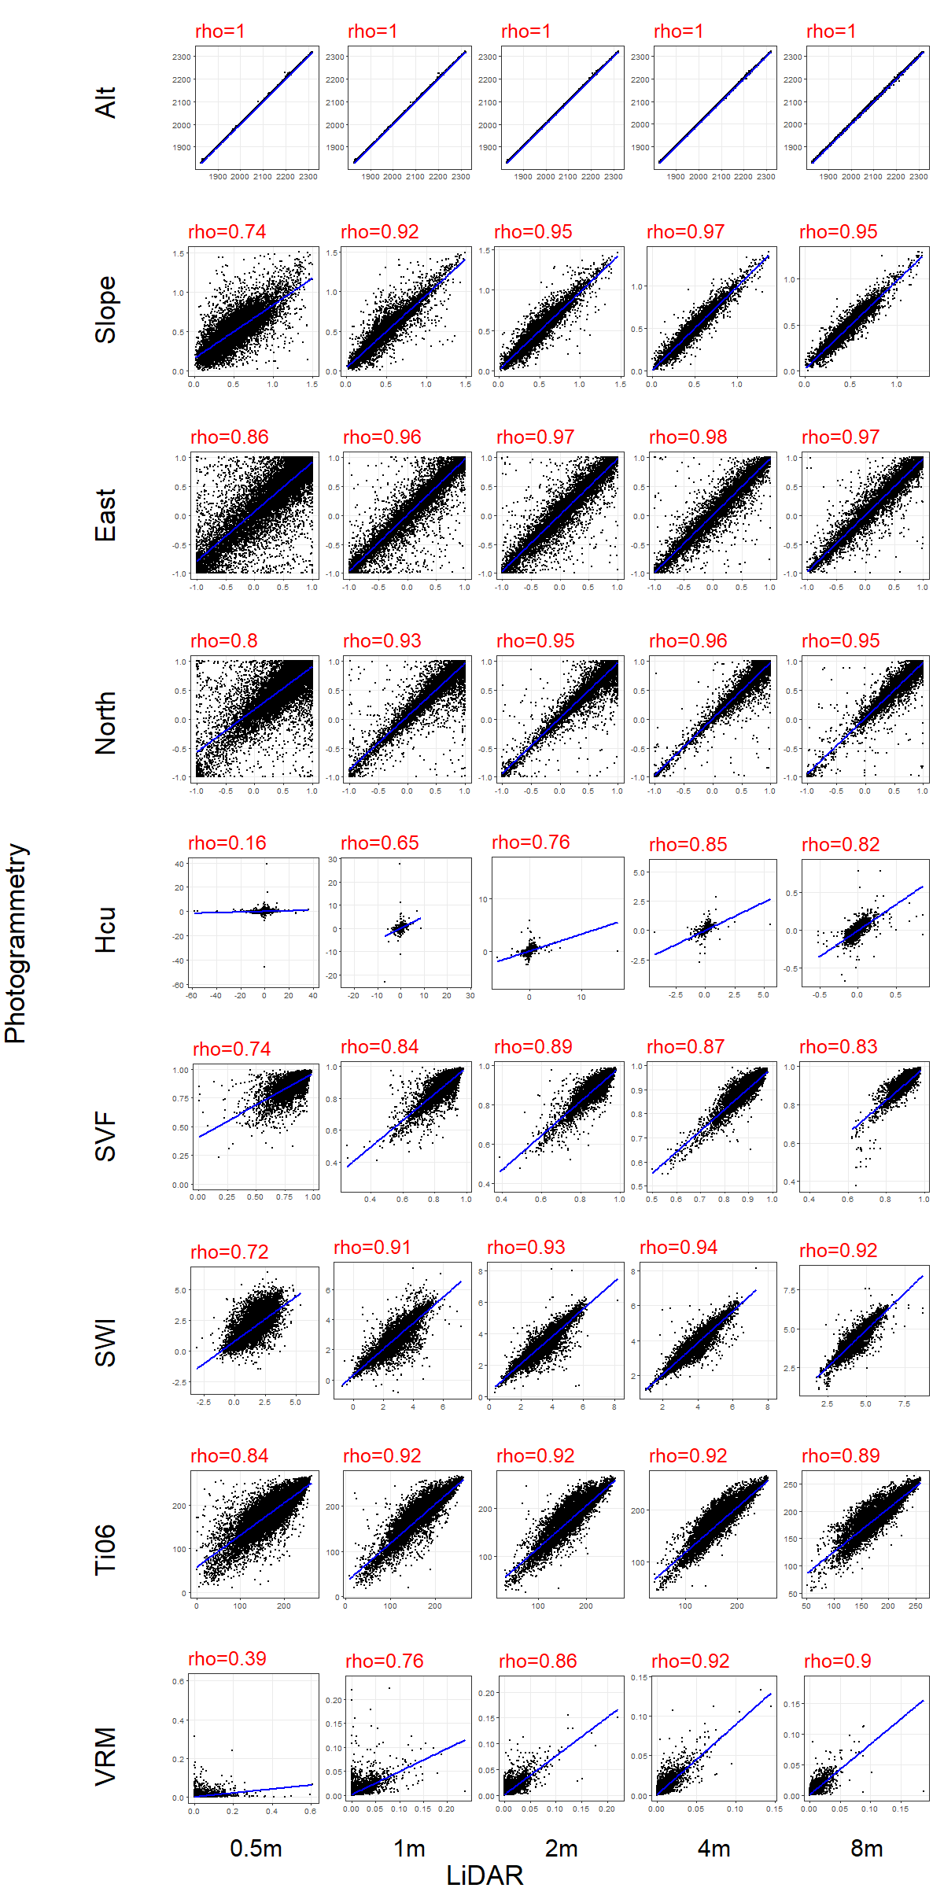  Elevation
b) Martinets | 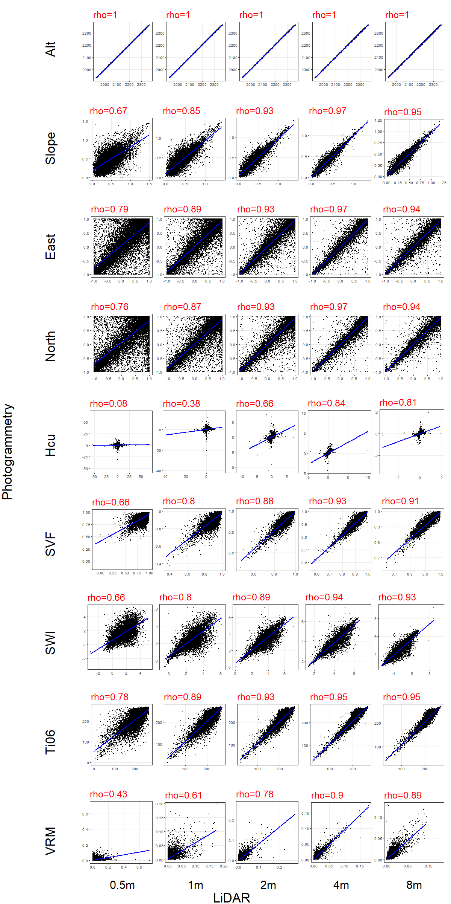  Elevation

