Supplemental Materials
Seroprevalence of SARS-CoV-2 infection among occupational groups from Bucaramanga and metropolitan area, Colombia

Figure S1. Geolocation process
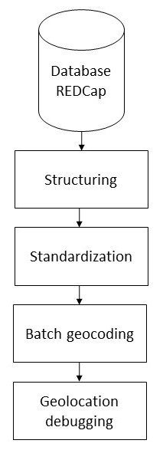

Table S1. Estimates of corrected and adjusted seroprevalence
Variable | Corrected prevalence  % (IC95%) | Adjusted prevalence  % (IC95%)
Municipality  Bucaramanga  Floridablanca  Girón  Piedecuesta | 17.8 (16.5 – 19.1)  17.5 (16.0 – 19.1)  25.7 (23.5 – 28.1)  18.2 (16.9 – 19.6) | 18.3 (17.0 – 19.5)  17.9 (16.3 – 19.5)  27.8 (24.4 – 31.2)  18.7 (16.0 – 21.5)
Age group  18 a 29  30 a 39  40 a 49  50 a 59  60 a 69  70 and more | 20.0 (18.7 – 21.4)  19.0 (17.0 – 21.1)  17.9 (15.6 – 20.4)  17.2 (15.1 – 19.5)  17.0 (13.0 – 21.8)  21.0 (14.7– 29.6) | 20.1 (18.4 – 21.7)  19.2 (17.5 – 20.9)  17.2 (15.2 – 19.1)  17.0 (14.6 – 19.5)  16.1 (11.4 – 20.8)  21.5 (10.7 – 32.4)
Occupational sector  Health,  Public transportation,  Public Force,  Public Services,  Security,  Construction,  Food,  Education,  Grocery store tenants/ Informal commerce,  Independent worker,  Adm/Municipal Services,  Cleaning,  Bike delivery workers,  Other | 18.6 (16.4 – 20.9)  15.9 (12.2 – 20.5)  23.3 (19.4 – 27.6)  12.5 (9.5 – 16.2)  21.2 (16.6 – 26.6)  21.0 (18.4 – 24.0)  21.8 (16.5 – 28.3)  13.1 (7.4 – 21.9)  27.9 (24.3 – 31.8)  23.3 (18.4 – 29.1)  16.2 (14.7 – 17.8)  24.3 (15.8 – 35.5)  31.8 (23.8 – 41.0)  19.0 (17.0 – 21.1) | 19.3 (17.9 – 20.6)  16.0 (11.7 – 20.3)  25.0 (18.2 – 31.8)  11.9 (7.7 – 16.0)  22.4 (14.9 – 29.9)  21.0 (17.2 – 24.7)  23.2 (16.6 – 29.7)  12.6 (6.9 – 18.3)  30.5 (24.2 – 36.9)  25.0 (20.8 – 29.1)  16.4 (14.2 – 18.5)  26.2 (18.0 – 34.3)  35.3 (10.0 – 60.6)  19.8 (16.0 – 23.5)

Figure S2a. Percentage of participants with presence of antibody
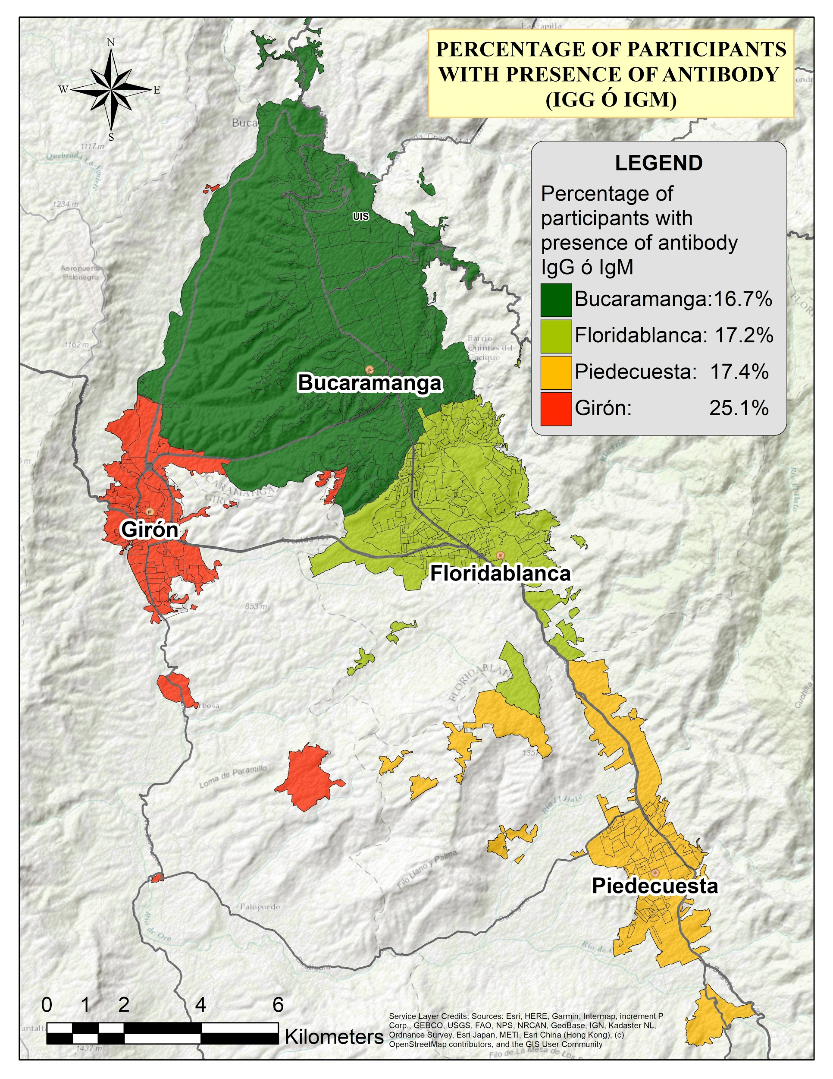
Figure 2a represents the proportion of participants with positive IgG or IgM antibodies, the highest percentage of participants is found in the Girón, followed by Piedecuesta, Floridablanca, and Bucaramanga.
S3 Figure 2b. Masculinity index
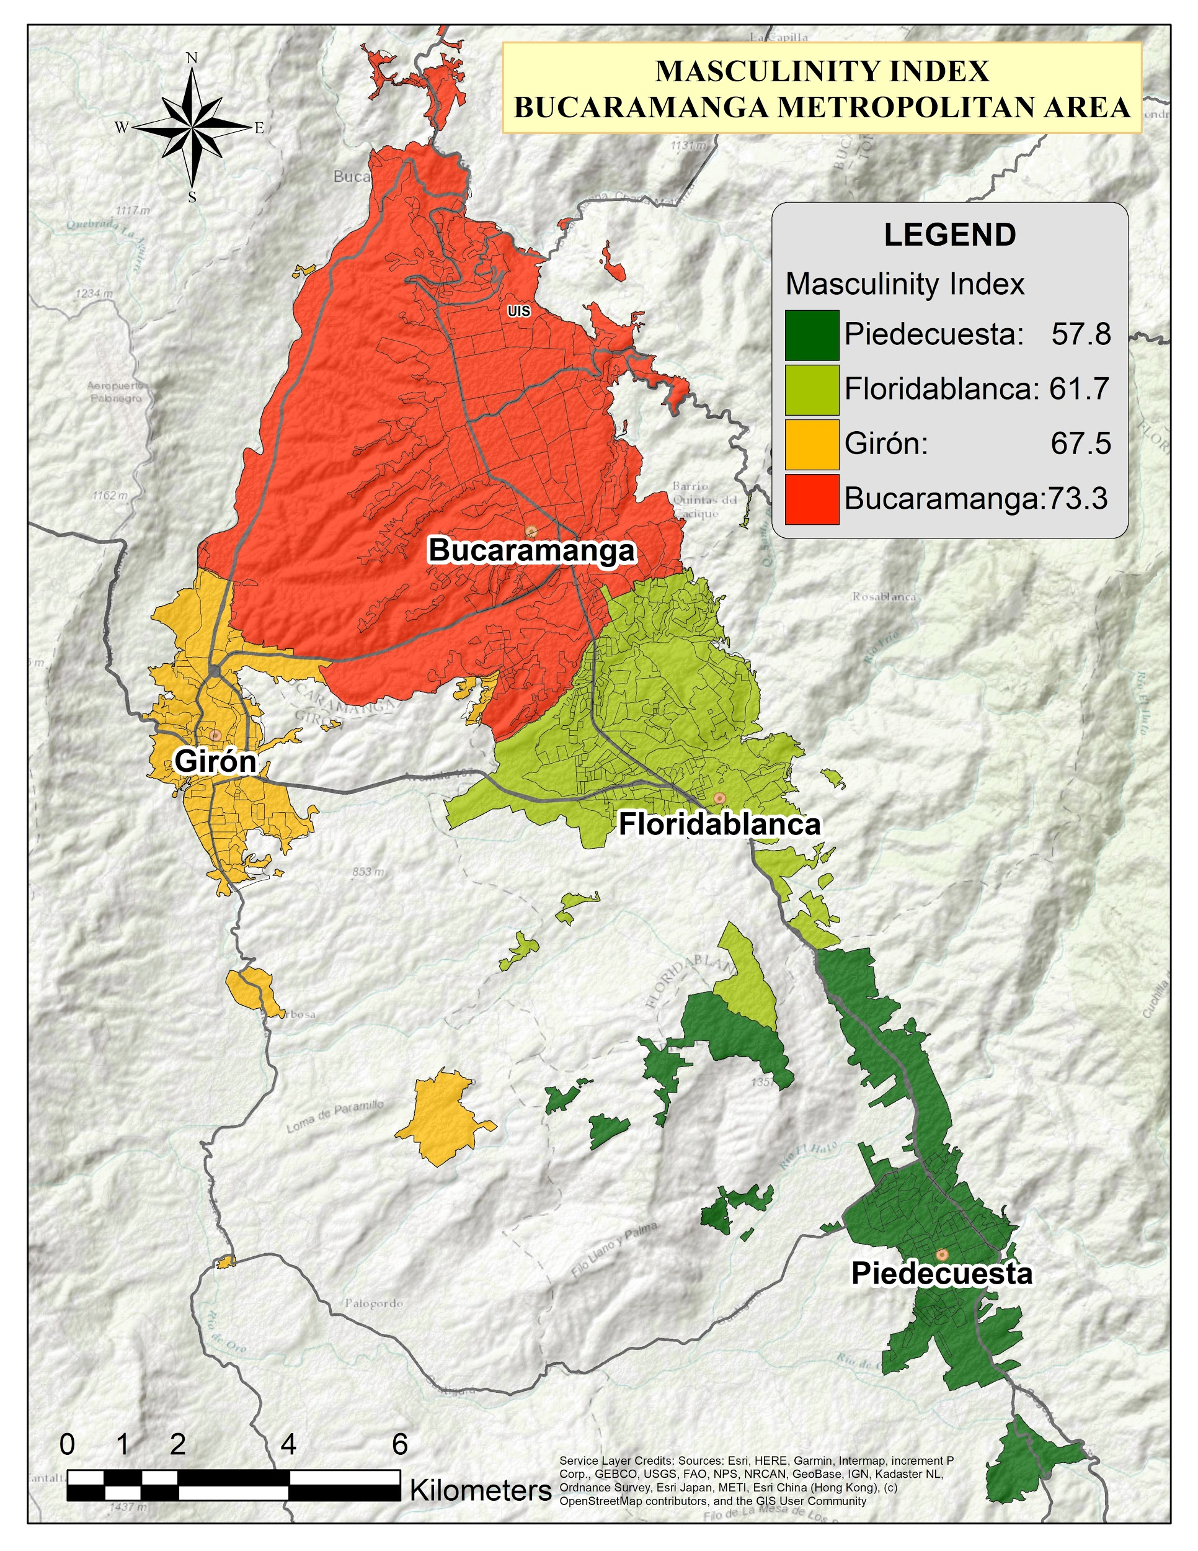
The masculinity index, commonly called sex ratio, is a demographic indicator that expresses the sex composition of a population. Figure 2b shows the ratio of men:women for each municipality, specifically the number of men participating for every 100 women, organized in cities from highest to lowest based on the indicator, it was found that Bucaramanga has the highest masculinity index with 73.3 men per 100 women, followed by the municipality of Girón with 67.5, Floridablanca with 61.7, and Piedecuesta with 57.8.

Table S2. Effect of days of recruitment on test results
Model | Coef (IC95%)
Test results + Days since recruitment began | 0.0016 (-0.0011; 0.0043)
Test results + Days since recruitment began adjusted by municipality | 0.0018 (-0.0006; 0.0042)
Test results + Days since recruitment began adjusted by municipality, occupational group | 0.0016 (-0.0007; 0.0040)
Test results + Days since recruitment began adjusted by municipality, occupational group, age | 0.0022 (-0.0005; 0.0050)
Test results + Days since recruitment began adjusted by municipality, occupational group, age, sex | 0.0022 (-0.0005; 0.0050)

