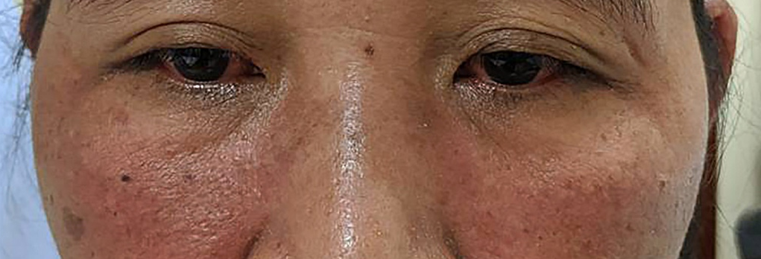
(a)
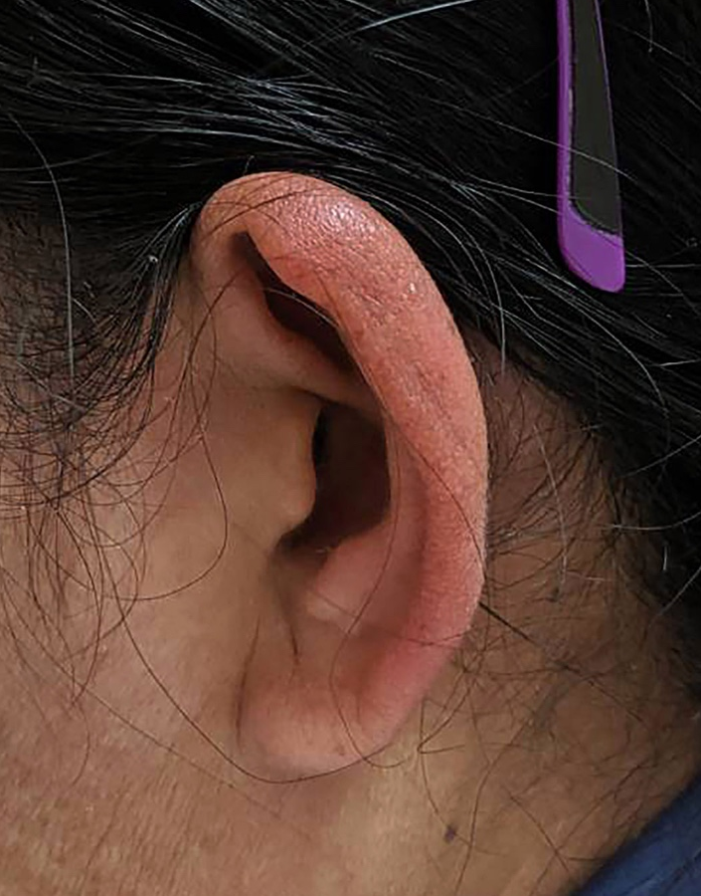 | 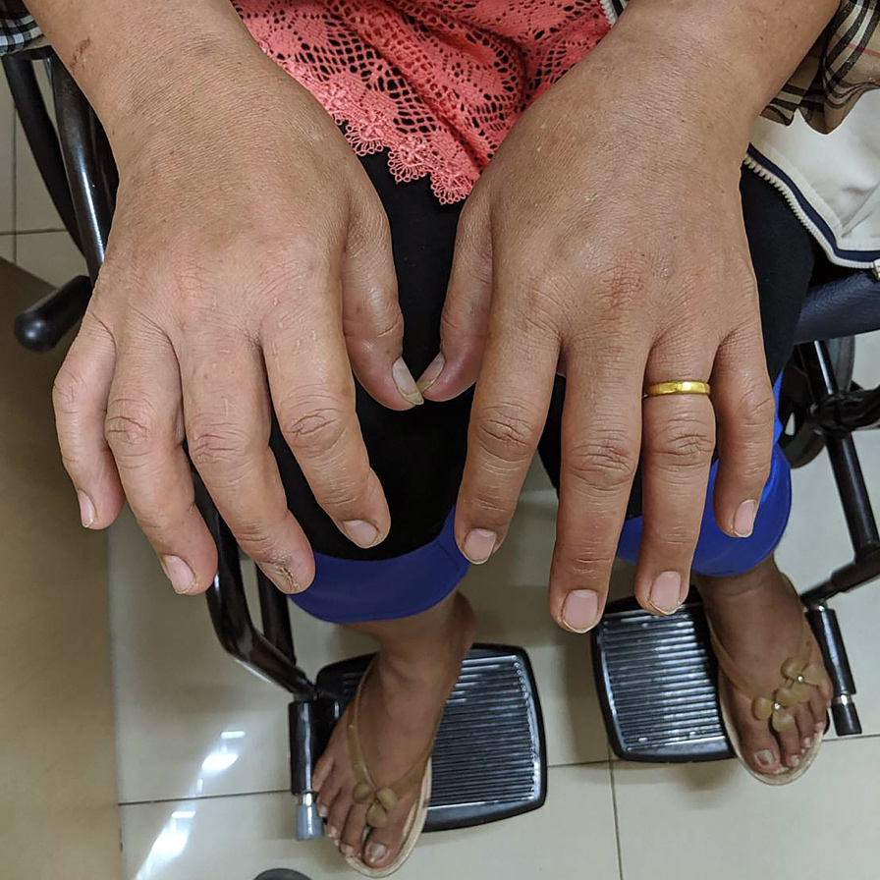
(b) | (c)
Figure S1 Images taken at presentation to the Fever Clinic during the acute CHIKV infection (October 2019). (a) Non-purulent conjunctivitis of both eyes and erythema over the cheeks, (b) erythema of the pinna (Milians ear sign), (c) bilateral swelling of metacarpophalangeal joints and ambulation in a wheel chair due to debilitating arthralgia of the knees.

Figure S2. Elapsed time between the initial presentation to the hospital and relapse of symptoms, clinical findings, and investigations performed during each visit.

