Article
Development of Phosphodiesterase-Protein Kinase complexes as novel targets for discovery of inhibitors with enhanced specificity
Nikhil K. Tulsian^{1,2}, Valerie Jia-En Sin³, Hwee-Ling Koh^{3*}, Ganesh S. Anand^{1,4*}
¹ Department of Biological Sciences, 14 Science Drive 4, National University of Singapore, Singapore – 117543
² Department of Biochemistry, 28 Medical Drive, National University of Singapore, Singapore – 117546
³ Department of Pharmacy, 18 Science Drive 4, National University of Singapore, Singapore – 117543
⁴ Department of Chemistry, The Pennsylvania State University, Philadelphia, United States of America - 16801
* Correspondence: KHL: phakohhl@nus.edu.sg; Tel.: +6565167962; GSA: gsa5089@psu.edu; Tel.: 814-867-1944

SUPPLEMENTARY INFORMATION

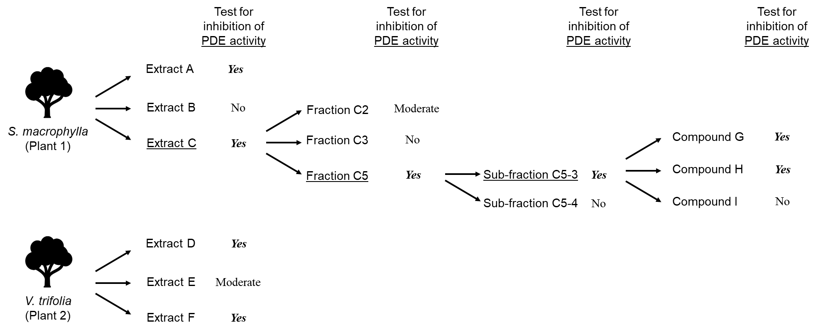
Supplementary Figure S1: Activity-guided fractionation of plant extracts.
Schematic of extraction of compounds/fractions from two species of medicinal plants - Swietenia macrophylla and Vitex trifolia. From each plant, three crude extracts were isolated and their PDE inhibition was tested by PDE-GloTM and FP assays. Each of the active/inhibitory fractions were then subjected to another round of fractionation and activity measurement. Qualitative results of activity assay are shown and the extracts/fractions selected for sub-fractionation are underlined.

Supplementary Table S1: Inhibition values for various extracts and fractions inhibiting PDE8 and PDE5, as determined by fluorescence polarization (FP) and PDE-GloTM assays. Average values (n = 6) were calculated as described in methods and their standard deviations (SD) are indicated.

(i) PDE8
S.No. | Sample | %FP inhibition | SD | %PDE-Glo inhibition | SD
1 | No PDE8 | 100 | 0.15 | 99.95 | 0
2 | PF-04 | 95.6 | 2.10 | 99.6 | 0.65
3 | IBMX | 0.24 | 1.96 | 92.3 | 6.4
4 | A | 6.56 | 0.55 | 24.7 | 6.1
5 | B | 32.58 | 2.90 | 6.4 | 9.6
6 | D | 40.2 | 1.05 | 99.7 | 2.3
7 | E | 88.56 | 2.78 | 99.71 | 2.60
(ii) PDE5
S.No. | Sample | %FP inhibition | SD | %PDE-Glo inhibition | SD
1 | No PDE5 | 100.00 | 0.10 | 100.00 | 0.00
2 | Sildenafil | 96.50 | 1.20 | 95.90 | 2.30
3 | A | 99.83 | 2.50 | 92.20 | 6.40
4 | B | 4.96 | 0.35 | 7.40 | 6.10
5 | C | 99.10 | 3.10 | 96.80 | 1.95
6 | D | 75.50 | 2.20 | 65.10 | 9.60
7 | E | 85.37 | 1.62 | 85.30 | 2.30
8 | F | 99.83 | 3.58 | 97.90 | 0.65
9 | G | 90.90 | 2.60 | 89.12 | 5.76
10 | H | 82.60 | 1.30 | 98.53 | 1.26
11 | I | 1.00 | 0.07 | 4.27 | 8.15
12 | C2 | 24.80 | 1.37 | 44.67 | 8.54
13 | C3 | 7.40 | 0.13 | -12.70 | 3.70
14 | C5 | 95.80 | 2.80 | 95.65 | 1.30
15 | C5-3 | 99.10 | 3.20 | 94.40 | 1.74

