Supplementary Figures
Figure S1. pre-clinical and clinical studies of phage therapy 2008-2021
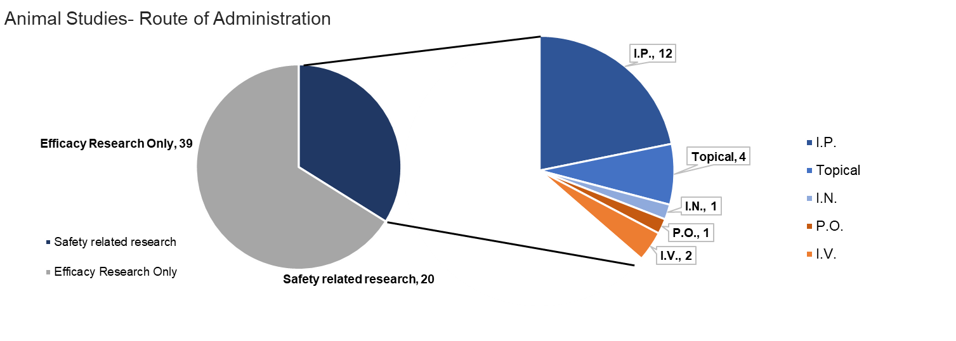
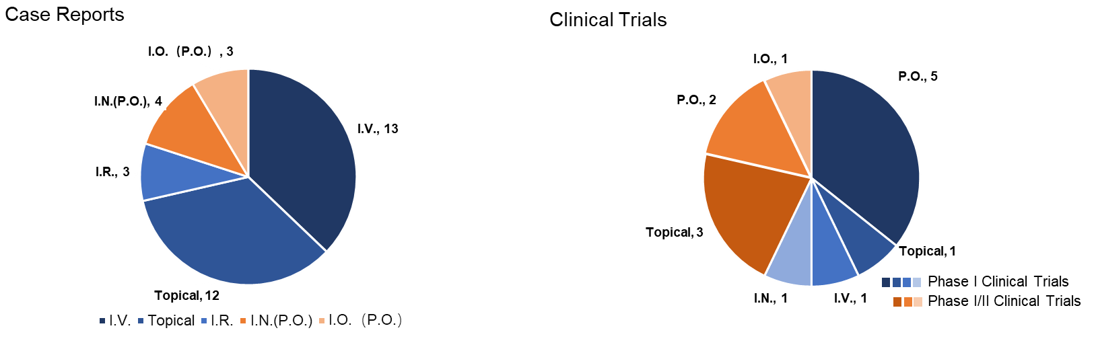

Our review included 59 animal studies of phage therapy. Of these, 20 examined safety measures in some capacity. Routes of phage administration included intraperitoneal (I.P.), inhalational (I.N.), topical, oral (P.O.), intravenous (I.V.). 35 case reports of phage therapy were included in humans. Of these, therapy was administered by I.V., single or combined with other administration, topical, intrarectal (I.R.), I.N., with or without P.O., Intravesical (I.O.), with or without P.O. This review also included 14 clinical trials in humans. the routes of administration included P.O., Topical, I.N., I.V. and I.O.

Figure S2. Pathogens targeted in phage therapy studies
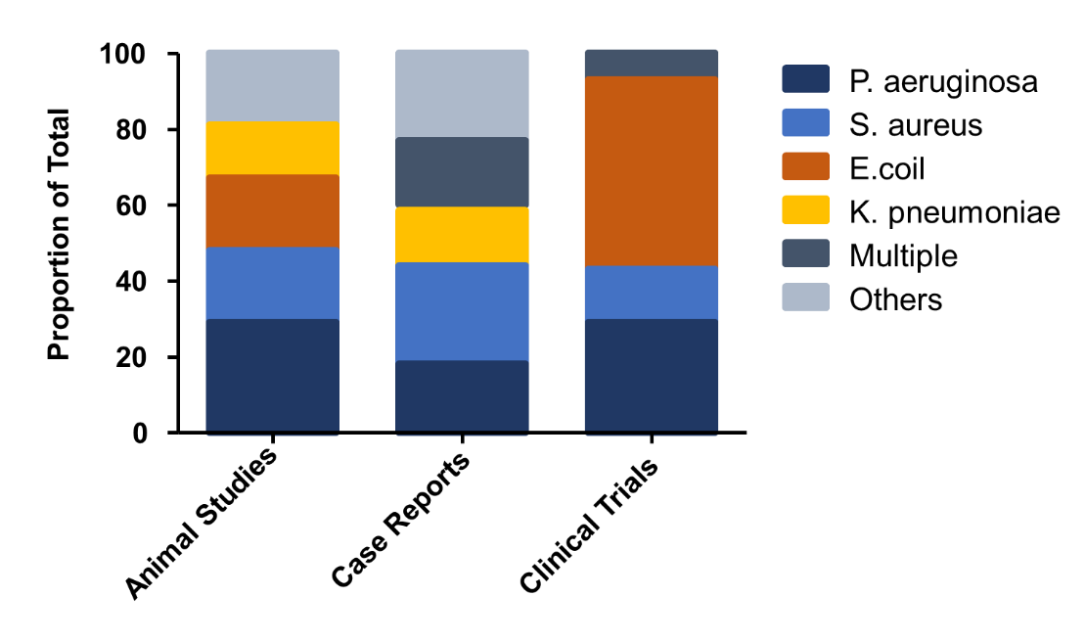
The percentage of cases that targeted specific pathogens are shown for animal studies, case reports and clinical trials. The target pathogens in animal studies included P. aeruginosa, S. aureus, E. coli, K. pneumoniae, or other pathogens. The target pathogens in case reports were P. aeruginosa, S. aureus, and K. pneumoniae, multiple pathogens infection, and other pathogens. The major pathogens of interest in clinical trials were E. coli, P. aeruginosa, S. aureus, and multiple pathogens infection. “Other pathogens” include: Enterococcus faecalis, Mycobacterium, Achromobacter xylosoxidans, Acinetobacter baumannii, Vibrio cholerae, Cronobacter spp.

Supplementary Table 1: Pre-clinical Studies
Reference | Animal model | Phage administration | Main safety outcomes
Dufour, et al. 2019 [1] | Mice (BALB/c)  E. coli  pneumonia | Phages 536_P1 and LM33_P  I.V. | No difference in behavior and weight,  Cytokine concentration in lung and blood: phage 536_P1 alone promoted a weak increase of anti-viral cytokines (INF-ɤ and IL-12) and chemokines in the lungs
Fong, et al. 2019 [2] | Sheep  P. aeruginosa  sinuses | PA phage cocktail  Topical | Phage was detected in blood,  No loss of appetite, fever, or other signs of systemic illness,  No significant changes in blood chemistry, SEM show no change in assess cilia
Drilling, et al. 2017 [3] | Sheep (Marino-cross)  S. aureus  Sinusitis | Phage cocktail NOV012;  Topical | No infectious phages in serum; General Health: appetite, fever, systemic illness; SEM shows no changes in cilia morphology;
Drilling, et al. 2014 [4] | Sheep  S. aureus;  sinusitis | phage cocktail (CTSA)  Topical | No Phage in kidney, spleen, liver, and brain; SEM showed no change in assess cilia
Chhibber, et al. 2008 [5] | Mice (BALB/c)  K. Pneumoniae  pneumoniae | phage SS  I.P. | No change in rectal temperature lethargy or sickness; Maximum phage counts in blood, peritoneal fluid and lungs were obtained after 6 h; No toxicity in mice
Jongsoo, el.at. 2019 [6] | Mice (C57BL/6)  P. aeruginosa;  pneumoniae | phages R656, R1836  I.P. | No difference in survival; No difference in the levels of TNF-α and IL-6 in the lungs; HE showed no toxicity in lung sections
Chang, et al. 2018 [7] | Mice (Swiss)  P. aeruginosa  Pneumoniae | Phage PEV20  I.N. | Level of phages in plasma was low  Histopathological examination showed no lung toxicity
Gelman, et al. 2018 [8] | Mice (ICR)  E. faecalis  peritonitis | Phage EFDG1, EFLK1  I.P. | No difference in physical condition; Phage alone mildly increase the level of TNF-α, antibiotic increased levels more; Phages alone did not result in any l adverse effects.
Cheng, et al. 2017 [9] | Mice (BALB/c)  E. faecalis bacteremia | Phage EF-P29  I.P. | No difference in health scores or body weight between normal
Oechslin, et al. 2016 [10] | Rat (Wist)  P. aeruginosa  Endocarditis | Phage cocktail PP1131  I.V. | Phage detected in blood, spleen, kidney, liver, lung, and brain; IL-1β, IL-6 significantly increased plasma levels may relate to phage-induced bacterial lysis
Galtier, et al. 2016 [11] | Mice (BALB/c)  E. coli  intestinal colonization | Phage AL505  P.O. | A lower impact on microbiota composition compared to antibiotic treatment
Jun, et al. 2014 [12] | Mice  BALB/c female  Vibrio parahaemolyticus | pVp-1  I.P. or P.O. | Phage detected in the mouse blood stomach, intestine. No changes in physical condition and survival; Titers of IgG and IgM against the phage increased by 170-fold and 50-fold, respectively. No adverse events were observed
Takemura-Uchiyama, et al. 2014 [13] | Mice (ICR)  S. aureus  septicaemia | Phage S13’  I.P.; | No unusual behavior or deaths were observed
Osanai, et.al. 2012 [14] | Mice (BALB/c)  K. Pneumoniae  bacteremia | Phage cocktail  I.P. | Phage shows in blood samples; No fever or general lethargy 30 days after injection; no adverse effects
Pouillot, et al. 2012 [15] | Rat (SD)  E. coli  Sepsis and  Meningitis | Phage S242  I.P. or s.c. | High concentration in blood, spleen and kidney, low in brain at 2-24 h; no difference in weight gain; no sign of toxicity was observed
Ľubomíra Tóthová et al. 2011 [16] | Mice  Cronobacter  UTI | Cronobacter-specifc phage  I.P. | No adverse effects were reported
Hung, et al. 2011 [17] | Mice (C57BL/6)  K. pneumoniae Bacteremia | bacteriophage NK-5  I.P. vs. P.O. | No difference in survival rate; phage alone resulted in no elevation of AST and ALT,TNF-α， IL-6, MCP-1, IFN-γ, IL-10, and IL-12 p70 levels; No death or adverse effect
Hawkins, et al. 2010 [18] | Dog  P. aeruginosa  otitis | Cocktail with Six phages  Topical | No treatment related inflammation was detected; no related adverse events
Sunagar, et al. 2010 [19] | Mice (ICR)  S. aureus  bacteremia | Phage GRCS  I.P. | No anaphylactic reactions or changes in core body temperature; titers of IgG and IgM against the phage increased above the background by 2500-fold and 100-fold respectively No other adverse events
Nishikawa, et al. 2008 [20] | Mice (BALB/c)  E. coli  UTI | phages T4 and KEP10  I.P. | No adverse effects according the physical exam and survival data

Supplementary Table 2: Case Reports
Reference | Case | Phage administration | Main safety outcomes
Lebeaux et al., 2021 [21] | 12-year-old male lung-transplanted cystic fibrosis  A. xylosoxidans | phage against  A. xylosoxidans;  Inhale | Clinical tolerance was perfect  No more details
Ferry et al., 2020 [22] | Three case with  S. aureus prosthetic joint infection | PP1493, PP1815, PP1957  Topical | No information about safety
Bao et al., 2020 [23] | 63-year-old female  UTI with K. pneumoniae infection | phages against  K. pneumoniae.  Topical | No adverse event occurred  No more details
Cano, et al.2020 [24] | 62-year-old male;  K. pneumoniae prosthetic knee infection | KpJH46Φ2  I.V. | No treatment-related adverse eﬀects and remained asymptomatic 34 weeks after completing treatment.
Rostkowska, et al. 2020 [25] | 60-year-old male;  K. pneumoniae  UTI | phage against  K. pneumoniae;  Intrarectal | No adverse reactions or intolerance reported
Doub, et al. 2020 [26] | 72-year-old male;  S. aureus  prosthetic joint infection. | SaGR51’1;  I.A. + I.V. | Albumin decreased,  therapy was stopped due to transaminitis
Rubalskii et al.2020 [27] | Case series of  Cardiothoracic Surgery Related Infections | Multiple phages;  Topical or I.N. | No adverse events reported
Gainey et al.2020 [28] | 10-year-old female  Achromobacter  CF | Phage Ax2CJ45Φ2  I.V. | No adverse events reported
Aslam et al.2019 [29] | 3 lung transplant patients  P. aeruginosa or B. dolosa | AB-PA01; Navy phage cocktail; BdPF16phi4281;  I.V. | Clinical and laboratory parameters were tested. No phage-related adverse events were identified
Nir-Paz el at. 2019 [30] | A 42-year-old male  Acinetobacter baumannii and  K. pneumoniae  bone infection | /  I.V. | No adverse events related to phage were noted clinically or on laboratory monitoring (liver function tests, complete blood counts, electrolytes)
Tkhilaishvili et al. 2019 [31] | 80-year-old female  P. aeruginosa  Joint Infection | /  Topical | No adverse events reported
Onsea et al.2019 [32] | Case series  Musculoskeletal Infections | BFC1 cocktail  Pyo bacteriophage  Topical | Clinical status was evaluated daily, and blood tests and serum samples for the phage neutralization assay. No adverse events reported
Corbellino et al.2019 [33] | 57-year-old  K. pneumoniae  gut infection | oral + I.R. | No adverse events reported
Susan, et al. 2019 [34] | 77-year-old female；  P. aeruginosa;  pneumonia | AB-PA01;  I.V.+ Inhale; | Well-tolerated with no adverse events detected either during therapy or subsequently
Gilbey, et al. 2019 [35] | 65-year-old male  S. aureus Endocarditis | AB-SA01  I.V. | No fevers, tachycardia, hypotension or rashes were detected after phage infusions and no adverse sequelae were attributable to the therapy
Law, et al. 2019 [36] | 26-year-old female  P. aeruginosa  CF | AB-PA01  I.V. | No adverse events were noted clinically or by lab exam
RM, et al. 2019 [37] | 15-year-old Mycobacterium abscessus  CF | BPs33ΔHTH-HRM10 and ZoeJΔ45  I.V. + Topical | Phages were detected in serum one day after starting treatment, reached titers in excess of 10⁹ pfu/ml and fell below detection one week; sera showed weak phage-neutralization antibody and cytokine responses. Diaphoresis and flushing but no fever or changes. No adverse reactions to phage administration
Kuipers et al. 2019 [38] | 58-year-old male  Klebsiella pneumoniae  UTI | /  oral + I.O. | No adverse events occurred.
Duplessis, et al. 2018 [39] | A 2-year-old male  P aeruginosa bacteremia; | phage cocktail  I.V. | Without identified host humoral responses targeting phage; Phage was withheld for decompensation concerning for anaphylaxis
LaVergne et al. 2018 [40] | 77-year-old male  - baumanii  brain injury surgical related infection | A. baumani phage  I.V. | Brief episode hypotension after the first dose
Ferry et al.2018 [41] | 80-year-old female  S. aureus  prosthetic joint infection | S. aureus phage  Topical | No adverse events reported
Fish, et al. 2018 [42] | 63-year-old female  S. aureus Osteomyelitis | Sb-1;  Topical | No safety monitoring
Ferry, et al. 2018 [43] | 60-year-old male  S. aureus  bone and joint infection | Phage cocktail  Topical | No safety monitoring
Hoyle, et al. 2018 [44] | 17-years-old female Achromobacter xylosoxidans  CF | phage cocktail  Inhale + oral | No safety monitoring
Chan, et al. 2018 [45] | 76-year old male  P. aeruginosa  aorto-cutaneous fistula infection | phage OMKO1  Instill | The patient had no complaints with stable vital signs and had laboratory values within normal limits
Ujmajuridze et al. 2018 [46] | UTI case serial  with different pathogen | phage cocktail Pyo  Intravesical  (I.O.) | One patient experienced sudden fever and chills on the third day of PT. No bacteriophage-associated adverse events have been detected
Schooley, et al. 2017 [47] | 68-year old female  A. baumannii Pancreatitis | Cocktail with 9 phages  I.V. + Instill | Phage neutralization antibody appeared in plasma (in vitro); PT was withheld for increased pressor requirementstwo days following initiation
Zhvania, et al. 2017 [48] | 16-year-old male;  S. aureus  skin infection | Sb1,  Topical, | No adverse reactions
Jennes, et al. 2017 [49] | 61-year-old male  P. aeruginosa Septicaemia; | Phage cocktail BFC1  I.V. + Instill | No adverse events, clinical abnormalities or changes in lab test related to phages
Fish et al. 2016 [50] | Case series,  S. aureus  diabetic foot ulcer | Sb-1;  Topical | No adverse events reported
Fadlallah et al. 2015 [51] | 65-year-old female  S. aureus  corneal abscess | phage SATA-8505  Topical | No adverse events reported
Rose et al. 2014 [52] | burn wounds  case serial  with S. aureus and P. aeruginosa | phage cocktail BFC-1;  Topical | No adverse events, clinical abnormalities or changes in laboratory test related to the application of phages
Khawaldeh, et al. 2011 [53] | 67-year-old female  P. aeruginosa  UTI | Pyophage  Instill | No adverse events reported
Kvachadze, et al. 2011 [54] | 7-year-old female S. aureus and P. aeruginosa  CF | Sb-1 and Pyophage  Nebulizer; | No adverse events reported
Letkiewicz,el.at.2009 [55] | Case series;  E. faecalis  chronic prostatitis | Coliphage  Intrarectal | No change significantly in the function of liver, pancreas, kidney, and bone marrow immune function did in response to the therapy

Supplementary Table 3: Clinical Trials
Reference | Trial | Phage administration | Main safety outcomes
Leitner et al., 2020 [56] | Phase I/II clinical trial  (UTI) | Pyophage  Intravesical  (I.O.) | Safety assessment included frequency and severity of adverse events during the treatment period according to the （CTCAE）v4.0 as grade 1 to 5.
Grubb et al., 2020 [57] | Phase I/II clinical trial  (gastrointestinal distress) | PreforPro  Oral | glucose, BUN, creatinine (CRE), creatinine kinase (CK), NA+, K+, Cl- and C-reactive protein; a daily stool log, and gut microbial populations.
Petrovic Fabijan et al. 2020 [58] | Phase I clinical trial  (endocarditis, sepsis) | AB-SA01  I.V. | The vital signs, clinical, haematological and blood biochemical parameters. The local adverse effects and systemic adverse reactions and evidence of renal or hepatic dysfunction. No adverse reactions were reported.
Ooi et al. 2019 [59] | Phase I clinical trial  (Rhinosinusitis) | AB-SA01;  Topical | Vital signs, physical examinations, clinical laboratory test results, and adverse events. Intranasal phage treatment was well tolerated, with no serious adverse events or deaths reported.
Febvre, et al. 2019 [60] | Phase I clinical trial | Coliphage cocktail  Oral; | a small but significant decrease in circulating IL-4 according the system inflammatory examination.
Gindin, et al. 2019 [61] | Phase I clinical trail | coliphages  Oral | No difference in liver and kidney function and metabolic parameters;  No adverse events observed by self-report or clinical exam.
McCallin, et al. 2018 [62] | Phase I clinical trial | Pyophage cocktail;  Oral or Nasal; | No difference in physical conditions; No different in clinical lab exam. No adverse events related to phage administration. The body temperature showed more fluctuations, but fever was only rarely observed and did not exceed 38 °C.
Sarker, et al. 2017 [63] | Phase I clinical trial | Two coliphage cocktails  Oral; | No viable coliphage in the serum; No difference in physical conditions; No difference in clinical lab exam. No serum was positive for LPS; No antibody increasing to LPS or phage. No adverse effects.
McCallin, et al. 2013 [64] | Phase I clinical trial | coliphage cocktail  Oral; | No safety issues reported according the physical data, clinical lab exam and no phage or phage antibody in serum detected. No adverse effects  Have no impact on fecal microbiota composition.
Sarker, et al. 2012 [65] | Phase I clinical trial | T4-like phage cocktail  Oral; | No subjects complain; No safety issues reported according the vital sign, clinical lab exam, No adverse effects and impact on fecal microbiota composition.
Rhoads, et.al 2009 [66] | Phase I clinical trial  (venous leg ulcers) | WPP-201 phage cocktail  Topical; | No safety issues reported according the vital sign, lab exam
Jault, et al. 2019 [67] | Phase I/II clinical trial  (burn patient) | phages cocktail PP1131  Topical, | not substantially diﬀerent in vital sign, physical examinations from standard care group.
Sarker, et al. 2016 [68] | Phase I/II clinical trial  (Acute bacterial diarrhea) | Two coliphages cocktails  Oral, | No changes in physical examinations and vital sign. No adverse events.
Wright. A. el, at. 2009 [69] | Phase I/II clinical trial  (chronic otitis) | Biophage-PA Cocktail;  Topical. | No reportable side effects from patient, and no evidence of local or systemic toxicity.

