Supporting Information

Novel approach for the synthesis of chlorophosphazene cycles with a defined size via controlled cyclization of linear oligodichlorophosphazenes Cl[PCl₂=N]_{n}–PCl₃⁺PCl₆–

Mikhail V. Gorlov*^{,1}, Nikolay S. Bredov¹, Andrey S. Esin¹, Igor S. Sirotin¹, Mikhail A. Soldatov¹, Volodymyr V. Oberemok², and Vyacheslav V. Kireev¹

¹ Mendeleyev University of Chemical Technology of Russia,
Miusskaya sq. 9, 125047 Moscow, Russia
² Taurida Academy, V.I. Vernadsky Crimean Federal University, Simferopol 295007, Republic of Crimea

Contents
Experimental part 3
General procedure of synthesis of linear oligodichlorophosphazenes 3
General procedure for cyclization reaction 3
Characterization 3
Table S1. Loadings of HMDS for synthesis of linear oligodichlorophosphazenes with
general formula [Cl(PCl₂=N)_{n}PCl₃]⁺[PCl₆]⁻ 4
Table S2. Loadings of HMDS for cyclization of linear oligodichlorophosphazenes with
general formula [Cl(PCl₂=N)_{n}PCl₃]⁺[PCl₆]⁻ 4
Table S3. ³¹P NMR chemical shifts of chlorocyclophosphazenes 4
Figure S1. Dependence of molecular weight of linear oligodichlorophosphazene [Cl(PCl₂=N)_{n}PCl₃]⁺[PCl₆]⁻ from amount of initiator PCl₅ 5
Figure S2. ³¹P NMR spectra of linear oligophosphazene [Cl(PCl₂=N)₂PCl₃]⁺[PCl₆]⁻ (A),
its product after cyclization (B), phenoxylated derivative of cyclization product (C)
and MALDI-TOF spectrum of phenylated product (D) 5
Figure S3. ³¹P NMR spectra of linear oligophosphazene [Cl(PCl₂=N)₇PCl₃]⁺[PCl₆]⁻ (A)
and its cyclization product (B) 6

Experimental part
General procedure of synthesis of linear oligodichlorophosphazenes: 100 mL of dichloromethane and HMDS under argon flow were placed into three-necked flask, equipped with magnetic stirrer, reflux condenser. The solution was stirred for 15 min at -55 °C and then 5 g (0.024 mol) of PCl₅ were added in one portion. The reaction mixture after that was stirred for another 15 min at -55 °C and then the temperature was raised during 2 h till 0 °C and mixture was stirred at this temperature for another 1 h. After that the mixture was naturally heated till room temperature and stirred for 2 h. After ending of reaction, the mixture was filtered under argon flow from the precipitated NH₄C and all volatile products were removed by vacuum rotary evaporation. The resulted product looks like viscous transparent greenish liquid. Loadings of HMDS and yields of products are given in Table S1.

General procedure for cyclization reaction: The calculated amount of HMDS was added under argon flow to reaction mixture, containing 2 g of linear oligodichlorophosphazene with specified chain length. After stirring at room temperature for 1.5 h, the mixture was filtered and all volatile compounds were removed by rotary evaporation. Loadings of HMDS and yields of products are given in Table S2.

Synthesis of phenoxycyclotriphosphazenes: In three-necked flask with reflux condenser and magnetic stirrer were added under argon flow 100 mL of dioxane, 3.89 (0.0414 mol) of phenol and 0.95 (0.0414 mol) of sodium. After full sodium dissolution to resulted mixture were added dropwise 30 mL of solution of 2 g of cyclic chlorophosphazene in dioxane. Then the mixture was stirred for 48 h at 100 °C. After that the mixture was cooled to room temperature and poured to water. The precipitated product was dissolved in chloroform and washed subsequently with 3% alkaline solution, 10% NaHCO₃ solution and water till neutral medium. Then the chloroform solution was dried with Na₂SO₄ and the solvent was removed by rotary evaporation. Yield of product after drying was 74-83 %, depending of chain length.

Characterization:
31P NMR spectra were recorded on “Bruker AMX-360” spectrometer (145.7 MHz) with the use of solvents CDCl₃ and acetone-d₆ and with the use of 80 % H₃PO₄ as internal standard. MALDI-TOF spectra were recorded on “Bruker Auto Flex II” spectrometer.

Table S1. Loadings of HMDS for synthesis of linear oligodichlorophosphazenes with general formula [Cl(PCl₂=N)_{n}PCl₃]⁺[PCl₆]⁻
n | Weight, g | mol | Yield of product, %
2 | 2.58 | 0.016 | 75
6 | 3.88 | 0.024 | 82
7 | 4.03 | 0.025 | 84
9 | 4.23 | 0.027 | 88

Table S2. Loadings of HMDS for cyclization of linear oligodichlorophosphazenes with general formula [Cl(PCl₂=N)_{n}PCl₃]⁺[PCl₆]⁻
n | Weight, g | mol | Yield of product, %
2 | 1.49 | 0.00923 | 130*
6 | 0.87 | 0.00539 | 80
7 | 0.79 | 0.00488 | 78
9 | 0.66 | 0.00410 | 71
* The formation of hexachlorocyclotriphosphazene is resulted not only after reaction of HDMS with [Cl(PCl₂=N)_{n}PCl₃]⁺[PCl₆]⁻ but also after its reaction with PCl₆⁻ ion.

Table S3. ³¹P NMR chemical shifts of chlorocyclophosphazenes.
Value of ³¹P NMR chemical shift of chlorophosphazenes [Cl₂P=N]_{n} |  |  |  | Ref.
5 | 6 | 7 | ≥8
– 17.0 | – 16.0 | – 18.0 | - | ^{[23]} (1976)
– 15.1 | – 15.3 | – 17.0 | – 17.7 | ^{[22]}(2014)

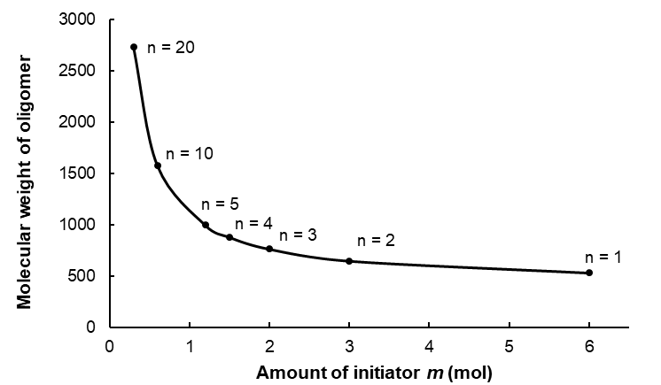
Figure S1. Dependence of molecular weight of linear oligodichlorophosphazene [Cl(PCl₂=N)_{n}PCl₃]⁺[PCl₆]⁻ from amount of initiator PCl₅.

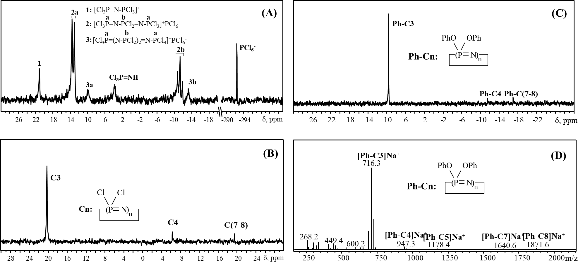
Figure S2. ³¹P NMR spectra of linear oligophosphazene [Cl(PCl₂=N)₂PCl₃]⁺[PCl₆]⁻ (A), its product after cyclization (B), phenoxylated derivative of cyclization product (C) and MALDI-TOF spectrum of phenylated product (D)

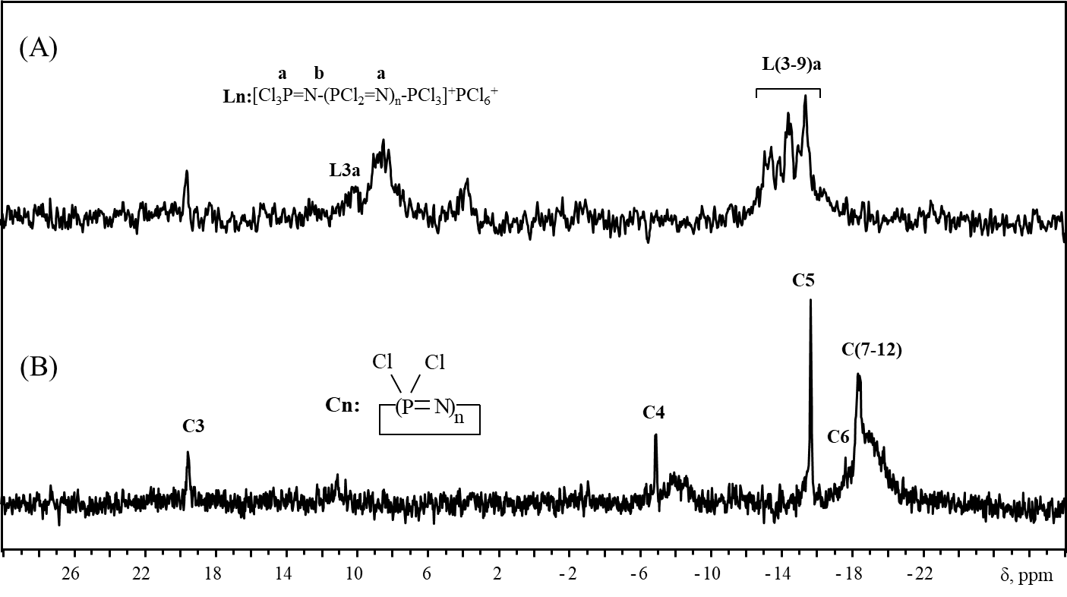
Figure S3. ³¹P NMR spectra of linear oligophosphazene [Cl(PCl₂=N)₇PCl₃]⁺[PCl₆]⁻ (A) and its cyclization product (B)

